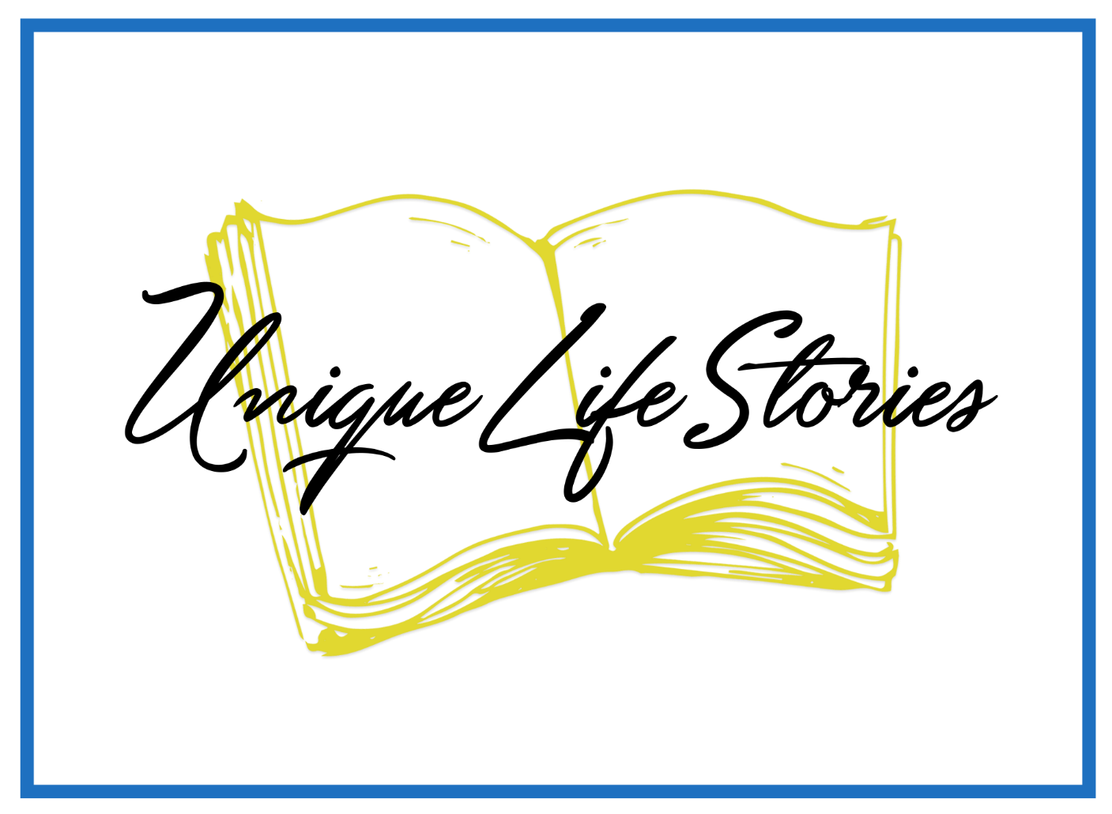

Unique Life Stories Helps Your Story Come to Life
When you work with Unique Life, we will work with you to get your life story come alive in whatever way that works the best for you. Perhaps you wonder how this will work. Here are the steps to working together.

- Preparation Meeting—We will talk in person or over the telephone to decide the scope of your project. At this time, we also will discuss cost outlines and the scope of your project.

- Actual work—Depending on the avenue you choose to preserve your story, we will either set up times for interviews or will work together on the stories or pictures you want to include in your life story. Then, the stories you want to share as well as the approach you want to take with your book (pictures and stories, special artifacts, drawings that either you provide, or I arrange to have done).

- Editing Work—At this point we will take the materials you have provided and the materials I have developed for you and put them together.

- Preview—Before anything is final, you will look at your project—whether a picture book, a chapter book, or any other book you have chosen. We will be able to make any changes or additions you see are necessary to make your story exactly right.

- Products—As per our agreement, you will receive the number of copies you have paid for. Of course, additional copies are always available.

- Presentation—We will help you celebrate the presentation of your story with family and friends

- Total hours—This number is totally dependent on what your project entails. Unique Life Stories will keep you appraised of the time as we go along.

It is my commitment at Unique Life Stories always to be in ready communication with you as we walk through these steps. This is your unique life story presented in its best form.

