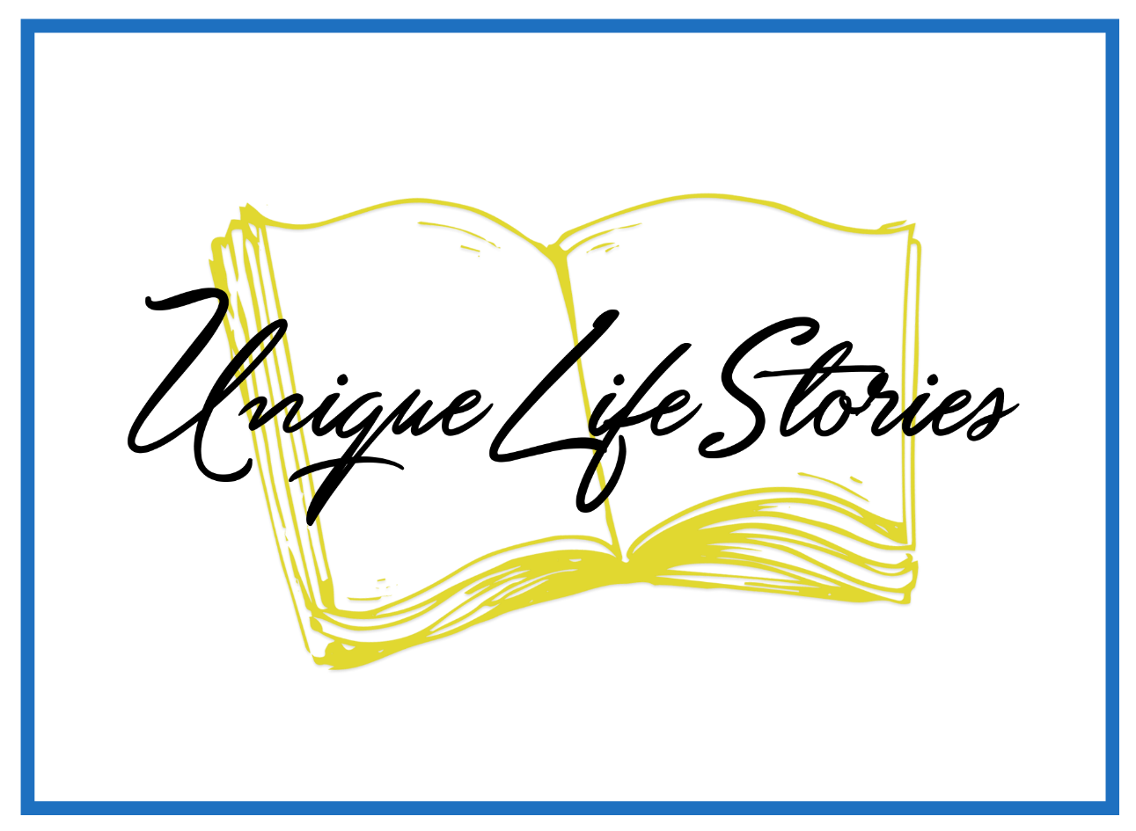

Writing Our Stories Through the Holidays

The last two months of the year are filled with music, decorations, special foods, and gifts, as we look to several important holidays—Veterans Day, Thanksgiving, Christmas, New Years Day, special religious holidays—just to mention a few. And there are special holidays of our own. For example, there are anniversaries of special events—both happy and sad. Happy could be birthdays, wedding anniversaries, work anniversaries, and countless other events special to our families or ourselves. Sad could be deaths of family members, for example.
So, let me show you how this might work.
Thanksgiving:
- Memories of childhood meals
  - Where did we celebrated, for example, at your or another relative’s house or someplace like a restaurant?
  - Who was the host/hostess?
  - What kind of food was served?
    - Any special food was always included?
    - What was my favorite?
    - What did I not really like?
  - How was the food prepared?
    - Did someone always bring a special dish?
    - Did others prepare the meat and what was that meat?
  - How was the table set?
    - Did adults and children eat at separate tables or even inside and outside?
    - Did your family use special dishes or disposable dishes?
    - Did you use special table linens or paper?
  - Now, how have you changed those childhood traditions in your own family?
  - What are the traditions of your own family?
    - Food
    - Style of eating—formal or informal
    - Where and how you celebrate
  - Who comes to the dinner?
    - Only immediate family
    - Extended family
    - Friends
    - Strangers
  - How do you express thankfulness for the Thanksgiving Holiday?
  - What are some other memories you have from your time as a child?
    - School programs
    - School pageants
    - Costumes
  - What kind of weather did you have in general when you were a child?

My childhood Thanksgiving memories using this method
When I was a child, all four of my grandparents were alive, as well as my maternal great-grandmother who lived with my mother’s parents on their farm in Central Texas. We drove from Mexico for Thanksgiving at least one year. We also drove down from Plainview, Texas a couple of times as well. We carried some prepared foods—my mother liked to make quick breads for the Thanksgiving holiday. We never took our dog, Blanca, along. She had to stay home, with the neighbor taking care of her.
As I remember most of my holidays as a small child, we were at the farm for the holiday, often with brothers and sisters of my grandfather who lived in the area. My grandmother had had breast cancer, losing much of the use of her left arm and hand. So, she did not do a lot of cooking. I can remember my grandmother cutting tomatoes in her hand—slicing sideways instead of down which is more common. My grandfather and mother did most of the cooking. Great-grandmother would sit at the kitchen table and cut vegetables and salad fixings. She did not stand and cook very much by the time I remember.
We always had a turkey, stuffed with bread stuffing, cooked in the kitchen oven. The house started smelling good early Thanksgiving Day morning. Sweet potato casserole, mashed white potatoes, green bean casserole, green salad, fruit salad, at least two jello dishes, filled with fruit, nuts, cottage cheese or cream cheese, cranberry sauce, pumpkin pie and apple pie and chocolate cream pie stood on the sideboard in the dining room. Several pitchers of iced tea, both sweet and unsweet stood on its own table, along with an Igloo cooler of and Kool-Aid for the children had their own table off to the side. The table was set with a lace and cloth tablecloth with matching cloth napkins, folded neatly to the side of the china plates, heavy silver flatware, and crystal goblets. Also, on the table were little glass containers holding pickles, fresh vegetables, butter, homemade rolls, as well as several salt and pepper shakers, all within reach of the guests. While the wooded dining table has only six chairs, it will comfortably sit twelve to fifteen people. And chairs from all over the house were added to the table for all the guests. The children were usually sent to eat our food on pretty paper plates to eat on the back screened in porch with paper cups. Many years there was not room for all the children at the table, along with all the adults. When the crowd was smaller, the children joined the adults at the dining table inside.
I have inherited that table and the sideboard that my stepmother and father had refinished. That means that this wooded table has lived in Texas, Virginia, and now Arizona, and is more than a hundred years old. Isn’t that amazing?
The Thanksgiving Dinner at the Burney farmhouse was a boisterous affair with lots of people and fancy dishes, making it a whole day affair, with leftovers all the rest of the weekend. We played outdoor games as children late into the night.
A few years we would go to my father’s parents’ house. It was a completely different holiday with them. My paternal grandparents were Baptist missionaries in Guatemala and were often out of the country when I was a child. However, I can remember a few times that we joined my grandparents at their house in Kermit, Texas. When we gathered there, my uncle, aunt and cousin joined us. I remember that was so much fun because even though my cousin was a boy, he was just a year younger than me and year older than my brother. So, we were just a year apart. He was from Arizona and that seemed so exotic to me. My aunt was always helping in the kitchen, so I often joined them there to talk and watch them cook. My mother generally stayed with the men, watching the boys who liked to play outside in the backyard sandy soil. The Collmers lived more humbly so our table was much less bountiful—chicken, green beans, green salad, jello salad, tamales, pinto beans, rolls, and tortillas. We often had carrot cake for desert and pumpkin pie. The whole family would sit around their table, elbow to elbow—ten people and we used the blue china dishes. Those dishes have a story as well. My grandmother wanted nicer dishes than the melamine dishes she used all the time. She found a jewelry story going out of business and they were selling these dishes as a set for just $100. She had saved up some money and my grandfather added money to it and they bought the set—a complete service for eight people, including tea and coffee pots and salt and pepper shakers and serving plates and bowls. These dishes were only used on those special occasions, like Thanksgiving. We always had prayer and moments to tell about what we were particularly thankful that year. My grandmother always giggled and said, “Having the family here this year.”
Such different holiday celebrations!

How has my own family celebrated?
Don and I have lived all over the world, often not within traveling distance of our parents. Before we had children, we often went to either of our parents’ houses or stayed home because one of us had to work—he at the hospital and me at the newspaper. Overseas, we often joined other missionaries at their homes for the special day. In Thailand, we were working with Cambodian refugees so ate Thanksgiving one Thursday evening after we got home from the Kamput Camp. We were a multinational group of people working together and all gathered at a career missionary’s home for sort of American-style dinner, with chicken and noodles. We did have pumpkin pie and a fruit pie and ice cream.
In Nigeria, we all brought our dishes to one house and shared Thanksgiving Dinner together. For several years, we had chicken as our main meat, but one year the X-ray department at the Eku Baptist Hospital decided to try to hatch some turkey eggs. Apparently, it is very tricky to hatch them, but they did raise several turkeys, selling one to the missionaries. One of the older ladies cooked the prized turkey that year and we had some traditional trimmings. We had white sweet potatoes instead of the orange yams, but other dishes were quite traditional.
When Don and I had our own home in Virginia, we often had our daughters home for the holiday, but very often invited foreign students or others who did not have family in the immediate area. We had lots of interesting conversations, as we explained the origin of the Thanksgiving holiday. To clearly explain that, we had to do some research!
Now that we live in Arizona far away from family, we have traveled back to Texas to spend time with our families there. And, this year, very pleasantly, both our daughters and son-in-law are all gathering in Waco, along with my brother and his girlfriend and perhaps some of their children. What a thrill this year will be—quite different from years past.
Traditions?
I remember my daughters dressing up as pilgrims as did the other missionary children and Nigerian friends so they could understand the meaning and history of Thanksgiving and the Pilgrims. I have lots of pictures of the children looking like they were from New England, right in the heat of West Africa. They were adorable, year after year, to my eyes.
We have always struggled to figure out how to express our gratitude at this holiday. I have a friend who taught me how to make a Thanksgiving turkey with the tailfeathers made in colored paper with something we were thankful written on them. That seems like a good idea, but I have not continued it since the children have grown up.
It seems like my Thanksgivings have not followed a pattern in all these decades. All of them have been special in their own way. Rarely have we not had any others at our Thanksgiving table, but that has happened once or twice. I have learned that I must be intentional in inviting people—it is possible to put off doing anything and find myself and my husband all by ourselves. One year, I was trying to be polite, and someone else invited everyone over to their house even though my husband and I had planned to do that. So, I missed being the hostess as I had planned.

You have your own special holiday celebrations—either from your childhood or from your own family as your children were growing up and you made new traditions. These questions may help you get started as we start celebrating with family and friends—however that might happen in this year of pandemic.

Let us know how we can help you get your story started. Contact us at carol@uniquelifestories.com

