
Starting Your Story with Pictures
One good way to start telling your story comes from using the picture albums you have made through the years. Perhaps you made one from a special vacation you took as a family to a faraway place or a national park. Perhaps it was a summer trip or a holiday trip. Maybe you have pictures from year after year of school pictures or holiday pictures. And sometimes we just have a random collection of pictures. Whatever your collection of pictures, you have a place to start in telling your story!
There are several ways to approach your story in pictures.
- Write a simple sentence with the place, date, names, and event for the picture. This is a quick way to get started but the information you are sharing is limited. Some questions might remain—why did you take this picture? Who and where are the people in this picture?
- You can take several pictures from the same place and time and group them all together to give a better view of that time and place. Then, your short explanatory sentences can give a better sense of your experience.
- You can write a little short story for a picture that tells what is happening and how you were affected by this picture.
- Another option is to take several pictures and put them a grouping of your choice—chronologically, sequentially by people or events, or any other way you might want to tell your story—life in the country and life in the city. Then, you can tell your story from those pictures—the pictures direct your story, adding what you want to include.
Now, what to do with those collected pictures and sentences or stories becomes the next issue. You can take your pictures and stories and put them in a new old-fashioned photo album or attach them to pages to collect in a loose-leaf notebook or folder. This method, certainly, will get your pictures and stories all in one place. These pages are a little fragile and may come apart if the pages are looked at repeatedly.
Another way to self-publish is to use one of the several online publishers allow you to drop in your pictures and sentences or short stories into a predetermined template. If your stories are too long, you will have to eliminate some of your words to make everything fit. You also may not be able to include as many pictures or stories as you originally intended.
However, you have spent many hours working on your special stories, doing on the hardest work. How can you best present your pictures and stories? Here are some ways a professional can help you finish your project.
- A professional person or company can help you move your picture and stories to a professional final product you will be proud to share with family and friends.
- Unique Life Stories accesses trusted photographers, videographers, and publishers to get your story to a beautiful finish.
- Our manuscript services take your stories and notes and turn them into a narrative that you, your family, and friends can enjoy for years and years.
- If your pictures need to be repaired or retouched to return to their original clarity, professionals can do that for you. Layout artists and editors help get your project finished with clarity and a beautiful layout.
- If you want to include music and graphics in your pictures and stories, a videographer can work magic for you—a movie you and your family can enjoy for years.
Pictures are just a way to get started on your story. Many people find this method of story telling to be rewarding and opens a treasure chest of memories that might otherwise be difficult to find.
Here is an example of writing your story with your pictures.
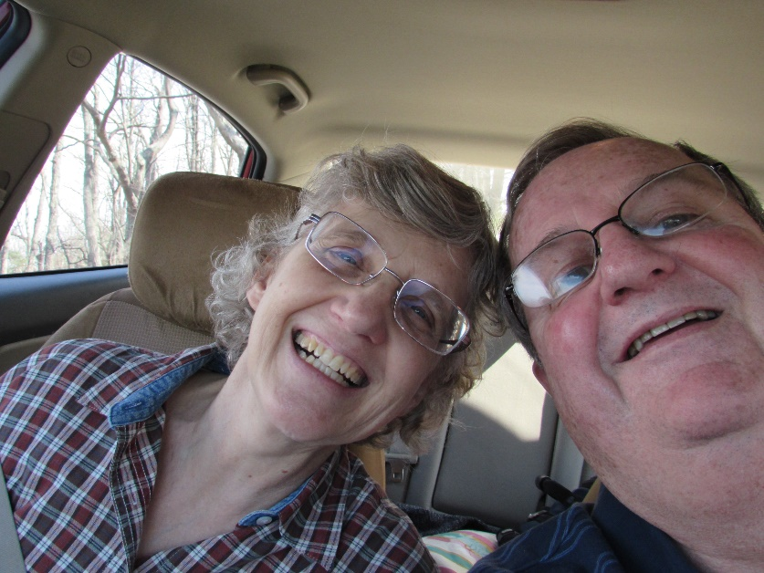
One Saturday in the late fall of 2014, Don and I escaped from city life in the Richmond area for a day along the Skyline Drive in Virginia. We just took a day for the two of us, carrying along a picnic of sandwiches and raw vegetables and fruit, with our walking sticks and hats. One of our favorite stops was a food truck that had the tastiest kettle popcorn—cooked in one of those huge cast iron kettles cooked over a hot fire. It had been there for years in the parking lot of an abandoned restaurant/store near the entrance to Skyline Drive National Park. As we walked on the trails in the woods, the colorful leaves on the ground made that had already fallen to the ground, making a slippery but colorful carpet for our feet. We wandered around for several hours and returned home after dark but energized for the next week.
That is one way to get started with your pictures to tell your unique story.

Remember…When you are ready to get started…we are ready to help!
Contact me at carol@uniquelifestories.com if you have any questions.

