# Data Analysis of Resource and People Management with Effective Usage of Skill Set in the AI Era

By Balamurugan Muthusamy

## Introduction

The AI era has transformed the way organizations manage human resources and optimize workforce efficiency. This thesis explores the role of AI in workforce allocation, skillset optimization, hiring, and industry-specific impact until 2030. Case studies from Indian industries provide practical insights into AI adoption.

## AI-Driven Resource and People Management

AI is revolutionizing workforce management through automation and predictive analytics, improving efficiency in hiring, skill mapping, productivity tracking, and retention strategies. Companies using AI have seen cost savings and operational efficiency gains.

The following trend graph represents AI-driven workforce optimization trends projected until 2030:

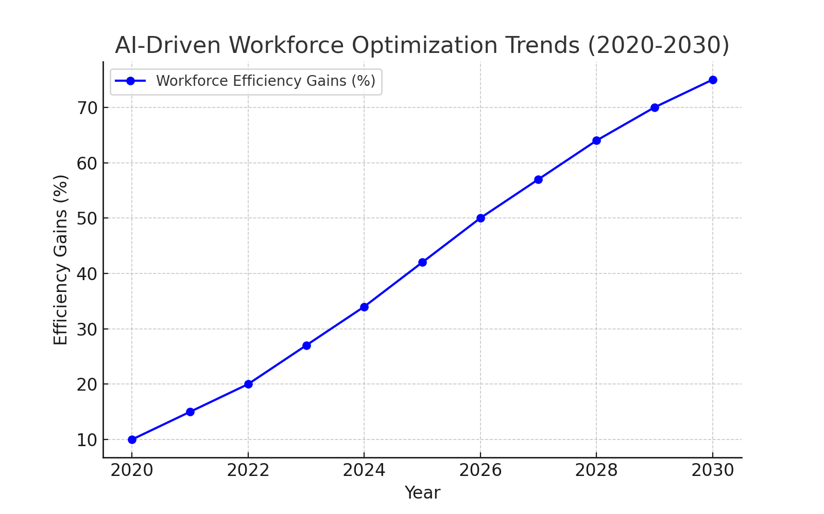

## AI-Driven Case Studies on Indian Industries

### 1. Healthcare: AI in Diagnostics & Patient Care (Apollo Hospitals)

Apollo Hospitals has integrated AI-driven diagnostics, improving accuracy and reducing diagnosis time by 40%. AI-driven predictive analytics enhances patient care and reduces treatment costs.

### 2. BFSI: AI in Fraud Detection & Risk Management (HDFC Bank)

HDFC Bank leverages AI-powered fraud detection, increasing efficiency by 60% and reducing operational costs by 20%. AI-driven banking automation is expected to further decrease fraud cases by 50% by 2030.

### 3. Manufacturing: AI in Smart Factories (Tata Motors)

Tata Motors utilizes AI-driven predictive maintenance and robotic automation, reducing machine downtime by 35% and improving production efficiency by 25%. By 2030, AI-powered smart factories are expected to increase productivity by 40%.

The following graph represents AI adoption trends projected across industries until 2030:

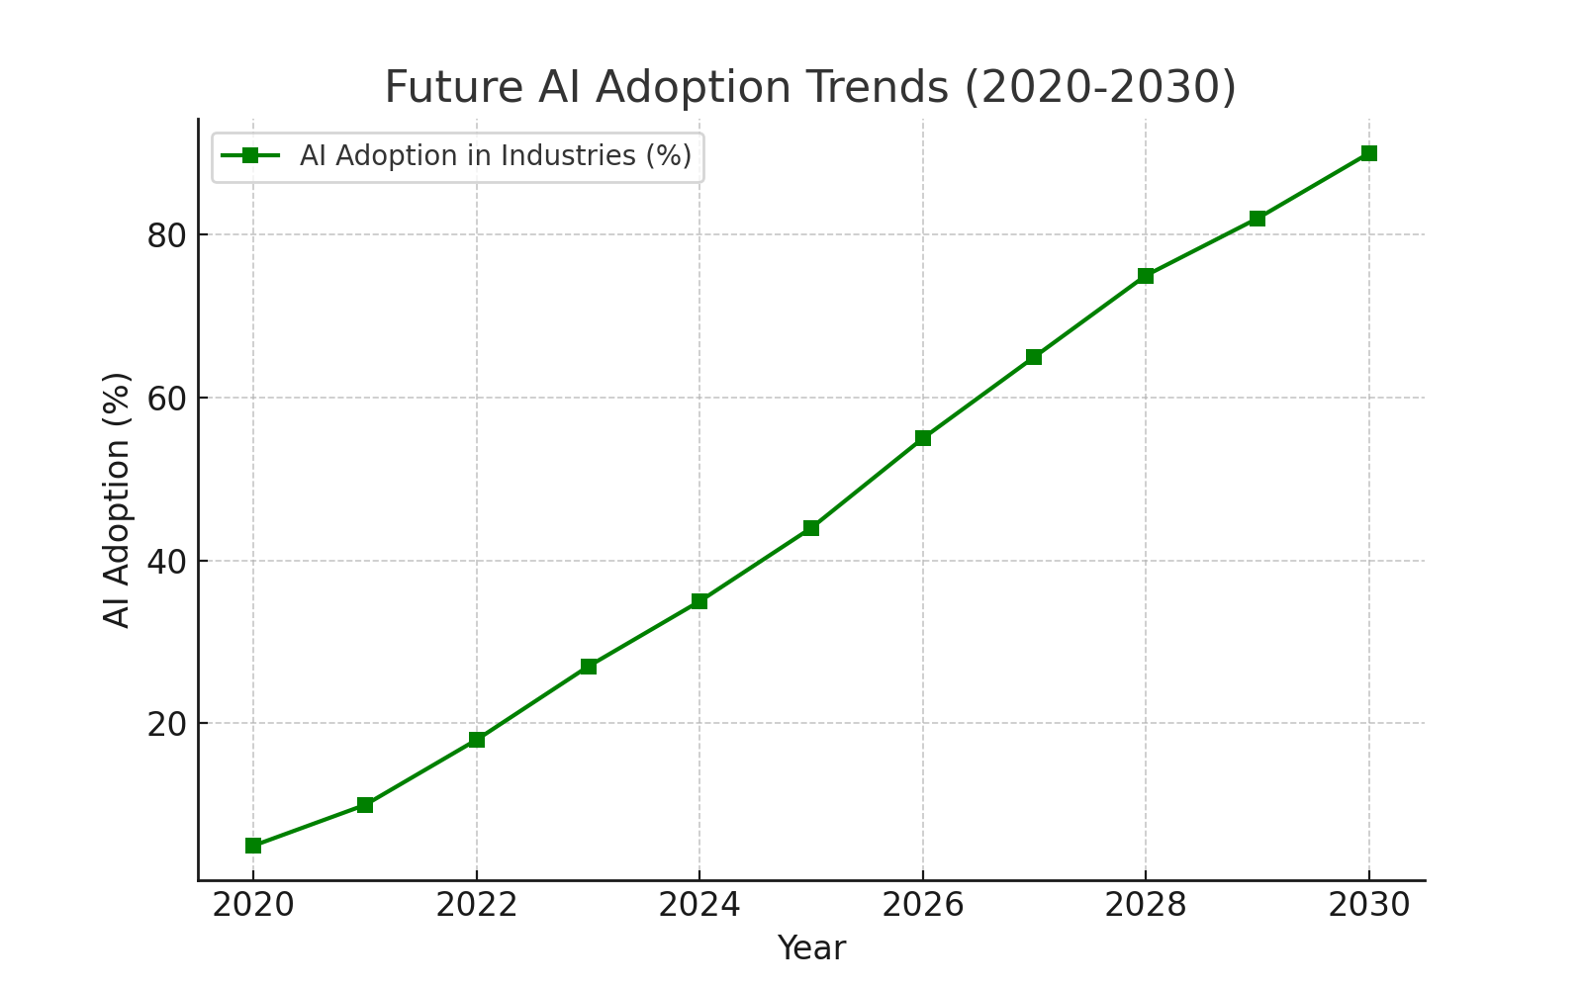

## Conclusion

AI-driven resource and people management strategies are revolutionizing industries, enhancing workforce efficiency, and redefining skillset requirements. Indian industries adopting AI are poised for sustained growth and innovation. Organizations must focus on AI-driven training and skill optimization to stay competitive in the evolving digital landscape.