**Hypertension (High Blood Pressure)**

Hypertension is the most common medical condition diagnosed in America. It is estimated that about 108 million Americans (45%) have hypertension!

Hypertension is defined as a blood pressure above 140/90 (or >130/80 with certain health conditions).

A “normal” blood pressure is less than 120/80, but a diagnosis of hypertension is not generally made until the blood pressure is greater than 140/90 on 2 separate occasions.

Blood pressure is measured with a stethoscope and a sphygmomanometer or with an automatic blood pressure cuff. It measures 2 numbers: systolic and diastolic pressure.

**Systolic Pressure when heart is beating**

**---------- = ------------------------------------------**

**Diastolic Pressure when heart is at rest**

Risks of hypertension:

1. Heart attack
2. Stroke
3. Heart failure
4. Dementia
5. Aneurysms

**KNOW YOUR GOAL!**

Your goal blood pressure is specific to YOU and YOUR medical situation. Here are common blood pressure goals per the American College of Cardiology/American Heart Association Guidelines published in 2017.

**Goal <130/80 if a patient has any of the following:**

* **All adults, unless otherwise specified**
* History of heart disease or >10% 10-risk of heart disease
* Diabetes
* Chronic Kidney Disease
* Stroke/TIA (mini stroke)
* Peripheral Arterial Disease (PAD)
* Heart Failure

Goal <140/90 if a patient has any of the following:

* Elderly and frail
* Unable to obtain goal <130/80
* Unable to obtain/tolerate/afford additional therapy
* End-stage renal disease

**Treatment for Hypertension:**

1. Lifestyle modifications:
   1. Weight loss (if overweight or obese)
   2. Exercise an average of 30 minutes/day for >5 days/week
   3. Limit salt intake to less than 2000mg of sodium per day (consider limiting to less than 1500mg of sodium per day if blood pressure if hard to control or have heart failure)
      1. Avoid adding salt when cooking or eating
      2. Avoid high sodium foods such as microwave dinners, canned soups
      3. Look for “low-sodium” or “no sodium” food items (broths, soups, etc.)
   4. Eat fresh fruits and vegetables daily (4-5 servings per day)
   5. Eat whole grains (6-8 servings per day)
   6. Eat lean meats (1 serving per day)
   7. Eat legumes and nuts (no salt)
   8. Eat healthy fats (limit saturated fats to <7% and no trans fats)
   9. Avoid/limit caffeine and alcohol intake

 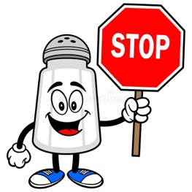  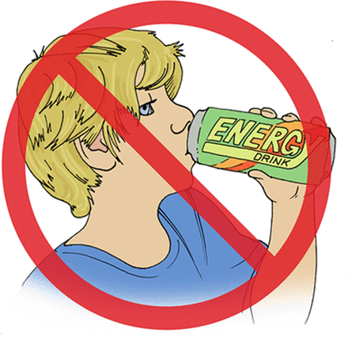

1. Medications:
   1. Medications are indicated when blood pressure remains above goal despite lifestyle efforts. Over 80% of adults will need blood pressure medication for hypertension.
   2. Medications not only decrease blood pressure levels, but some have been proven to decrease the risk of heart disease and kidney failure!
   3. Therapy Options:
      1. **ACE inhibitors/ARBs:** 
         1. Work in the kidneys to reduce blood pressure AND protect the kidneys.
         2. Indicated in patients with hypertension and/or diabetes. Often used first-line for any patient with hypertension.
         3. Side effects: Very well tolerated. ACE inhibitors can sometimes cause a dry, persistent cough. If this occurs, talk to your doctor or pharmacist before you stop the medication! Can increase potassium levels and affect kidney function tests. Will need lab work before and after starting therapy.
         4. Examples:
            1. ACE inhibitors: lisinopril, enalapril, captopril, benazepril
            2. ARBs: losartan, valsartan, irbesartan, olmesartan, candesartan
      2. **Diuretics:**
         1. Work in the kidneys to pull fluid out of your body.
         2. Indicated as first-line for any patient with hypertension.
         3. Often used together with ACE inhibitors or ARBs for double mechanism blood pressure lowering in combination pill.
         4. Side effects: Very well tolerated. Main side effect is frequent urination (pulling off fluid!). Take diuretics in the morning and early afternoon to avoid nighttime trips to the bathroom. Diuretics can increase or decrease potassium and sodium in the body along with affecting kidney function. Will need lab work before and after starting therapy.
         5. Examples:
            1. Loop diuretics: furosemide, bumetanide, torsemide
            2. Thiazide diuretics: Chlorthalidone, hydrochlorothiazide, metolazone, indapamide
            3. Potassium-Sparing diuretics: spironolactone, eplerenone, triamterene
      3. **Calcium Channel Blockers (CCBs):**
         1. Two different types of CCBs: one type works in the heart while the other works in the blood vessels outside of the heart.
         2. Most people will receive the dihydropyridine CCBs to cause dilation of the blood vessels outside the heart and, therefore, lower the pressure needed to push blood out of the heart. Some people may receive a non-dihydropyridine CCB that lowers blood pressure directly in the heart due to decreased heart rate and contractility. These are less commonly used, but may be seen in people who have hypertension AND need heart rate reduction.
         3. Side effects: The dihydropyridines are very well tolerated, but sometimes cause edema (swelling) in the upper and lower extremities. The non-dihydropyridines have some more side effects related to low heart rate, dizziness, lightheadedness, and constipation.
         4. Examples:
            1. Dihydropyridine: amlodipine, felodipine, nifedipine
            2. Non-dihydropyridine: verapamil, diltiazem
      4. **Beta-Blockers:**
         1. Work in the heart by reducing heart rate and contractility.
         2. Beta-Blockers are now generally reserved for people with hard-to-treat hypertension or those with heart disease. Beta-blockers have been shown to decrease deaths in people with heart disease! Even without high blood pressure, patients with a history of a heart attack should be on a beta-blocker unless contraindicated.
         3. Side effects: Generally, well tolerated at lower doses, but higher doses may lead to dizziness or lightheadedness. Simply titrate slowly to find the best tolerated dose! Many people often feel very tired when first starting beta-blocker therapy. That is because it lowers the heart rate which leads to less oxygen circulating around the body and it may take 2-3 months to adjust to the new oxygen levels. This is perfectly safe and normal as long as your heart rate is not dropping too low (under 60) or you are having dizziness leading to possible falls!
         4. Examples: carvedilol, metoprolol, bisoprolol, atenolol, nadolol, propranolol
      5. **Others:**
         1. Hydralazine, clonidine, guanfacine, prazosin, methyldopa, reserpine, minoxidil are some examples.
         2. These are rarely used, but may be indicated in patients with resistant hypertension or multiple intolerances to previously reviewed therapies.
         3. If you are on one or more of these therapies and do not believe you have tried others, please discuss with your provider.

