Foundation Stage

Learning about technology starts from birth because it’s the way the world works today. Technology is an integral part of all young children’s environment and world. They are surrounded by technology just as they are surrounded by language, print and numbers. In the home, technology includes remote controls for television, DVDs and sound systems, toys that have buttons and buzzers, mobile phones, washing machines, microwave ovens and other machines that require programming, and of course, computers and mobile devices such as iPads. Outside the home, children are also immersed in the technological world: they see automatic doors, cash machines, bar code scanners, digital tills and weighing machines, and security cameras. Technology is something children are going to grow up with, learn about and master, and use as a tool to increase their understanding in all areas of learning.

Many activities in the early years revolve around children developing an understanding of their environment. Settings encourage children to explore, observe, solve problems, predict, discuss and consider. ICT resources can provide tools for using these skills as well as being examined in their own right, with computers not the only resources. ICT equipment added to role-play reflects the real world, builds on children’s experiences and allows them opportunities to understand how, why, when and where different forms of technology are used in everyday life.

Early experiences form a foundation upon which KS1 and KS2 can build and the current early learning goals have specific objectives relating to ICT.

New EYFS Framework for September 2021: The EYFS framework is structured very differently to the national curriculum as it is organised across seven areas of learning rather than subject areas. The aim of this document is to help subject leaders to understand how the skills taught across EYFS feed into national curriculum subjects. This document demonstrates which statements from the 2020 Development Matters are prerequisite skills for computing within the national curriculum. The table below outlines the most relevant statements taken from the Early Learning Goals in the EYFS statutory framework and the Development Matters age ranges for Three and Four-Year-Olds and Reception to match the programme of study for computing.

The most relevant statements for computing are taken from the following areas of learning:
• Personal, Social and Emotional Development
• Physical Development
• Understanding the World
• Expressive Arts and Design
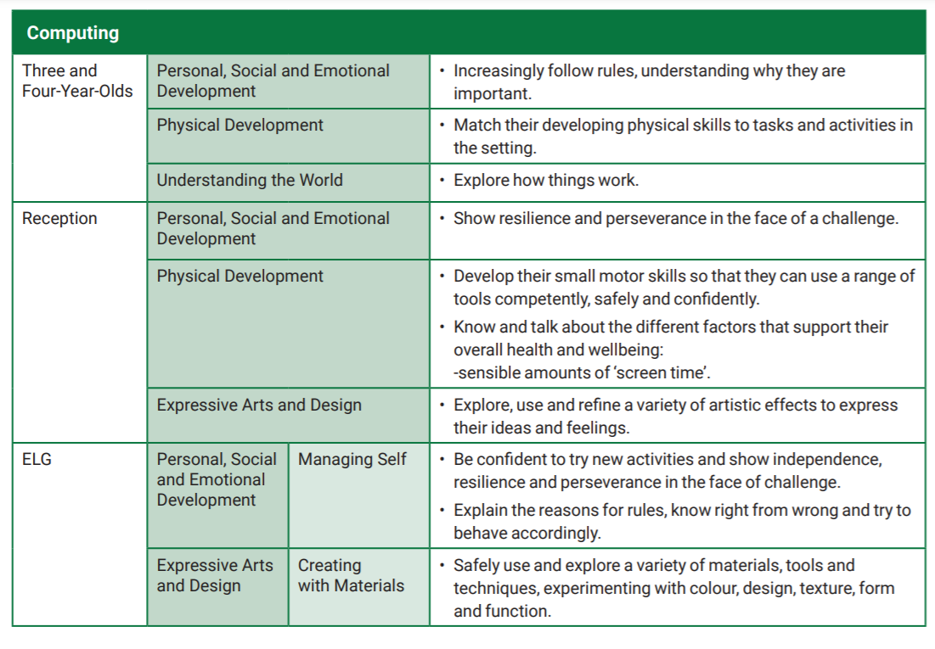

New EYFS framework from 2021
 | Year 1 / 2 | Year 3 / 4 | Year 5 / 6
Information Technology  Multimedia | Graphics  Use ICT to generate ideas for their work.  Use various tools such as brushes, pens, rubber, stamps, shapes.  Save, retrieve and print work.  Text  Use spacebar, backspace, delete, arrow keys, return. Start to use two hands when typing.  Word process short texts to present.  Sound recording  Record sound at and away from a computer. Use software to record sounds.  Change sounds recorded. Save, retrieve and edit sounds. Video  Capture video.  Discuss which videos to keep and which to delete. Arrange clips to create a short film.  Add a title and credits.  Presentation (2Connect)  Choose a suitable subject and collect some information.  Create a mindmap of this data. Link appropriate bubbles.  Present the information to a group. | Graphics  Acquire, store and combine images from cameras or the internet for a purpose.  Use the print screen function to capture an image.  Select certain areas of an image and resize, rotate and invert the image.  Edit pictures using a range of tools in a graphics program.  2Create a story  Create a new book aimed at a target audience. Combine text, images and sound on each page.  Add information about the author and title for publishing. Animation (I Can animate / 2animate)  Plan what they would like to happen in their animation. Take a series of pictures to form an animation.  Move items within their animation to create movement on playback.  Edit and improve their animation.  Text  Get quicker at typing with both hands.  Use a variety of font sizes, styles and colours. Align text left, right and centre.  Presentation (Powerpoint)  Create a title slide and choose a style. Change the layout of a slide.  Insert a picture/text/graph from the Internet or personal files. Decide upon and use effective transitions. | Sound Recording (Audacity)  Collect audio from a variety of resources including own recordings and internet clips.  Create a multi-track recording using effects. Edit and refine their work to improve outcomes.  Animation  Plan a multi-scene animation including characters, scenes, camera angles and special effects.  Use stop –go animation software (Ican Animate / Hue animation)  with an external camera to shoot animation frames.  Adjust the number of photographs taken and the playback rate to improve the quality of the animation.  Publish their animation and use a movie editing package to edit/refine and add titles.  Graphics  Use to create a 3D representation of a vehicle. Use the tools available to design their own fit for purpose  Vehicle.  Change the style, colour and texture used.  Change the viewpoint angle whilst designing the vehicle to gain insight to its look from a variety of angles.  Presentation (Powerpoint)  Work independently to create a multi slide presentation that includes speakers notes.  Use transitions and animations to improve the quality of the presentation.  Include sounds and moving graphics in the slides. Present to a large group or class using the notes made.

 | Year 1 / 2 | Year 3 / 4 | Year 5 / 6
Computer Science  Programming | Bee-bots / Purple Mash- Coding  Give commands including straight forwards /  backwards / turn one at a time.  Explore what happens when a sequence of instructions is given.  Give a set of simple instructions to follow out a task. Give a set of instructions to form simple geometric  shapes.  Improve/change their sequence of commands. | 2Code-Purple Mash  Navigate the Scratch programming environment. Create a background and a sprite for a game. Add inputs to control their sprite.  Use conditional statements within the program to control the  sprite (if…then..) | Purple Mash- Coding  Use external triggers and infinite loops to control sprites. Create and edit variables.  Use conditional statements.  Design their own game including sprites, backgrounds, scoring and/or timers.  Use conditional statements, loops, variables and broadcast messages in the game.  The game finishes when a player wins or loses and they must know they have won or lost.  Evaluate the effectiveness of the game and debug as required.

 | Year 1 / 2 | Year 3 / 4 | Year 5 / 6
Information Technology  Online | Internet research  Talk about websites they have been on.  Explore a website by clicking on the arrows, menus and hyperlinks.  Emails (Yr2)  Recognise an email address. Find the @ key on the keyboard. Contribute to a class email.  Open and select to reply to an email as a class. | Blogging  Navigate to view their class blog.  Understand that it can be updated from a range of devices. Comment on their class blog.  Internet research  Type in a URL to find a website. Add websites to a favorites list.  Use a search engine to find a range of media, e.g. images, texts  Think of search terms to use linked with questions they wish to answer.  Talk about the reliability of information on the Internet, e.g. the difference between fact and opinion.  Emails  Log into an email account, open, create and send an email. Attach files to an email.  Download and save files from an email. Email more than one person and reply to all. | Internet Research  Use advance search functions in Google (quotations). Understand websites such as Wikipedia are made by users (link to  E-Safety).  Use strategies to check the reliability of information (cross check with another source such as books).  Use their knowledge of domain names to aid their judgment of the validity of websites.  Blogging  Register for a blog, select a URL and navigate to their blog once it is created.  Alter the theme and appearance of their blog, adding background images etc.  Create a new post, save it as a draft and publish it. Embed photos, hyperlinks and videos into posts. Reorganise posts and remove posts they no longer want.  Like/follow other blogs and build up their blog content over the year.

 | Year 1 / 2 | Year 3 / 4 | Year 5 / 6
Digital Literacy  E-Safety | Make decisions about whether or not statements found on the internet are true or not.  Identify devices that can be used to search the  Internet.  Identify what things count as personal information. Identify when inappropriate content is accessed and  act appropriately.  Recognise that a variety of devices can be used to connect a number of people.  Consider other people’s feelings on the Internet. | Question the ‘validity’ of what they see on the internet.  Use a browser address bar not just search box and shortcuts. think before sending and comment on consequences of  sending/posting.  Recognise online behaviours that would be unfair. Recognise social networking sites and social networking  features built into other things (such as online games and handheld games consoles)  Make judgments in order to stay safe, whilst communicating with others online.  Tell an adult if anything worries them online.  Identify dangers when presented with scenarios, social networking profiles etc.  Articulate examples of good and bad behavior online. | Judge what sort of privacy settings might be relevant to reducing different risks.  Judge when and when not to answer a question online. Be a good online citizen and friend.  Articulate what constitutes good behavior online.  Use different sources to double check information found online.  Find ‘report’ and ‘flag’ buttons in commonly used sites and  name sources of help (childline, cybermentors etc)  Click-CEOP button and explain to parents what it is for. Discuss scenarios involving online risk.  State the source of information found on the Internet. Act as a role model for younger pupils.
Information Technology  Data | Know that images give information.  Say what a pictogram is showing them. Put data into a program.  Sort objects and pictures into lists or simple tables. Make a simple Y/N tree diagram to sort information. Create and search a branching database. | Choose information to put into a data table. Recognise which information is suitable for their topic. Design a questionnaire to collect information.  sort and organize information to use in other ways. Create and search a branching database.  create a database from information I have selected. | Create data collection forms and enter data accurately from these.  Know how to check for and spot inaccurate data. Know which formulas to use when I want to change my  spreadsheet model.  Make graphs from the calculations on my spreadsheet. Sort and filter information.  Understand that changing the numerical data effects a calculation.

Assessment- The majority of children will be working at age related expectations. However, some children will be identified as working below and above these.
Number in the cohort:
Working below age related expectations | Working above age related expectations
Number working below: | Number working above:

Comments for the subject leader:

