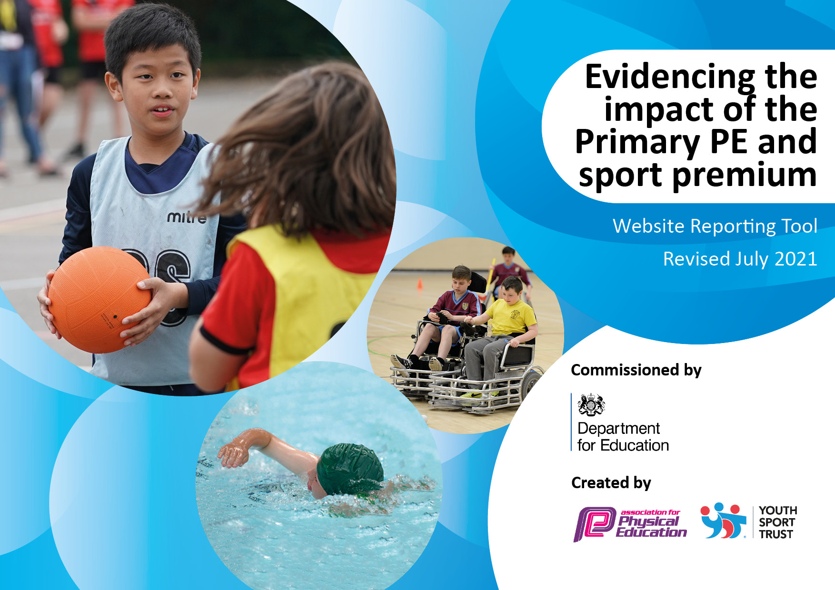
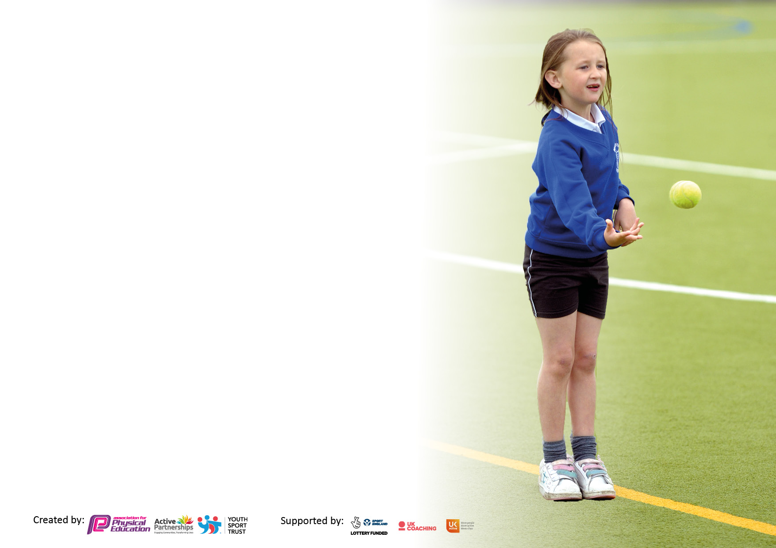

It is important that your grant is used effectively and based on school need. The Education Inspection Framework makes clear there will be a focus on ‘whether leaders and those responsible for governors all understand their respective roles and perform these in a way that enhances the effectiveness of the school’.

Under the Quality of Education Ofsted inspectors consider:
Intent - Curriculum design, coverage and appropriateness
Implementation - Curriculum delivery, Teaching (pedagogy) and Assessment
Impact - Attainment and progress

To assist schools with common transferable language this template has been developed to utilise the same three headings which should make your plans easily transferable between working documents.

Schools must use the funding to make additional and sustainable improvements to the quality of Physical Education, School Sport and Physical Activity (PESSPA) they offer. This means that you should use the Primary PE and sport premium to:

- Develop or add to the PESSPA activities that your school already offer
- Build capacity and capability within the school to ensure that improvements made now will benefit pupils joining the school in future years
- The Primary PE and sport premium should not be used to fund capital spend projects; the school’s budget should fund these.

Pleasevisitgov.ukfortherevisedDfEguidanceincludingthe5keyindicatorsacrosswhichschoolsshoulddemonstrate animprovement.Thisdocumentwillhelpyoutoreviewyourprovisionandtoreportyourspend.DfEencouragesschools to use this template as an effective way of meeting the reporting requirements of the Primary PE and sport premium.

We recommend you start by reflecting on the impact of current provision and reviewing the previous spend.

Schools are required to publish details of how they spend this funding, including any under-spend from 2019/2020, as well as on the impact it has on pupils’ PE and sport participation and attainment. All funding must be spent by 31st July 2022.

We recommend regularly updating the table and publishing it on your website throughout the year. This evidences your ongoing self-evaluation of how you are using the funding to secure maximum, sustainable impact. Final copy must be posted on your website by the end of the academic year and no later than the 31st July 2021. To see an example of how to complete the table please click HERE.

Details with regard to funding
Please complete the table below.

Total amount carried over from 2019/20 | £0
Total amount allocated for 2020/21 | £16,961
How much (if any) do you intend to carry over from this total fund into 2021/22? | £0
Total amount allocated for 2021/22 | £16,961
Total amount of funding for 2021/22. To be spent and reported on by 31st July 2022. | £16,961 (additional £2989 spent from budget)
Swimming Data
Please report on your Swimming Data below.

Meeting national curriculum requirements for swimming and water safety.

N.B. Complete this section to your best ability. For example you might have practised safe self-rescue techniques on dry land which you can then transfer to the pool when school swimming restarts.
Due to exceptional circumstances priority should be given to ensuring that pupils can perform safe self rescue even if they do not fully meet the first two requirements of the NC programme of study
What percentage of your current Year 6 cohort swim competently, confidently and proficiently over a distance of at least 25 metres?  N.B. Even though your pupils may swim in another year please report on their attainment on leaving primary school at the end of the summer term 2020.  Please see note above | 87%
What percentage of your current Year 6 cohort use a range of strokes effectively [for example, front crawl, backstroke and breaststroke]?  Please see note above | 87%
What percentage of your current Year 6 cohort perform safe self-rescue in different water-based situations? | 68%
Schools can choose to use the Primary PE and sport premium to provide additional provision for swimming but this must be for activity over and above the national curriculum requirements. Have you used it in this way? | No ( no extra sessions available)

Action Plan and Budget Tracking
Capture your intended annual spend against the 5 key indicators. Clarify the success criteria and evidence of impact that you intend to measure to evaluate for pupils today and for the future.

Academic Year: 2020/21 | Total fund allocated: | Date Updated:
Key indicator 1: The engagement of all pupils in regular physical activity – Chief Medical Officers guidelines recommend that primary school pupils undertake at least 30 minutes of physical activity a day in school |  |  |  | Percentage of total allocation:
 |  |  |  | %
Intent | Implementation |  | Impact
Your school focus should be clear what you want the pupils to know and be able to do and about  what they need to learn and to  consolidate through practice: | Make sure your actions to achieve are linked to your intentions: | Funding allocated: | Evidence of impact: what do pupils now know and what can they now do? What has changed?: | Sustainability and suggested next steps:
Active PE sessions for each cohort with a focus on improving fitness across the school.  Including regularly running a mile.  Orienteering sessions to be introduced to PE across the school  Continue to have active lunchtimes where children have access to a range of physical activity | New fitness schemes of work being used regularly.  Orienteering equipment purchased and is regularly used in PE sessions.  Play workers to continue to be employed at lunchtime in order to organise and set up games and activities. | £4, 120  £12, 380 | Children fitter and are able to show increased fitness scores.  Lesson observations and planning shows that children are regularly accessing high quality orienteering sessions.
Key indicator 2: The profile of PESSPA being raised across the school as a tool for whole school improvement |  |  |  | Percentage of total allocation:
 |  |  |  | %
Intent | Implementation |  | Impact
Your school focus should be clear what you want the pupils to know and be able to do and about  what they need to learn and to  consolidate through practice: | Make sure your actions to achieve are linked to your intentions: | Funding allocated: | Evidence of impact: what do pupils now know and what can they now do? What has changed?: | Sustainability and suggested next steps:
Sports week to take place in the Summer Term. Children have the opportunity to try new sports. CPD opportunities for staff.  Skipping workshops to develop fitness. Links with fitness scheme of work | Children try new sports- archery, fencing, climbing, skateboarding etc  Whole school skipping workshop | £1000  £350 –whole da | Children develop new skills and experience sports and activities that are not on statutory PE curriculum  New games and types of skip learnt. Children continue to skip and be active at playtime and lunchtime.

Key indicator 3: Increased confidence, knowledge and skills of all staff in teaching PE and sport |  |  |  | Percentage of total allocation:
 |  |  |  | %
Intent | Implementation |  | Impact
Your school focus should be clear | Make sure your actions to | Funding | Evidence of impact: what do | Sustainability and suggested
what you want the pupils to know | achieve are linked to your | allocated: | pupils now know and what | next steps:
and be able to do and about | intentions: |  | can they now do? What has
what they need to learn and to |  |  | changed?:
consolidate through practice:
Audit of staff confidence in delivering all areas of PE  Ensure staff have training on orienteering.  Staff training on fitness schemes of work for children | Staff meeting and subject leader time to analyse questionnaires and put an action plan together.  Coaching sessions/ sharing good practice. TAs to observe PE subject Staff meeting /Inset to present schemes of work. | £500  £500 | Areas identified and action plan put into place for training and sharing good practice  Staff confident to deliver fitness schemes of work.
Key indicator 4: Broader experience of a range of sports and activities offered to all pupils |  |  |  | Percentage of total allocation:
Intent | Implementation |  | Impact
Your school focus should be clear | Make sure your actions to | Funding | Evidence of impact: what do | Sustainability and suggested
what you want the pupils to know | achieve are linked to your | allocated: | pupils now know and what | next steps:
and be able to do and about | intentions: |  | can they now do? What has
what they need to learn and to |  |  | changed?:
consolidate through practice:
Additional achievements:  Outdoor and adventurous for year 5 and year 6  Climbing and high rope trip for Year 3 and Year 4 to develop confidence.  Orienteering and forest school activities at another location.  Bikeability for year 5 and 6 children.  2 Cyclo cross day for all junior children.  Cycling sessions for Infants and Reception | Children to participate in outdoor and adventurous activities at another location- Lea Green, Pine Lakes  West Park leisure Centre- High Rope trail. To take place in the summer term  This is to be linked in to visits to West Park and Lea Green.  Younger children to attend a local site researched by PE co-ordinator.  Cycle Derby to provide Bikeability sessions during the Spring Term  Provided by Cycle Derby. All junior children to participate  A series of 6 sessions delivered by Cycle Derby. The aim being to get all children to ride without stabilisers. | £400- Bus cost  £200 bus cost  No cost  £250  £250 | Children develop confidence, team building and out door and adventurous skills.  Children develop confidence, team building and out door and adventurous skills.  Develop team building, fitness and perseverance.  Knowledge of road safety. Able to ride their bike safely on the road.  Improved balance and development of new skills.  Improved balance and co-ordination. To be able to ride without stabilisers.

Key indicator 5: Increased participation in competitive sport |  |  |  | Percentage of total allocation:
 |  |  |  | %
Intent | Implementation |  | Impact
Your school focus should be clear | Make sure your actions to | Funding | Evidence of impact: what do | Sustainability and suggested
what you want the pupils to know | achieve are linked to your | allocated: | pupils now know and what | next steps:
and be able to do and about | intentions: |  | can they now do? What has
what they need to learn and to |  |  | changed?:
consolidate through practice:
 |  | £

Signed off by
Head Teacher: | Sarah Briggs
Date: | Sep 2021
Subject Leader: | Justin Comasky
Date: | Sep 2021
Governor: | Rob Grover
Date: | Se 2021

