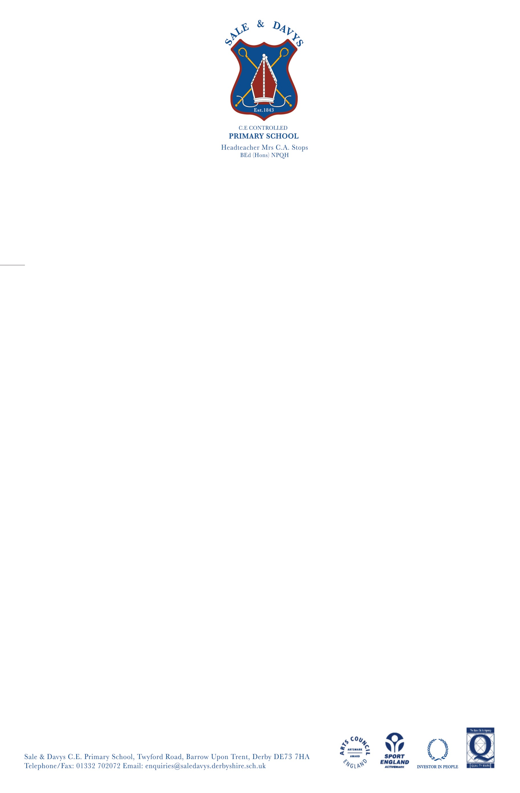

Monday 2nd November 2020

Dear Parents

A very warm welcome back to the second half of the Autumn Term. I hope you are all well and that you have managed to spend some quality time with your family over the short break.

The term leading up to Christmas is always a busy one and at Sale and Davys we are planning lots of exciting and safe events for the children. We will still have a Nativity Play and Festive Afternoon and these will be recorded for parents to view on our website. The annual Christmas Arts Week will go ahead as will the Christmas parties. We are even hoping to receive a video call from Santa! We will also be introducing some new events such as ‘The Santa Mile’ and a Nativity photo freeze. Each class will also produce a decorated Christmas tree for the church Christmas Tree Trail. As you can see lots of fun for the children which we think is so important during these challenging times. Festive Plan to follow shortly.

**PE Kit**

This term we are asking children to wear PE kit to school on the days they have PE. We still want our children to look smart everyday so please ensure that they wear a plain navy tracksuit or sweatshirt and jogging bottoms (no logos) with black or white trainers. Thank you for your support with this as I know we all have high expectations of dresscode for the children.

**Birthdays**

We are very aware that during this challenging time children are missing out on many social interactions including having friends round for tea and holding a birthday party. In light of this we have decided to host four parties each half term, one for each class. The idea is that all the children in the class who have a Birthday during that half term get a chance to be Birthday Boys or Birthday Girls for the afternoon. All children will be invited to wear party clothes on this day and traditional party games will be played. The PTA have kindly offered to provide cakes for all the classes so please do not send any sweets or cake into school. Since we have already had our first half term we will be hosting our first ‘Birthday Party Afternoon’ for children born in the months of September and October on Friday 13th November. We are all looking forward to seeing lots of happy faces!

**Pick up and drop off**

Due to the increase in corona virus cases please could parents drop off and pick up children promptly and leave the school site as quickly as possible. Thank you to everyone for wearing face masks as this helps to keep us all safe.

**Suspected cases of Corona Virus**

If anyone in your household shows any symptoms of the Corona Virus then please ensure that all household members stay at home until a negative test result comes back. Online learning will be provided for all children who have to self-isolate. This will be set daily on our secure Purple Mash site

**AUTUMN TERM DATES**

4th November – PTA Zoom meeting – Please return your reply slip if you would like to volunteer

13th November - Birthday Party Afternoon

16th November – INSET – SCHOOL CLOSED - First Aid Training for Staff

18th December – end of Autumn Term 2

21st – 1st January 2021 School closed for Christmas Holiday

4th January 2021 – Start of Spring Term 1

Yours sincerely

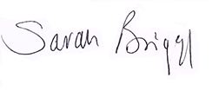

p

**Mrs S Briggs**

Headteacher

BEd (Hons) NPQH

*We will all achieve our very best by loving learning, showing resilience and by developing Christian values within our community.*

**NEWSLETTER – November 2020**