Information for Schools Newsletters / Communications to parents

FREE summer food support vouchers for families who receive benefit related free school meals

As part of the Household Support Scheme, Derbyshire County Council are distributing one-off grocery vouchers to families eligible for benefit related free school meals. A £50 grocery voucher will be provided to every eligible child.

The Council intends to start to distribute the vouchers to families from Friday 8 July and expect the process to be completed by Wednesday 13 July 2022.

How will the vouchers be provided to parents?

The majority of vouchers will be sent out by email with a smaller number sent via text.

Emails will be sent out by the Council’s voucher provider, Huggg LTD and will be sent from the address: hello@huggg.me
On occasion emails from Hugggs can be directed into a recipient’s junk mail folder so please check your junk if you cannot see the voucher in your inbox.
The emails will look like this and will have a link to download the voucher:

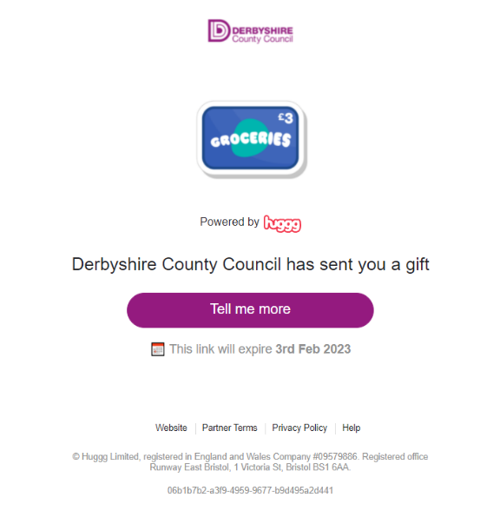

Vouchers sent by text will be sent from the Council’s ‘email to text’ system and will show as being sent from Derbyshire County Council. The text messages will include a link to download the voucher from the Hugggs website.

I haven’t received a voucher and believe I am eligible

If you are eligible and haven’t received a voucher by Thursday 14 July 2022 you can complete the Council’s online enquiry form (which will be available on the page from 14 July) at www.derbyshire.gov.uk/householdsupportfund

How can parents who are struggling financially apply for further financial support from the Household Support Fund?

Information about how parents can apply for a grant from the Household Support Fund is available on the Council’s website at: www.derbyshire.gov.uk/householdsupportfund.

Grant applications via this route are taken over the phone and, due to very high demand, callers may have to wait a considerable amount of time to get through or to receive a call back.

Families do not have to be eligible for benefit related free school meals to access a Household Support Fund grant, as the Council recognises there may be families who are not eligible but who may be struggling financially due to being on a low income. More information about eligibility is available on the website.

Holiday Activities and Food Programme #HAF2022

Derbyshire County Council and StreetGames are excited to let you know that the popular holiday activities and food programme is back for the summer holidays and is completely free of charge for school aged children 4-16yrs who are eligible for benefit related free school meals!

Visit www.itsaboutmederbyshire.co.uk now to find out more and book your free place for your child(ren) so they can take part in a local club and enjoy our brilliant mix of fun action-packed days and tasty food.

The holiday clubs are running across the county from Monday 25th July – Friday 2nd September, with provision in every district/borough.
Clubs will run on average for 4 hours a day and each day your child will enjoy a fun-packed programme filled with a wide range of sports and games, arts and crafts, cookery, dance and music. Programmes will vary depending on the type and location of each local club, but every day there will be a delicious nutritious meal served up for free!

Book now: www.itsaboutmederbyshire.co.uk
Can’t get out this summer? The itsaboutme website has loads of great ideas to keep kids of all ages entertained. There’s hundreds of downloadable games and activities and links to videos that you and your family can enjoy at any time and in any weather.
We hope you will take advantage of this great opportunity so your child(ren) can have a fantastic summer break with their friends - and be fit and ready to return to school in the autumn term.

