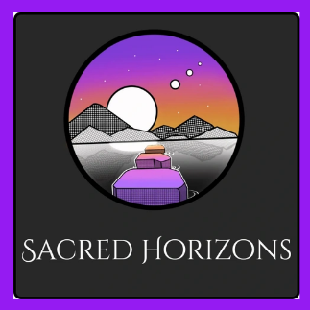
October 3, 2024: Wisdom Sharing Resources

- Gene Keys:
  - Home - Gene Keys
  - Triple Flame - Gene Keys
- Pam Gregory – Astrologer:
  - Pam Gregory - YouTube
  - Facebook
  - Pam Gregory - Spiritual Development - The Next Step
- Next Level Soul with Alex Ferrari:
  - Next Level Soul Podcast - YouTube
  - Next Level Soul with Alex Ferrari | Answering the Big Questions About Life - Next Level Soul
- The Untethered Soul - Book by Michael A. Singer
- Sacred Horizons:
  - Facebook (Sacred Horizons)
  - Sacred Horizons - Astrology Readings, Oracle Card Readings, Energy Work, Metaphysical Services

