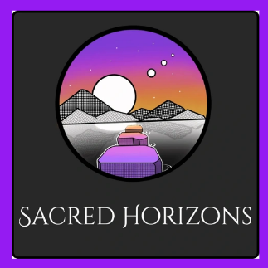
February 8, 2025: Wisdom Sharing Resources

- Pam Gregory:
  - Interview with Dr David Clements: https://youtu.be/t4V5dSU5s6U?si=fW3BR992-q3s3TiX
  - Global Activation Meditation 1 – Anchoring a deep new light intelligence energetic ISC - Global Activation Meditation 1 - Anchoring a deep new light intelligence energetic from the Infinite Source Intelligence - crowdcast

