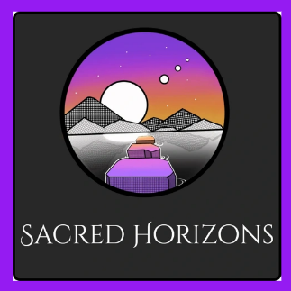
June 14th, 2025: Wisdom Sharing Resources

Schumann Resonance daily update: Consciously Erin - YouTube
Triple Flame: Triple Flame - Gene Keys
SACRED SITES, STARGATES, AND STAR FAMILY RETREAT — Laurie Reyon
Bashar/Darryl Anka interview with Heart Coherence Collaborative
Pam Gregory Astrologist Jupiter in Cancer
Amazon - The Future Human
Quantum Internet: https://www.facebook.com/share/p/18yL3SwNxz/?mibextid=wwXIfr
Notes From The Universe - TUT

