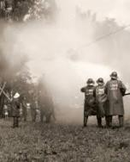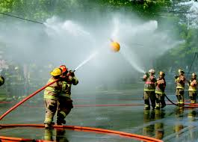

**Fire Department Games Registration Form**

This form maybe used to register in the contests held on Saturday, June 28, 2025. Games set to begin @ 12:30PM. If more room is needed please use additional page.

**This Registration Form must be brought to Registration.**

Department Name: Company Number:

Team Captain: Team Members: * Please note shirt size (S-XXL)

|  |  |
| --- | --- |
| 1. | 4. |
| 2. | 5. |
| 3. | 6. |

|  |  |
| --- | --- |
| **Circle ALL contests you would like to enter:** |  |
| Waterball | Chief’s Race |
| Bucket Brigade | Fastest Dressed Obstacle Course |

A signed copy of the Rules MUST be turned in on the day of the event at the registration table. Event Rules can be found at **cdrnfp.org**. A copy of the Rules will be available at the field on the day of the event.

Please make checks payable to **Crossroads Disaster Relief NFP**.

**Mail Payment to**: Crossroads Disaster Relief NFP, P.O. Box 1014, Effingham, IL 62401

Please sign and date the waiver and return it with your registration, thanks!