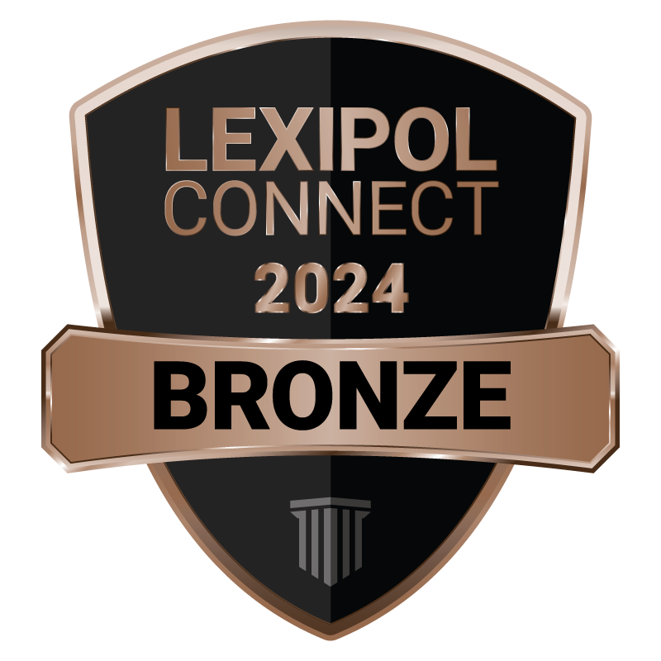

**Town of Talihina Police Department**

**FOR IMMEDIATE RELEASE**

**June 24, 2025**

**The Talihina Police Department Is Recognized for Excellence in Policy Management and Training**

The Talihina Oklahoma Police Department proudly announced its recognition for excellence in policy management and training by Lexipol, the leading provider of solutions that empower excellence in public safety

The Lexipol Connect program tracks The Talihina Police Department’s performance on five metrics proven to measure success in policy management. Talihina achieved Bronze-level recognition for consistent and effective policy dissemination to personnel, timely processing of recommended policy updates as laws change, and personnel training on policies.