Table of Contents
Old Testament Survey – Introduction p.2
Genesis 3
The Patriarchal Stage 7
Genesis - Family Tree 24
Exodus 25
Leviticus 36
Numbers 36
Deuteronomy 38
Joshua 39
Judges 46
Ruth 50
1 Samuel 52
2 Samuel 59
1 Kings 65
The Divided Kingdom 71
1&2 Kings/1&2 Chronicles 71
Northern Kingdom 75
Southern Kingdom 79
Oral Prophets 86
Elijah 86
Elisha 88
Writing Prophets 90
Isaiah 90
Jeremiah 105
Lamentations 114
Minor Prophets 115
Captivity Stage 120
Ezekiel 120
Daniel 127
Return Stage (Ezra, Zechariah, Haggai) 134
Esther 136
Nehemiah 138 Wisdom Books
Job 142
Proverbs 147
Psalms 149
Ecclesiastes 150
Song of Solomon 152
Conclusion 154
Old Testament Survey
David Scott Nichols M.D.

The Old Testament is the intriguingly true story of how our universe and mankind came into existence, the soon thereafter ‘Fall of Man’, and God’s plan for a pathway to reconciliation and redemption. God used one group of people, his “chosen people”, the Jews, to provide for all of us a carefully documented written record of the entire process.
From Creation to the Fall of Mankind, to God’s plan for our redemption, the pages of the Old Testament tell us many important things that will bring us a better understanding of just how God does work and what it is that He expects from us. It many ways, it is an exciting adventure as mankind struggles to do the will of God, always succeeding when he does. However, way more often than not, man has been unable to do God’s will. This has resulted in many disastrous problems since the first man and woman walked this earth.
The Old Testament clearly shows all of us how we should live, what the result will be if we do indeed follow God’s plan… it shows the ultimate fate of those of us that do entrust their lives to God. It also reveals the fate of those that do not and instead follow their own devices. Related to this is the underlying theme that courses through every one of the 39 books in the Old Testament. We will discover this theme as we review each of these books in this lecture series – that is, the ultimate appearance of a Messiah on the earth, the Savior of all those who will follow and believe in Him.
The Old Testament gives us important insights regarding the the search for the meaning of life (Ecclesiastes) and the “problem of pain” (Job). It also contains beautiful songs and poems covering all aspects of life, many tips on wisdom (Proverbs, Psalms, Job), and so much more.
In the following pages/lectures, I will give a brief survey of the Old Testament so that we all can have a grasp on just what was going on in the world prior to the birth of Jesus Christ and trace God’s hand through the history of His people. I believe you will find it an interesting and worthwhile endeavor.

Genesis:
Creation – The first two chapters of the Bible describe the creation of the universe and mankind. It states in Genesis that the universe was created in six days. Note that God was present at creation and exists outside the universe. This is consistent with current scientific understanding and the concept we arrive at concerning the nature of God from philosophy.
Secular science says that our universe began with a “Big Bang” – all in an instant of time. The Bible states that our universe began with a “big bang”… created by God, in an instant of time! On the other hand, both the Hindu and Buddhist religions believe in a god and universe that is contrary to this belief.
The field of philosophy has many “proofs” for the existence of God. Let me mention three very briefly:
- The Moral Argument for God’s existence: C.S. Lewis liked this one. It basically states that since there is a ‘universal moral code’ shared by all people, God must exist to have placed this ‘code’ within humanity. There is no logical reason for people to have morals if there is no God – but they do!
- Teleological Argument: everything that we see that shows evidence of intelligent design, such as a watch, does indeed have an intelligent designer. The more complex the design, the more intelligent the designer. Since the universe has incredible evidence of very fine-tuned, complex design that is absolutely necessary for the existence of man, it must have an incredible Designer… God.
- Cosmological Argument: my favorite of all philosophical proofs. As this is a little esoteric, I will defer defining this here, but for those interested, the details are easily found in philosophy books or, more readily, on the Internet.
Incidentally, when Einstein recognized all of these facts, he changed from an atheist to a believer in God!
To return now to Genesis… on the 6th day, God created land creatures and man. There has always been a debate as to whether God meant six actual 24 hour days or six ‘day-ages’. A ‘day-age’ would be a period of time much longer than 24 hours and would therefore account for the secular belief that our earth and our universe is actually about 5 billion and 14 billion years old respectively. The fact of the matter is that the details are not actually that important, in my opinion anyway, as there is massive proof that God did create the world and that the Holy Bible is true. So, in some way or another, God created the world in six days (or day-ages) and then rested on the 7th day. As all of you know, Adam was created on the 6th day, and some time later God made Eve out of one of Adam’s ribs. Initially, man and woman lived in the beautiful Garden of Eden in perfect, blissful harmony with God.
The Fall – In chapter 3 of Genesis, very unfortunately, Adam and Eve sinned after being tempted by Satan. God promptly banished them from the Garden of Eden and placed certain judgments on mankind. He cursed Satan and nature. God did not curse mankind but yet did note than man and woman would now find nothing good in life apart from Jesus Christ.
Man that is born of woman is of few days and full of trouble. Job 14:1
Cain and Abel – Genesis 4 Cain and Abel were the first two sons of Adam and Eve. Cain brought a bloodless offering to God and was rejected (although to human minds his offering probably seemed reasonable). Abel offered God what He asked for, a lamb sacrifice. This was accepted by God. [One point that was being made here… we may think we know better than God, but we don’t]! Cain was so incensed that he became the first murderer as he killed his brother, Abel. Cain soon left the area and went east of Eden to the land of Nod where he lived out his life.
Adam and Eve had another son after the death of Abel (many more children too). His name was Seth. These Old Testament people lived hundreds of years (until after the environment changed after the Flood). Seth had a long line of famous progeny, including Enos, Enoch and Methuselah (who lived to be 969 years old – oldest age on record) and Lamech. Methuselah’s grandson was Noah.
During Noah’s time, the earth had deteriorated due to sin to the point where God stated:
And God saw that the wickedness of man was great in the earth, and that every imagination of the thoughts of his heart was only evil continually. And it repented the Lord that He had made man on the earth, and it grieved Him at His heart. And the Lord said, I will destroy man whom I have created from the face of the earth; both man and beast, and the creeping thing, and the fowls of the air; for it repented me that I have made them. Genesis 7:5-7
Noah was a just man. He had a wife and three sons, Shem, Ham and Japheth. God instructed Noah to build an ark of gopher wood. He had precise instructions from God and followed them exactly. After completing the ark, Noah, his wife, his sons and their wives and all the animals and fowl (and adequate food) were brought onboard. The flood came for 40 days and the waters continued to rise for five months. It took over one year for the waters to totally subside. Only Noah and his family were left alive to replenish the earth with people. This they did. The ark came to rest on Mount Ararat where several modern day explorers have reported seeing a wooden object that fits the description of the ark!
It should be pointed out that the environment after the Flood is much different than before the flood. Before the Flood, our world was most probably enveloped by a mist; the seasons almost assuredly manifested themselves differently than they do now. For some reason, the age that man can live diminished fairly quickly after the Flood, and soon mankind began living to the age we typically see today. After the Flood, God made a covenant with Noah and mankind and the animals: He would never again destroy the earth with water. The rainbow is the sign that God gave of this covenant.
Let us take a look at Noah’s three sons: discussed in Genesis 9-11
Shem – the Jewish nation arose from Shem as well as many of the Arab nations
Japheth – descendants include Germans, Russians, Persians, Greeks, Italians, and Spaniards
Ham – descendents include Egypt, Africa, Ethiopia, Canaanites of Palestine, Hittites, Nimrod, Philistines, Jebusites and probably the forefathers of the people of China, Japan, and India
It is intriguing to note that Genesis states that Noah was incensed at his son Ham after that young man allowed his father to lay naked and on display in his tent after Noah apparently got drunk with wine. Ham also had begun to tell others of his father’s indiscretion. On the other hand, Noah’s other two sons covered him and kept this incident discreet. Due to these actions, Noah blessed Shem and Japheth and allowed that they would expand their territories in the future. More importantly, Noah stated that Ham would become the “slave” to his brothers… and that Canaan would be the slave of Shem. This is an interesting concept to think about as we look back through history and note what the political situation is in the Middle East today.
Not too many years after the Flood, the leaders of the people decided to build a Tower to the Heavens (The Tower of Babel). Their goal was to be god-like instead of trying their utmost to be followers of God. God quickly stopped this attempt by confounding their language and scattering them abroad in various directions over the face of the earth… hence the various nations came into being as noted above.
Before getting into the next section of the Patriarchal Stage, I would like to point out an interesting observation that Dr. Dean Willmington made in his book Guide to the Bible. He notes that before the Fall, Adam did not have in his vocabulary the following seven words; death, nakedness, cursed, sorrow, thorns, sweat, and sword. After the Fall, Adam and all of humanity thereafter has had to deal with all of these miserable things. Yet, the second Adam, Jesus, came and ultimately will restore all of His followers to a perfect and just relationship with the Father where once again life will be literally perfect!

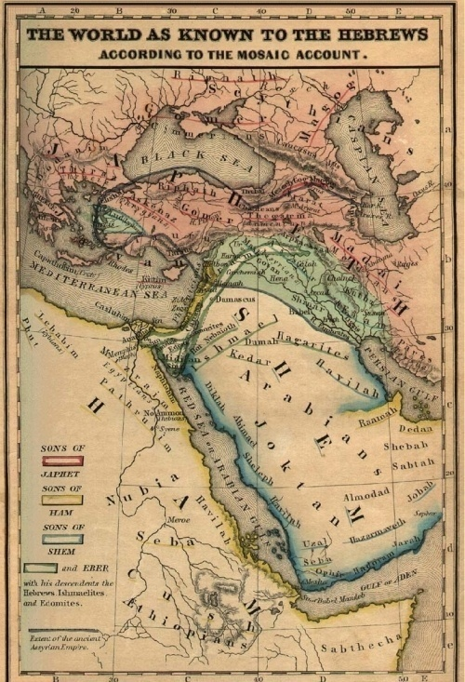
Patriarchal Stage
We have just completed discussing God’s creation of the world and mankind. After the Fall and the severe moral deterioration that eventually followed, God used a great worldwide Flood to begin the re-population of the earth again… this time with the intent to use a certain nation to carry out His purposes. In His perfect time, God planned to provide for mankind a mechanism to re-gain their relationship with Him and to someday gain entrance into Heaven. This nation was Israel. Through this nation, God was to eventually provide for our salvation!
The father of Israel was and is Abraham (called Abram initially). Abram was a descendent of Shem. A man named Terah was his father. Nahor and Haran were his brothers. Haran was the father of Lot. God called Abram out of the land of Ur of the Chaldees – a seaport on the Persian Gulf. He lived at about the same time as Job. He was born in approximately 2166 B.C. It is interesting to note that for years skeptics laughed at the actual existence of a place called Ur… until C. T. Wooley, a famous British archaeologist, discovered the ruins of this civilization in 1922-1934. It was located in what now is southern Iraq on the Euphrates River.
Abram was told by God to leave Ur and proceed to Canaan. Likely reasons for this move would include getting Abram away from the bad influences of the people in that region who believed in polytheistic gods and to give Abram the Land of Promise that God had chosen for him. Although he delayed in Haran for many years, after another “word” from God, Abram proceeded with his wife Sarai and his nephew Lot and journeyed into the land of Canaan. Abram was a man of reasonable wealth as was Lot. Soon after their entrance into Canaan, Abram built an altar to God for the blessings God had given to him and his family. This altar was built just east of Bethel, a town that was very close to the later location of Jerusalem. Abram continued to move around Canaan in the months to come as he was, in fact, a nomad. Also, Abram was interested in exploring this “land of promise”. A little while later, there was a famine in the land of Canaan and Abram decided to move south and west to Egypt. Keep in mind, he was not told to do this by God. When he got into Egypt, he attempted to gain favor with the Pharaoh by telling him that Sarai was his sister (she was his half-sister, but more importantly, she was his wife). He was concerned that he might be killed if Pharaoh took his very beautiful Sarai for a wife in his harem. Pharaoh would have to eliminate any competition… that is, her current husband. If he were only her brother, he figured he instead would be compensated with food and goods and that, he rationalized, would be best for all. Actually, this was a terrible idea. Pharaoh did take Sarai with plans of making her his wife and he did give Abram much bounty. Fortunately, God rescued this bad situation by inflicting sickness onto Pharaoh and his household and revealing to the Pharaoh the truth. Amazingly, Pharaoh allowed Abram and Sarai to escape with their lives and these two returned to Canaan immediately. This was one of the rare episodes where Abram did not demonstrate the great faith for which he would become famous.

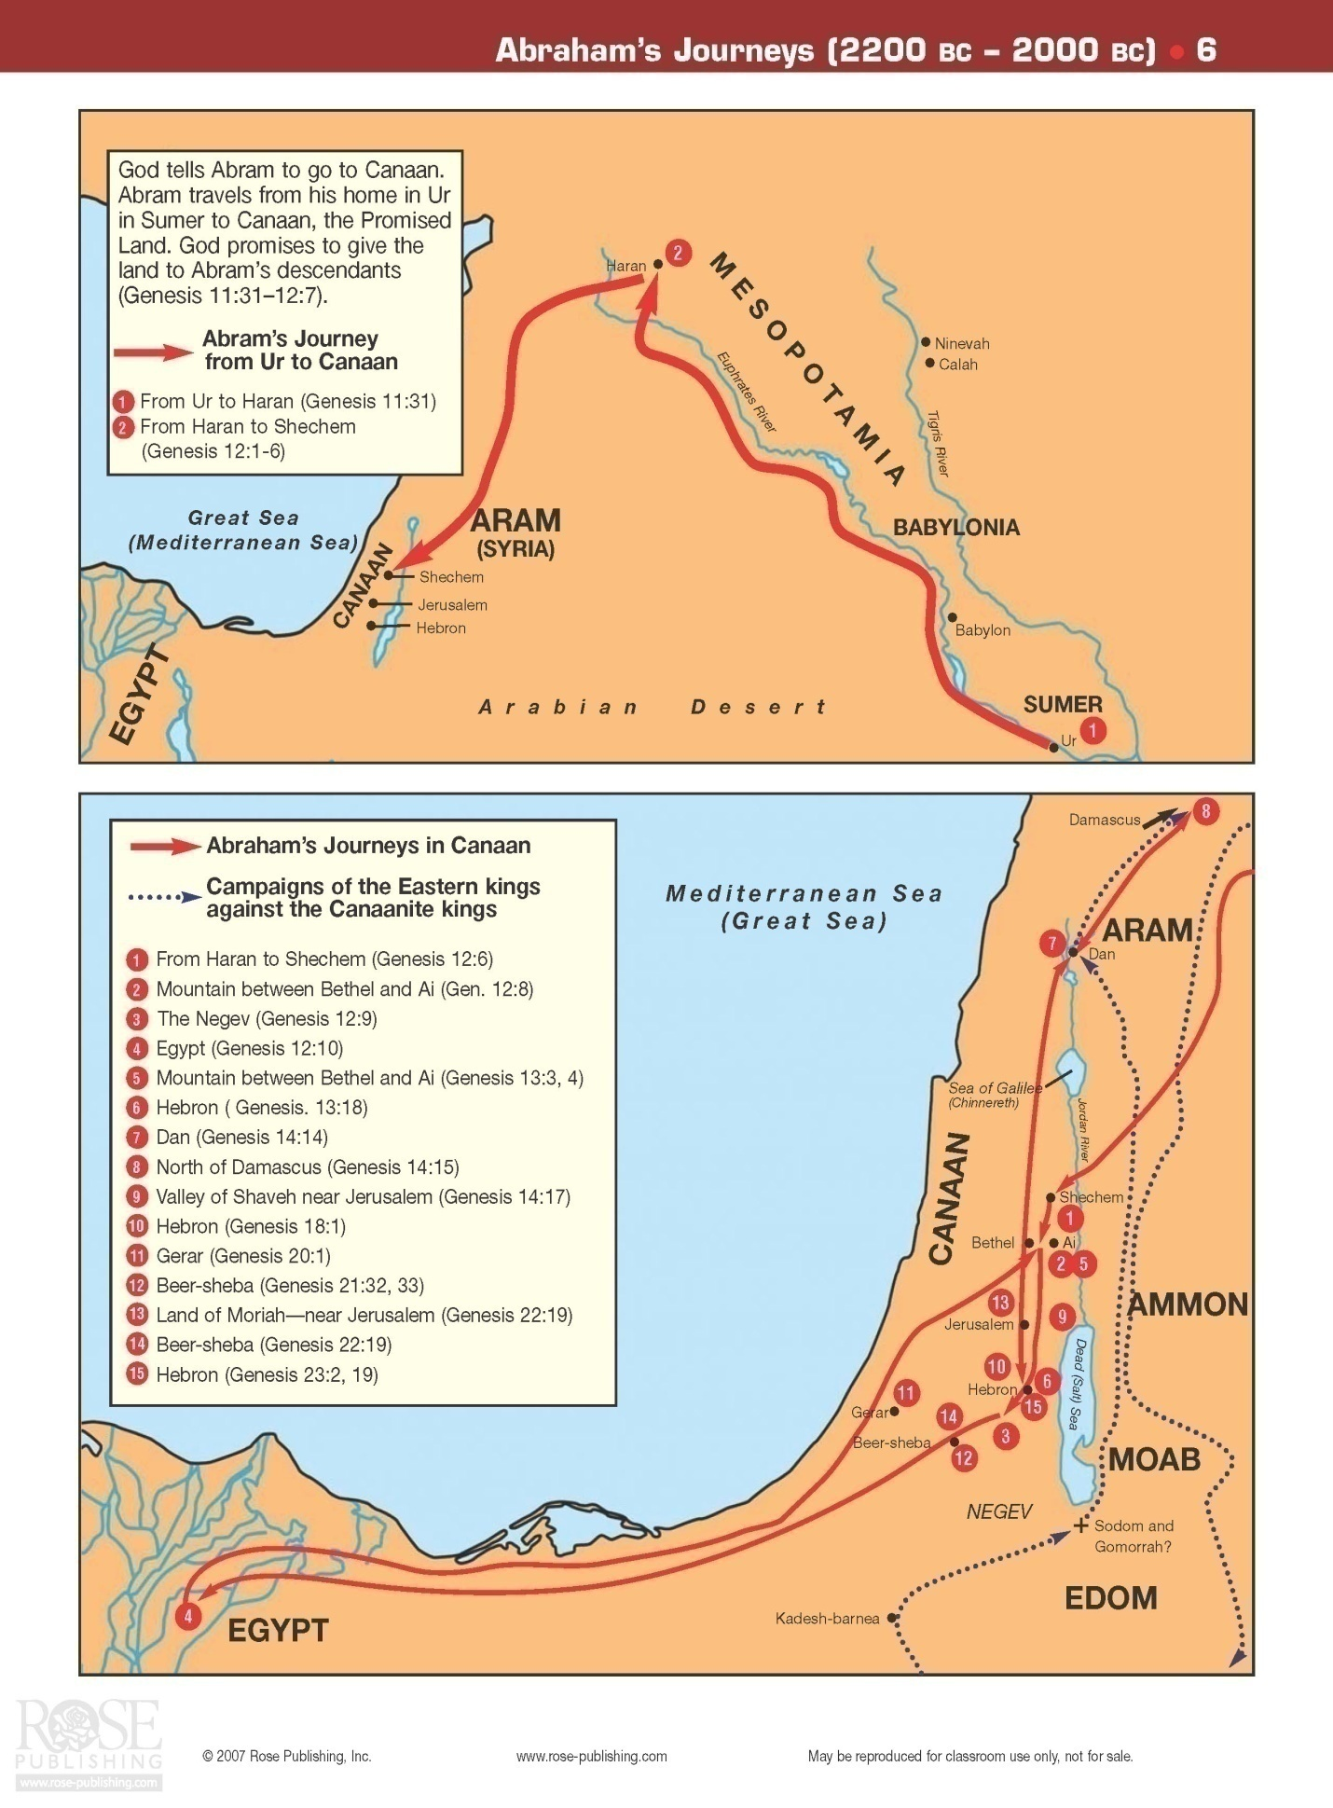
After living from place to place as was the custom in those days, Abram and Lot eventually landed back in Bethel. They both had come into significant wealth during those years as God had blessed them both. In the opinion of Lot at least, the area that they now both shared was not really big enough for their two growing families given all of their livestock and possessions. A couple other indigenous communities lived there as well. Therefore, in order to avoid any further quarrelling, Abram told Lot to pick land in any given direction and that would be Lot’s land… Abram would take what was left. Lot chose the land of Sodom (to the east and south) among the cities of the plains of Jordon as they looked green and lush in those days. Abram was left with the land of Canaan. Just after Lot departed, God spoke to Abram and made His covenant with him. He told Abram that all the land that he could see, north, east, south and west, was promised to him and his heirs… and that his heirs would be as plentiful as the dust of the earth!
all the land which thou seest, to thee will I give it, and to thy seed for ever. And I will make thy seed as the dust of the earth; so that if a man can number the dust of the earth, then shall thy seed also be numbered. Genesis 14:15-16
So, if one believes the Bible, it is obvious whose land it is over in the Middle East.
The years passed and Lot and Abram continued their lives in their chosen land. Unfortunately for Lot, the land that had looked so promising years earlier was now being attacked by foreign powers. Sodom fell and Lot, living there, was taken captive. When Abram learned of this situation, he took many of his men and friends and went after his nephew to rescue him. This mission was successful! He defeated the king who had defeated Sodom, Kedorlaomer. Both the king of Sodom and the king of Salem came out to congratulate and thank Abram. Abram turned down the king of Sodom’s offer to keep the goods he had won in battle.
King Melchizedek of Salem, also a priest of God, apparently lived and reigned in Jerusalem (Salem = Jerusalem). This is one of the few times he is mentioned in the scripture. Later, he is referenced when Christ is noted to be a priest “in the order of Melchizedek”. This king apparently was a priest of the one true God, although his knowledge of God must have been somewhat limited. Interestingly, Abram tithed to him at this time… even though the idea of tithing was not developed until much later. Melchizedek also brought out wine and bread (later to be the same symbols used in the Lord’s Supper) and blessed Abram. This was a very mysterious event and almost certainly is some sort of pre-figuration of Jesus Christ. Of course, Jesus was a King, Priest and Prophet. Melchizedek was not called a prophet.
After these things the word of the Lord came to Abram in a vision, saying, "Do not be afraid, Abram. I am your shield, your exceedingly great reward." But Abram said, "Lord God, what will You give me, seeing I go childless, and the heir of my house is Eliezer of Damascus?" Then Abram said, "Look, You have given me no offspring; indeed one born in my house is my heir!" And behold, the word of the Lord came to him, saying, "This one shall not be your heir, but one
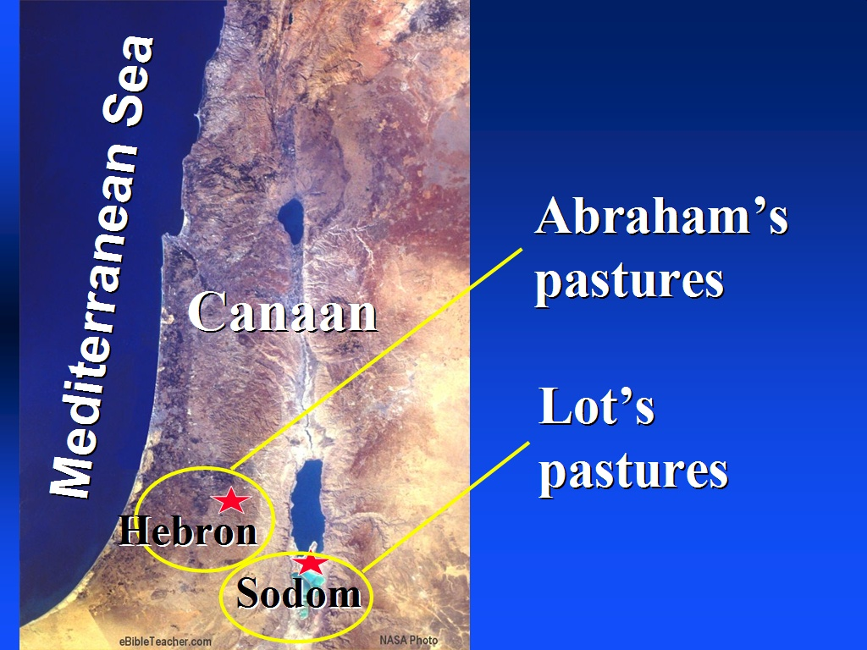
who will come from your own body shall be your heir." Then He brought him outside and said, "Look now toward heaven, and count the stars if you are able to number them." And He said to him, "So shall your descendants be." And he believed in the Lord, and He accounted it to him for righteousness. Gen 15:1-6

This is a very important verse. Paul references this in Romans when he lists several Old Testament saints, including Abraham as being saved by ‘faith’…. not by ‘works’. This is the story that he retells.
Then He said to Abram: "Know certainly that your descendants will be strangers in a land that is not theirs, and will serve them, and they will afflict them four hundred years. And also the nation whom they serve I will judge; afterward they shall come out with great possessions. Now as for you, you shall go to your fathers in peace; you shall be buried at a good old age. But in the fourth generation they shall return here, for the iniquity of the Amorites is not yet complete." And it came to pass, when the sun went down and it was dark, that behold, there appeared a smoking oven and a burning torch that passed between those pieces. On the same day the Lord made a covenant with Abram, saying: "To your descendants I have given this land, from the river of Egypt to the great river, the River Euphrates-- the Kenites, the Kenezzites, the Kadmonites, the Hittites, the Perizzites, the Rephaim, the Amorites, the Canaanites, the Girgashites, and the Jebusites." Gen 15:13-21

Of course, God was speaking of the time that the Israelites would be spending in Egypt in the generations to come.

Although God promised Abram that he would be the father of a nation so large it could not be numbered, Abram became restless as he and Sarai aged. Unfortunately, these two did not have the patience to wait on God… they forgot that God’s time is not our time. Eventually, Sarah told him to sleep with her handmaid, Hagar, in order to have a son. This was not an unusual custom in those days. Abraham did this, unfortunately. Sadly, Hagar had come to despise Sarai because of this situation. Sarai was very upset and went to Abram. She said it was up to him to judge between Hagar and her. Abram told Sarai to do whatever she believed best. With this added power, Sarai succeeded in driving Hagar away. An angel of the Lord appeared to Hagar and comforted her with the information that her son would have many descendents, too numerous to count. She also told her to return to Sarai and submit to her. After returning to the family, Hagar bore Abram a son… Ishmael. Ishmael’s descendents have been at odds with those of Abraham’s next son, Isaac, ever since… today these descendents make up a large portion of the Arab people!
God once again appeared to Abram when he was an old man of 99 years. He confirmed his covenant again, this time by telling Abram to have all future males in his line circumcised.
God talked with him, saying: "As for Me, behold, My covenant is with you, and you shall be a father of many nations. No longer shall your name be called Abram, but your name shall be Abraham; for I have made you a father of many nations. I will make you exceedingly fruitful; and I will make nations of you, and kings shall come from you. And I will establish My covenant between Me and you and your descendants after you in their generations, for an everlasting covenant, to be God to you and your descendants after you. Also I give to you and your descendants after you the land in which you are a stranger, all the land of Canaan, as an everlasting possession; and I will be their God." Gen 17:3-8

This covenant was irrevocable and not conditional. Later, God would give a conditional covenant as we will see… conditioned on the people, His people, following Him and obeying Him. When explaining this covenant to Abram, God also changed the name of Sarai to Sarah (princess). That very day, Abraham (father of many) took his son Ishmael, all other males born in his household and himself to get circumcised. Ishmael was 13 years old.
Eventually, God did do what He said he would do… provide Abraham and Sarah a son… years after Sarah was, naturally speaking, barren. Yet, that is not a problem for God. Isaac was born to Abraham and Sarah one year later when Abraham was 100 years old and Sarah was 90 years old! God continued the line of the patriarchs when he supernaturally allowed Sarah to become impregnated by Abraham at their old age. This union resulted in their second son, Isaac (the name means “he will laugh” as Abraham and Sarah laughed when they thought of having a child at such an old age). God continued His covenant with Abraham through his son, Isaac…
I will establish my covenant with him for an everlasting covenant, and with his seed after him. Genesis 17:19
God also continued, and as for Ishmael, I have heard thee: Behold I have blessed him, and will make him fruitful, and will multiply him exceedingly, twelve princes shall he beget, and I will make him a great nation. Genesis 17:20
Hence, God made two large nations from Abraham’s two sons… one, the Jewish nation, the other, of course, the Arab nations. They have been at odds with one another ever since.
It was not long after this time that God decided to destroy the terribly wicked city of Sodom. When God revealed his plan to Abraham, that old gentleman tried his best to convince the Lord to spare that land. Abraham reasoned that God would be “sweeping away the righteous with the wicked.” Genesis 18:23 God recognized that Sodom was indeed lost, yet relented to the bargaining of Abraham and agreed that He would spare the city from destruction if there were only ten righteous people. But there weren’t!
Lot and his family were still living in that land. They were warned by angels to run away immediately or they would be lost in the destruction. Lot and his two daughters did successfully escape. Lot’s wife hesitated and looked back toward the city as fire and brimstone rained down. The Bible says she was turned into a “pillar of salt”. It is really interesting to know that evidence of this type of destruction is found in that region today. So that was the end of Sodom (and of the city Gomorrah).
Sadly, Lot’s two daughters who had just escaped death with their father decided to engage in a terrible act of incest in order to “preserve their family line.” They got their father drunk and “slept” with Lot. This sinful act produced two sons. These two boys were the “fathers” of the Ammonites and the Moabites later mentioned throughout the Bible.
As Isaac grew, there came the inevitable tension between Sarah and Hagar as both wanted only the best for their sons. At a feast for Isaac on the day he was weaned, the teenaged Ishmael mocked the little baby. This bothered Sarah to the point that she went to Abraham and requested that he “get rid of that slave woman and her son.” Genesis 21:10 It was not only this incident that concerned Sarah, but she was worried over the future inheritance for Isaac as well. As Sarah was Abraham’s wife and he loved her as such, Abraham sent Hagar and his son Ishmael away, sadly. They eventually went south to the Desert of Paran. God was with the boy as he became an archer, later marrying an Egyptian girl his mother found for him.
This allowed for a tranquil time for several years for the family of Abraham. Isaac grew to be a fine young man. There came one fateful day, however, that God had a test for Abraham… and for Isaac as well. God said to Abraham, Abraham!" And he said, "Here I am." Then He said, "Take now your son, your only son Isaac, whom you love, and go to the land of Moriah (the same mountain where Jesus was sacrificed), and offer him there as a burnt offering on one of the mountains of which I shall tell you." Gen 22:1-2
Can you even imagine what had to be going through the mind of Abraham at that time? There had to be many conflicting thoughts. How could he possible kill his beloved son? How could God ask him to do this? How could God create a nation of people from his heirs, if he was about to sacrifice Isaac? Etc.
Be that as it may, Abraham did get up and make travel arrangements (for a three day trip) to take Isaac and two servants with his saddled donkey up to the mountain. He even cut the wood for the offering. When he reached the mountain, Abraham had to tell his son what he planned to do:
So Abraham took the wood of the burnt offering and laid it on Isaac his son; and he took the fire in his hand, and a knife, and the two of them went together. But Isaac spoke to Abraham his father and said, "My father!" And he said, "Here I am, my son." Then he said, "Look, the fire and the wood, but where is the lamb for a burnt offering?" And Abraham said, "My son, God will provide for Himself the lamb for a burnt offering." So the two of them went together. Then they came to the place of which God had told him. And Abraham built an altar there and placed the wood in order; and he bound Isaac his son and laid him on the altar, upon the wood. And Abraham stretched out his hand and took the knife to slay his son. But the Angel of the Lord called to him from heaven and said, "Abraham, Abraham!" So he said, "Here I am." And He said, "Do not lay your hand on the lad, or do anything to him; for now I know that you fear God, since you have not withheld your son, your only son, from Me." Then Abraham lifted his eyes and looked, and there behind him was a ram caught in a thicket by its horns. So Abraham went and took the ram, and offered it up for a burnt offering instead of his son. And Abraham called the name of the place, The-Lord-Will-Provide; as it is said to this day, "In the Mount of The Lord it shall be provided." Then the Angel of the Lord called to Abraham a second time out of heaven, and said: "By Myself I have sworn, says the Lord, because you have done this thing, and have not withheld your son, your only son-- blessing I will bless you, and multiplying I will multiply your descendants as the stars of the heaven and as the sand which is on the seashore; and your descendants shall possess the gate of their enemies. In your seed all the nations of the earth shall be blessed, because you have obeyed My voice." So Abraham returned to his young men, and they rose and went together to Beersheba; and Abraham dwelt at Beersheba. Gen 22:6-19
Please note the amazing similarities between this poignant incident between Abraham and his only son and the one that would come later between God and His only Son at the same place! This kind of incident is referred to as a “type” of Christ. Many such types are seen in the Old Testament. A Type is defined as a person, thing or event that parallels a certain person, thing or event in the New Testament… most commonly concerning the life of Jesus.
Sarah died at the age of 127 years old in Hebron. Abraham arranged to bury her by purchasing a cave for a burial place – the cave of Machpelah. Today, it is believed that several of the patriarchs are buried there, including Sarah, Abraham, Rebekah, Isaac, Jacob and Leah. Tradition has it that the cave is located beneath the Mosque of Abraham, a Muslim shrine, in Hebron. By burying Sarah in Canaan, Abraham signaled his plan to be in that land forever and his total commitment to the Lord’s covenant with him.
Continuing on, Abraham now had decided that it was time for Isaac to marry. He sent one of his trusted servants out to find a bride. Yet, he told this man not to bring back a wife from any of the Canaanites. He wanted Isaac’s bride to be from his own people. The servant accomplished this by heading north to the town of Nahor. Here the servant found a beautiful young girl named Rebekah. He had prayed to God that He would reveal the proper choice for Isaac by having the first woman to come out to a watering spring be God’s choice for Isaac. Rebekah was that young woman. After proper introductions and discussions with her elders, she decided she would go with the servant to meet and marry Isaac. She was the daughter of Bethuel, the son of Abraham’s brother… his father’s grandniece. Upon arriving, Isaac was very pleased with his prospective bride, soon married her and loved her. She helped also to mend the wound in Isaac caused by his mother’s death.
Several years later, Abraham died at the age of 175 years old. Both of his sons reunited to bury him with Sarah in the cave at Machpelah.
Rebekah was similar to Sarah in that she too was barren. Isaac prayed to God to allow his wife to give birth. Rebekah eventually gave birth to Esau and Jacob. They were fraternal twins. . Isaac was 60 y.o at the time of their birth. Esau came out of the womb first, all hairy and red in complexion. Jacob was born while still grasping Esau’s heel. These two brothers were markedly different. Esau was a cunning hunter. Jacob was a “plain man, dwelling in tents.” Genesis 25:27
But the children struggled together within her; and she said, "If all is well, why am I like this?" So she went to inquire of the Lord. And the Lord said to her: "Two nations are in your womb, Two peoples shall be separated from your body; One people shall be stronger than the other, And the older shall serve the younger." Gen 25:22-23

As will become apparent, these two sons took very different directions in their lives. Jacob, continued on as the heir of the “promise”. Esau travelled a different path as we shall see.
From an early age, Isaac favored Esau as he was an outdoorsman, loving to hunt. Rebekah favored the quieter Jacob who tended to stay back in the tents and help out there. Esau and Jacob remained with the family for a fairly long time before striking out on their own. Esau was 40 years old when he married a Hittite woman. Jacob was still a bachelor.
Esau, apparently having too little respect or interest in his birthright as the first born son, traded it to Jacob for a bowl of stew (one day when he was famished and faint after working hard in the field). Of course, this caused a lot of tension between them. Esau realized the stupid trade he had made and regretted his action almost immediately, but it was too late. He had lost his birthright – the trade was binding! Years later, after his marriage to the Hittite woman, his mother Rebekah, actually plotted to help Jacob receive the other very important gift from father to son… the “blessing”. She convinced Jacob to trick his blind father into believing that he was Esau and get his father to bless him instead of Esau… who should have received this important “blessing”. As was the custom of that day and those people, once a blessing was given it could not be revoked and given to another. That being the case, Jacob had hoodwinked his brother Esau out of his birthright and the first born son’s blessing. This resulted in a great deal of goods and territory for Jacob, and conversely much land and monetary loss for the older brother, Esau. Obviously, Esau was furious.
Jacob was off and running right after receiving this blessing as he had to leave or face Esau! Rebekah directed him to go to her brother Laban in Haran. She hoped that in time Esau might forgive Jacob… but, now was certainly not that time. Isaac said goodbye to his younger son as well, blessed him and requested that he not marry a Canaanite woman (as Esau had done). That would have been too much for Rebekah to bear.
Interestingly, in time, Esau went out and joined with Isaac’s brother, Ishmael. Together their progeny has given us the Arab nations. Esau also was the father of the Edomites.
Jacob was visited by God in a dream soon after he fled north toward Haran. While stopping in Bethel, God confirmed His covenant with Jacob through a dream, “I am the Lord God of Abraham thy father, and the God of Isaac: the land wherein thou liest, to thee will I give it, and to thy seed.” Genesis 28:13
Jacob continued north to Padan Aram - Haran. He finally located his uncle Laban and was given a nice reception. Laban had two daughters, Leah and Rachel. Jacob wanted to marry Rachel and told Laban that he would work for him for seven years for the honor of marrying Rachel. That was the deal and after those seven years, the time for the wedding arrived. But then Laban tricked Jacob…
Now it came to pass in the evening, that he took Leah his daughter and brought her to Jacob; and he went in to her. And Laban gave his maid Zilpah to his daughter Leah as a maid. So it came to pass in the morning, that behold, it was Leah. And he said to Laban, "What is this you have done to me? Was it not for Rachel that I served you? Why then have you deceived me?" And Laban said, "It must not be done so in our country, to give the younger before the firstborn. Fulfill her week, and we will give you this one also for the service which you will serve with me still another seven years." Then Jacob did so and fulfilled her week. So he gave him his daughter Rachel as wife also. And Laban gave his maid Bilhah to his daughter Rachel as a maid. Then Jacob also went in to Rachel, and he also loved Rachel more than Leah. And he served with Laban still another seven years Gen 29:23-30

Jacob had six sons with Leah, two with her maidservant Zilpah and two more with Rachel and two with her maidservant Bilhah. As it turned out, there were actually four women who produced the twelve sons of Jacob. From these sons came the twelve tribes of Israel.
After the fourteen years that Jacob promised to work for Laban in exchange for Rachel, he also offered to work for many more years for the opportunity to gather livestock. By this time, Jacob had devised a plan whereby he would be able to add much livestock to his total by some underhanded trickery. He felt that he was entitled to do this because of what Laban had done to him over the previous 14 years. Laban had ideas of his own. At one point, however, God intervened and told Jacob it was time for him to go back to the land of his fathers. This Jacob did as he took Leah and Rachel and his sons and all the wealth he had accumulated. Rachel decided to steal her father’s idols as well. She did this without telling anyone, including Jacob. Laban was told that Jacob had fled and therefore he went in pursuit. While travelling south, God appeared to Laban and told him to go easy on Jacob. Upon meeting up, after a verbal
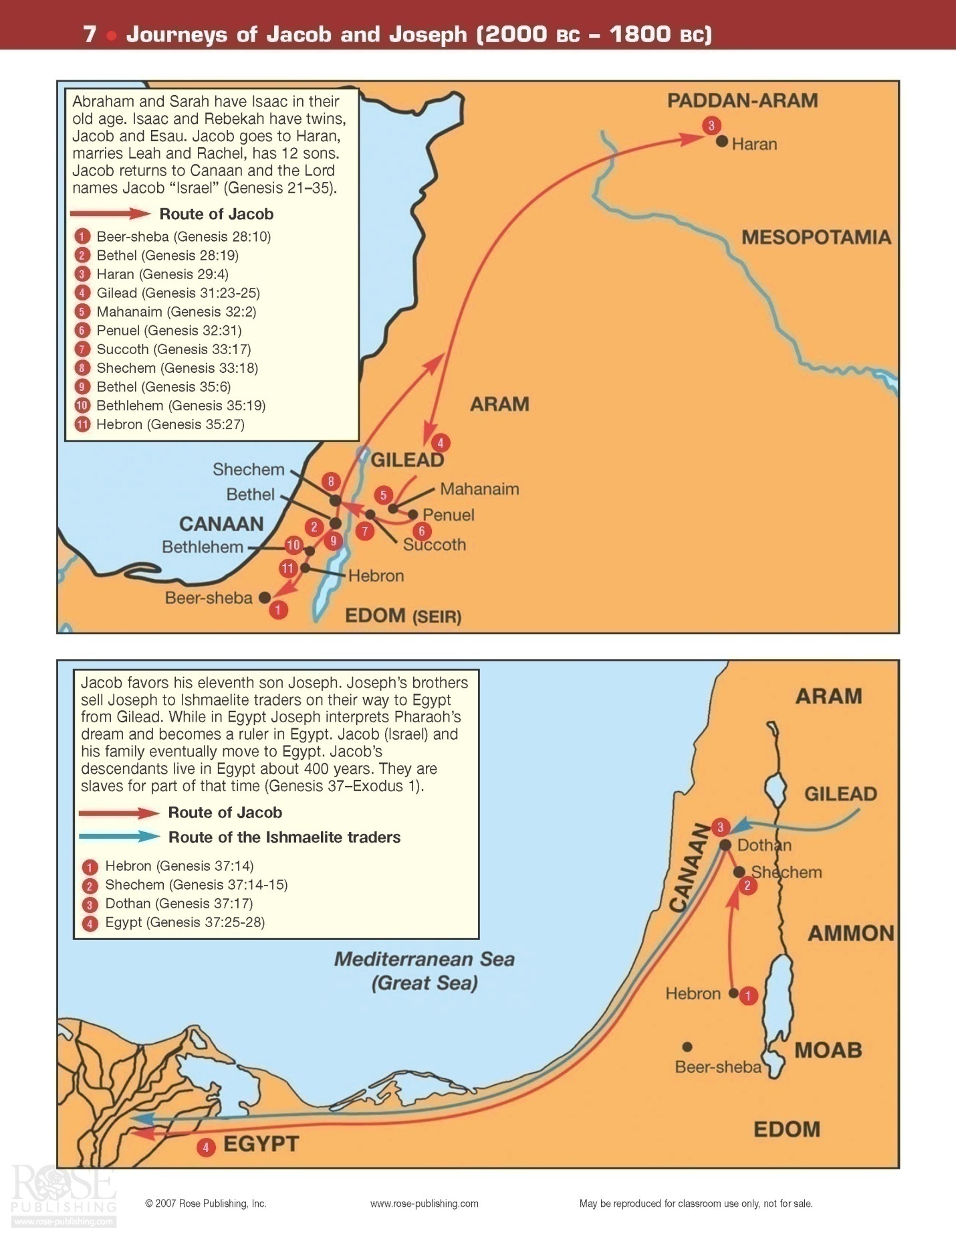

sparring match, the two of them came to an understanding, a truce, that allowed Jacob to continue on toward his homeland. They sealed the deal by building a large mound of stones that they referred to as Galeed, which means ‘heap of stones’. This all took place on the mount of Gilead.
And Laban said, This heap is a witness between me and thee this day. Therefore was the name of it called Galeed; Gen 31:47-48
Rachel stealthily hid the much sought after idols from her father. Some theologians believe that they not only were important to Laban for their use in pagan worship ceremonies, but also indicated that the possessor had certain ownership rights to the land. In other words, it was possible that Jacob might have been able to claim some inheritance subsequent to Laban’s death if he had desired - since his wife was in possession of the idols. This is unclear.
Now, he only had Esau to worry about. And worry he did. Recall that he had also fled from his hometown just under 20 years earlier as he knew Esau was terribly upset with him! Surely Jacob had not led the most righteous life up to this point. On the other hand, he had now begun to follow the lead of the God of his fathers. This would change things as he would soon see.
When Jacob drew near to where he knew Esau was encamped, he sent several of his party to attempt to pacify his older brother with a multitude of gifts.
Then Jacob sent messengers before him to Esau his brother in the land of Seir, the country of Edom. And he commanded them, saying, "Speak thus to my lord Esau, 'Thus your servant Jacob says: "I have dwelt with Laban and stayed there until now. I have oxen, donkeys, flocks, and male and female servants; and I have sent to tell my lord, that I may find favor in your sight." ' " Then the messengers returned to Jacob, saying, "We came to your brother Esau, and he also is coming to meet you, and four hundred men are with him." So Jacob was greatly afraid and distressed; and he divided the people that were with him, and the flocks and herds and camels, into two companies. And he said, "If Esau comes to the one company and attacks it, then the other company which is left will escape." Then Jacob said, "O God of my father Abraham and God of my father Isaac, the Lord who said to me, 'Return to your country and to your family, and I will deal well with you': I am not worthy of the least of all the mercies and of all the truth which You have shown Your servant; for I crossed over this Jordan with my staff, and now I have become two companies. Deliver me, I pray, from the hand of my brother, from the hand of Esau; for I fear him, lest he come and attack me and the mother with the children. For You said, 'I will surely treat you well, and make your descendants as the sand of the sea, which cannot be numbered for multitude.' " Gen 32:3-12
So here Jacob was, having burned his bridges behind him with Laban and now facing possible death at the hands of an angry brother – one whom he had wronged greatly when they were younger. He knew he did not deserve it, but he cried out to his God to intervene and salvage the situation. Somehow he hoped that God would still honor the promise he had given Abraham and Isaac earlier – that his descendents would be a great multitude. That very night, Jacob sent his family, servants and livestock ahead as he stayed behind to pray. What a night of prayer that was…
a Man wrestled with him until the breaking of day. Now when He saw that He did not prevail against him, He touched the socket of his hip; and the socket of Jacob's hip was out of joint as He wrestled with him. And He said, "Let Me go, for the day breaks." But he said, "I will not let You go unless You bless me!" So He said to him, "What is your name?" He said, "Jacob." And He said, "Your name shall no longer be called Jacob, but Israel; for you have struggled with God and with men, and have prevailed." Then Jacob asked, saying, "Tell me Your name, I pray." And He said, "Why is it that you ask about My name?" And He blessed him there. And Jacob called the name of the place Peniel: "For I have seen God face to face, and my life is preserved." Just as he crossed over Penuel the sun rose on him, and he limped on his hip. Gen 32:24-31

So here we see that Jacob had an actual encounter with the pre-incarnate Jesus. Jacob would not let go, figuratively and literally speaking until he had received a blessing from his God. Finally, Jacob was ready to follow God in earnest.
The next morning came and Jacob finally came face to face with his long lost brother…

But Esau ran to meet him, and embraced him, and fell on his neck and kissed him, and they wept. And he lifted his eyes and saw the women and children, and said, "Who are these with you?" So he said, "The children whom God has graciously given your servant." Then the maidservants came near, they and their children, and bowed down. And Leah also came near with her children, and they bowed down. Afterward Joseph and Rachel came near, and they bowed down. Then Esau said, "What do you mean by all this company which I met?" And he said, "These are to find favor in the sight of my lord." But Esau said, "I have enough, my brother; keep what you have for yourself." And Jacob said, "No, please, if I have now found favor in your sight, then receive my present from my hand, inasmuch as I have seen your face as though I had seen the face of God, and you were pleased with me. Please, take my blessing that is brought to you, because God has dealt graciously with me, and because I have enough." So he urged him, and he took it. Gen 33:4-11

So it turns out that all of Jacob’s fears were unfounded. That is the way it often is in our lives as well. God tells us to not fear ‘tomorrow’. He will be there for us. Often those things that we fear the most do not even eventuate. On the other hand, it is certainly easier to say this than to do it. Yet, we should pray for God’s help always to keep us from anxiety concerning future events. Plan for tomorrow, yet live - without fear - for today.

After this most happy meeting between the two previously estranged brothers, they soon departed to get on with their lives in differing parts of the land. Esau returned to Seir. Jacob continued on to eventually land in Shechem (in central Canaan) where he promptly built an altar to the Lord.

A terrible incident took place while living in Shechem. Hamor was the ruler in that region not Canaan. One of his sons, Shechem, raped one of Jacob’s daughters, Dinah. Of course, when Jacob and his sons heard of this they were outraged. The brothers wanted revenge. Hamor attempted to assuage the situation by telling Jacob how sorry everyone felt and that actually Shechem was in love with Dinah and wanted to marry her. Shechem himself asked what he could do to make things right. Dinah’s brothers, still seeking revenge, hatched a plan. They said that all could be made right if Shechem and the other males in his family (including servants) were circumcised before the marriage to Dinah. Shechem agreed to this and all of the males in that household were indeed circumcised on the same day. Just three days later, while all of these males were still in significant post-op pain, the sons of Jacob attacked these men and killed them. They had gained their measure of revenge…and then some. They also took with them their conquered foe’s livestock. When Jacob heard of this, he was very upset. He knew that repercussions would be felt… if not now, at some future date. Yet, the sons still claimed that what they did was needed and right.

After this incident, God told Jacob to gather his possessions and family and move on to Bethel. That was the place that God had revealed Himself to Jacob when he was fleeing from Esau all those many years ago. Jacob got everyone together, told them to leave any and all symbols of other gods behind (such as idols and trinkets) and move on to their new city. Once again, upon arrival, he built an altar to God.

Then God appeared to Jacob again, when he came from Padan Aram (aka Haran - where he had married Leah and Rachel), and blessed him. And God said to him, "Your name is Jacob; your name shall not be called Jacob anymore, but Israel shall be your name." So He called his name Israel. Also God said to him: "I am God Almighty. Be fruitful and multiply; a nation and a company of nations shall proceed from you, and kings shall come from your body. The land which I gave Abraham and Isaac I give to you; and to your descendants after you I give this land." Gen 35:9-12

So now God had confirmed His promise to Jacob (which means “deceiver”) and repeated the name change of Jacob to Israel which means “He strives with God… and prevails”.
Some time later, Israel left Bethel to move on to Ephrath. On this journey, Rachel went into labor with the twelfth (and last) son of Israel. She gave birth to Benjamin, but sadly, died in childbirth. Israel built a pillar to honor his beautiful wife and placed it over her tomb near the city where she died… later to be called Bethlehem.
Jacob visited his father Isaac in Mamre, near Hebron. Isaac lived there as had Abraham for much of his life. On one such visit, his father died at the age of 180 years old. He was buried by his sons Esau and Jacob. Note that these two sons came together for this burial as had Ishmael and Isaac for the burial of their father Abraham.
All of the twelve sons of Israel were now born. These men would be the men through which that God would build His promised nation; they were the “chosen people”. The oldest son, Reuben, committed the arrogant sin of sleeping with one of his father’s concubines. This would eventually contribute to him losing his birthright as the firstborn child. On the other end of the spectrum, the penultimate son of Israel, Joseph, pleased his father greatly. It became apparent, as he grew to be a teenager, that Joseph was the favorite son of Jacob. He was given a special honor of a “coat of many colors”, marking him as the future leader of the household. This was normally an honor reserved for the eldest son. At the age of 17, Joseph gave “a bad report” concerning some of his brothers to his father. To make matters even worse between Joseph and his siblings, he also blithely interpreted one of his dreams that indicated that his brothers apparently were one day going to be subservient to him – even to the point of bowing down to him! He had another dream that was similar in content but also suggested that his father and mother would bow down to him as well. For all of these reasons, sadly, but not surprisingly, his brothers had a deep jealousy and even a hatred for Joseph. His brothers seized upon an opportunity one day when out tending their flock to get rid of him. Jacob had sent his son Joseph out to grazing land in Shechem where his other sons were grazing their flocks. He asked Joseph to report back to him concerning how his other boys were doing. Joseph, upon arriving in Shechem, was told that they had moved on to Dothan. As he approached Dothan, his brothers saw him in the distance. Their jealousy and anger was still so great that they conspired to kill him! Rueben intervened and the final result was that Joseph was sold into slavery to some Midianite merchantmen for twenty pieces of silver. They took him into Egypt. The brothers brought back his “coat of many colors”, soiled in blood for effect. They told their father that Joseph had been killed by a ferocious animal. Israel (Jacob) was devastated.
After arriving into Egypt, Joseph was sold to Potiphar, the captain of the guard, an officer of the Pharaoh. Joseph went through many difficult times. Yet, due to his inherent capabilities and intelligence, and trust in God, he rose to great power in Egypt. Although he was at one time sent to prison unjustly (Potiphar’s wife falsely accused him of attempted rape after she had unsuccessfully attempted to seduce Joseph), he continued to honor the Lord and serve the Lord. God blessed him with supernatural ability to understand the meaning of certain dreams. While in prison, Joseph used this power to correctly interpret the dreams of both the chief cupbearer and the chief baker of the Pharaoh. The cupbearer’s dream was interpreted by Joseph to mean that the cupbearer would be brought back into the Pharaoh’s service within three days… this did come true! Joseph asked the cupbearer to see if he could get him released from prison. Unfortunately, the cupbearer forgot to mention anything of Joseph when he got back to his position with the Pharaoh. The chief baker, encouraged by the successful result of the cupbearer’s dream, came to Joseph with his dream. Unfortunately, the interpretation was nowhere near as pleasing. As a matter of fact, Joseph prophesied that the poor baker would be hung by Pharaoh in three days… and this came true as well!
Two years later, the cupbearer finally remembered Joseph and his unusual ability when Pharaoh had a perplexing dream that no one else could interpret. He recommended Joseph to the Pharaoh and then Joseph did properly interpret the dream. Eventually, he was made “ruler” of Egypt by the Pharaoh – basically, he had the position of the Prime Minister. He was thirty years old when he began his service to the Pharaoh. He continued to run Egypt brilliantly. Through Pharaoh’s dream, Joseph knew that seven years of prosperity would be followed by seven years of famine. In his position of power and with his innate intelligence and God’s help, he brilliantly prepared for these lean years. During this famine, Egypt gained much land, wealth and power. Famine had struck in his old homeland as well during this time. His brothers (all except for Benjamin) finally came to Egypt seeking corn during this famine. Joseph quickly recognized his brothers, but they did not know who he was. He, of course, was still upset that they had treated him so terribly. Therefore, Joseph proceeded to teach them quite a lesson. Through an intriguing series of events revolving around Joseph accusing them of being spies, he kept Simeon as hostage and sent the others back to their father. They pleaded with Joseph and told them that they were not spies but only in Egypt for food. Their father and little brother awaited them back in Canaan. Joseph was stern and told them that they had to bring back their youngest brother so that their story could be verified… otherwise, Simeon was in mortal danger. After an agonizing reunion with their father back home, the continuance of the famine, with many tears and with great trepidation, all eleven of Joseph’s brothers eventually travelled back to Egypt. Joseph again did not make things easy for them. This time he even arranged things so it looked as if Benjamin robbed the Prime Minister’s silver cup. Just before passing sentence on the youngest brother… that he remain in Egypt as his slave… Joseph revealed his true identity while giving all of the brothers his complete forgiveness. As he said, “Ye thought evil against me, but God meant it unto good…” Genesis 50:20
The Pharaoh, still completely impressed with Joseph for many varied reasons, had Joseph bring his entire family to Egypt. The book of Genesis ends with Jacob (Israel) giving blessings to each of his twelve sons (and Joseph’s two sons, Ephraim and Manasseh) before his death. When Jacob died, he was returned to the land of Canaan to be buried where Abraham, Isaac, Rebekah, Leah, and Sarah were already buried. The last few verses of Genesis show Joseph promising his brothers and their families that someday God will bring them out of Egypt and back into Canaan, their land of promise. “So Joseph died, being a hundred and ten years old: and they embalmed him, and he was put in a coffin in Egypt.” Genesis 50:26
Before ending our discussion of the life of Joseph, it must be noted that few, if any, individuals in the Old Testament are more impressive types of Jesus than this incredible man. It There are at least fifty excellent parallels between the lives of Joseph and that of our Lord Jesus!

Genesis - Family Tree
Exodus:
After Joseph’s death, the twelve tribes of Israel continued to live and work in Egypt. Originally, seventy people went down with Jacob to live with Joseph. They were very fruitful, so much so that the Pharaohs became distrustful of them as their numbers rose quickly and greatly. Israel was multiplying as God had predicted to eventually become as the “dust of the earth” in number. Over the next few hundred years, their number grew to approximately three million people. Unfortunately, with the passing of Joseph and the change of Pharaohs, the Israelites eventually became a slave nation. They were forced to work hard by the Egyptians, being involved in projects such as building the towns and the pyramids. This still was not sufficient to keep their numbers down, so the Pharaoh finally ordered the death of all male Hebrew babies. Obviously, this would hold down their population. One of these babies escaped death. One Hebrew mother sent her baby son floating down the river… watching as he was found by the Pharaoh’s daughter.
She took an ark of bulrushes for him, daubed it with asphalt and pitch, put the child in it, and laid it in the reeds by the river's bank. And his sister stood afar off, to know what would be done to him. Then the daughter of Pharaoh came down to bathe at the river. And her maidens walked along the riverside; and when she saw the ark among the reeds, she sent her maid to get it. And when she had opened it, she saw the child, and behold, the baby wept. Ex 2:3-6
Pharaoh’s daughter gave the baby to his actual mother (unknowingly) to nurse until he was old enough to be brought back to her. Then the little one was brought into her palace and was raised as her son, a young prince. He was called Moses, an Egyptian name.
As the familiar history teaches us, there came a time that Moses had to flee Egypt after he killed an Egyptian man that had been mistreating his Israelite brothers. He went into the land of Midian where he spent many years, got married to a woman named Zipporah, had a son (Gershom), and seemingly was content to live out his years. But, back in Egypt, God’s chosen people were getting increasingly depressed and angry as they continued to work in severe bondage. God, once again, acted to keep his program on track… bringing his chosen people to the Promised Land… and much more as we will see.
And he led the flock to the back of the desert, and came to Horeb, the mountain of God. And the Angel of the Lord appeared to him in a flame of fire from the midst of a bush. So he looked, and behold, the bush was burning with fire, but the bush was not consumed. Then Moses said, "I will now turn aside and see this great sight, why the bush does not burn." So when the Lord saw that he turned aside to look, God called to him from the midst of the bush and said, "Moses, Moses!" And he said, "Here I am." Then He said, "Do not draw near this place. Take your sandals off your feet, for the place where you stand is holy ground." Moreover He said, "I am the God of your father--the God of Abraham, the God of Isaac, and the God of Jacob." And Moses hid his face, for he was afraid to look upon God. And the Lord said: "I have surely seen the oppression of My people who are in Egypt, and have heard their cry because of their taskmasters, for I know their sorrows. So I have come down to deliver them out of the hand of the Egyptians Ex 3:1-8

God and Moses had an incredible, “burning bush” encounter in which Moses was told to lead the Israelites out of Egyptian bondage. After initially balking at this enormous task, Moses accepted his call and with the help of his brother Aaron, was able to actually get the Pharaoh to let the Hebrews go! At one point during this encounter, Moses asked God what to say to the Israelites when they would ask him just who had sent him back into Egypt with his incredible plan. God then told Moses what to say.
Then Moses said to God, "Indeed, when I come to the children of Israel and say to them, 'The God of your fathers has sent me to you,' and they say to me, 'What is His name?' what shall I say to them?" And God said to Moses, "I AM WHO I AM." And He said, "Thus you shall say to the children of Israel, 'I AM has sent me to you.' " Ex 3:13-14

God is the great “I AM”. The point in this name is that God always was, is and will be. He was not created. He has been in existence since eternity past and will be for eternity in the future.
One other question that Moses asked God was how he would be able to convince the Pharaoh that he was actually speaking for the one true God. God gave Moses His answer in a most spectacular way…
Then Moses answered and said, "But suppose they will not believe me or listen to my voice; suppose they say, 'The Lord has not appeared to you.'" So the Lord said to him, "What is that in your hand?" He said, "A rod." And He said, "Cast it on the ground." So he cast it on the ground, and it became a serpent; and Moses fled from it. Then the Lord said to Moses, "Reach out your hand and take it by the tail" (and he reached out his hand and caught it, and it became a rod in his hand), "that they may believe that the Lord God of their fathers, the God of Abraham, the God of Isaac, and the God of Jacob, has appeared to you." Ex 4:1-5

Moses had to demonstrate God’s supreme power several times through multiple plagues, including the eventual slaying of the first born sons of the Egyptians – that is, anyone not ‘covered’ by the Passover blood – another allusion to the coming Christ 1500 years later. Jesus Christ, the Messiah, one day would be coming onto the world’s scene with the ultimate purpose to die and shed His blood to save His people (that includes anyone and everyone that puts their trust in Him) from their sins. These “Christians” would be covered by His blood!
The ten plagues of Egypt in order: water turned into blood, frogs, gnats, flies, livestock pestilence, boils, hail and lightning, locusts, darkness, death of firstborn
This last “plague” was the most potent. God now was about to strike Pharaoh deep in his heart. This judgment would cost Pharaoh his first born son.
Now the Lord spoke to Moses and Aaron in the land of Egypt, saying, "This month shall be your beginning of months; it shall be the first month of the year to you. Speak to all the congregation of Israel, saying: 'On the tenth day of this month every man shall take for himself a lamb, according to the house of his father, a lamb for a household…. Your lamb shall be without blemish, a male of the first year…. And they shall take some of the blood and put it on the two doorposts and on the lintel of the houses where they eat it……. It is the Lord's Passover. For I will pass through the land of Egypt on that night, and will strike all the firstborn in the land of Egypt, both man and beast; and against all the gods of Egypt I will execute judgment: I am the Lord. Now the blood shall be a sign for you on the houses where you are. And when I see the blood, I will pass over you; and the plague shall not be on you to destroy you when I strike the land of Egypt. So this day shall be to you a memorial; and you shall keep it as a feast to the Lord throughout your generations. You shall keep it as a feast by an everlasting ordinance. Ex 12:1-3,5,7,12-14

This was the last straw. Pharaoh was broken. Finally, the Israelites were free to leave Egypt and head toward the promised land of Canaan. It should be noted that Moses took the bones of Joseph for a proper burial back in Canaan. God led them by using a pillar of a cloud in the daytime and a pillar of fire at night. This was for protection, light and direction.
Then the children of Israel journeyed from Rameses to Succoth, about six hundred thousand men on foot, besides children. A mixed multitude went up with them also, and flocks and herds--a great deal of livestock. And they baked unleavened cakes of the dough which they had brought out of Egypt; for it was not leavened, because they were driven out of Egypt and could not wait, nor had they prepared provisions for themselves. Now the sojourn of the children of Israel who lived in Egypt was four hundred and thirty years. Ex 12:37-40

Upon their release, God led Moses southeast requiring that they cross the Red Sea. It would have been faster and shorter to travel northeast and go through the land of the Philistines but God wanted to keep the Israelites from encountering resistance at this time. The Philistines would have certainly given them plenty.
Another problem developed soon after their release. The Pharaoh had a change of heart and sent hundreds of chariots out after them. They thought that they had the Israelites boxed in as they were backed up to the Red Sea. As it would far too often be the case in the future, the Hebrew people began muttering and complaining that Moses and God had led them out of Egypt only to be killed! Moses replied, “Fear not, stand still, and see the salvation of the Lord, which He will show you today, for the Egyptians who you have seen today, you will see no more.” Exodus 14:13
God then moved the pillar of fire between the Egyptian soldiers and the Hebrews while Moses raised his hand over the Red Sea. It parted and the people walked through. At the right time, God removed the barrier of the pillar of fire, and the chariots charged after the Israelites in hot pursuit. Just as the Hebrews came out the other side, God allowed the walls of the Red Sea to come back together, killing thousands of Egyptian soldiers. This was indeed the last time that the Hebrews would see their slave-masters.
After the Israelites successfully passed through the Red Sea, they next exulted the Lord God with praises for their deliverance… “Then sang Moses and the children of Israel this song unto the Lord, and spake, saying, I will sing unto the Lord, for He hath triumphed gloriously; the horse and his rider hath He thrown into the sea.” Ex. 15:1
God promised them that He would protect them from disease if they would follow Him… as well protect them in every other respect. Unfortunately, the people did not follow God for very long at all.
The book of Exodus is a “type” of the journey that mankind undertakes as we find ourselves lost and in bondage, but then are rescued by God and brought out of this slavery to freedom and union with God. Our salvation is beautifully shown in the Passover as the sons were saved by the death of the lamb and the application of the blood of the lamb to the doorposts. We are similarly saved by the death of the Lamb of God, Jesus, and our acceptance of the fact and application of His sacrifice … His shedding of blood for our salvation. It was not enough that the lambs died, but the blood needed to be applied to the doorposts. It is only when we accept our free gift of salvation (the shedding of the blood of Jesus) that we are saved today. In both cases, it is a gift that is given. However, it needs to be accepted to be of any value.
It is a worthwhile and interesting exercise to analyze the parallels between the chosen people’s exodus out of Egyptian slavery to their final destination in the Promised Land as compared to mankind’s journey from the slavery of sin to their Savior’s promise of Heaven (or the peace and joy of salvation through Him). All along the way, comparisons can be made. For example, we have already noted the Passover analogy, but also think about: the crossing of the Red Sea, receiving the Law, Rejecting God’s gift of the Promised Land at Kadesh-Barnea by most of the people, their wandering in the wilderness, the crossing of the Jordan River, the entrance into the Promised Land, and even their life while in the Promised Land. All of these points of the journey of the Israeli people have a parallel with mankind’s journey through life. At the very least, some of these parallels are not just coincidental. Certainly, there are different ways to look at varying points in these journeys, but it all makes for a very intriguing discussion. For example, some may look at the Promised Land as Heaven while others look at it as the Christian resting in their life in Christ. There are also varying ways to look at the wandering in the wilderness. During the lecture, time will be spent to share varying opinions on this topic.

For three days after evading the Egyptian army by traversing the Red Sea, the Israelites were unable to find food or water. The people already began to “murmur” against God that He brought them out of Egypt only to let them perish in the desert. God then provided water and food. Moses was instructed to throw a piece of wood into the bitter waters of the nearby bitter waters of Marah. The water immediately became sweet. God caused manna from heaven to appear each morning (except the Sabbath) – this was a form of bread.
the Lord spoke to Moses, saying, "I have heard the complaints of the children of Israel. Speak to them, saying, 'At twilight you shall eat meat, and in the morning you shall be filled with bread. And you shall know that I am the Lord your God.'" So it was that quails came up at evening and covered the camp, and in the morning the dew lay all around the camp. And when the layer of dew lifted, there, on the surface of the wilderness, was a small round substance, as fine as frost on the ground. So when the children of Israel saw it, they said to one another, "What is it?" For they did not know what it was. And Moses said to them, "This is the bread which the Lord has given you to eat. This is the thing which the Lord has commanded: 'Let every man gather it according to each one's need, one omer for each person, according to the number of persons; let every man take for those who are in his tent.'" Then the children of Israel did so and gathered, some more, some less. So when they measured it by omers, he who gathered much had nothing left over, and he who gathered little had no lack. Every man had gathered according to each one's need. And Moses said, "Let no one leave any of it till morning." Notwithstanding they did not heed Moses. But some of them left part of it until morning, and it bred worms and stank. And Moses was angry with them. So they gathered it every morning, every man according to his need. And when the sun became hot, it melted. Ex 16:11-21

It is worth noting that God wanted to provide His people only with enough sustenance for one day. Similarly, in the New Testament, Jesus tells us to pray for our “daily bread”. We are to have faith that God will continue to provide for us as each day comes.
In the succeeding weeks, the people travelled from place to place. When the lack of water became an issue again, God instructed Moses to strike a large rock at Horab and water immediately came forth. The point is that God always provided what the people needed, in His perfect timing, not necessarily theirs. Fairly soon after their escape, the Amalekites came and attacked the Israelites at Rephidim. Intriguingly, God used an interesting tactic to provide for the victory. Moses stood at the top of a hill with his arms extended. As long as his arms were held up, the battle was going in the favor of Israel. If his arms tired, the Amalekites began to turn the tide. Moses therefore had his arms held up by two men (Aaron and Hur) until the battle was won! This is just one more example of how God provided the victory. It was important that the Israel people understand that God would always provide if they would only trust Him and follow Him.
Soon after this time, Moses’ father-in-law came to Moses to meet with him. Moses had arrived in the land near where this man lived. Jethro was taking care of Moses’ wife and children (Gershom and Eliezer) at that time as Moses fulfilled the mission God had for him. They had a joyful reunion. Jethro noticed just how weary Moses appeared and suggested that he delegate some of his work. In particular, he showed Moses how to select good, honest men to help him with the judgment of the smaller disputes that arose amongst the people. This freed Moses up to handle the more difficult situations that came up. The Israelites had begun their system of judges that they would use for years into the future.
Soon, Moses continued on his way with the people. Three months after crossing the Red Sea, the Israelites came to the Desert of Sinai. There they camped out at the base of the mountain. Then God called to Moses and told him to tell the people, “You yourselves have seen what I did to Egypt and how I carried you on eagles’ wings and brought you to myself. Now if you obey me fully and keep my covenant, then out of all nations you will be my treasured possession. Although the whole earth is mine, you will be for me a kingdom of priests and a holy nation.” Exodus 19:4-6
Three days later, God appeared to the people at the base of the mountain preceded by a loud trumpet blast with thunder and lightning and a thick cloud. Then God showed His presence with fire and smoke and the trembling of the mountain. He instructed Moses to come to the top of the mountain while the people were to stay at the base. At the top of the mountain, Moses received the “law”, including the Ten Commandments, various other laws and instructions concerning various religious festivals. He also was carefully and fully instructed on the building of the Tabernacle and its furnishing (ex. the veil, lampstand, utensils, etc.), the altar, and sacrificial offerings. Other instructions were given in this and at least four other trips up the mountain, including the consecration of the priests. One set of instructions was concerning the Ark of the Covenant. This is the famous wooden container that contains the Ten Commandments and other precious items. It also has marked significance with respect to the concept behind the mercy seat… how this relates to our relationship with God through Jesus to be explained later in the New Covenant (Testament).
"And they shall make an ark of acacia wood; two and a half cubits shall be its length, a cubit and a half its width, and a cubit and a half its height. And you shall overlay it with pure gold, inside and out you shall overlay it, and shall make on it a molding of gold all around. You shall cast four rings of gold for it, and put them in its four corners; two rings shall be on one side, and two rings on the other side. And you shall make poles of acacia wood, and overlay them with gold. You shall put the poles into the rings on the sides of the ark, that the ark may be carried by them. The poles shall be in the rings of the ark; they shall not be taken from it. And you shall put into the ark the Testimony which I will give you. You shall make a mercy seat of pure gold; two and a half cubits shall be its length and a cubit and a half its width. And you shall make two cherubim of gold; of hammered work you shall make them at the two ends of the mercy seat. Make one cherub at one end, and the other cherub at the other end; you shall make the cherubim at the two ends of it of one piece with the mercy seat. And the cherubim shall stretch out their wings above, covering the mercy seat with their wings, and they shall face one another; the faces of the cherubim shall be toward the mercy seat. You shall put the mercy seat on top of the ark, and in the ark you shall put the Testimony that I will give you. And there I will meet with you, and I will speak with you from above the mercy seat, from between the two cherubim which are on the ark of the Testimony, about everything which I will give you in commandment to the children of Israel. Ex 25:10-22

Moses was also instructed how to make holy garments for Aaron and his sons for the proper attire required for ministering to the Lord God. This included very detailed descriptions of the ephod, breastplate, the turban, sashes, cords, trousers, etc. After this was accomplished, Aaron and his sons were consecrated to God through an elaborate ceremony which included the sacrifice of a bull and a ram.
Artisans were found from the tribes of Judah (Bezalel) and Dan (Aholiab) to design and build various aspects of the Ark, mercy seat and the Tabernacle.
All of this took a lot time. On one of his many trips up the mountain, Moses was gone from the people for forty days waiting on God for his instructions. Remember, God does things in God’s timing. Amazingly, and very unfortunately, the Israelites began to think that Moses was not coming back this time. They then began crying for “gods who will go before us” Exodus 32:1 Aaron amazingly and foolishly relented and allowed them to make a golden calf out of their gold jewelry. When Moses finally came down from the mountain with the stone tablets, he was incensed! He not only saw this terrible idol but most of the people were engaged in ribald acts of debauchery. As he came to the base of the mountain, Moses threw the tablets at this scene. Then he burned the calf, ground it to powder, sprinkled it into water and made the guilty Israelites drink it! Moses then instructed the Levites to go through the camp, killing those that were no longer “for the Lord”. About 3,000 died that day.
Although Moses was well aware of the Israelites great sin, he asked God to forgive His people… something Moses was to do many times in the years to come. God did forgive but He also punished them. This became a common theme over the next thousand years!
After the golden calf debacle, Moses met once again with God in the “Tent of Meeting”. This was a special tent that was set up outside the camp. A pillar of cloud would come down while God spoke to Moses inside. When the people saw this happening, they would stand outside of their tents and worship God. Through all of these communications with God, Moses was given all of the laws that God wanted His people to learn and obey. This included those laws noted in Numbers and Leviticus and Deuteronomy – hundreds of laws given for the good of God’s people. They would prove impossible to keep perfectly, but it was God’s plan for all His people to try their best. When they found that they had sinned by not obeying a particular law or laws, they were to offer an appropriate sacrifice, which God also outlined in detail to Moses.
As an interesting side point, when Moses came back from meeting with God on Mt. Sinai, the skin of his face shone. This frightened Aaron and the children of Israel, so Moses wore a veil over his face after his meetings with God from that time onward. He would take the veil off when he met with God, then place it over his face when he returned to the people.
Besides the law, God told Moses to establish a tabernacle where God could meet with His people and where sacrifices could be brought. Detailed plans were given to Moses as to how to construct the tabernacle and what God wanted to be inside the structure. There is much to be learned from a study of the Tabernacle and its contents… and how they relate to Christ and God’s ultimate plan for salvation. The Tabernacle was used for divine fellowship between God and His people from its construction in the desert until the completion of Solomon’s Temple in 950 B.C. The last verses of Exodus note what happened when Moses had completed the building and furnishing of the Tabernacle, “Then the cloud covered the Tent of Meeting (the Tabernacle) and the glory of the Lord filled the tabernacle. Moses could not enter the Tent of Meeting because the cloud had settled upon it, and the glory of the Lord had filled the tabernacle. In all the travels of the Israelites, whenever the cloud lifted from above the tabernacle, they would set out…… So the cloud of the Lord was over the tabernacle by day, and fire was in the cloud by night, in the sight of all the Israelites during all of their travels.” Exodus 40: 36-38
As a final note concerning God’s communications with Moses on the mountain and in the desert, many special “feasts” were also established by God to allow the Israelites to honor Him and to help them remember all of the glorious things God had done for them in the past. Amazingly, these feasts also had a future fulfillment/significance in the life and times of Jesus. A study will be made of these feasts at a later time showing their importance to the Israelites of that time as well as to the Christian of today.

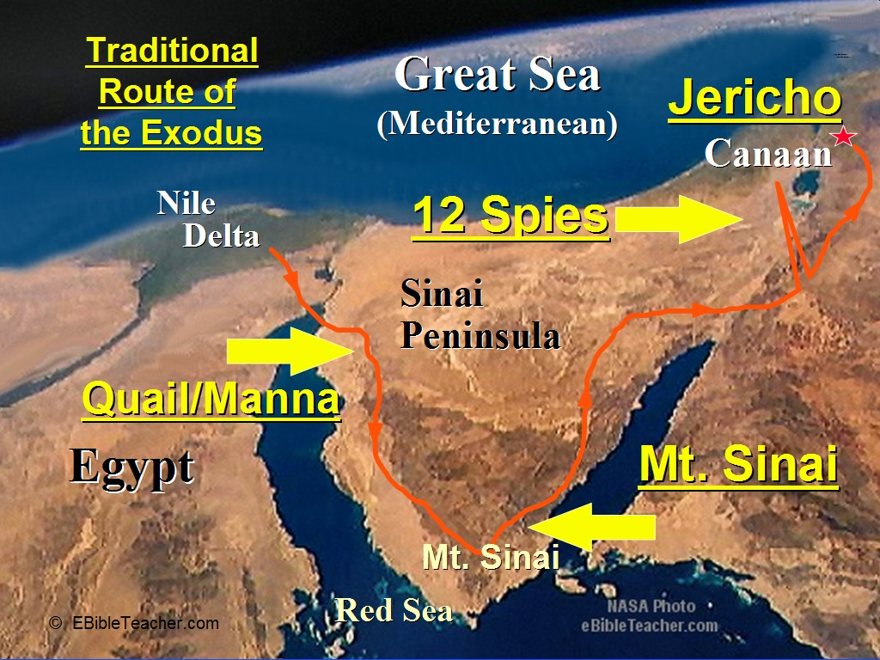

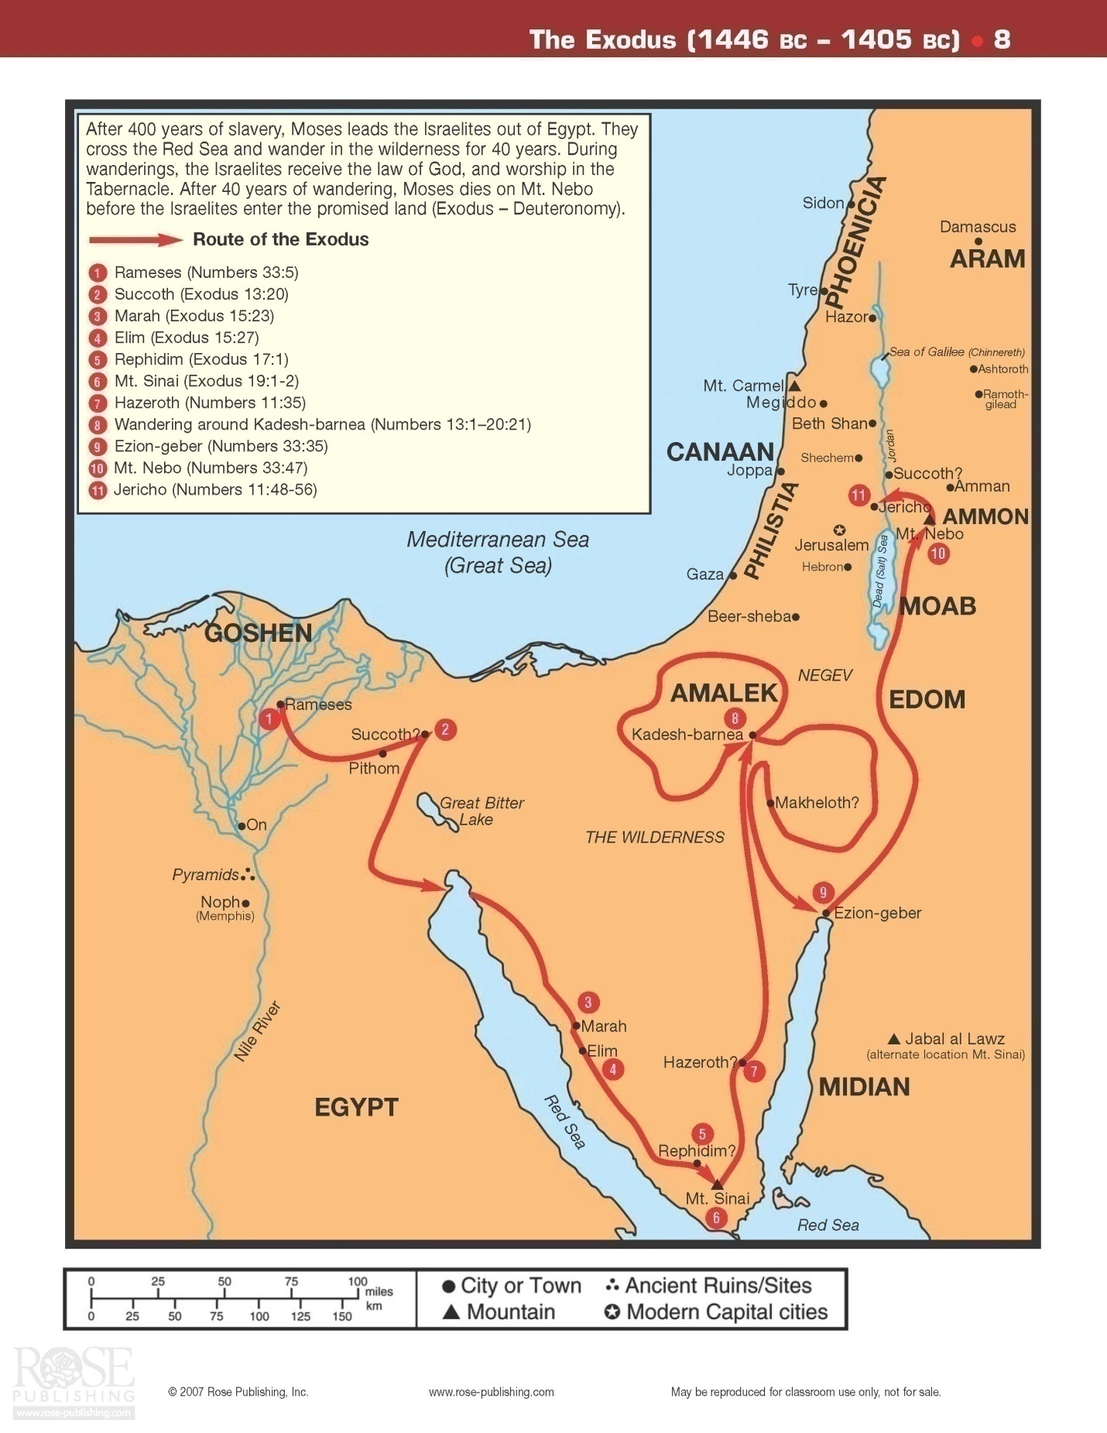

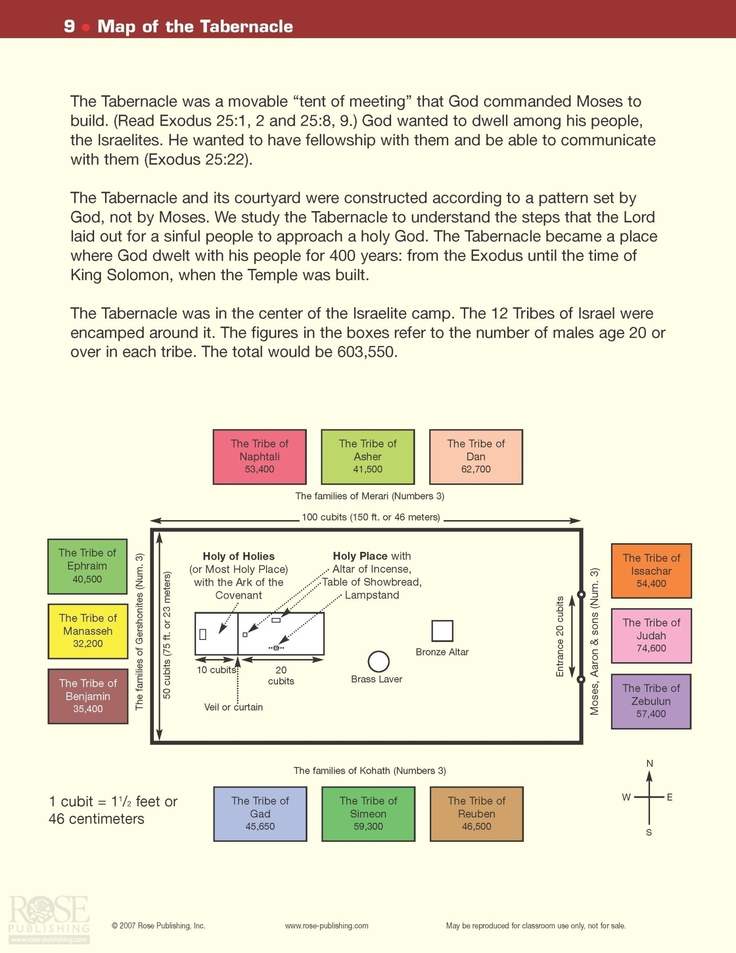
Leviticus:
This book concerns itself with giving detailed instructions describing the various offerings that the Lord gave to Moses. These include the following: Burnt Offering, Grain Offering, Peace Offering, Sin Offering, Trespass Offering, Offering of Restitution. Many laws concerning cleanliness are described in detail as well in this book. For example, the methods of dealing with lepers, unclean animals, bodily discharges, and more are covered.
One chapter explains the death of two of Aaron’s sons, Nadab and Abihu, as they offered “profane” offerings to the Lord. God was making the point that His laws and ways were to be followed to the letter, especially when it came to the method of worship from His priests. That was their total job and they had better do it correctly to demonstrate their faith.
The latter third of this book goes into additional laws of morality, the appropriate behavior for priests, rules for proper sacrificing of animals, and Sabbath laws.
Finally, a very important section is dealt with… the Feasts of Israel. Theses feasts are: Passover, Unleavened Bread, The Festival of Firstfruits, Festival of Harvest, Festival of Trumpets, Day of Atonement, Festival of Shelters. These feasts find their fulfillment thousands of years later in the life of Jesus Christ. For example, Passover speaks of Calvary………..Unleavened Bread speaks of the sinless body of Jesus……. Firstfruits foreshadows the resurrection……. Harvest speaks of the coming of the Holy Spirit at Pentecost………. Trumpets is likely marking the future Rapture……….the Day of Atonement points to Israel’s National restoration at the second coming at the end of the Tribulation …………. Shelters speaks of God living with His people during the Millineum.
The events in this book took place over a period of about one month paralleling the time noted at the end of Exodus. After the Law was given, God moved his people out toward Canaan.
Numbers:
This book begins with God directing that a census be taken of the people in a specific way. Following this, several chapters are used to describe the duties of the priests and Levites in addition to several more laws being given. Then it was time for God to move the Israelites … just after the second Passover:
Now it came to pass on the twentieth day of the second month, in the second year, that the cloud was taken up from above the tabernacle of the Testimony. And the children of Israel set out from the Wilderness of Sinai on their journeys; then the cloud settled down in the Wilderness of Paran. So they started out for the first time according to the command of the Lord by the hand of Moses. Num 10:11-13

As usual, some of the people began to complain about their circumstances and as usual Moses entreated God to forgive them. God once again did and He also provided a great feast of quail for them to eat. Soon thereafter God said to Moses, “Send some men to explore the land of Canaan which I am giving to the Israelites. From each ancestral tribe send one leader.” Numbers 13:1
So, Moses did send out a scouting party of twelve men from their encampment at Kadesh-Barnea. When they came back (after 40 days), ten men reported that there was no way that the Israelite army could defeat the powerful, large fortified cities in Canaan. Not only were the cities protected so well, many of the men were simply stronger and bigger than the Israelites. It would be a lost cause! Not so fast, said Joshua and Caleb. Caleb noted, “We should go up and take possession of the land for we can surely do it.” Numbers 13:30 Sad to say, the Israelite people sided with the nay-sayers and, although Joshua and Caleb pleaded with them that God would lead them to victory and to a land “flowing with milk and honey”, the people only talked of stoning them! Then God appeared at the Tabernacle, “The Lord said to Moses, ‘How long will these people treat me with contempt? How long will they refuse to believe in me in spite of all the miraculous signs I have performed among them? I will strike them down with a plague and destroy them, but I will make you into a nation greater and stronger than they.” Numbers 14:11-12
After much intercession by Moses, God forgave them again. Yet, He did note that no one over the age of 20 would ever set foot in the “Promised Land”, Canaan… except for Joshua and Caleb. Everyone else would wander in the desert until all had died and been buried. Only then, would their children be led across by Joshua to the ‘land of milk and honey’.
The forty years (one year for each day that they scouted out the land) that the Israelite tribes wandered in the desert are briefly described in the book of Numbers. A few of the more interesting developments are noted:
- The Edomites, Esau’s descendents, refused passage through their land
- Aaron’s authority was challenged by Korah in a brief rebellion. God caused Aaron’s staff to sprout blossoms and almonds on it as proof that God had given him authority to lead the twelve tribes
- The ashes of a Red Heifer were used for use in ceremonial cleansing when needed
- Miriam and Aaron died
- Moses gets punished by God when he strikes angrily at a rock to produce water… instead of gently touching it as ordered. His punishment was that he would only get to see the Promised Land, not enter into it.
- Eleazar, Aaron’s son, assumes the chief priest’s duties after the death of Aaron
- At one point on the journey, many people were dying from snake bites. They came to Moses for help. Then the Lord said to Moses, "Make a fiery serpent, and set it on a pole; and it shall be that everyone who is bitten, when he looks at it, shall live." So Moses made a bronze serpent, and put it on a pole; and so it was, if a serpent had bitten anyone, when he looked at the bronze serpent, he lived. Num 21:8-9 Very interestingly, this verse was seen by Jesus as a foreshadowing of His death on the cross

- Balaam, a diviner, was contracted to curse Israel. God made this impossible as every time Balaam opened his mouth to curse Israel, only blessings came out! One of these rants produced the following: "I see Him, but not now; I behold Him, but not near; A Star shall come out of Jacob; A Scepter shall rise out of Israel, and batter the brow of Moab, And destroy all the sons of tumult. Num 24:17 This was an allusion to Christ.
- God specified the boundaries of the land of Canaan for each of the twelve tribes. They did not possess all of this land yet, but God had it divided up. All they needed to do was to follow God’s lead and it would be theirs. For example, soon we shall see how easy this could be at Jericho.
Deuteronomy:
Forty years have passed and the Israelites are camped by the Jordon River ready to enter the Promised Land. Moses pointed out to the people that it was only an eleven day trip from Horeb to Kadesh-barnea. Yet, because of their fathers lack of faith, they had to wander in the desert for the past forty years! Now all of these older men had died. Moses continued to address these young Israelites as he explained the history of the nation to them, especially what had taken place since their sojourn in Egypt. After reviewing this history, Moses spent much time and wrote of the many laws and edicts that had been given to them by God. When these laws were completed, it was time for Moses to pass the torch of leadership to Joshua. He told the people that God had anointed Joshua to take his place as he was very old and, frankly, would die soon. Moses also told them that the Law was to be read at least every seven years at the Festival of Shelters. The Book of the Law was to be kept beside the Ark of the Covenant. Moses finished up by singing a song, The Song of Moses and blessing the people that he had so lovingly served for forty years. Then, he went up into Mount Nebo, where God allowed him to see the Promised Land before he died. God, Himself, buried Moses. Moses was given a beautiful eulogy:
But since then there has not arisen in Israel a prophet like Moses, whom the Lord knew face to face, in all the signs and wonders which the Lord sent him to do in the land of Egypt, before Pharaoh, before all his servants, and in all his land, and by all that mighty power and all the great terror which Moses performed in the sight of all Israel. Deut 34:10-12
Joshua:
At the conclusion of the forty years, God told Joshua to send out two spies to Jericho to evaluate the situation before their strike. Rahab, a former harlot, helped to hide them and later to escape to return to the Israelite camp. They reported to Joshua that the land was ready for the taking. As an important side note, Rahab later was to marry an Israelite and would become the great-great-grandmother of King David… and, of course, Jesus was also from her line as well!
Once Joshua heard from the spies, he brought all of the people to the Jordan River where they camped before crossing. With the Ark of the Covenant leading the way, they began to cross the Jordan River. God had told Joshua that when they stepped into the water, the river would dry up. As soon as the priests carrying the Ark and one man from each tribe stepped into the river, the Jordan progressively dried up so the people could pass to the other side. God had Joshua take the time to collect twelve stones to commemorate the crossing. Then Joshua set up twelve stones in the midst of the Jordan, in the place where the feet of the priests who bore the Ark of the Covenant stood; and they are there to this day. Joshua 4:9

Soon the twelve tribes had passed on to other side of the Jordon…. And those twelve stones which they took out of the Jordan, Joshua set up in Gilgal. Joshua 4:20 (another set of stones were planted as a memorial approximately one mile from the Jordon).

When the kings of the other nations heard of this wonder, they had no desire to fight the Israelites. Four significant events took place soon after the crossing:
- the men were circumcised. The ceremony of circumcision had temporarily halted during their wanderings in the desert
- the manna stopped appearing each morning… now they could eat of the land promised to them many years ago!
- The first Passover was observed in the Promised Land
- The Israelites now looked at Joshua as deserving a successor to Moses as their leader under God
And it came to pass, when Joshua was by Jericho, that he lifted his eyes and looked, and behold, a Man stood opposite him with His sword drawn in His hand. And Joshua went to Him and said to Him, "Are You for us or for our adversaries?" So He said, "No, but as Commander of the army of the Lord I have now come." And Joshua fell on his face to the earth and worshiped, and said to Him, "What does my Lord say to His servant?" Then the Commander of the Lord's army said to Joshua, "Take your sandal off your foot, for the place where you stand is holy." And Joshua did so. Joshua 5:13-15

The preceding verses almost certainly reveal a pre-incarnate appearance by Jesus to Joshua. Then God told Joshua how to march around the walls of Jericho (a very fortified city) for six days. On the seventh day, they were to march around seven times while blowing trumpets of ram’s horns in front of the Ark. With a loud shout, after the seventh trip around the wall, the wall would fall… and it did! Rehab and her family were saved… the others within the walls, were not. Joshua placed a curse on Jericho:
"Cursed be the man before the Lord who rises up and builds this city Jericho; he shall lay its foundation with his firstborn, and with his youngest he shall set up its gates." Joshua 6:26
This curse involved three things:
- Jericho would be rebuilt by one man – in 930B.C., a man named Hiel, from Bethel, began to rebuild Jericho
- His first son would die when he laid its foundation – his oldest son, Abiram, died during that time
- His youngest son, Segub also died when the gates were completed
Right after this victory, one of the Israelite men, Achan, took certain items from Jericho that had been forbidden by God. He wanted them for himself and thought that he could get away with it. Bad idea. The problem was discovered when Joshua recognized that something inexplicable was interfering with his men as they went out to fight against the men from Ai. He talked to God and was told that someone in Joshua’s midst was the problem:
"There is an accursed thing in your midst, O Israel; you cannot stand before your enemies until you take away the accursed thing from among you." Josh 7:13
The next morning, Joshua carefully interrogated the people and Achan did confess of his transgression. Unfortunately, this confession did not result in the sparing of his life. In fact, Joshua took him out and destroyed him, his family and possessions! This did result in God removing His impediment on the Israeli tribes and instead He supernaturally helped them defeat the city called Ai.
After the conquest of Ai, Joshua continued to rack up victories and land for the twelve tribes of Israel. He led them to victory in the south over the Amorites. Interestingly, a southern city named Gibeon finagled a non-aggression treaty out of Joshua. Men from this city dressed very shabbily and acted as if they had just travelled from a far-away land. In fact, this was only a ruse as they were local residents. However, this ruse resulted in Joshua making the treaty with them – thinking that they were from outside of the Promised Land. (God had prohibited the making of this kind of treaty with any peoples within the Land of Promise). Once made, however, the treaty was honored. This saved Gibeon from destruction at the hands of Joshua.
During the battle with the Amorites, Joshua commanded the sun to stand still:
"Sun, stand still over Gibeon; And Moon, in the Valley of Aijalon." So the sun stood still, And the moon stopped, Till the people had revenge Upon their enemies. Josh 10:12-13

Strangely, this is difficult for many Christians to accept. Why? If one can believe that God created the universe, rose from the dead, saved us from our sins, etc., it would be a “piece of cake” to make the sun stand still for a day or two!

After defeating the Amorites, Joshua was successful in subduing the remainder of the southern Canaanite resistance. He then headed north, defeated Hazor and killed its king. At this time, Israel controlled most of Canaan. Joshua was given Timnath-serah for his possession. Caleb was given Hebron as a special reward for his devotion to God forty year earlier (recall that he and Joshua were the only two men that proposed that the Israelites go in and take the Promised Land). The twelve tribes had the land divided up between them. This included the land that Moses had subdued earlier and the recent acquisitions by Joshua. Although not all of the land was under complete control by each of the tribes, the land was divided up between them. It would be the responsibility of each tribe to gain control of that portion of land still in the hands of a foreign power… with the help of its brother tribes. The Levites were promised certain cities throughout the land. Reuben, Gad and one-half of the tribe of Manasseh returned to the eastern side of the Jordon River after their noble help in war for their brothers.

Joshua left his countrymen with a wonderful speech/sermon just before his death. He reminded them how God had given them so very much as they followed Him and obeyed His commandments. He told them that if they remained faithful, God would soon give them the remainder of their Promised Land. Joshua told them never to associate with the other nations that they were conquering… never to adopt any of their customs or beliefs. Never, ever worship any other god! He told them if they did, God would use these nations as traps for the Israelites.
At the conclusion of the book of Joshua and Joshua’s life, God once again confirmed His covenant with His people through the words of Joshua. The people stated that they would remain faithful. Joshua cautioned them repeatedly to be careful not to turn their backs on God. He died at 110 years old. The Israelites did remain faithful throughout his lifetime and for some time after his death. Joshua was buried in the Promised Land. Joseph’s bones were also buried there as they had been brought up from Egypt when they escaped about 70 years earlier.

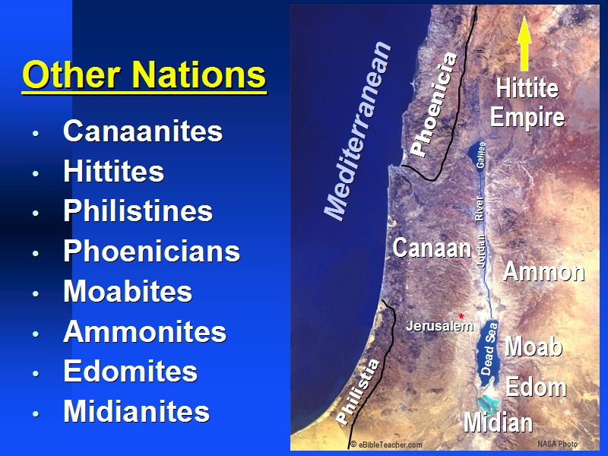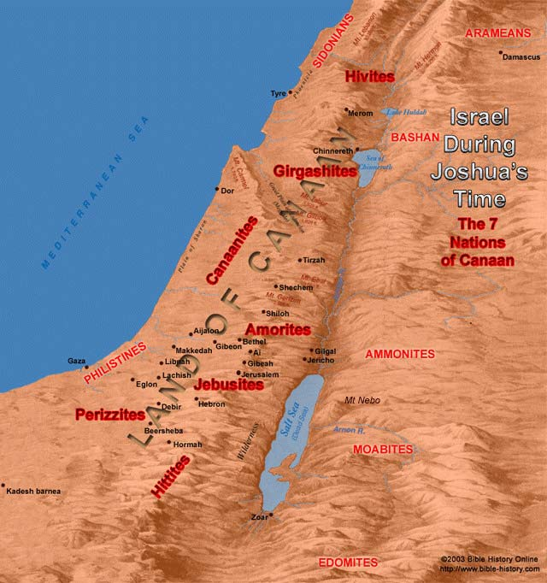

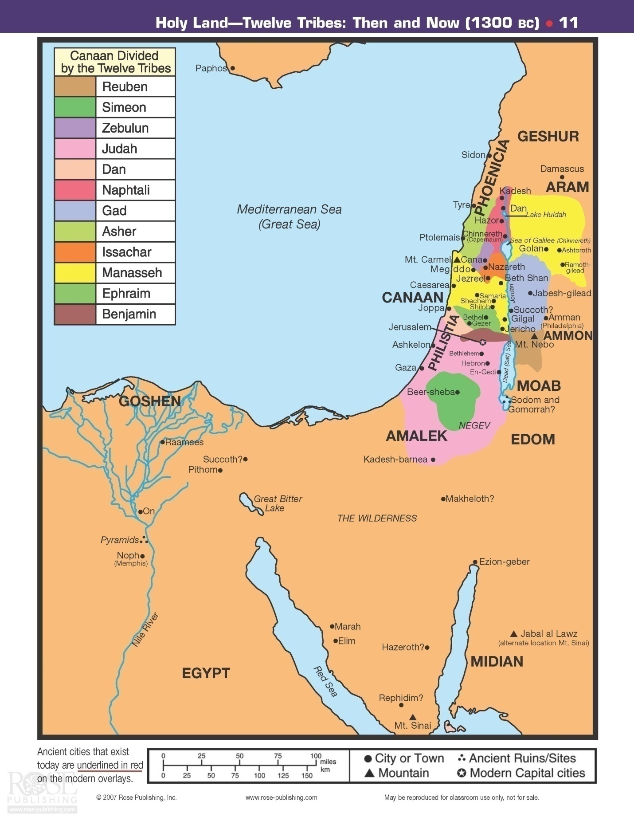
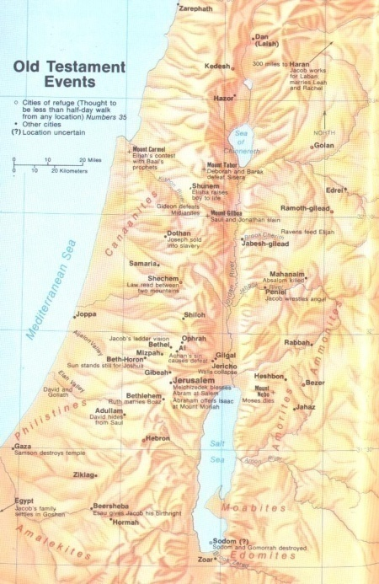
The Judges Stage
After Joshua’s death, Israel entered into one of their darkest time periods in their history… this is called the Judges Stage. There no longer was one great man of God who was in control of the twelve tribes… as were Moses and Joshua.
Initially, God used the tribe of Judah to go up against the Canaanites. With the help of his brother, Simeon, Judah was able to defeat the Canaanites and the Perizzites. Soon after this, they went and took control of Jerusalem. Some time later, the city of Jerusalem was lost until it was re-captured by King David a couple hundred years later. Judah continued his conquests which included Debir and Hebron. Simeon continued his allegiance to Judah as they both led their men to victories over Gaza, Ekron and Ashkelon. The other tribes were also going forward attempting to gain control of the land they had been promised. All did make strides in this direction, but all these tribes unfortunately allowed remnants of the foreign peoples to remain. These foreigners continued with their pagan Baal worship. This would result in terrible consequences for the “Chosen People”.
Within one generation after the death of Joshua, the people “knew neither the Lord nor what He had done for Israel. Then the Israelites did evil in the eyes of the Lord and served the Baals. They forsook the Lord, the God of their fathers, who had brought them out of Egypt. They followed and worshipped various gods of the people around them” Judges 2:10-12 As Joshua had foretold, God then allowed the idolatrous nations to successfully raid and defeat the Israelites in various places. They worshipped Baal and Canaanite goddesses, called the Ashtoreths.
Then the Lord raised up judges, who saved them out of the hands of these raiders. Judges 2:16
This period of Israel’s history spanned approximately 300 years. It involved seven apostasies on Israel’s part and seven periods of servitude to seven heathen nations. Throughout this time, there were fifteen judges in all. They served primarily as military reformers. Four times it is noted in this book that “In those days was no king in Israel; every man did that which was right in his own eyes.”
It is simple to see what the problem was: They did what was right in their eyes… not in God’s eyes. They compromised their position and intermingled their beliefs and comingled with those heathen nations that God had allowed them to conquer. They, worst of all, began worshipping other gods.
Here is list of the Judges: Othniel, Ehud, Shamgar, Barak, Gideon, Tola, Jair, Jephthah, Ibzan, Elon, Abdon, Samson, Deborah, Eli, and Samuel
Each judge ruled for many years and the book of Judges discusses their successes and failures.
After allowing Israel to be oppressed for eight years due to their sin, God raised up Othniel, Caleb’s nephew, to lead them over their Mesopotamian oppressor and into a forty year period of peace. After another dark period due to Israel’s sin, Ehud was able to hatch a plan allowing him to kill the Moabite king, Eglon, and subsequently led Israel over the Moabites. This was the pattern during this time of the judges… a time of proper worship, peace and prosperity, followed by a time of forgetting the God of their fathers which always resulted in their loss of independence.
Note that one of the judges was a woman, Deborah. She ruled along with Barak and together they conquered, with the help of God, Sisera, the captain of King Jabin’s army (the king of Canaan). Barak was the military leader that Deborah called for this task. These two Israelite judges got a little help from an unlikely source. When Sisera fled the advancing Barak, he went to the tent of the wife of his friend, Heber the Kenite. She treated Sisera kindly and gave him every impression that she would hide him from the Israelite army. But, she instead drove a tent peg into his temple! Nice lady. With his general dead, King Jabin soon surrendered. God had delivered up the king of Canaan to his people. So the land once again had rest for forty years. Unfortunately, as was always the case eventually, the Israelites soon did “evil in the sight of the Lord; and the Lord delivered them into the hand of Midian seven years.” Judges 6:1
Once again, as they fell under the oppression of the Midianites, the Israelite people cried unto God for a deliverer. God provided an interesting way out… through a man named Gideon. The Angel of the Lord called Gideon to lead his people to victory over the Midianite-Amalekite-Arab alliance. We learn a little about “throwing down a fleece” when this story is studied. At first, Gideon was perplexed when confronted by the Angel of the Lord. He wasn’t sure of what he saw and heard. Gideon asked for a sign that it really was a message from God. The answer came when the Angel of the Lord caused a fire to come out of a rock and consume meat and unleavened bread Gideon had previously placed on the top of this large rock. Thus convinced that God was at work, he built an altar there. That same night, God told him to cut down the altar to Baal and use the wood from the wooden image next to this altar and offer a burnt sacrifice to the one true God. Well, Gideon complied. The next morning, the men of the city went to Gideon’s father, Joash, and said, “bring out your son, that he may die.” Judges 6:30 Joash answered as one would hope he would, “If he (Baal) be a god, let him plead for himself.” Judges 6:31
While this was going on, another problem was brewing. The Midiantes, Amalekites and other peoples from the East were gathering after crossing over into the Valley of Jezreel. Gideon was moving to bring victory to his people. At this time, Gideon asked God if He would please show him that He planned to bring Israel victory through Gideon’s leadership by giving him a sign. God agreed to this request. Gideon would throw out a fleece on the grass. If only the fleece was wet in the morning from dew, but the surrounding land was dry, Gideon would know that God was in this plan. The next morning, the fleece was very wet, the land was dry. Then Gideon asked if God would do just the opposite for the next morning. God did this as well for a sign to Gideon. Now it was very obvious that Gideon was God’s man to lead Israel over the foreign powers.
Summarizing the campaign, God whittled down Gideon’s army from 22,000 to 300 men. God wanted the enemy, and Israel herself, to know for sure it was God who delivered the victory. When the combatants were 300 Israeli troops to tens of thousands of the enemy troops, God was ready for war. With the use of trumpets, torches and empty pitchers … and most of all surprise, God quickly routed the enemy. Gideon then chased the Midianites across the Jordon River as they ran in retreat. Although Gideon asked for some food from two Israeli cites during this chase, they refused to help. Eventually however, Gideon caught up to the two Midian kings, Zebah and Zalmunna. He took them captive and crushed the remaining army. Gideon did not go easy on the two cities that had denied him aid.
So God had used Gideon to lead Israel to victory over the Midianites and Amalekites and other eastern forces. As often was the case after stirring victories during these times, the people enjoyed peace for forty years. Then, Gideon died and the people reverted back to Baal worship once again. Unfortunately, “as soon as Gideon was dead, the children of Israel turned again, and went a whoring after Baalim and made Baal-Berith their god.” Judges 8:33
A very murderous reign directly followed Gideon’s death. His son by a Shechem concubine, Abimelech, talked his way into power. He arranged to kill his competition, the 70 sons that Gideon had from his many wives. One son hid himself and survived, the youngest son, Jotham. He predicted, through a parable, that eventually Abimelech and the Shechemites would kill one another. This happened a few years later.
Approximately six additional judges came on the scene for Israel before one of the more famous made his appearance. Samson. In fact, he may well be the most well-known of all the judges. Most everyone knows this story to some degree. Samson was a Nazarite with God given supernatural strength. A Nazarite was a man that had vowed certain things to God – either for a lifetime or for a specified period of time. Three things in common among all Nazarites were: they would not cut their hair, they would abstain from wine, and they would avoid contact with dead bodies. Even as a child, at times Samson felt the spirit of the Lord move within him.
In Old Testament times, the Holy Spirit did not come into a person and live for their entire earthly life as now happens when one accepts Christ as Savior. Instead, the Holy Spirit would intermittently come upon a person and give them extra power and knowledge for varying periods of time. It would take Christ’s great sacrifice before people would have the great privilege of having the Holy Spirit as their constant companion. Of course, we must learn to yield to God’s Spirit in order to live the life that He has designed for us.
During Samson’s early life, the Philistines had dominion over the Israelites. Samson co-mingled with them early on in his adult life and married a girl from Timnath, a Philistine woman… which was against Mosaic Law. Yet, God used this sinful act to eventually lead Samson in an uprising against these same Philistines – an example of God’s providential care. Using treachery, the Philistine men answered a riddle (concerning a lion and honey) that Samson had given them at his seven day wedding feast resulting in the loss of some material goods and some of Samson’s pride (Samson’s new wife told them the answer as the men threatened to burn down her father’s house otherwise).
"Out of the eater came something to eat, and out of the strong came something sweet." Judges 14:14 (This was alluding to honey within a honeycomb in the lion’s carcass)
The way that he was treated at his wedding feast and the fact that he lost his bet to these men angered Samson to an incredible degree. In fact it caused him to go down to Ashkelon and kill thirty men in order to give their clothes and belongings to those men who had answered his riddle Even worse, when Samson returned to the home of his bride, her father had already given her to the best man! These significant slights against Samson caused him great anger towards the Philistine people. With God’s supernatural help, Samson defeated singlehandedly a thousand men with a jawbone of a donkey and put the remaining Philistine men to route. Over the next twenty years, Samson remained a judge for the Israeli people as they apparently lived in relative peace in this area of Canaan. Then, however, Samson’s actions resulted in his fall from grace. His physical desires led him first to a harlot in Gaza where he was attacked but was able to escape, again due to his superior strength. Then, he met Delilah. The famous story of Samson and Delilah then played out and resulted in his downfall, capture and blinding. He was bound with bronze shackles and set to grinding in the prison. A repentant Samson finally triumphed at the end of his life when, his hair re-grown, a symbol of his repentant spirit, he prayed to the Lord, “Oh sovereign Lord, remember me, oh God, please strengthen me just once more, and let me with one blow get revenge on the Philistines for my two eyes. Then Samson reached towards the two central pillars on which the temple stood……. Samson said, let me die with the Philistines! Then he pushed with all his might, and down came the temple on the rulers and all the people in it. Thus he may have killed more when he died than while he lived.” Judges16:28-30
The final story related in the book of Judges concerns an atrocious crime in the town of Gibeah, near Bethlehem. Under duress, a man allowed his concubine to be raped repeatedly by several men from the tribe of Benjamin just outside his house. The following morning he found her on his doorstep, dying. After her death, he cut her up into twelve pieces and delivered one section to each of the twelve tribes of Israel. He did this horrible thing as he wanted each tribe to know exactly what the Benjamites had done. It certainly made an impression! The eleven other tribes sent a total of 400,000 men to challenge the tribe of Benjamin to turn over the guilty men. They refused. The other twelve tribes declared war and when all was finished, the tribe of Benjamin had only 600 warriors remaining. When it was discovered that the city of Jabesh-Gilead had not joined in the fight against the Benjamites, the eleven tribes killed the men of this city. That left approximately 400 women that were given as future wives to the 600 remaining men from the tribe of Benjamin. With this remnant, this tribe was able to re-populate over time.
During the course of these three hundred years, the various judges listed above had varying success at keeping the Israelite tribes in control over their respective portions of Canaan allotted to them. As mentioned earlier, this was a dark time in the history of God’s promised people. In fact, as has been seen from the examples above, it is quite amazing how far that mankind can sink into perversion when they forget God. This happens even when they ostensibly are following the false gods of any other religion. Those gods are simply non-existent, if not worse (i.e. demons). At first thought, it may be a little difficult for us to fathom how low people can sink. Yet, just take a moment to think about all of the atrocities that still take place in our world today.
Although the twelve tribes added to their land when they were following the Lord, they spent far too much time out of His will while adopting the customs and even, at times, worshipping the gods of the prior inhabitants of the land of Canaan. God continued His practice of blessing his people when they were true to Him, and punishing them when they fell away. This, He still does today.
At the conclusion of this time period, a young man named Samuel came on the scene who was used by God to establish the period of Kingship in Israel – which, although is currently in hiatus, will actually never end. Before getting into a study of Samuel and the kings of Israel, let’s take a brief time to discuss one other important character from the Old Testament; Ruth, who lived in the time of the judges.
The book Of Ruth: Ruth was a Moabite who lived during these times of Judges. During a famine, a Bethlehem citizen, Elimelech, travelled to Moab with his wife Naomi and their two sons. The two sons married – Ruth (means friendship) married one, and a young woman named Orpah (means stubborn) the other. Unfortunately, soon the two sons and Elimelech died. Naomi decided to go back to her native land of Palestine. Ruth accompanied her even though Naomi felt it best for her to stay in her homeland. Orpah decided to stay behind. Ruth said, “… whither thou goest, I will go; and where thou lodge, I will lodge. Thy people shall be my people, and thy God my God…. Ruth 1:16-17
After a very difficult trip, Naomi and Ruth arrived back in Palestine. Naomi was so disillusioned, she told her neighbors to call her Mara (which means bitter). Ruth went out to glean wheat to help provide for their food. God’s providential care brought her into a meeting with a relative of Elimelech, a kindly older gentleman named Boaz. They eventually married and had a son named Obed. Obed was the grandfather of King David! God works in mysterious and wonderful ways.
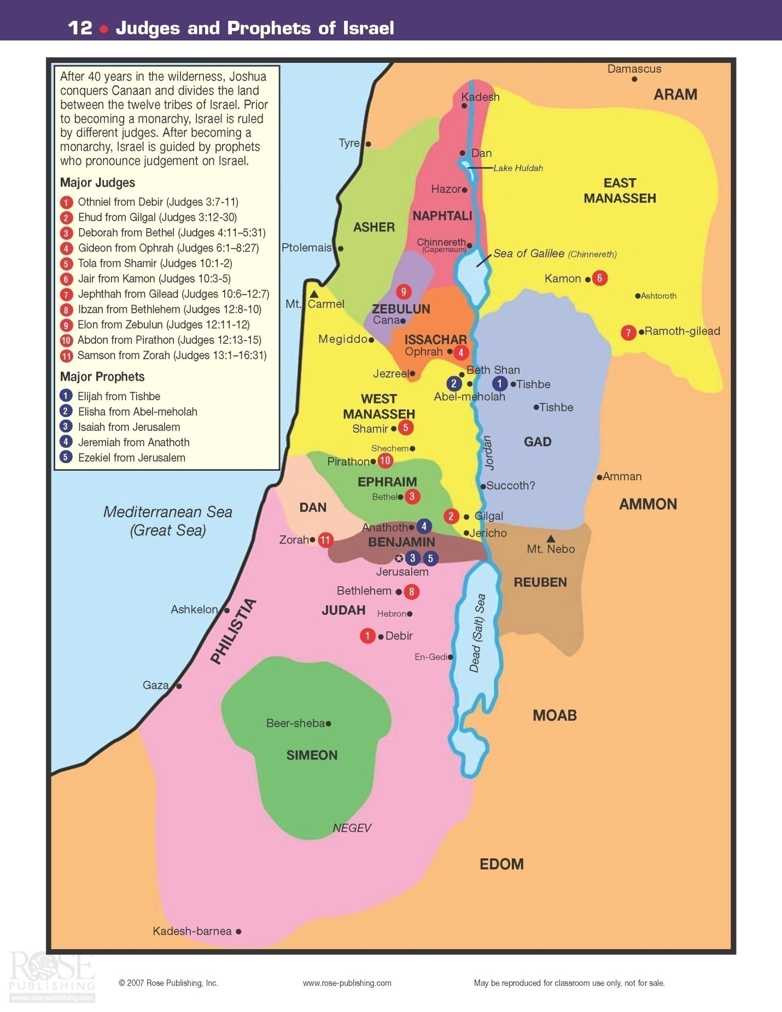

1 Samuel:
Samuel was the last of the judges.
There are two different views with respect to the date of the Exodus from Egypt. Traditionally, it is believed to have occurred in 1446 B.C.. Yet, there are some theologians who believe the date was closer to 1296 B.C.. There is definitely more consensus regarding specific dates as the period of Judges comes to a close. Samuel was born in, approximately, 1105 B.C.. As we shall see, he ushered in the time of kings to the people of Israel. He not only was a judge, but also was a prophet… he also started a school for future prophets as well.
The book of 1 Samuel opens in approximately 1105 B.C.. “There was a certain man from Ramathaim, a Zuphite from the hill country of Ephraim, whose name was Elkanah…, an Ephramite. He had two wives, one was called Hannah and the other Peninnah. Peninnah had children, but Hannah had none.” 1 Samuel 2:1-2
Another man named Eli had two sons, Haphni and Phineas who were priests at Shiloh. “Eli’s sons were wicked men; they had no regard for the Lord.” 1 Samuel 2:12
Hannah was barren and this was extremely depressing for her. Her husband sympathized with her as he loved her very much. One day at the Tabernacle in Shiloh, after once again weeping and praying, Hannah vowed “O Lord Almighty, if you will only look upon your servant’s misery and remember me, and not forget your servant but give her a son, then I will give him to the Lord for all the days of his life, and no razor will ever be used on his head.” 1 Samuel 1:11 Hannah was promising to God that if He would supernaturally “open up her womb” and give her a son, she would raise him as a Nazarite and give him to the Lord for lifelong service. Two other famous Nazarites were Samson and John the Baptist. As noted earlier, a Nazarite was a man that demonstrated certain specific characteristics: refrained from wine, did not cut hair on his body, and avoided contact with the dead. Eli heard her prayer and told Hannah that God would honor her request. God did grant Hannah’s prayer request and she bore a son, Samuel… born in approximately 1105 B.C.. Hannah “gave him to the Lord” as she had promised.
While Samuel was still a boy, Eli’s two sons sinned greatly in the eyes of God while performing their priestly duties. A certain man of God came to Eli and warned him that because of the perverted deeds of his sons, God was going to cut them off from their position as priests of Israel. Although they were Levites and God had given them a special place in His worship, God was not going to continue to honor those who dishonored Him:
'Far be it from Me; for those who honor Me I will honor, and those who despise Me shall be lightly esteemed. Behold, the days are coming that I will cut off your arm and the arm of your father's house, so that there will not be an old man in your house. 1 Sam 2:30-31

At the same time, the Lord was preparing the boy Samuel for very important duties as a judge and prophet over Israel. Samuel was a Levite and, as an adult, served God as a priest along with performing the duties of his other offices. One night while lying down in the Temple of the Lord (where he served the Lord), where the Ark of God was, the Lord called Samuel. Samuel answered, “Here I am.” (1 Samuel 3:4) However, Samuel mistakenly thought that this voice was from Eli who was lying down in another place in the temple. He ran to Eli three times asking what Eli wanted before the wiser Eli realized that it was the Lord who was calling for the boy. He instructed Samuel to go back and say, “Speak, Lord, for you servant is listening.” (1 Samuel 3:9) After doing this, God delivered verbally to Samuel His plan for judgment against Eli’s family (for their sins) that would come in the near future. When Eli firmly requested that Samuel reveal God’s message, Samuel did tell Eli the bad news, Eli replied, “He is the Lord; let Him do what is good in His eyes.” (1 Samuel 3:18)
Soon after this, the Philistines attacked and captured the Ark of the Covenant and took it with them. History suggests that it never returned to Shiloh and that Shiloh may have been destroyed by the Philistines around this time. Nob would later replace Shiloh as the Israeli city of priests and worship. During the battle, Haphni and Phinehas were killed. When Eli heard this news, he died suddenly. He was 98 years old and had helped lead Israel for 40 years.
The Ark of the Covenant became a terrible curse for the Philistines. For example, the idol of Dagon fell down, as if in a position of worship, when the Ark was brought near. From Ashrod to Gath, from Ekron to Beth-Shemesh, destruction and plagues followed the unrighteous holders of the Ark. For this reason, not long after its capture, the Philistines gave up possession of the Ark. They hatched a plan that would allow them to be totally sure that it was the power of the Israeli God that was causing them all their recent ills. They would hitch up two milk cows to the Ark and send it on its way back to the Israeli city, Beth Shemesh. If the cows took it to the city, it would demonstrate that this God of Israel was indeed behind all the heartache that they had received by virtue of stealing the Ark. Why? Because two milk cows would not be expected to go all the way to that town unless a supernatural power directed them. The cows did take the Ark to Beth Shemesh! Unfortunately for the people in that city, thousands looked into the Ark – this was strictly prohibited by God. Therefore these people were instantly killed. This devastation of the city’s population caused the town elders to ask the men from Kirath-Jearim to come and claim the Ark. It was then brought to Kirath-Jearim where it remained until its eventual move to Jerusalem by David.
As Samuel grew into manhood, he assumed the role of judge and prophet. He convinced the Israelites of the necessity to turn away from their idols and turn back to God. He gathered them together at Mizpah for prayer and worship. Samuel prayed for Israel and God honored the prayers of Samuel and the people. Soon thereafter, the Philistine attacked but God led Israel to victory and even pushed back the Philistines from land that they had previously taken. “Throughout Samuel’s lifetime the hand of the Lord was against the Philistines.” 1 Samuel 7:13 He led the Israelites to peace with their neighbors and restored much of the land that previously had been captured. He continued as judge and prophet all the days of his life travelling a circuit from Bethel to Gilgal to Mizpah from year to year… always returning to his home in Ramah. Peace was in the land for the rest of his life.
As he grew old, he appointed his sons as new judges over Israel. Unfortunately, they were not good men and were rejected by the elders. They now wanted a king to lead them, just as their surrounding nations had.
This displeased Samuel because he realized that the Lord was, in fact, the King over all Israel. However, he took this issue to the Lord in prayer… “And the LORD said unto Samuel, Hearken unto the voice of the people in all that they say unto thee: for they have not rejected thee, but they have rejected Me, that I should not reign over them. According to all the works which they have done since the day that I brought them up out of Egypt even unto this day, wherewith they have forsaken me, and served other gods, so do they also unto thee. Now therefore hearken unto their voice: howbeit yet protest solemnly unto them, and shew them the manner of the king that shall reign over them.” 1 Sam 8:7-10
Then Samuel went and warned the people about the problems that a reign of kings would bring to the nation of Israel. Unfortunately, the people refused to listen and said… “We want a king over us. Then we will be like all the other nations, with a king to lead us and to go out before us and fight our battles.” (1 Samuel 8:19-20) Sadly, they had forgotten the reason they escaped from Egypt and had been brought in to their promised land to possess and occupy it… that reason was and is the only true king, God. God then relented and told Samuel, “Listen to them and give them a king.” 1 Samuel 8:22
Now there was a man of Benjamin, whose name was Kish, the son of Abiel, the son of Zeror, the son of Bechorath, the son of Aphiah, a Benjamite, a mighty man of power. And he had a son, whose name was Saul, a choice young man, and a goodly: and there was not among the children of Israel a goodlier person than he: from his shoulders and upward he was higher than any of the people. 1 Sam 9:1-2

Through God’s providential care, Saul was named Israel’s first king (in 1051 B.C.) via a selection process engineered by Samuel. This selection was confirmed to Saul via three very detailed signs that he would see while walking through the land. At the conclusion of his walk, God’s Holy Spirit would change him into a man more worthy to be king of Israel. After all these things took place, Saul went to Gilgal and awaited Samuel’s appearance.
After initially being reluctant to be presented to the people, Saul finally was announced as their first king by Samuel in a ceremony at Mizpah. The people shouted, “ Long live the king.” (1 Samuel 10:24) A few initially questioned this selection. However, after Saul led the Israelites to a stunning victory over the Ammonites, he was strongly supported as king.
Saul was thirty years old when he became king, and he initially followed Samuel’s counsel… that is, the Lord’s direction. Unfortunately, later in his reign he took it upon himself to disregard specific instructions from Samuel (that is, from the Lord) in another battle against the Philistines. He was supposed to await the arrival of Samuel to offer a burnt offering to the Lord. He did wait for seven days, but then became impatient. Saul went ahead and did make the offering himself. Unfortunately, Saul was a king, not a priest. This resulted in the following edict from the Lord through Samuel, “Thou hast done foolishly: thou hast not kept the commandment of the LORD thy God, which he commanded thee: for now would the LORD have established thy kingdom upon Israel for ever. But now thy kingdom shall not continue: the LORD hath sought him a man after his own heart, and the LORD hath commanded him to be captain over his people, because thou hast not kept that which the LORD commanded thee.” 1 Sam 13:13-14
Although God had literally spoken, Saul continued for many years to lead Israel in numerous victories and take control of larger and larger sections of the “promised land”.
And there was sore war against the Philistines all the days of Saul: and when Saul saw any strong man, or any valiant man, he took him unto him. 1 Sam 14:52
Samuel also said unto Saul, The LORD sent me to anoint thee to be king over his people, over Israel: now therefore hearken thou unto the voice of the words of the LORD. Thus saith the LORD of hosts, I remember that which Amalek did to Israel, how he laid wait for him in the way, when he came up from Egypt. Now go and smite Amalek, and utterly destroy all that they have, and spare them not; but slay both man and woman, infant and suckling, ox and sheep, camel and ass. 1 Sam 15:1-4
Saul went out and led Israel to a resounding victory over the Amalikites. Sadly, however, he did not follow God’s specific instructions to destroy all that they had… “But Saul and the people spared Agag, and the best of the sheep, and of the oxen, and of the fatlings, and the lambs, and all that was good, and would not utterly destroy them. 1 Sam 15:9
Saul admitted his sin and begged for forgiveness from Samuel. Samuel certainly felt sorry for Saul and apparently forgave him. God, however, did not rescind his rejection of Saul as king.
Soon after this episode, Samuel was called by God to go into Bethlehem to the home of Jesse where he would find God’s selection for the next king of Israel. Upon arrival, Samuel was introduced to seven of Jesse’s sons. Although the eldest son Eliab was tall and regal in appearance, neither he, nor any of the other sons present, was God’s choice. As the Lord said, “the LORD seeth not as man seeth; for man looketh on the outward appearance, but the LORD looketh on the heart. 1 Sam 16:7-8
Finally, Jesse sent for his youngest son, David, who was out in the fields tending sheep. “He was ruddy, with a fine appearance and handsome features. Then the Lord said, ‘Arise, anoint him: for this is he.’ Then Samuel took the horn of oil, and anointed him in the midst of his brethren: and the Spirit of the LORD came upon David from that day forward.” 1 Sam 16:12-13
Note that David was visited by the Holy Spirit as had Saul before him.
Soon thereafter, David was summoned by Saul to comfort the king by playing his harp. Later, David would compose many songs that would be saved for us to read and sing in the Psalms. Saul came to like David very much.
Not long after this introduction to King Saul, David found himself at the base camp of Saul’s army as the Israelites were stymied by the powerful giant Goliath… the champion of the Philistine army. The challenge from Goliath was for a duel between the Israelite champion and himself. To the winner would go the victory for the entire battle! No one seemed to have the courage to meet Goliath in battle… that is until David, a boy, told King Saul that he could handle the job. “Thy servant kept his father's sheep, and there came a lion, and a bear, and took a lamb out of the flock: And I went out after him, and smote him, and delivered it out of his mouth: and when he arose against me, I caught him by his beard, and smote him, and slew him. Thy servant slew both the lion and the bear: and this uncircumcised Philistine shall be as one of them, seeing he hath defied the armies of the living God.” 1 Sam 17:34-36
So David went out to face Goliath. He at first put on Saul’s battle gear, but was unable to comfortably wear it… so, he took it off. With God’s hand on him, he defeated and beheaded the Philistine champion and ushered in complete victory that day to the Israelites. David, of course, became a hero to the people. “Saul hath slain his thousands, and David his ten thousands.” 1 Sam 18:7
This caused marked jealousy in King Saul. David continued to be blessed by God in his service to Saul and as a leader of the army. This continued success increased Saul’s jealousy and hatred toward David. He hoped that David would fall in battle. He also decided that he would increase those chances. At first he offered his daughter Merab in marriage if David fought and killed many Philistines. He did kill the Philistines, but that offer fell through… she had married someone else. He next offered David another daughter in marriage (Michal, who loved David) if David would kill one hundred Philistines. David killed two hundred and did marry Michal. All these successes simply resulted in Saul being more jealous of David.
Saul continued his attempts to kill David. On one attempt, Michal saved David from men that Saul had sent out to kill him. Saul’s son, Jonathan, loved David like a brother. So far, it had not become blatantly obvious to Jonathan that his father really was planning to kill his best friend, David. David was aware of this, but he decided to propose a test that would allow Jonathan to know for sure… one way or the other. David would not show up for a planned banquet. Saul’s reaction to this would reveal to Jonathan the real truth concerning this issue. Saul did indeed let his feelings be known. He was so angry that he almost killed his own son, Jonathan! Jonathan got away from that difficult situation and signaled that David was indeed right… Saul was out to kill him!
After this encounter, David and Jonathon reaffirmed their covenant of friendship and went their separate ways. David began his life as a fugitive. One of the first places he went for food and shelter was in the land of Nod. He had a few trusted men with him. The only food available was the holy bread. David convinced the priest, Ahimelech, to give them this bread. David did not tell the priest that he was being hunted by Saul as he was not sure that Ahimelech could be trusted. There was another man there that saw David and his little band of men, a man named Doeg, an Edomite, the chief of the herdsmen who belonged to Saul. 1 Sam 21:7 Later this would prove to be a problem for the priests as Doeg would reveal this visit by David to Saul.
After taking the sword of Goliath for his own (as it was on display there in Nod), David headed off to his next stop. He first tried to see if he could find refuge in Philistine territory from Achish the king of Gath. Unfortunately, fearing he had been recognized, he quickly feigned madness in order to escape. This worked.
The next stop was an escape to the cave of Adullam. When his family heard of his whereabouts, they came to see him. They were also in trouble now as they were related to David. David, fearing for their lives, took them east to the land of Moab, where his great grandmother, Ruth, was born. He asked these folks to watch over his family until it was safe for their return. David returned to Israel to continue his life on the run. As the months went on, David had more and more men come over to his side and join his fledgling “army”. At one point, Jonathon visited David in the wilderness of Ziph where David hid out in the forests and caves. That would be their final meeting.
For the remainder of Saul’s life, he attempted to find and kill young David. David successfully eluded the king and, over time, raised a fairly large contingent of soldiers/followers himself. At one point, God delivered King Saul into David’s hands, giving him an opportunity to kill his pursuer. This happened in a cave in the Wilderness of En Gedi where David and some of his men were hiding out. Saul stopped in to “attend to his needs”. David let Saul escape but did cut off the hem of his robe to let Saul know that David could have killed him. When Saul realized that David had spared his life, he wept and said, “Thou art more righteous than I: for thou hast rewarded me good, whereas I have rewarded thee evil. And thou hast shewed this day how that thou hast dealt well with me: forasmuch as when the LORD had delivered me into thine hand, thou killedst me not. For if a man finds his enemy, will he let him get away safely? Therefore may the Lord reward you with good for what you have done to me this day. And now I know indeed that you shall surely be king, and that the kingdom of Israel shall be established in your hand. Therefore swear now to me by the Lord that you will not cut off my descendants after me, and that you will not destroy my name from my father's house." So David swore to Saul. And Saul went home, but David and his men went up to the stronghold. 1 Sam 24:17-22
Saul returned home after this encounter. Unfortunately, Saul soon continued his quest to eliminate David. Of course, he never succeeded. On at least one other occasion, David spared Saul’s life when he could have taken it. David thought to himself, “I shall now perish one day by the hand of Saul: there is nothing better for me than that I should speedily escape into the land of the Philistines; and Saul shall despair of me, to seek me any more in any coast of Israel: so shall I escape out of his hand. And David arose, and he passed over with the six hundred men that were with him unto Achish, the son of Maoch, king of Gath.” 1 Sam 27:1-2
So, for the remainder of Saul’s life he sought to add to his conquests as David and his men resided in the land of the Philistines. They stayed there for more than one year. In fact, the Philistine leader, Achish, came to admire David even making him his bodyguard. David had led Achish to believe that he was raiding Israelite outpost territory. Actually, he was raiding other foreign strongholds instead.
After Samuel had died, King Saul had a very unusual experience:
Now Samuel had died, and all Israel had lamented for him and buried him in Ramah, in his own city. And Saul had put the mediums and the spiritists out of the land. Then the Philistines gathered together, and came and encamped at Shunem. So Saul gathered all Israel together, and they encamped at Gilboa. When Saul saw the army of the Philistines, he was afraid, and his heart trembled greatly. And when Saul inquired of the Lord, the Lord did not answer him, either by dreams or by Urim or by the prophets. Then Saul said to his servants, "Find me a woman who is a medium, that I may go to her and inquire of her." And his servants said to him, "In fact, there is a woman who is a medium at En Dor." So Saul disguised himself and put on other clothes, and he went, and two men with him; and they came to the woman by night. And he said, "Please conduct a seance for me, and bring up for me the one I shall name to you." Then the woman said to him, "Look, you know what Saul has done, how he has cut off the mediums and the spiritists from the land. Why then do you lay a snare for my life, to cause me to die?" And Saul swore to her by the Lord, saying, "As the Lord lives, no punishment shall come upon you for this thing." Then the woman said, "Whom shall I bring up for you?" And he said, "Bring up Samuel for me." When the woman saw Samuel, she cried out with a loud voice. And the woman spoke to Saul, saying, "Why have you deceived me? For you are Saul!" And the king said to her, "Do not be afraid. What did you see?" And the woman said to Saul, "I saw a spirit ascending out of the earth." So he said to her, "What is his form?" And she said, "An old man is coming up, and he is covered with a mantle." And Saul perceived that it was Samuel, and he stooped with his face to the ground and bowed down. Now Samuel said to Saul, "Why have you disturbed me by bringing me up?" And Saul answered, "I am deeply distressed; for the Philistines make war against me, and God has departed from me and does not answer me anymore, neither by prophets nor by dreams. Therefore I have called you, that you may reveal to me what I should do." Then Samuel said: "Why then do you ask me, seeing the Lord has departed from you and has become your enemy? And the Lord has done for Himself as He spoke by me. For the Lord has torn the kingdom out of your hand and given it to your neighbor, David. Because you did not obey the voice of the Lord nor execute His fierce wrath upon Amalek, therefore the Lord has done this thing to you this day. Moreover the Lord will also deliver Israel with you into the hand of the Philistines. And tomorrow you and your sons will be with me. The Lord will also deliver the army of Israel into the hand of the Philistines." 1 Sam 28:3-19

For many years, the Philistines and Saul-led Israeli troops engaged in numerous battles. In the end, however, Saul and three of his sons (including David’s great friend, Jonathan) were killed. Saul committed suicide by falling on his sword in 1011 B.C. Philistine archers had wounded him critically prior to this, however. The spirit of Samuel had predicted the fate of the King and his sons.
ll Samuel:
II Samuel opens just after David has defeated the Amalekites. While in the town of Ziglag, he found out about the recent death of Saul and his sons. This brought him great sorrow as he loved Jonathan and loved Israel that was now without its king. He even felt sorrow for King Saul. In time, David prayed to God and asked Him whether he should go into Judah. God answered in the affirmative and told him to go into Hebron. There David reigned as king for several years over the tribe of Judah… the tribe of his origin.
For a short period of time, the “house of Saul” was at war against the “house of David”. David, who had the Lord’s blessing, naturally grew stronger. Saul’s “house”, led by one remaining son of King Saul, Ishbosheth, ruled over all of the tribes except Judah. Eventually they yielded their attempts at power. The commander of Ishbosheth’s forces, Abner, defected to David’s side after he was upbraided by the king for sleeping with one of Saul’s former concubines. He made a deal with David to convince the other tribes to follow David in exchange for a position of import in David’s court. David agreed as long as he would be given his wife Michal back… she had previously been taken away from David by Saul and given to another man. This all worked to David’s advantage, although Abner was not so lucky. David’s top general and nephew, Joab, killed Abner. He did this because Abner had previously taken the life of Joab’s brother, Asahel. David was incensed at this needless killing of a top warrior who had many friends among the people. He made known his lament for Abner and the common folk appreciated his sentiment. All the while, David was increasing his power and prestige in the land.
So David began as king of Judah and soon had all the other tribes come to him at Hebron saying, “Behold, we are thy bone and thy flesh. Also in time past, when Saul was king over us, thou wast he that leddest out and broughtest in Israel: and the LORD said to thee, Thou shalt feed my people Israel, and thou shalt be a captain over Israel. So all the elders of Israel came to the king to Hebron; and king David made a league with them in Hebron before the LORD: and they anointed David king over Israel. David was thirty years old when he began to reign, and he reigned forty years. In Hebron he reigned over Judah seven years and six months: and in Jerusalem he reigned thirty and three years over all Israel and Judah.” 2 Sam 5:1-5
David soon took Jerusalem by force by defeating the Jebusites. He got into the city through a water supply tunnel. [Centuries later, King Hezakiah would embark on a grand plan to build a new, much better tunnel system for water delivery]. David re-named the city the “City of David”. Hiram, king of Tyre, helped David build a house for his family in Jerusalem.
At the height of his powers, David then defeated the Philistines from Geba to Gezar. He always attributed the victories to the Lord! God did use His miraculous powers to ensure victories in these battles. David next brought the Ark of the Covenant to Jerusalem. This was a very big occasion, however marked with tragedy. While the people worshipped in celebration of the event, Uzzah made the fateful mistake of reaching out to steady the Ark when it began to fall along the way. God struck him down dead! That was the punishment for this infraction of God’s Law. This upset David to the point that he put aside the entrance of the Ark into Jerusalem for three months as he left it outside the city in the house of Obed-Edom the Gittite. God demonstrated His appreciation of the Ark, and its significance, by blessing this house over the course of these three months. David took note of these blessings, and finally did bring the Ark of the Covenant into Jerusalem. That resulted in a glorious celebration. King David himself was leaping and whirling before the Lord; 2 Sam 6:16
Unfortunately, his wife, Michal, thought this was undignified for her husband the king. David told her that he would always show his love and joy for and in the Lord and never be ashamed. God was not pleased with Michal’s attitude and she remained barren the rest of her life.
After David had accomplished all of these tasks, God came to the prophet Nathan with a beautiful, lengthy promise to David. This is known as the Davidic Covenant. God said, “I took thee from the sheepcote, from following the sheep, to be ruler over my people, over Israel: And I was with thee whithersoever thou wentest, and have cut off all thine enemies out of thy sight, and have made thee a great name, like unto the name of the great men that are in the earth. Moreover I will appoint a place for my people Israel, and will plant them, that they may dwell in a place of their own, and move no more. 2 Sam 7:8-10 I will set up thy seed after thee, which shall proceed out of thy bowels, and I will establish his kingdom. He shall build an house for my name, and I will establish the throne of his kingdom for ever. 2 Sam 7:12-14 “Thine house and thy kingdom shall be established for ever before thee: thy throne shall be established for ever. 2 Sam 7:16
Although God was not going to allow David to actually build the Temple of God, God was going to give David the plans for the Temple and, even more importantly, God was going to establish an everlasting Covenant with him as noted above. David spent a good portion of the latter years of his life gathering materials for the Temple and making sure that his son Solomon was well aware of God’s plan for the Temple. God wanted the “man of peace”, Solomon to build the Temple.
David then generously acknowledged the Lord’s covenant, the “Davidic Covenant”. “Thou art great, O LORD God: for there is none like thee, neither is there any God beside thee, according to all that we have heard with our ears. And what one nation in the earth is like thy people, even like Israel, whom God went to redeem for a people to himself, and to make him a name, and to do for you great things and terrible, for thy land, before thy people, which thou redeemedst to thee from Egypt, from the nations and their gods? For thou hast confirmed to thyself thy people Israel to be a people unto thee for ever: and thou, LORD, art become their God. And now, O LORD God, the word that thou hast spoken concerning thy servant, and concerning his house, establish it for ever, and do as thou hast said. And let thy name be magnified for ever, saying, The LORD of hosts is the God over Israel: and let the house of thy servant David be established before thee. For thou, O LORD of hosts, God of Israel, hast revealed to thy servant, saying, I will build thee an house: therefore hath thy servant found in his heart to pray this prayer unto thee. And now, O Lord GOD, thou art that God, and thy words be true, and thou hast promised this goodness unto thy servant: Therefore now let it please thee to bless the house of thy servant, that it may continue for ever before thee: for thou, O Lord GOD, hast spoken it: and with thy blessing let the house of thy servant be blessed for ever.” 2 Sam 7:22-29
As the years went on, David continued to expand the Israelite territory. In addition to the Philistine territories, he defeated the Jebusites, king of Zobah, the Edomites, Syria, the Ammonites and others. In fact, “the Lord gave David victory wherever he went.” 2 Samuel 8:14b
David also was very generous and always remembered his friends. His best friend, Jonathon, now dead still had a living son needing some help. Recall the crippled son, Mephibosheth. David asked Saul’s former servant if he knew of any relatives left from Saul’s house. He was told that Mephibosheth was still alive. David welcomed his friend’s boy into his home as one of his own sons and gave him all of his grandfather’s Saul former land.
David and Bathsheba: One spring evening, a sinful encounter occurred with terrible long term consequences. While David’s men were off at war, David spotted the beautiful Bathsheba bathing. Soon after, he slept with her and a child was conceived. Realizing his disastrous sin, he tried to cover it up by attempting to arrange for her warrior husband to sleep with her soon thereafter. This was not successful. In desperation, he ordered Urich (the husband) to be placed in the front of the lines where, indeed, he was killed. David had arranged for his murder!
Nathan, the prophet, revealed the Lord’s punishment to David for his terrible sinful acts of murder and adultery. Nathan came to David and presented the king with an anecdote to make his point:
"There were two men in one city, one rich and the other poor. The rich man had exceedingly many flocks and herds. But the poor man had nothing, except one little ewe lamb which he had bought and nourished; and it grew up together with him and with his children. It ate of his own food and drank from his own cup and lay in his bosom; and it was like a daughter to him. And a traveler came to the rich man, who refused to take from his own flock and from his own herd to prepare one for the wayfaring man who had come to him; but he took the poor man's lamb and prepared it for the man who had come to him." So David's anger was greatly aroused against the man, and he said to Nathan, "As the Lord lives, the man who has done this shall surely die! And he shall restore fourfold for the lamb, because he did this thing and because he had no pity." Then Nathan said to David, "You are the man! 2 Sam 12:1-7
Nathan went on to describe God’s displeasure with David and concluded with:
‘the sword shall never depart from your house, because you have despised Me, and have taken the wife of Uriah the Hittite to be your wife.' Thus says the Lord: 'Behold, I will raise up adversity against you from your own house; and I will take your wives before your eyes and give them to your neighbor, and he shall lie with your wives in the sight of this sun. For you did it secretly, but I will do this thing before all Israel, before the sun.' " So David said to Nathan, "I have sinned against the Lord." And Nathan said to David, "The Lord also has put away your sin; you shall not die. However, because by this deed you have given great occasion to the enemies of the Lord to blaspheme, the child also who is born to you shall surely die." Then Nathan departed to his house. 2 Sam 12:10-15

Although God will forgive any sin, Christians may well “reap” the consequences of those sins while we live on this earth… that is, until we die and reach our ultimate reward in Heaven.

So David was in for a lot of misery as he began to reap the penalty for the sin that he had sown. The child conceived in sin, would die. David, who had been continuously pleading with God for the child’s life while there was still hope, got up, washed himself, and went to the Lord’s house to worship right after the newborn’s death. This shocked many in his house. His answer was, “While the child was yet alive, I fasted and wept: for I said, Who can tell whether GOD will be gracious to me, that the child may live? But now he is dead, wherefore should I fast? can I bring him back again? I shall go to him, but he shall not return to me. And David comforted Bathsheba his wife, and went in unto her, and lay with her: and she bare a son, and he called his name Solomon: and the LORD loved him. “ 2 Sam 12:22-24
The next significant chapter in King David’s life began with the unfortunate rape of one of his daughters, Tamar. She was raped by one of her half-brothers, Amnon. Absalom, a favorite of David, and full brother of Tamar, was livid after he found out about this rape. He bided his time for the right moment, and two years later he ordered Amnon’s murder. Knowing that this would have serious repercussions, Absalom fled into Geshur where he stayed for three years. David was distraught about the death of Amnon, also about the apparent loss of his other eldest son, Absalom.
Joab, in time, schemed to convince David to send for Absalom through the use of a “wise woman’s” request to David. This woman’s story convinced David that he should at least allow his son, Absalom, to return to Jerusalem. David had a feeling that Joab might have been behind this little charade, so he asked the woman if that was so. She said that he Joab had set the whole thing up. David let this go… but only after he told Joab that he knew what he had done. So, after three years, Absalom did return to Jerusalem at the request of his father. However, it took over two years before he was allowed to see his father, David.
Obviously, Absalom harbored ill feelings towards his father and he eventually raised himself so large a following that he led a revolt against the king! Although initially fleeing from Jerusalem when he heard Absalom was coming to fight him, David soon triumphed over his son. This was accomplished, in part, through the use of a spy, Hushai the Archite. Hushai returned to the court of Absalom and gave him bad military advice that resulted in David’s victory and the death of his son, Absalom. Joab commanded the forces of David while David’s nephew, Amasa, was Absalom’s chief general. While David’s army defeated his son’s army, 20,000 Israeli people died in the civil war. God continued to use unusual means to assure the victory. When the war was winding down, David did everything in his power to spare his rebellious son, but was not successful. Absalom got hung up in a tree and then had three daggers plunged into his heart by Joab – to finish the kill!
Sadly, Absalom died during this insurrection. King David was shaken terribly once again, “O my son Absalom, my son, my son Absalom! Would God I had died for thee, O Absalom, my son, my son!” 2 Sam 18:33
David’s life was coming to a close. He returned to Jerusalem after repelling the resurrection and continued as king until the end of his life, winning battles for God’s chosen people while acquiring more and more of the “promised land”. He also had to spend significant effort, especially following the failed insurrection by Absalom, to keep all of the tribes of Israel in the kingdom… in other words, to keep a United Kingdom.
The final event described in this book relates the story of David calling for a census of the people. Joab suggested to David that God would not take kindly to this as it might suggest that He was not adding to their numbers as quickly as maybe David thought He should (and possibly other reasons as well). As it turns out, Joab was absolutely correct. God was angered to the point that He gave David three choices of punishment… all that would result in death for his countrymen. David chose what he felt was the least of these punishments… a plague that would last three days – this caused 70,000 people to die. David pleaded that God would confine His anger and punishment to him, David. This was not to be the case. God finally stopped the plague from wiping out Jerusalem. David was instructed by God to build an altar on the threshing floor of Araunah the Jebusite and offer pray and burnt offerings.
And David built there an altar to the Lord, and offered burnt offerings and peace offerings. So the Lord heeded the prayers for the land, and the plague was withdrawn from Israel. 2 Sam 24:25
David refused the gift of this threshing floor and instead insisted on paying for it. He believed that it was necessary to purchase anything that was used in a sacrifice to God. It must cost something.
David spent some time organizing the Israeli tribes into effective units. For example, he organized the Levite priests into 24 groups and assigned each division to serve two weeks each year. His organizational system lasted in some form until at least the time of Jesus. He also organized many other aspects of worship and the twelve tribes. For one most example, he organized the music of Temple worship, assigning 288 men various duties.
Finally, after serving as king for forty years, he died, the greatest king of Israel, until Jesus came on the scene.

1 Kings:
As David approached death, one of his sons, Adonijah, exalted himself as the next king of Israel. He made preparation to take control after his father’s death. Nathan was aware of this and knowing that God had chosen Solomon as the next in line, he went to Bathsheba, Solomon’s mother, to induce her to go to David and have him confirm Solomon as his successor. This she did and David responded with “Even as I sware unto thee by the LORD God of Israel, saying, Assuredly Solomon thy son shall reign after me, and he shall sit upon my throne in my stead; even so will I certainly do this day.” 1 Kings 1:30
Solomon was brought to Gihon where he was anointed as the next king of Israel in 971 B.C. The people recognized him as such. This quickly brought to a close the brief attempt of Adonijah to become the king.
David soon thereafter died but not before he blessed his son as king and gave him directions to follow God, walk in His ways, and to keep his statutes and commandments. His main point was that Solomon must follow God’s statutes if he and Israel were going to receive God’s blessings. Otherwise, God would punish him and Israel. After giving him much additional important advice, David died.
Then sat Solomon upon the throne of David his father; and his kingdom was established greatly 1 Kings 2:12

Solomon was not ready to take on the duties of king, so he went to the Lord and asked…
“Give therefore thy servant an understanding heart to judge thy people that I may discern between good and bad: for who is able to judge this thy so great a people? And the speech pleased the Lord, that Solomon had asked this thing. And God said unto him, Because thou hast asked this thing, and hast not asked for thyself long life; neither hast asked riches for thyself, nor hast asked the life of thine enemies; but hast asked for thyself understanding to discern judgment; behold, I have done according to thy words: lo, I have given thee a wise and an understanding heart; so that there was none like thee before thee, neither after thee shall any arise like unto thee. And I have also given thee that which thou hast not asked, both riches, and honor: so that there shall not be any among the kings like unto thee all thy days. And if thou wilt walk in my ways, to keep my statutes and my commandments, as thy father David did walk, then I will lengthen thy days. “ 1 Kings 3:9-1

The classic example given to demonstrate the wisdom of Solomon is the story concerning the two harlot women who each claimed that a certain baby was their own. Solomon had to decide which one was telling the truth. So Solomon replied…

And the king said, "The one says, 'This is my son, who lives, and your son is the dead one'; and the other says, 'No! But your son is the dead one, and my son is the living one.'" Then the king said, "Bring me a sword." So they brought a sword before the king. And the king said, "Divide the living child in two, and give half to one, and half to the other." Then the woman whose son was living spoke to the king, for she yearned with compassion for her son; and she said, "O my lord, give her the living child, and by no means kill him!" But the other said, "Let him be neither mine nor yours, but divide him." So the king answered and said, "Give the first woman the living child, and by no means kill him; she is his mother." And all Israel heard of the judgment which the king had rendered; and they feared the king, for they saw that the wisdom of God was in him to administer justice. 1 Kings 3:16-28

God did indeed grant Solomon great wisdom, riches and power. He continued to rule Israel as a united kingdom for forty years. During this time, he undertook the building of God’s first temple… Solomon’s Temple.

And the word of the LORD came to Solomon, saying, “Concerning this house which thou art in building, if thou wilt walk in my statutes, and execute my judgments, and keep all my commandments to walk in them; then will I perform my word with thee, which I spake unto David thy father: And I will dwell among the children of Israel, and will not forsake my people Israel. So Solomon built the house, and finished it. 1 Kings 6:11-14

Now Solomon made a treaty with Pharaoh king of Egypt, and married Pharaoh's daughter; then he brought her to the City of David until he had finished building his own house, and the house of the Lord, and the wall all around Jerusalem. 1 Kings 3:1

His father had received the plans from God but God wanted to wait for David’s son, Solomon to actually build the Temple as He did not want a man of war (which David certainly was) being involved in the actual building project. The Temple was completed in Solomon’s time, a beautiful place for God to dwell and His people to worship. It was built on Mt. Moriah where Abraham had almost sacrificed his son Isaac. Its dimensions were 90’x30’x45’(high). It was begun in approx. 967 B.C.. It took seven years to complete. It stood until destroyed in 586 B.C. by the Babylonians. Huram, a great craftsman from Tyre supervised the work. When the Ark of the Covenant was brought from the Tabernacle into this beautiful Temple, God’s presence came down into it with so much power and glory that the priests could not continue with their duties that day! The dedication took 14 days and was a wonderful time of praise and worship and remembrance for what God had done for the people of Israel. God’s fire from heaven burned up the sacrifices to conclude the ceremonies which indicated God’s acceptance of the Temple.

God came to Solomon after all these festivities at night and said…
if My people who are called by My name will humble themselves, and pray and seek My face, and turn from their wicked ways, then I will hear from heaven, and will forgive their sin and heal their land. Now My eyes will be open and My ears attentive to prayer made in this place. ¹⁶ For now I have chosen and sanctified this house, that My name may be there forever; and My eyes and My heart will be there perpetually. As for you, if you walk before Me as your father David walked, and do according to all that I have commanded you, and if you keep My statutes and My judgments, then I will establish the throne of your kingdom, as I covenanted with David your father, saying, 'You shall not fail to have a man as ruler in Israel.' "But if you turn away and forsake My statutes and My commandments which I have set before you, and go and serve other gods, and worship them, then I will uproot them from My land which I have given them; and this house which I have sanctified for My name I will cast out of My sight, and will make it a proverb and a byword among all peoples. And as for this house, which is exalted, everyone who passes by it will be astonished and say, 'Why has the Lord done thus to this land and this house?' Then they will answer, 'Because they forsook the Lord God of their fathers, who brought them out of the land of Egypt, and embraced other gods, and worshiped them and served them; therefore He has brought all this calamity on them.' " 2 Chron 7:14-22

Solomon also built his palace… a task that took thirteen years! It was incredibly lavish and beautiful.
Solomon expanded the territory of Israel to a size never before attained. He also created naval ports on the Mediterranean Coast as well as on the Red Sea. This allowed for excellent trade with all the Mediterranean countries, many African nations and some in Arabia. Unfortunately, all of these glorious building projects and expansion necessitated a great amount of manual labor. Solomon used slave labor for much of this work. Most was provided by non-Israeli inhabitants of the land that had not been totally eradicated in previous wars with the Israelites.
As the years of his reign passed, Solomon continued his building projects, gathering of wealth and, unfortunately, adding to his collection of wives and concubines. Many of these wives were from foreign countries and brought into Solomon’s house ideas of foreign gods and idolatrous practices. “For it came to pass, when Solomon was old, that his wives turned away his heart after other gods: and his heart was not perfect with the LORD his God, as was the heart of David his father.” 1 Kings 11:4
And the LORD was angry with Solomon, because his heart was turned from the LORD God of Israel, which had appeared unto him twice, and had commanded him concerning this thing, that he should not go after other gods: but he kept not that which the LORD commanded. Wherefore the LORD said unto Solomon, Forasmuch as this is done of thee, and thou hast not kept my covenant and my statutes, which I have commanded thee, I will surely rend the kingdom from thee, and will give it to thy servant. Notwithstanding in thy days I will not do it for David thy father's sake: but I will rend it out of the hand of thy son. Howbeit I will not rend away all the kingdom; but will give one tribe to thy son for David my servant's sake, and for Jerusalem's sake which I have chosen. 1 Kings 11:9-13
The one tribe God was referring to was the tribe of Judah, David’s family tribe. As will be seen, after Solomon died, the vast majority of the people of Israel gave allegiance to one of Solomon’s servants and they became known as the Northern Kingdom. One of his sons did retain the Kingdom known as Judah… also known as the Southern Kingdom.
One of Solomon’s almost countless wives was the queen of Sheba…
And when the queen of Sheba had seen all the wisdom of Solomon, the house that he had built, the food on his table, the seating of his servants, the service of his waiters and their apparel, his cupbearers, and his entryway by which he went up to the house of the Lord, there was no more spirit in her. Then she said to the king: "It was a true report which I heard in my own land about your words and your wisdom. However I did not believe the words until I came and saw with my own eyes; and indeed the half was not told me. Your wisdom and prosperity exceed the fame of which I heard. Happy are your men and happy are these your servants, who stand continually before you and hear your wisdom! Blessed be the Lord your God, who delighted in you, setting you on the throne of Israel! Because the Lord has loved Israel forever, therefore He made you king, to do justice and righteousness." Then she gave the king one hundred and twenty talents of gold, spices in great quantity, and precious stones. There never again came such abundance of spices as the queen of Sheba gave to King Solomon. 1 Kings 10:4-10

Upon his death, the United Kingdom of Israel, which had remained essentially united for 120 years (Saul – 40 years, David – 40 years, Solomon – 40 years) would be no longer.

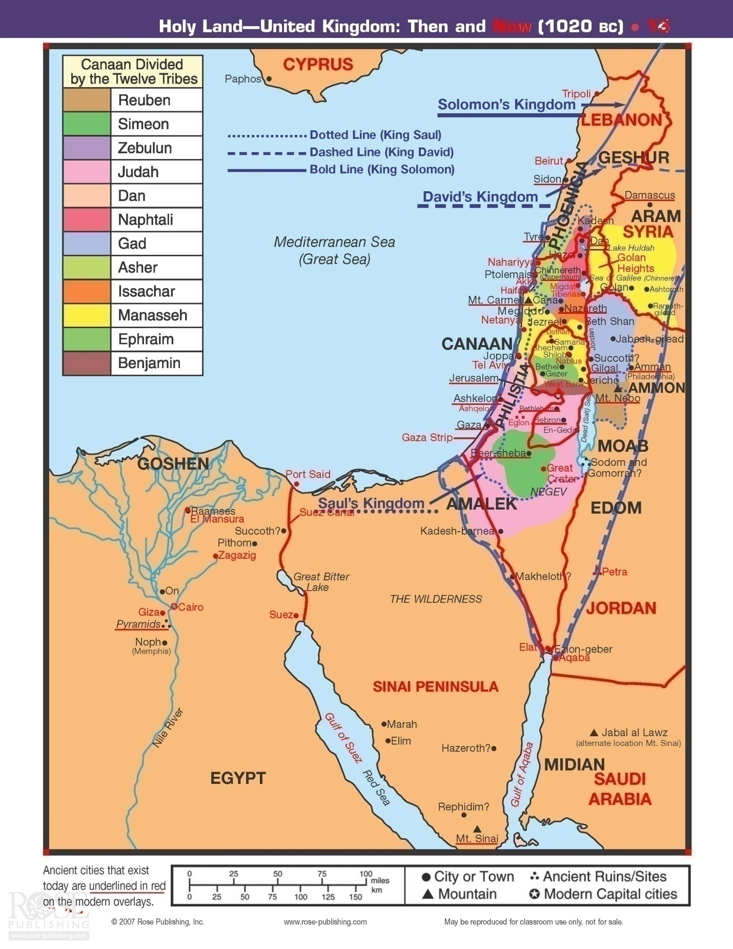

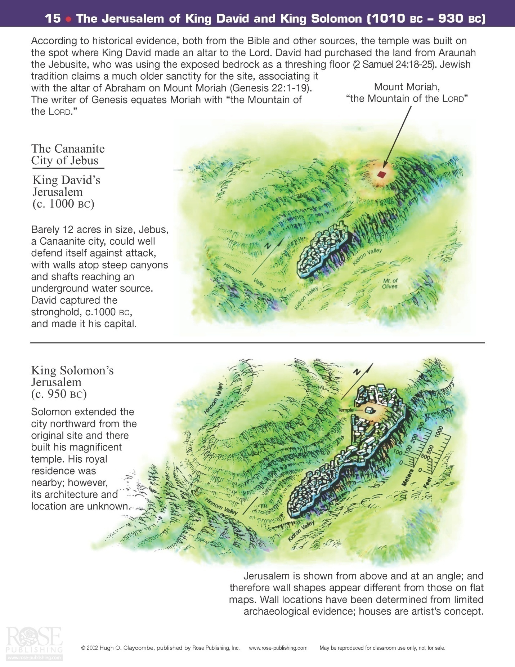
The Divided Kingdom Stage
1 and 2 Kings/ 1 and 2 Chronicles
As God had promised just prior to Solomon’s death, the kingdom was soon to be divided into two parts… the Northern Kingdom (called Israel) and the Southern Kingdom (called Judah). This took place in 931 B.C... This division began in the following way: after King Solomon’s death, his son, Rehoboam took charge immediately. But this was not to last very long.
Just a short time before Solomon’s death, one of his former officials, Jeroboam, had attempted to rebel against his reign. This was unsuccessful and, therefore, he had to escape into Egypt. Now that Solomon was no longer alive, Jeroboam returned to Israel where he had a following among at least ten of the tribes. In fact, he was asked to return by some of the leaders of Israel to make an attempt to change the ways of Rehoboam. He led a contingent of leaders and went to Rehoboam and said to him, “ "Your father made our yoke heavy. Now therefore lighten the hard service of your father and his heavy yoke on us, and we will serve you." 1 Kings 12:4-5 Rehoboam was given advice by the elders to give these tribes what they wanted as they felt that this would strengthen his hold on the Kingdom and make all of the tribes loyal to him. Unfortunately for the new king, he instead listened to his younger colleagues and went back and told Jeroboam and the assembly of leaders that had come to him that he planned to be and even tougher leader than his father had ever been! This promptly resulted in the formation of the Northern Kingdom with Jeroboam being declared its leader! “And when all Israel saw that the king did not listen to them, the people answered the king, ‘What portion do we have in David? We have no inheritance in the son of Jesse. To your tents, O Israel! Look now to your own house, David.’ So Israel went to their tents. But Rehoboam reigned over the people of Israel who lived in the cities of Judah. Then King Rehoboam sent Adoram, who was taskmaster over the forced labor, and all Israel stoned him to death with stones. And King Rehoboam hurried to mount his chariot to flee to Jerusalem. So Israel has been in rebellion against the house of David to this day. And when all Israel heard that Jeroboam had returned, they sent and called him to the assembly and made him king over all Israel. There was none that followed the house of David but the tribe of Judah only.” 1 Kings 12:16-20 Before long, the tribe of Benjamin joined with the tribe of Judah to form the Southern Kingdom. For hundreds of years, the Southern and Northern Kingdoms would be involved in wars with other nations and between each other. Some portion of the Benjamite tribe would side with the Northern Kingdom.
Almost immediately after the secession of Israel, Rehoboam was going to lead the armies of Judah and Benjamin against them. Yet, on this occasion, he listened to the Lord who spoke through a prophet named Shemalah, “Do not go up to fight against your brothers, the Israelites.” I Kings 12:24
God had spoken to Jeroboam and told him that He would bless his reign as long as the king would follow and honor Him and lead the people of Israel in the way of the Lord. Sadly, Jeroboam instead was concerned that some or all of the ten tribes of Israel would slowly filter back into the Southern Kingdom alliance as they would be going back to Jerusalem (the capital of Judah – the Southern Kingdom) for their worship and to offer sacrifices. He felt that they would eventually want to “give their allegiance to their lord.” 1 Kings 12:27 Because of this concern, Jeroboam made two golden calves to be the new gods for his people. He set one up in Bethel (considered special due to Jacob’s previous worship experiences there) and the other in Dan. These, unfortunately, became the new gods for that generation of people in the new Kingdom of Israel. He also added to this perversion by setting up sacrificial festivals to these idols, appointing false priests and other such sinful abominations. On one occasion, Jeroboam was met by a “man of God” who came from Jerusalem to Bethel and called out to the King when he had just engaged in the burning of incense at an unholy altar. He prophesized that some day there would be a man (it turned out to be a king) who would execute divine judgment on the non-Levitical priesthood begun by Jeroboam. A miraculous “sign” accompanied this prophesy in that Jeroboam’s arm was “withered” as he stretched it out toward the “man of God” as he called for his arrest and the altar was split apart spilling the ashes onto the ground (rendering this blasphemous ceremony null and void). The prophesy was fulfilled approximately 300 years later.
Thus says the Lord: 'Behold, a child, Josiah by name, shall be born to the house of David; and on you he shall sacrifice the priests of the high places who burn incense on you, and men's bones shall be burned on you.' 1 Kings 13:2

King Josiah would be the king that would do this three centuries later…
Moreover the altar that was at Beth-el, and the high place which Jeroboam the son of Nebat, who made Israel to sin, had made, even that altar and the high place he brake down; and he burned the high place and beat it to dust, and burned the Asherah. And as Josiah turned himself, he spied the sepulchres that were there in the mount; and he sent, and took the bones out of the sepulchres, and burned them upon the altar, and defiled it, according to the word of Jehovah which the man of God proclaimed, who proclaimed these things. 2 Kings 23:15-16

Jeroboam made his royal residence in the city of Shechem. This was only about 25 miles north of Jerusalem. He fortified that city as well as Penuel, east of the Jordon River..
It is important to note that although God did indeed plan to punish his chosen people with the division of their kingdom, He always planned to bless them if they would only repent and follow Him. He asked them to follow his commandments and honor Him as the one and only God. Yet, Jeroboam was only the first in a long line of kings of Israel that failed to honor God. In fact, not one of the nineteen Northern Kingdom kings was God-fearing… not one! The Southern Kingdom had twenty kings over their three hundred plus years of existence, at least a handful that were loyal to the Lord. Highlights of all of these kings and a review of the major events in the history of both nations (Israel and Judah) from 931 B.C. to 586 B.C. follows.

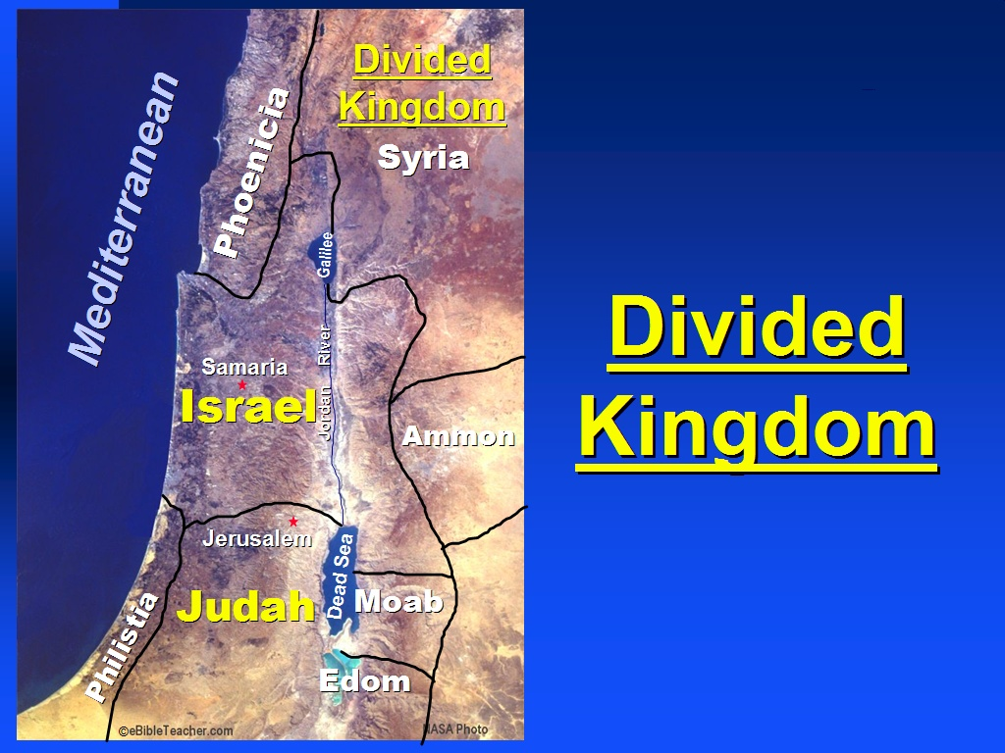

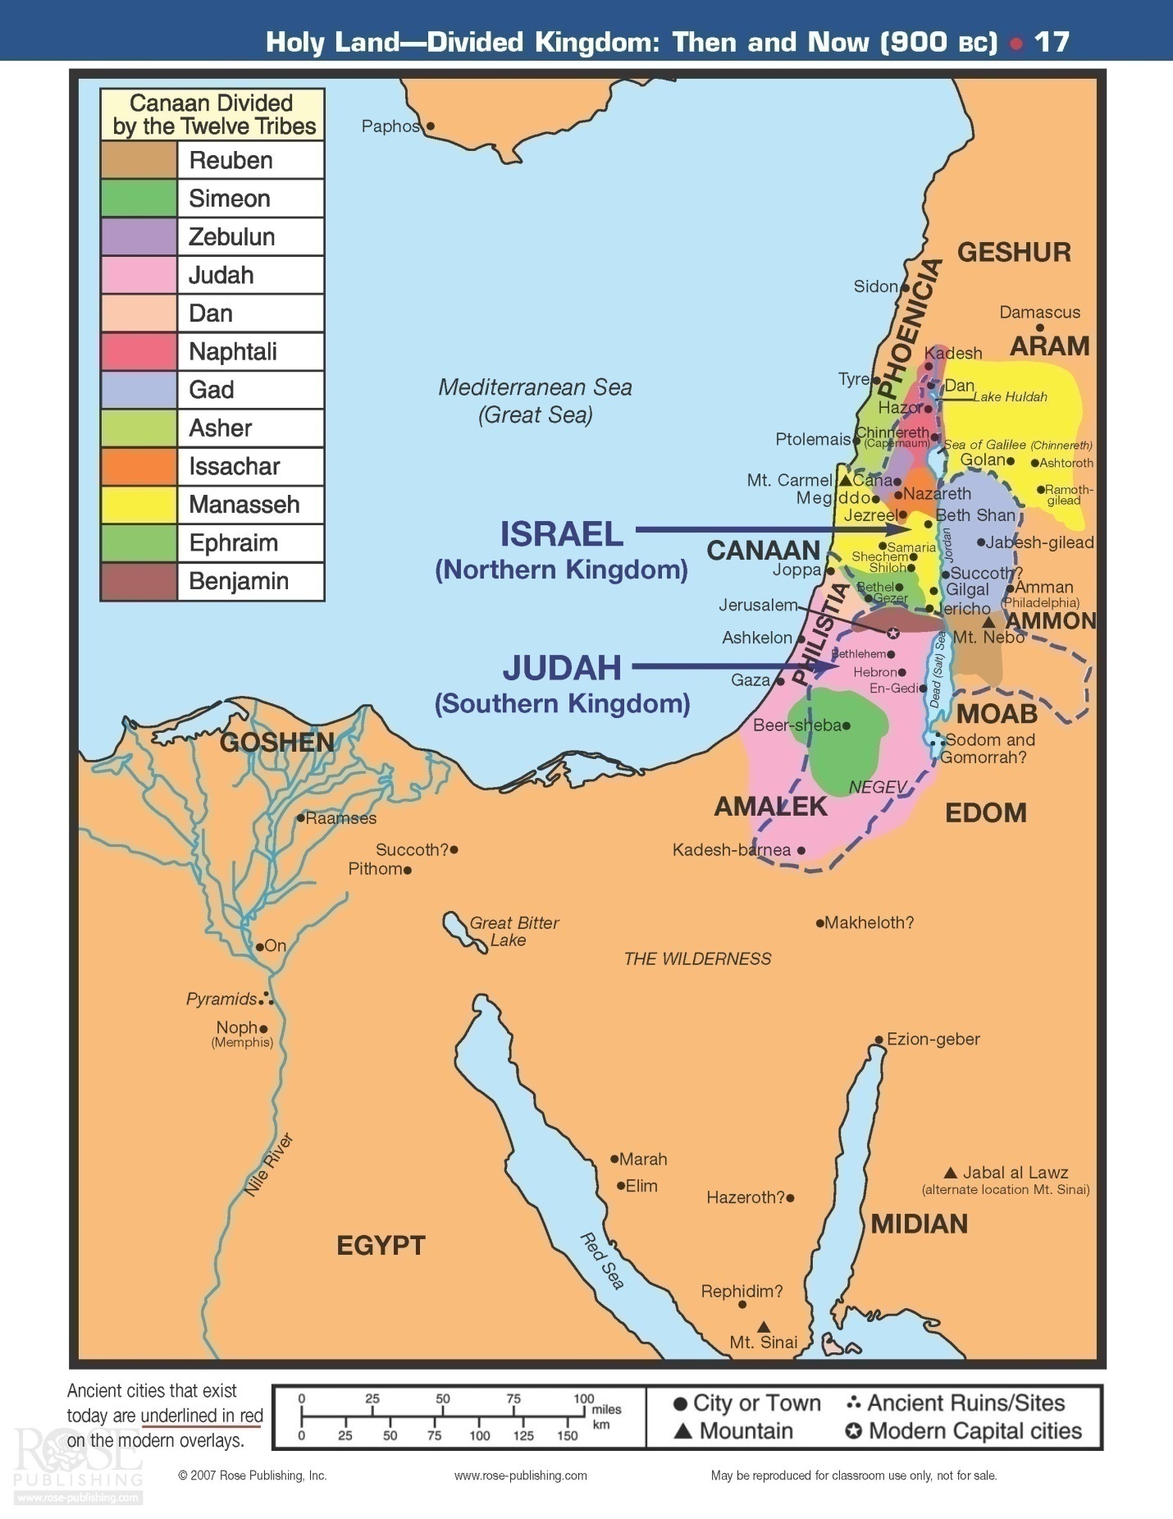

The Northern Kingdom (Israel):
Kings: 19 total
Jeroboam (931-909) Nadab (910-908) Baasha (909-885) Elah (885-883) Zimri (885-7 days) Omri (885-873) Ahab (874-853) Ahaziah (853-851) Jehoram (852-840) Jehu (841-813) Jehoahaz (817-797) Jehoash (798-782) Jeroboam ll (793-752) Zechariah (753- 6 months) Shalllum (752 – 1 month) Menahem (752-742) Pekahiah (742-740) Pekah (740-732) Hoshea (732-721) (all years are B.C.)
All of these kings of Israel were un-saved. The capital was Samaria. This, of course, is where the term Samaritan came from, later used by our Lord, Jesus. The kingdom lasted for 210 years when it was captured by the Assyrians in 721 B.C... There was no return from captivity as there would be for the Southern Kingdom of Judah. The people would eventually scatter throughout the earth. The tribes of this Northern Kingdom are often referred to as the “Lost Tribes of Israel”. Of course, God has not lost any one individual from any of these tribes.
Many of the kings bear mentioning in some detail; others more briefly:
Jeroboam: the first king of Israel, a former cabinet member of Solomon’s court. Note the actions he took as described earlier. He eventually lost a battle to the second king of Judah, Abijah, secondary to God’s intervention. Due to his marked heresy, God brought disaster on the house of Jeroboam.
I will bring disaster on the house of Jeroboam, and will cut off from Jeroboam every male in Israel, bond and free; I will take away the remnant of the house of Jeroboam, as one takes away refuse until it is all gone. The dogs shall eat whoever belongs to Jeroboam and dies in the city, and the birds of the air shall eat whoever dies in the field; for the Lord has spoken!" 1 Kings 14:10-11

Nadab: Jeroboam’s son, he was assassinated by Baasha. All of his brothers were also assassinated thereby fulfilling the prophesy that none of Jeroboam’s line would continue as kings.
Baasha: another evil king, assassinated Nadab and then his entire family! He also engaged in war throughout his reign with King Asa of Judah, a Godly king.
Elah: The son and successor of Baasha, king of Israel. His reign lasted for approximately two years. He was killed while drunk, by Zimri (commander of half of Elah’s chariots), in the house of his steward Azra, who was probably a confederate in the plot.
Zimri: He killed all the household of Baasha, according to the word of the Lord, which He spoke against Baasha by Jehu the prophet, for all the sins of Baasha and the sins of Elah his son, by which they had sinned and by which they had made Israel sin, in provoking the Lord God of Israel to anger with their idols. 1 Kings 16:12-13
When the people found out what Zimri had done, they selected Omri, the commander of the army, as their new king and he went after Zimri immediately. He lasted as king for seven days!
And it happened, when Zimri saw that the city was taken, that he went into the citadel of the king's house and burned the king's house down upon himself with fire, and died. 1 Kings 16:18

Omri: He moved the capital of Israel from Tizrah to Samaria
Ahab: Omri’s son, he married the virago, Jezabel. He worshipped Baal which caused great hardship for Israel, especially famine. A great prophet of God, who lived during Ahab’s time, was Elijah. More will be discussed about Elijah later. Ahab ruled from Samaria, the city that his father had turned into the capital of Israel. At one point during his reign, Ben-hadad, along with 32 other kings planned to invade this city. After a verbal exchange between the two kings, Israel easily defeated the invading forces in the hills and in the plains due to God’s intervention. God had previously told Ahab that He would give him the victory to remind Ahab of His power and the importance of following Him always. After their defeat, Ahab allowed the enemy to escape contrary to God’s command. Because of this God said:
"Thus says the Lord: 'Because you have let slip out of your hand a man whom I appointed to utter destruction, therefore your life shall go for his life, and your people for his people 1 Kings 20:42

There was one other episode in the lives of Ahab and Jezabel worth mentioning. After the episode above, Ahab offered to buy a vineyard from a man named Naboth. Naboth did not want to sell it as he wanted to pass it on to his heirs. Ahab was upset about this. Jezabel came to the rescue in her typical manner. She wrote letters to several nobles and elders convincing them to get people to give false witness that Naboth was a blasphemer. This was done and resulted in the poor man’s death by stoning. Hence, Ahab got the land! For these and other reasons, God had Elijah confront Ahab and let him know that his death and that of Jezabel would be horrendous. A not unexpected ending for a bad king and his evil wife.

'Thus says the Lord: "In the place where dogs licked the blood of Naboth, dogs shall lick your blood, even yours." And concerning Jezebel the Lord also spoke, saying, 'The dogs shall eat Jezebel by the wall of Jezreel.' The dogs shall eat whoever belongs to Ahab and dies in the city, and the birds of the air shall eat whoever dies in the field." 1 Kings 21:19,23-24

Ahab’s life was about to come to an end. He invited the then ruling king of Judah, Jehoshaphat, to join him in an effort to free Ramoth in Gilead from Syrian control. Jehoshaphat wanted to make sure that this was God’s will. Ahab had 400 of his lackey prophets say that it was. Yet, Jehoshaphat wanted an “independent” prophet to give his understanding of God’s will… that man was Micaiah. Micaiah always gave reports contrary to Ahab’s wishes… because they were, indeed, God’s actual will! This time he said that disaster would result if they went to war against that foe at that time. Ignoring this prophesy, the two kings went to war. Ahab disguised himself to try to avoid the Syrian’s attempts on his life. He tried to make Jehoshaphat the focus of their attention. This almost resulted in the death of the southern king. Ahab died as the result of a random arrow that brought to an end this terrible reign.
Ahaziah: This king reigned only two years. After an injury, he sent his servants to inquire of the Canaanite god, Baalzebub, as to whether he would recover. Elijah intercepted the servants and told them to tell the king that he would die for his turn to a foreign god. Ahaziah then sent two contingents of fifty men to inquire of Elijah concerning this decree. In both instances, Elijah called down fire from heaven to consume the men. The men in the third delegation asked for mercy from Elijah that he would let them live. He did as God spoke to him…
And the angel of the Lord said to Elijah, "Go down with him; do not be afraid of him." So he arose and went down with him to the king. Then he said to him, "Thus says the Lord: 'Because you have sent messengers to inquire of Baal-Zebub, the god of Ekron, is it because there is no God in Israel to inquire of His word? Therefore you shall not come down from the bed to which you have gone up, but you shall surely die.'" So Ahaziah died according to the word of the Lord which Elijah had spoken. 2 Kings 1:15-17

Jehoram (Joram): He was the youngest son of Ahab and Jezabel. He became the king when his brother, Ahaziah, died. He formed an alliance with Judah and Edom to put down a rebellion by the Moabites. When their water ran low, he asked Elisha to pray for water. Elisha, the prophet, lived during his reign and performed many miracles. Elisha did deliver the water as requested, although he stated that it was because of the king of Judah’s (Jehoshaphat) allegiance to God that he did so. The morning sun gave the water lying in a valley, the appearance of being blood stained. This confused the Moabites into thinking that many of their enemy had already perished. Their subsequent overconfidence allowed the Israel-Judah-Edom alliance to defeat Moab and abort their rebellion. Joram was assassinated by Jeru.
Jehu: He was chosen by God through Elisha to become king of Israel. He had been a military leader. God used him to avenge all of the evil deeds done by Ahab and Jezebel. He assassinated both Ahaziah (Judah) and Joram (Israel). He then entered into the palace grounds in Jezreel. Jezebel was thrown from a window to her death at Jehu’s command. By the time that a few servants went out a little later to claim her body for burial, she had been ravaged by dogs! This was the fulfillment of a previous prophesy by Elijah…
"This is the word of the Lord, which He spoke by His servant Elijah the Tishbite, saying, 'On the plot of ground at Jezreel dogs shall eat the flesh of Jezebel; and the corpse of Jezebel shall be as refuse on the surface of the field, in the plot at Jezreel, so that they shall not say, "Here lies Jezebel.'" 2 Kings 9:36-37

Jehu went about killing all of Ahab’s heirs, purging Israel of his influence. He then lured many of the worshippers of Baal to a large feast given for the foreign god, Baal. When all had arrived, he slaughtered these worshippers and destroyed their temple. Jehu had accomplished much in driving out these evil influences from Israel. However, after these things were done, he did not completely eliminate all of the other pagan influences from the region of Israel, and he certainly did not re-institute the worship of the one true God. Although he did not do the job one would have liked, God did allow for his heirs to continue to rule over Israel for four more generations.

Jehoahaz: He followed his father, Jehu, as king of Israel. He was another in the long line of bad kings of Israel. His attitude toward God resulted in Israel being under oppression by Aram throughout his reign.

Jehoash: In the thirty-seventh year of Joash king of Judah, Jehoash the son of Jehoahaz became king over Israel in Samaria, and reigned sixteen years. And he did evil in the sight of the Lord. So Joash rested with his fathers. Then Jeroboam sat on his throne. And Joash was buried in Samaria with the kings of Israel. 2 Kings 13:10&13
Jehoash was able to regain some of the lands of Israel that they had lost during the preceding decades. He was in power when Elisha died. A story will be told when the prophet Elisha is discussed a little later relating to an incident that happened between the king and prophet at the end of Elisha’s life. At one point, he was engaged in a war with Judah and their king, Amaziah. He defeated his southern rival and destroyed a portion of the wall of Jerusalem. He also took some of the Temple’s treasures back to Samaria with him.

Jeroboam ll: He ruled longer than any other northern king, 41 years. He recovered much of the previously lost territory for Israel during his reign. However, he also was not a Godly king. Jonah began his prophetic ministry during this time.
Zechariah: He was the last in the line of Jehu’s descendents on the throne, as had been prophesized. Shallum, his successor killed him after he had ruled for just six months!
Shallum: He was killed only one month after he had killed Zechariah!
Menahem: He assumed control after he assassinated Shallum. He paid tribute to King Pul of Assyria in order to have the opportunity to rule without the Assyrians invading Israel.
Pekahiah: The son of Menahem. A typical bad king of Israel, reigned for two years, then was killed by Pekah.
Pekah: He reigned almost 20 years. Tilgaeh-pileser, the king of Assyria, captured large sections of Israel as time for the fall of the entire nation of Israel neared. At one point, Pekah joined forces with Aram in an attempt to slow the Assyrian aggression. The king of Judah, King Ahaz, preferred to pay tribute to avoid an Assyrian attack. This angered the alliance of Pekah and Aram and they attacked Judah… but were unable to subdue that southern kingdom. Assyria continued its march as they next took over Damascus, Syria.
Hoshea: Israel’s last king. Assyria had crushed the Pekah/Israel-Aram alliance so Hoshea paid tribute to Assyria for a period of time. He then joined with Egypt in rebelling against Assyria eventually resulting in his being imprisoned. Assyria captured the kingdom of Israel to conclude his reign. This happened in 721 B.C..

The Southern Kingdom (Judah):
Kings: 20 total
Rehoboam (931-914) Abijah (914-911) Asa (911-870) Jehoshaphat (873-848) Joram (853-845) Ahaziah (841) Athaliah (841-835) Joash (835-795) Amaziah (796-767) Uzziah (792-740) Jotham (750-736) Ahaz (735-719) Hezekiah (716-687) Manasseeh (697-642) Amon (643-641) Josiah (641-610) Jehoahaz (609 – 3 months) Jehoiakim (609-598) Jehoiachin (598 – 3 months) Zedekiah (597-586) (all years are B.C.)
Rehoboam: (bad) Solomon’s son who made the stupid decision to follow the advice of his unwise young friends that resulted in him losing the ten northern tribes (and a portion of the tribe of Benjamin) from his kingdom. Because Jeroboam drove the Levite priests back into Judah, the southern kingdom did have a basis for Godly worship that was always missing for the northern tribes. Recall that Jeroboam did not want to risk “his people” going back to Jerusalem and repenting… turning back to God. Unfortunately, Rehoboam allowed Judah to be caught up in idol worship, homosexuality, and other sinful activities. During the fifth year of his reign, King Shishak of Egypt invaded Judah. So for the first time in 100 years, Jerusalem was attacked by a foreign power! God saved Jerusalem, but several fortified cities of Judah did fall. Also, God allowed for the plunder of the Temple treasury, including the golden shields of Solomon. Rehoboam replaced these with bronze shields – symbolizing the deteriorating condition of God’s chosen people at this time.
Abijam (Abijah): (bad) The son of Rehoboam won a significant battle over King Jeroboam with God’s intervention. Yet, he quickly turned his back on God and died only three years after his reign began.
Asa: (good-bad) He began his rule in 911 B.C. and reigned for forty-one years. In the early years of his kingdom, he fenced in many of the cities of Judah for protection. He also led the people in a great revival. Then, he was faced with an invasion by the Ethiopians. Although hopelessly outnumbered, God granted the prayer request of Asa and smote the Ethiopians. For thirty-six years, Asa ruled quite well. Then, unfortunately, the northern king, Baasha, declared war on Judah. Instead of recalling the reason for his earlier victories, and turning to God completely, he allied himself with a Syrian king in his battle with Baasha. This foolish tactic resulted in Asa being rebuked by God through the prophet Hanani. The remainder of his reign and life were sadly regrettable. He died a painful death after a reign of forty-one years.
Jehoshaphat: (good) The son of Asa, he reigned for twenty-five years and continued many of the moral reforms and building projects that his father had begun. He also instituted a nationwide religious training program. He, like his father before him, got sidetracked in the later years of his rule as he made ungodly alliances with three northern kings (Ahab, Ahaziah, and Jehoram). Eventually, Jehoshaphat repented and continued his spiritual reforms. Near the latter years of his reign, he was faced with a war against the Moabites and their allies. He was justly concerned and went to God for his help. The prophet Jahaziel spoke for God,
'Do not be afraid and do not be dismayed at this great horde, for the battle is not yours but God's. Tomorrow go down against them. Behold, they will come up by the ascent of Ziz. You will find them at the end of the valley, east of the wilderness of Jeruel. You will not need to fight in this battle. Stand firm, hold your position, and see the salvation of the Lord on your behalf, O Judah and Jerusalem.' Do not be afraid and do not be dismayed. Tomorrow go out against them, and the Lord will be with you." Then Jehoshaphat bowed his head with his face to the ground, and all Judah and the inhabitants of Jerusalem fell down before the Lord, worshiping the Lord. And the Levites, of the Kohathites and the Korahites, stood up to praise the Lord, the God of Israel, with a very loud voice. And they rose early in the morning and went out into the wilderness of Tekoa. And when they went out, Jehoshaphat stood and said, "Hear me, Judah and inhabitants of Jerusalem! Believe in the Lord your God, and you will be established; believe his prophets, and you will succeed." And when he had taken counsel with the people, he appointed those who were to sing to the Lord and praise him in holy attire, as they went before the army, and say,
"Give thanks to the Lord, for his steadfast love endures forever."
And when they began to sing and praise, the Lord set an ambush against the men of Ammon, Moab, and Mount Seir, who had come against Judah, so that they were routed. For the men of Ammon and Moab rose against the inhabitants of Mount Seir, devoting them to destruction, and when they had made an end of the inhabitants of Seir, they all helped to destroy one another.
When Judah came to the watchtower of the wilderness, they looked toward the horde, and behold, there were dead bodies lying on the ground; none had escaped. When Jehoshaphat and his people came to take their spoil, they found among them, in great numbers, goods, clothing, and precious things, which they took for themselves until they could carry no more. They were three days in taking the spoil, it was so much. On the fourth day they assembled in the Valley of Beracah, for there they blessed the Lord. Therefore the name of that place has been called the Valley of Beracah to this day. Then they returned, every man of Judah and Jerusalem, and Jehoshaphat at their head, returning to Jerusalem with joy, for the Lord had made them rejoice over their enemies. They came to Jerusalem with harps and lyres and trumpets, to the house of the Lord. And the fear of God came on all the kingdoms of the countries when they heard that the Lord had fought against the enemies of Israel. So the realm of Jehoshaphat was quiet, for his God gave him rest all around.” 2 Chron 20:15-30

Jehoram (Joram): Joram married Athaliah, daughter of Ahab. He ruled in the same fashion as did Ahab. During his reign, Judah lost Edom. He ruled at approximately the same time as a king with the same name ruled Israel.

Ahaziah: Joram’s son, another godless ruler of the southern kingdom. At one point, he formed an alliance with King Joram of Israel to fight the foreign king, Hazael, from Aram (Syria). Both Ahaziah and Joram were assassinated by Jeru .

Athaliah: a woman ruler, the only queen of Judah, was ruthless and a sinful leader. She worshipped Baal as did her mother, Jezebel. She tried to murder all of the royal heirs of David. She failed as noted below:

But Jehoshabeath, the daughter of the king, took Joash the son of Ahaziah, and stole him away from among the king's sons who were being murdered, and put him and his nurse in a bedroom. So Jehoshabeath, the daughter of King Jehoram, the wife of Jehoiada the priest (for she was the sister of Ahaziah), hid him from Athaliah so that she did not kill him. And he was hidden with them in the house of God for six years, while Athaliah reigned over the land. 2 Chron 22:11-12

Joash: He was crowned king in a coup at the age of seven. While the ceremony took place, Athaliah came to investigate and was promptly killed! He ruled for forty years beginning in 835 B.C. While the prophet, Jehoiada lived, Joash was a good king, repairing the Temple, destroying the temples of Baal, and otherwise ushering in a time of revival. However, after the death of this good prophet of God, Joash forgot his God and the latter part of his reign was marked by a loss of much of the remaining Temple treasures, the stoning of a Zechariah, Jehoiada’s son, simply for denouncing Judah’s sinful idolatry. Jerusalem also was captured by Syria during this time. The city was looted and Joash wounded, and soon thereafter killed by his own palace officials.

Amaziah (Ahaziah): (a good king) Son of Joash, the eighth king of Judah. He reigned from 796-767 B.C. He was only 25 years old when he became king of Judah. He conquered the Edomites and took their capital, Petra. Stupidly, after this conquest, he began to worship some of the Edomites gods. This was certainly going to result in his downfall. He then challenged Joash, the king of Israel to battle, but was completely defeated. This war was the result of Amaziah’s pride and certainly should have been avoided. He apparently spent many years in Samaria as their captive from this war. During this time, his young son, Uzziah, assumed control over Judah. Upon his release, he returned to function as co-regent with his son.

Uzziah: He ruled for fifty-two years. There was a period of co-regency with Amaziah. He was a good king, helped by the prophet Zechariah. He was able to restore much power to Judah and Jerusalem. He built fortified towers, water reservoirs, farms, vineyards, re-organized his army into better fighting units, built much better ammunitions and won many wars against other nations. Unfortunately, he too had a bad ending to his long rule. The more he accomplished the greater his fame spread…
“And his fame spread far, for he was marvelously helped, till he was strong. But when he was strong, he grew proud, to his destruction. For he was unfaithful to the Lord his God and entered the Temple of the Lord to burn incense on the altar of incense. But Azariah the priest went in after him, with eighty priests of the Lord who were men of valor, and they withstood King Uzziah and said to him, "It is not for you, Uzziah, to burn incense to the Lord, but for the priests the sons of Aaron, who are consecrated to burn incense. Go out of the sanctuary, for you have done wrong, and it will bring you no honor from the Lord God." Then Uzziah was angry. Now he had a censer in his hand to burn incense, and when he became angry with the priests, leprosy broke out on his forehead in the presence of the priests in the house of the Lord, by the altar of incense. And Azariah the chief priest and all the priests looked at him, and behold, he was leprous in his forehead! And they rushed him out quickly, and he himself hurried to go out, because the Lord had struck him. And King Uzziah was a leper to the day of his death, and being a leper lived in a separate house, for he was excluded from the house of the Lord. And Jotham his son was over the king's household, governing the people of the land.” 2 Chron 26:15-21
It should be quite a lesson to us all to note how many times the kings of Judah (and also Saul and Solomon of the United Kingdom) did so well early in their lives, only to let the sin of pride turn their latter years into a very poor witness for God. Let none of us be guilty to this.
Jotham: (good king) He reigned from 750-736 B.C. Although he did many good things, He also failed to effectively deal with the widespread religious apostasy of Judah. Isaiah, Hosea and Micah began their ministries during this time.
But still the people acted corruptly. He built the Upper Gate of the house of the Lord, and he built extensively on the wall of Ophel. Moreover he built cities in the mountains of Judah, and in the forests he built fortresses and towers. He also fought with the king of the Ammonites and defeated them. 2 Chron 27:2-5

Ahaz: (bad king) Began his reign as a twenty year old. He ruled over Judah at the time when Isaiah lived. Isaiah told him not to worry about the alliance of Israel and Syria as God would protect Judah. In fact, God asked Ahaz to ask Him for a sign (to prove that God would intervene for Judah) as God was going to show the king that He would certainly protect Judah as He had just promised. Ahaz would not put the Lord to the test. So the Lord gave him the following sign, through Isaiah, anyway:

“The Lord himself will give you a sign. Behold, the virgin shall conceive and bear a son, and shall call his name Immanuel.” Isaiah 7:14 [Immanuel means “God with us”] This came true, to a degree, shortly after Isaiah made the prophesy - in the birth of one of Isaiah’s sons to a young woman that was betrothed to him at the time of this word from God. Yet, the real fulfillment of this prophesy came 700 years later with the birth of Christ! Only Jesus completely satisfied all of the aspects of this prediction.
Ahaz continued his pagan ways throughout his time of power… he even ordered a pagan alter (a replica of one he saw in Damascus) to be placed in the Temple to appease Tiglath-Pileser, the Assyrian king! He paid tribute to the pagan king. Worse yet, he offered his son as a sacrifice to the pagan god! When he died, he was not buried in the royal tombs due to his heinous acts against God.
Hezekiah: a very good king of Judah… the best up to that time. He ushered in a time of revival while breaking up the idols that had been built before his time of rule. He re-instituted animal sacrifices in the Temple… he realized that “it is the blood that maketh an atonement for the soul.” Lev. 17:11 He organized the Temple orchestra and choir. He also had the grandest Passover since the time of Solomon… he even sent invitations to the northern tribes… some joyfully accepted and came! The originally planned seven day celebration turned into a fourteen day feast. Revival broke out all around Judah.
As he grew to old age, his great successes led him to become proud (this problem of pride flairs up again)! Thus he was stricken with a fatal boil-like disease. Recognizing his sin, he prayed to be spared. God answered his pleading by giving him an additional fifteen years of life… Hezekiah was the only man ever given this type of knowledge. In these last fifteen years, Hezekiah at one time showed visiting Babylonians the riches of Jerusalem. Isaiah rebuked him for this and then predicted that some many years after the king’s death, Babylon would capture Judah and take the people and bounty into captivity!
One final incident of his reign should be mentioned. Sennacherib, the king of Assyria, began to threaten Jerusalem in the fourteenth year of Hezekiah’s reign. It looked like this city in Judah should be very easy to defeat at that time. Yet God delivered the Assyrians into Judah’s hands as 185,000 troops died one night as they waited to attack the city of Jerusalem. The angel of the Lord, perhaps Christ himself, did the fighting that night!
Manasseh: He reigned the longest of all kings of either kingdom, 55 years. He was the son of Hezekiah. He was a wicked king for most of his reign, but repented near the end while he was in prison, forgiven by God, and was allowed to return as king. He spent most of his reign worshipping foreign gods and involved in the use of enchantments, witchcraft, familiar spirits, and with wizards. He sacrificed his own sons to an idol! It is likely that any one that had even a remnant of the Holy Scriptures would have been put to death during his reign. Near the end of his very long reign, he was captured and brought to Babylon where he finally repented of his sinful ways. God brought him back to Jerusalem where he spent the last few years of his life doing his best to un-do some of the damage he had done previously.
He took away the foreign gods and the idol from the house of the Lord, and all the altars that he had built in the mount of the house of the Lord and in Jerusalem; and he cast them out of the city. He also repaired the altar of the Lord, sacrificed peace offerings and thank offerings on it, and commanded Judah to serve the Lord God of Israel. 2 Chron 33:15-16 (NKJV)

Amon: the son of Manasseh, he was very evil. He ruled for 2 years and then was killed by his servants.
Josiah: He began his reign in 640 B.C. and ruled for thirty-one years. He was an extremely great and Godly king – of course, these two go hand in hand. He was the last Godly king. He apparently turned to God in about 632 B.C. Hilkiah, the High Priest, discovered the book of Moses among the debris in the Temple as Josiah had started many significant repairs to the Temple. They used this to start a great revival and an even larger Passover celebration than his great-grandfather, Hezekiah had staged. He tore down the altar to Baal that Jeroboam had erected in Bethel. He smashed the Asherah poles, read the Book to the people and made a covenant to observe it. He removed the idols from all the land of Judah and all other territory that he controlled at that time. These reforms were probably the greatest that Judah had ever seen. God promised that Judah would not be defeated while this good king lived. Unfortunately, he was killed in battle against the Egyptians. He was attempting to stop the Egyptians from hooking up with the Assyrians in their battle against the Babylonians. Babylonia had crushed the Assyrian capital of Ninevah in 612 B.C. The Egyptian Pharaoh, Neco, marched through Palestine on his way to joining up with the Assyrian army. Josiah was killed in battle at Meggido (the Valley of Jezreel) and Judah had to begin to pay tribute to Egypt. In 605 B.C., Egypt and Assyria lost their war with Babylon at the famous Battle of Carchemish (mentioned in the movie “Patton”).
Josiah, like Hezakiah, brought the worship of God back to the people. Jeremiah, Nahum, Habakkuk, and Zephaniah began their ministries during this time. All three of Josiah’s sons would become kings… all three would be bad kings.
Jehoahaz: a son of Josiah, captured and imprisoned by the Pharaoh after only 90 days as king.
Jehiokim: originally named Eliakim, another son of Josiah, put into office by Neco (who also changed this king’s name). He was a vassal of the Pharaoh doing whatever he was told. Later, he was under the control of Babylon. He burned Jeremiah’s scroll at one point. He served as king for ten or eleven years. He finally rebelled against Babylon and was killed.
Jehiochin: He was only king for about 3 months before he was carted off to Babylon along with his wives and family in 597 B.C. He became the king of Judah, while still very young, after the death of his father, Jehiokim. There he remained a prisoner, actually in prison and wearing prison garments, for thirty-six years, until the death of Nebuchadnezzar, when Evilmerodach, succeeding to the throne of Babylon, brought him out of prison, and made him sit at the kings table.
Zedekiah (Mattaniah until his name was changed by Nebuchadnezzar): The last king of Judah… another son of Josiah. He was appointed king by Nebuchadnezzar. He reigned for eleven years before being captured. After at times trying to placate Nebuchadnezzar, he finally tried to hold him off from capturing Jerusalem… against the advice of the prophet Jeremiah (he made life very difficult for this great man of God, by the way). After holding back the Babylonians for thirty months (beginning in 588 B.C.), the city of Jerusalem was finally plundered. The king and his sons suffered terrible deaths after being brought to Babylon in 586 B.C. The king was captured at Jericho and blinded before being taken to Babylon for his eventual fate. It is of interest to note that Jeremiah predicted that he would see the king of Babylon while Ezekiel predicted that he would not see the city of Babylon. Both were correct! This ended the divided kingdom stage of the twelve tribes of Israel.
At the conclusion of the raiding of Jerusalem, Nebuchadnezzar placed a man named Gedaliah over the remnants of the people in that city. After only three months, he was assassinated. The people mostly went off to Egypt at that time. Many were already in Babylon.
During the divided kingdom, the majority of the kings of Judah and all nineteen of the kings of Israel were ungodly. Obviously, God did not use these ungodly men (and women) to carry down his message from one generation to the next. Instead, for the most part, the prophets of God kept his message intact and added to it over the time period from 931 B.C. to 586 B.C.

Elijah and Elisha
There were two “oral prophets” during this time that deserve special mention.
Elijah: Elijah is introduced in the Bible in 1 Kings 17:1 where he announces a 3 ½ year drought during the reign of King Ahab as a punishment for sin. Right after this pronouncement, he is told by the Lord to escape into the Kerith Ravine east of Jordan where he subsequently is fed by ravens while finding water in a nearby brook. When the brook dried up, he was told to go and see a widow who provided him with food and drink. Elijah eventually was called to raise her son from the dead! Sometime later, he arranged for a contest between his God, our Lord, and the gods of Baal on Mt. Carmel. In a very interesting encounter, Elijah showed the power of God and the total lack of power of the idols/gods of Baal. After the prophets of Baal had totally failed to bring fire upon their altars, as was their test, Elijah began his demonstration of God’s power:
He repaired the altar of the Lord that was broken down. And Elijah took twelve stones, according to the number of the tribes of the sons of Jacob, to whom the word of the Lord had come, saying, "Israel shall be your name." Then with the stones he built an altar in the name of the Lord; and he made a trench around the altar large enough to hold two seahs of seed. And he put the wood in order, cut the bull in pieces, and laid it on the wood, and said, "Fill four waterpots with water, and pour it on the burnt sacrifice and on the wood." Then he said, "Do it a second time," and they did it a second time; and he said, "Do it a third time," and they did it a third time. So the water ran all around the altar; and he also filled the trench with water. And it came to pass, at the time of the offering of the evening sacrifice, that Elijah the prophet came near and said, "Lord God of Abraham, Isaac, and Israel, let it be known this day that You are God in Israel and I am Your servant, and that I have done all these things at Your word. Hear me, O Lord, hear me, that this people may know that You are the Lord God, and that You have turned their hearts back to You again." Then the fire of the Lord fell and consumed the burnt sacrifice, and the wood and the stones and the dust, and it licked up the water that was in the trench. Now when all the people saw it, they fell on their faces; and they said, "The Lord, He is God! The Lord, He is God!" And Elijah said to them, "Seize the prophets of Baal! Do not let one of them escape!" So they seized them; and Elijah brought them down to the Brook Kishon and executed them there. 1 Kings 18:30-40

Then, at Elijah’s command, the people seized the prophets of Baal and Elijah executed them. Next, he told Ahab that the drought would end… and soon there was a heavy downfall. When Ahab told his evil wife of Elijah’s deeds that day, Jezebel called for Elijah’s death. Elijah retreated to a day’s journey away from Beersheba where he showed his depression and fear. Isn’t it interesting how this great man of God and faith still had these tendencies within him. Yet, no man or woman, in our current imperfect state, can be counted on to do the strong and right thing at all times.
“And he asked that he might die, saying, ‘It is enough; now, O Lord, take away my life, for I am no better than my fathers’." l Kings 19:4

Elijah was very upset with his weakness and depression… he wanted to simply die.

God sent an angel to minister to him with food and drink. Soon he traveled forty days to Mt. Horeb where he went into a cave. God came to him and asked, “What are you doing here, Elijah?” 1 Kings 19-9
Elijah answered…
"I have been very jealous for the Lord, the God of hosts. For the people of Israel have forsaken your covenant, thrown down your altars, and killed your prophets with the sword, and I, even I only, am left, and they seek my life, to take it away." 1 Kings 19:14
And God said, "Go out and stand on the mount before the Lord." And behold, the Lord passed by, and a great and strong wind tore the mountains and broke in pieces the rocks before the Lord, but the Lord was not in the wind. And after the wind an earthquake, but the Lord was not in the earthquake. And after the earthquake a fire, but the Lord was not in the fire. And after the fire the sound of a low whisper.” 1 Kings 19:11-12
God spoke in this whisper to tell Elijah what to do. He will often do the same for us. One thing God told Elisha that day was to anoint his successor, Elisha, which he did. Elisha became the student of Elijah, and he would one day become his successor.
"Go, return on your way to the Wilderness of Damascus; and when you arrive, anoint Hazael as king over Syria. Also you shall anoint Jehu the son of Nimshi as king over Israel. And Elisha the son of Shaphat of Abel Meholah you shall anoint as prophet in your place. It shall be that whoever escapes the sword of Hazael, Jehu will kill; and whoever escapes the sword of Jehu, Elisha will kill. Yet I have reserved seven thousand in Israel, all whose knees have not bowed to Baal, and every mouth that has not kissed him." 1 Kings 19:15-18

Although Elijah had told the Lord that he was the only one left of the Israelites that had not forsaken His covenant, God said that there were 7,000 others that were still faithful. When the great prophet Elijah’s life was coming to an end, he traveled his preaching circuit one last time (Gilgal to Bethel to Jericho) divided the Jordan River, crossed over it and had his last discourse with his student and friend Elisha. He tested his student, Elisha, by suggesting that he might want to return to the quite life of the farm. On three occasions Elijah suggested that Elisha do this, but each time, Elisha refused. He had passed the test.
When they had crossed the Jordan, Elijah said to Elisha, "Ask what I shall do for you, before I am taken from you." And Elisha said, "Please let there be a double portion of your spirit on me." And he said, "You have asked a hard thing; yet, if you see me as I am being taken from you, it shall be so for you, but if you do not see me, it shall not be so." And as they still went on and talked, behold, chariots of fire and horses of fire separated the two of them. And Elijah went up by a whirlwind into heaven. And Elisha saw it and he cried, "My father, my father! The chariots of Israel and its horsemen!" And he saw him no more.” 2 Kings 2:9-12
Elijah was translated into Heaven without tasting death! His ministry spanned the reigns from Ahab to Ahaziah.

Elisha: As it turns out, Elisha indeed seemed to have a double portion of Elijah’s spirit. He performed a multitude of miracles. Just to mention a few: purified waters at Jordan and Jericho, he parted the Jordon as had Elijah, he produced oil in previously empty vessels, raised a dead boy, healed Naaman (a Syrian army commander) from leprosy by having him wash seven times in the Jordon River, purified a pot of poison stew, fed a hungry crowd with a small gift of bread (similar to what Jesus would later do), caused an axe head to float in the water, and many more.
On another occasion, he caused an invading army of Arameans to be struck blind. They were then led to Samaria where their sight was restored. They were then set free as they now realized that it was foolish to fight against a God so powerful.
Elisha lived during the reigns of Jehosaphat to Jehoash. On his deathbed, he was visited by King Jehoash, a wicked northern king. Elisha commanded that the king shoot arrows from Elisha’s bedroom window. This was to symbolize Israel’s victory over the Syrians. He was then instructed to strike the floor with some arrows which he did three times. Elisha had wanted him to do this five or six times. Elisha told the king that he would indeed defeat the Aramean king in three battles (consistent with the king striking the ground three times), but by not following his command to the letter, he would not totally defeat Aram, the Armean king. This, of course, turned out to be true.
Years after Elisha’s death, a dead man was tossed into Elisha’s tomb in an attempt to quickly hide the body. Instead, the corpse, after touching the bones of Elisha, was brought to life and stood up! Even in his death, Elisha provided evidence for the power of God.

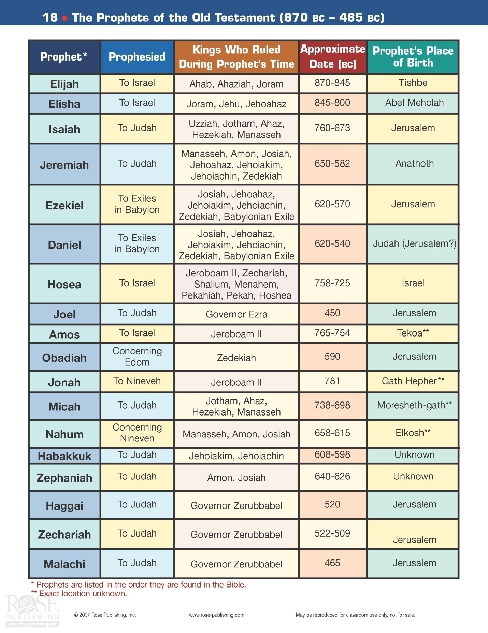
The Writing Prophets of the Divided Kingdom Stage:
A list of the prophets and their ministry years and place of ministry follows:
Obadiah (850-810) (Edom) Jonah (785-750) (Ninevah) Nahum (650-620) (Ninevah) Amos (760-753) (Israel) Hosea (760-700) (Israel) Joel (841-834) (Judah) Isaiah (739-681) (Judah) Micah (735-700) (Israel) Zephaniah (640-620) (Judah) Habakkuk (609-606) (Judah) Jeremiah (627-575) (Judah)
Many theologians consider Isaiah to be the greatest prophet of this group of Godly men. Of course, they all had important roles to fill as they served God in their time.
Isaiah: This book has tremendous scope as it brings forth great truths for the time in which it was written, throughout all of human history that follows and even into the future, into the millennial kingdom. He was the father of two children. Interestingly, he gave them names that related to coming prophesies. One was named Shear-jashub (meaning ‘a remnant will return’ noting that some Israelis would come back to Israel at some point) and Maher-shalal-hash-baz (meaning ‘swift to plunder and quick to spoil’ – predicting the fall of the Northern Kingdom in 722 B.C.). He had a wonderful introduction into his life work as follows:
In the year that King Uzziah died, I saw the Lord sitting upon a throne, high and lifted up; and the train of his robe filled the temple. Above him stood the seraphim. Each had six wings: with two he covered his face, and with two he covered his feet, and with two he flew. And one called to another and said:
"Holy, holy, holy is the Lord of hosts; the whole earth is full of his glory!"
And the foundations of the thresholds shook at the voice of him who called, and the house was filled with smoke. And I said: "Woe is me! For I am lost; for I am a man of unclean lips, and I dwell in the midst of a people of unclean lips; for my eyes have seen the King, the Lord of hosts!" Then one of the seraphim flew to me, having in his hand a burning coal that he had taken with tongs from the altar. And he touched my mouth and said: "Behold, this has touched your lips; your guilt is taken away, and your sin atoned for. And I heard the voice of the Lord saying, "Whom shall I send, and who will go for us?" Then I said, "Here am I! Send me." Isaiah 6:1-8
Please note that Isaiah was not waiting for someone else to do the Lord’s work… he said, I am the man!
The first chapter of the book of Isaiah concerns itself with a vision that Isaiah had about Judah:
Alas, sinful nation, A people laden with iniquity, A brood of evildoers, Children who are corrupters! They have forsaken the Lord, They have provoked to anger The Holy One of Israel, They have turned away backward. Isaiah 1:4

Jerusalem had degenerated from a glorious religious capital early in the days of King David to a capital of sin – they had forsaken the Lord. It will not always be that way. There will come a time, during the millennial kingdom when…
Now it shall come to pass in the latter days that the mountain of the Lord's house shall be established on the top of the mountains, and shall be exalted above the hills; and all nations shall flow to it. Many people shall come and say, "Come, and let us go up to the mountain of the Lord, To the house of the God of Jacob; He will teach us His ways, And we shall walk in His paths." For out of Zion shall go forth the law, and the word of the Lord from Jerusalem. He shall judge between the nations, and rebuke many people. They shall beat their swords into plowshares, and their spears into pruning hooks; Nation shall not lift up sword against nation, Neither shall they learn war anymore. O house of Jacob, come and let us walk In the light of the Lord. Isaiah 2:2-5

Unfortunately, the actions of the Israelites will certainly delay that coming beautiful day. God has some lessons to teach and many millions of people to save before that time will come. Judah had not followed the Lord…
For Jerusalem stumbled, And Judah is fallen, because their tongue and their doings are against the Lord, to provoke the eyes of His glory. Isaiah 3:8

At some point in the future God will act to correct the prideful actions and attitude of men…
The lofty looks of man shall be humbled, The haughtiness of men shall be bowed down, and the Lord alone shall be exalted in that day. For the day of the Lord of hosts shall come upon everything proud and lofty, Upon everything lifted up-- And it shall be brought low-- Isaiah 2:11-12
God continues and tells what will become of his vineyard, Israel…
And now, please let Me tell you what I will do to My vineyard: I will take away its hedge, and it shall be burned; and break down its wall, and it shall be trampled down. I will lay it waste; It shall not be pruned or dug, But there shall come up briers and thorns. I will also command the clouds that they rain no rain on it." For the vineyard of the Lord of hosts is the house of Israel, and the men of Judah are His pleasant plant. He looked for justice, but behold, oppression; Isaiah 5:5-7

Israel was going to be punished for turning away from God. It is really amazing how many chances God gave Israel to repent and follow Him. It is also amazing the proof that He gave them that it was incredibly worth their while to do so. Yet, they could not do it! Neither can America! Look at how God has blessed our country due to its honoring Him at our inception and for so many years. Then, take a look at our country today. The time for our judgment cannot be far away…

It is really interesting to see where God allowed the Assyrians to begin their conquest of Israel; that geographical area coincides with the area where the Messiah, Jesus, spent most of His time during His ministry years! The following verse points out where the siege by the Assyrians would begin, and what would come many centuries later:

Nevertheless the gloom will not be upon her who is distressed, as when at first He lightly esteemed The land of Zebulun and the land of Naphtali, and afterward more heavily oppressed her by the way of the sea, beyond the Jordan, in Galilee of the Gentiles. The people who walked in darkness have seen a great light; those who dwelt in the land of the shadow of death, upon them a light has shined. Isaiah 9:1-2
Isaiah goes on to tell the people of his day that Israel will soon fall to the Assyrians. There is no doubt that very difficult times were coming. Yet, one day in the future, the Messiah would come and bring with Him salvation…

For unto us a Child is born, unto us a Son is given; and the government will be upon His shoulder. And His name will be called Wonderful, Counselor, Mighty God, Everlasting Father, Prince of Peace. Of the increase of His government and peace there will be no end, upon the throne of David and over His kingdom, to order it and establish it with judgment and justice from that time forward, even forever. Isaiah 9:6-7

So God would use the Assyrians to capture Israel, the northern kingdom. Yet, God would punish these foreigners later as well:

Therefore it shall come to pass, when the Lord has performed all His work on Mount Zion and on Jerusalem, the He will say, "I will punish the fruit of the arrogant heart of the king of Assyria, and the glory of his haughty looks." Isaiah 10:12

God often uses other nations to accomplish His purpose with His chosen people, but then they get their due as well! Assyria would lose 185,000 men in 701 B.C. as its attempt to take Jerusalem failed due to God’s intervention (remember that Jerusalem would not fall until 586 B.C. at the hands of Babylon). Later, Babylon would defeat the Assyrians in 605 B.C. at Carchemish in a very famous battle. God uses the image of a very large tree being cut down easily by Him to accomplish His plans…

Behold, the Lord, The Lord of hosts, Will lop off the bough with terror; Those of high stature will be hewn down, And the haughty will be humbled. He will cut down the thickets of the forest with iron, and Lebanon will fall by the Mighty One. Isaiah 10:33-34

Here is one of several verses in Isaiah showing that although Israel will be punished for their sins and rebellion against God, there will be a remnant that will one day rise again. He uses the image of a stump out of which the nation of Israel will grow again
And though a tenth remains in the land, it will again be laid waste. But as the terebinth and oak leave stumps when they are cut down, so the holy seed will be the stump in the land. Isaiah 6:13

God continues the imagery of trees to speak of a coming day when His Messiah will come. He is contrasting what He needs to do because of the nation of Israel’s disbelief, verses what will happen some glorious day in the future. Even while describing that day, God actually is, at times, speaking of two different advents: the birth of our Lord, Jesus coming as our ‘Suffering Servant and Savior’ as well as His second coming as King of Kings and Lord of Lords.

In that day the Branch of the Lord shall be beautiful and glorious; Isaiah 4:2
For he grew up before him like a young plant, and like a root out of dry ground; Isaiah 53:2
After these prophesies concerning the chosen people, Isaiah went on to prophesy the fate of many of the surrounding nations, such as Moab, Babylon, Edom, Ethiopia, Egypt, Tyre, Sidon etc. All of these came true down to the last detail… and plenty of details were given. These predictions were given in chapters 13-23.

The 24th chapter wraps up these prophesies of coming destruction and ends with…

For the Lord of hosts will reign On Mount Zion and in Jerusalem and before His elders, gloriously. Isaiah 24:23
That is indeed how everything will conclude on the day that Jesus returns with His family (Christians) to set up His kingdom on the earth.
Isaiah continues with God’s message concerning the soon coming fall of Israel to Assyria as He tells them that God will teach them a lesson using the tongue of a foreign nation as they obviously were not listening to their own prophet’s message:
For with stammering lips and another tongue He will speak to this people, Isaiah 28:11

Chapter 29 notes how Israel will be brought down for a time. However, at some future day, their people will finally see the light and return to their God, the one true God of the universe:

You shall be brought down, You shall speak out of the ground; Your speech shall be low, out of the dust; Your voice shall be like a medium's, out of the ground; And your speech shall whisper out of the dust. "Moreover the multitude of your foes shall be like fine dust, And the multitude of the terrible ones Like chaff that passes away; Yes, it shall be in an instant, suddenly. You will be punished by the Lord of hosts with thunder and earthquake and great noise, with storm and tempest and the flame of devouring fire. The multitude of all the nations who fight against Ariel, Even all who fight against her and her fortress, and distress her, shall be as a dream of a night vision. Isaiah 29:4-7

For the Lord has poured out on you the spirit of deep sleep, And has closed your eyes, namely, the prophets; And He has covered your heads, namely, the seers. The whole vision has become to you like the words of a book that is sealed, which men deliver to one who is literate. Isaiah 29:10-11

Therefore, behold, I will again do a marvelous work among this people, A marvelous work and a wonder; Isaiah 29:14

Is it not yet a very little while until Lebanon shall be turned into a fruitful field, and the fruitful field be esteemed as a forest? In that day the deaf shall hear the words of the book, and the eyes of the blind shall see out of obscurity and out of darkness. The humble also shall increase their joy in the Lord, and the poor among men shall rejoice In the Holy One of Israel. For the terrible one is brought to nothing, the scornful one is consumed, and all who watch for iniquity are cut off— Isaiah 29:17-20

"Jacob shall not now be ashamed, nor shall his face now grow pale; But when he sees his children, the work of My hands, in his midst, they will hallow My name, And hallow the Holy One of Jacob, and fear the God of Israel. These also who erred in spirit will come to understanding, and those who complained will learn doctrine." Isaiah 29:22-24

"Woe to the rebellious children," says the Lord, "Who take counsel, but not of Me, And who devise plans, but not of My Spirit, That they may add sin to sin; Who walk to go down to Egypt, and have not asked My advice, to strengthen themselves in the strength of Pharaoh, and to trust in the shadow of Egypt! Therefore the strength of Pharaoh shall be your shame, and trust in the shadow of Egypt shall be your humiliation. Isaiah 30:1-3

With these words, God tells Israel to make sure that they do not look for the answers to their problems in Egypt. This He literally means, but also He figuratively means it too. Recall that Egypt represents any group of people or nation that is lost in sin… it represents the “world”. We cannot ever look to the world for the answers to our deepest problems. If we do at best we will get a temporary “fix”… at worst, it will be a disaster at the outset!
For the Egyptians shall help in vain and to no purpose. Isaiah 30:7

Woe to those who go down to Egypt for help, and rely on horses, Who trust in chariots because they are many, and in horsemen because they are very strong, But who do not look to the Holy One of Israel, Nor seek the Lord! Isaiah 31:1

God reminds the people that He awaits their return to Him… their call for help when they finally realize the error of their ways and the fact that they will get nothing but grief from “Egypt”. In that “day”, the Lord will come and redeem His people… all of His people, the original chosen people and those grafted in… all Christians, all who trust in Jesus, the Messiah.

For the people shall dwell in Zion at Jerusalem; you shall weep no more. He will be very gracious to you at the sound of your cry; When He hears it, He will answer you. Isaiah 30:19

Until the Spirit is poured upon us from on high, and the wilderness becomes a fruitful field, And the fruitful field is counted as a forest. Then justice will dwell in the wilderness, And righteousness remain in the fruitful field. The work of righteousness will be peace, And the effect of righteousness, quietness and assurance forever. Isaiah 32:15-17

Behold, your God will come with vengeance, with the recompense of God; He will come and save you." Then the eyes of the blind shall be opened, and the ears of the deaf shall be unstopped. Then the lame shall leap like a deer, And the tongue of the dumb sing. For waters shall burst forth in the wilderness, and streams in the desert. The parched ground shall become a pool, and the thirsty land springs of water; In the habitation of jackals, where each lay, There shall be grass with reeds and rushes. A highway shall be there, and a road, and it shall be called the Highway of Holiness. The unclean shall not pass over it, but it shall be for others. Whoever walks the road, although a fool, shall not go astray. No lion shall be there, nor shall any ravenous beast go up on it; It shall not be found there. But the redeemed shall walk there, and the ransomed of the Lord shall return, and come to Zion with singing, with everlasting joy on their heads. They shall obtain joy and gladness, and sorrow and sighing shall flee away. Isaiah 35:4-10

In chapters 36-39, Isaiah retells the story of how their trust in the Lord delivered them from the hands of the large, advancing army of Assyria and their powerful King Sennacherib. This event had happened in the recent past… the people of Israel would still have it fresh in their memory. Although the Assyrian king had boasted about the ease that he would defeat King Hezekiah and capture Jerusalem, Isaiah prophesied that God would deliver Jerusalem. In fact, Sennacherib would not even set foot in the holy city. With the intervention of the Angel of the Lord, Assyria was soundly defeated losing 185,000 men. Soon after his return to his homeland, King Sennacherib was killed by his own sons.

Chapter 39 concludes the section of Isaiah that is primarily concerned with the judgment that God was going to exercise on Israel due to their unbelief and sin. The rest of the book is concerned with the coming glorious time when they would return to their God, the coming of the Messiah and the millennial kingdom.

Some very memorable verses are found in the first chapter of this section:

The voice of one crying in the wilderness: "Prepare the way of the Lord; Make straight in the desert a highway for our God. Isaiah 40:3 (John the Baptist as he heralds the coming of the Messiah)

The grass withers, the flower fades, but the word of our God stands forever." Isaiah 40:8
The Bible will always be with us. It is inerrant and eternal and gives us the message for our salvation… God’s message to us.

The glory and power of God is then noted:
It is He who sits above the circle of the earth, and its inhabitants are like grasshoppers, Who stretches out the heavens like a curtain, Isaiah 40:22

The Lord is the everlasting God, the Creator of the ends of the earth. He does not faint or grow weary; his understanding is unsearchable. He gives power to the faint, and to him who has no might he increases strength. Even youths shall faint and be weary, and young men shall fall exhausted; but they who wait for the Lord shall renew their strength; they shall mount up with wings like eagles; they shall run and not be weary; they shall walk and not faint.
Isaiah 40:28-31

Now Isaiah begins to foretell of the coming Messiah and what He will be like and what He will accomplish:
"Behold! My Servant whom I uphold, My Elect One in whom My soul delights! I have put My Spirit upon Him; He will bring forth justice to the Gentiles. He will not cry out, nor raise His voice, nor cause His voice to be heard in the street. A bruised reed He will not break, and smoking flax He will not quench; He will bring forth justice for truth. He will not fail nor be discouraged, till He has established justice in the earth; Isaiah 42:1-4
"I, the Lord, have called You in righteousness, And will hold Your hand; I will keep You and give You as a covenant to the people, As a light to the Gentiles, to open blind eyes, To bring out prisoners from the prison, Those who sit in darkness from the prison house. I am the Lord, that is My name; And My glory I will not give to another, Isaiah 42:6-8

God then reminds the people of Israel that they had failed miserably as His servant and witnesses to the world…

They shall be greatly ashamed, who trust in carved images, who say to the molded images, 'You are our gods.' "Hear, you deaf; and look, you blind, that you may see. Who is blind but My servant, Isaiah 42:17-19

This people I have formed for Myself; They shall declare My praise. "But you have not called upon Me, O Jacob; and you have been weary of Me, O Israel. Isaiah 43:21-22

Now it was about the time to send out His perfect Servant… in effect, Himself – as the second person of the mysterious Trinity.

But now, thus says the Lord, who created you, O Jacob, And He who formed you, O Israel: "Fear not, for I have redeemed you; I have called you by your name; You are Mine. When you pass through the waters, I will be with you; and through the rivers, they shall not overflow you. When you walk through the fire, you shall not be burned, nor shall the flame scorch you. For I am the Lord your God, The Holy One of Israel, your Savior; Isaiah 43:1-3

Trust in the all-knowing, all loving God. Only He knows everything and His ways are not our ways… we can’t always understand… that is when we need to have faith that He loves us and knows what He is doing…

I will bring your descendants from the east, and gather you from the west; I will say to the north, 'Give them up!' And to the south, 'Do not keep them back!' Bring My sons from afar, and My daughters from the ends of the earth-- Everyone who is called by My name, Whom I have created for My glory; I have formed him, yes, I have made him." Bring out the blind people who have eyes, and the deaf who have ears. Let all the nations be gathered together, and let the people be assembled. "You are My witnesses," says the Lord, "and My servant whom I have chosen, that you may know and believe Me, and understand that I am He. Before Me there was no God formed, nor shall there be after Me. I, even I, am the Lord, and besides Me there is no savior. Isaiah 43:5-11

God tells the Israelites that He will not forget them. Even now the Jews are being gathered up and are returning by the millions to their homeland just as God predicted would happen right here. Even before the current Israeli return to their homeland, and their last return as Jesus will soon be returning, another return was amazingly predicted by Isaiah approximately 150 years before the event…….

Who says of Cyrus, 'He is My shepherd, And he shall perform all My pleasure, Saying to Jerusalem, "You shall be built," And to the temple, "Your foundation shall be laid." ' Isaiah 44:28

God tells the name of the King that will allow for the return of the Jews from Babylon over a century before they were even taken captive into that nation! This is truly incredible proof of God’s wonderful power.

God reminds the Israeli people about His power, righteousness and glory and tells us all how to be saved…

And there is no other God besides Me, A just God and a Savior; There is none besides Me. "Look to Me, and be saved, All you ends of the earth! For I am God, and there is no other. I have sworn by Myself; The word has gone out of My mouth in righteousness, And shall not return, That to Me every knee shall bow, Every tongue shall take an oath. He shall say, 'Surely in the Lord I have righteousness and strength. Isaiah 45:21-24

He also notes the absurdity of the idols so many people worship (even today in varying forms) and points out the differences between these silly worthless gods and the one True God:

They bear it on the shoulder, they carry it and set it in its place, and it stands; from its place it shall not move. Though one cries out to it, yet it cannot answer nor save him out of his trouble. "Remember this, and show yourselves men; recall to mind, O you transgressors. Remember the former things of old, For I am God, and there is no other; I am God, and there is none like Me, Declaring the end from the beginning, And from ancient times things that are not yet done, Saying, 'My counsel shall stand, And I will do all My pleasure,' Calling a bird of prey from the east, the man who executes My counsel, from a far country. Indeed I have spoken it; I will also bring it to pass. I have purposed it; I will also do it. "Listen to Me, you stubborn-hearted, Who are far from righteousness: I bring My righteousness near, it shall not be far off; My salvation shall not linger. And I will place salvation in Zion, For Israel My glory. Isaiah 46:7-13

Then comes a ‘song’ concerning the coming Servant, Savior, Messiah:

"And now the Lord says, Who formed Me from the womb to be His Servant, to bring Jacob back to Him, so that Israel is gathered to Him (For I shall be glorious in the eyes of the Lord, and My God shall be My strength), Indeed He says, 'It is too small a thing that You should be My Servant To raise up the tribes of Jacob, And to restore the preserved ones of Israel; I will also give You as a light to the Gentiles, That You should be My salvation to the ends of the earth.' " Thus says the Lord, The Redeemer of Israel, their Holy One, To Him whom man despises, To Him whom the nation abhors, To the Servant of rulers: "Kings shall see and arise, Princes also shall worship, Because of the Lord who is faithful, The Holy One of Israel; And He has chosen You." Isaiah 49:5-7

Isaiah goes on to contrast the rebellious Israel with the coming Messiah, Jesus. While Israel will turn their back on God and fail Him, Jesus would certainly not:

The Lord God has opened My ear; And I was not rebellious, Nor did I turn away. I gave My back to those who struck Me, And My cheeks to those who plucked out the beard; I did not hide My face from shame and spitting. "For the Lord God will help Me; Therefore I will not be disgraced; Therefore I have set My face like a flint, And I know that I will not be ashamed. Isaiah 50:5-7

Please note the parallels in these words and what happened when Christ was on His way to the cross. In the next chapter, Isaiah tells the people that there will come a day when God will bless Zion once again. At some distant point in time, there will be a righteous remnant that will turn back to Him and He will once again comfort them:

"Listen to Me, you who follow after righteousness, You who seek the Lord: Look to the rock from which you were hewn, And to the hole of the pit from which you were dug. Look to Abraham your father, And to Sarah who bore you; for I called him alone, and blessed him and increased him." For the Lord will comfort Zion, He will comfort all her waste places; He will make her wilderness like Eden, And her desert like the garden of the Lord; Joy and gladness will be found in it, Thanksgiving and the voice of melody. Isaiah 51:1-3

Chapters 52 and 53 are amazing prophetic chapters in Isaiah. They talk of the coming suffering servant Messiah. This was not what the chosen people wanted, nor were looking for. Yet, when one reads these and the many other verses in the Old Testament, there can be no doubt that the Messiah first had to die for our sins as the required Perfect Sacrificial Lamb. What other reason would there have been for the “type” of the lamb sacrifice seen throughout the scriptures? Certainly, the death and shedding of blood of an animal could not be an adequate substitution for the sins of man. But, a perfectly led life of a man/God, then the punishment of death and the subsequent suffering is exactly what was called for by God. The suffering Messiah would accomplish this… and did! These next two chapters tell of this future event…

Behold, my servant shall deal wisely, he shall be exalted and lifted up, and shall be very high. Like as many were astonished at thee (his visage was so marred more than any man, and his form more than the sons of men), so shall he sprinkle many nations; kings shall shut their mouths at him: for that which had not been told them shall they see; and that which they had not heard shall they understand. Isaiah 52:13-15

Chapter 53 An incredible prediction of the coming of Jesus about 700 years later
Who has believed what they heard from us? And to whom has the arm of the Lord been revealed? For he grew up before him like a young plant, and like a root out of dry ground; he had no form or majesty that we should look at him, and no beauty that we should desire him. He was despised and rejected by men; a man of sorrows, and acquainted with grief; and as one from whom men hide their faces he was despised, and we esteemed him not. Surely he has borne our griefs and carried our sorrows; yet we esteemed him stricken, smitten by God, and afflicted. But he was wounded for our transgressions; he was crushed for our iniquities; upon him was the chastisement that brought us peace, and with his stripes we are healed. All we like sheep have gone astray; we have turned every one to his own way; and the Lord has laid on him the iniquity of us all. He was oppressed, and he was afflicted, yet he opened not his mouth; like a lamb that is led to the slaughter, and like a sheep that before its shearers is silent, so he opened not his mouth. By oppression and judgment he was taken away; and as for his generation, who considered that he was cut off out of the land of the living, stricken for the transgression of my people? And they made his grave with the wicked and with a rich man in his death, although he had done no violence, and there was no deceit in his mouth. Yet it was the will of the Lord to crush him; he has put him to grief; when his soul makes an offering for sin, he shall see his offspring; he shall prolong his days; the will of the Lord shall prosper in his hand. Out of the anguish of his soul he shall see and be satisfied; by his knowledge shall the righteous one, my servant, make many to be accounted righteous, and he shall bear their iniquities. Therefore I will divide him a portion with the many, and he shall divide the spoil with the strong, because he poured out his soul to death and was numbered with the transgressors; yet he bore the sin of many, and makes intercession for the transgressors. Isaiah 53:1-12
Several other incredibly famous verses follow to remind the reader that they can find the Lord and be saved. But, do not delay… seek Him when you feel the call of His Spirit. Also, remember that His ways are infinitely higher than your ways… you may not understand everything about His plans for the world nor His plans for you… it does not matter. Just have faith in Him and follow Him! He has proven worthy of our trust!

Seek the Lord while He may be found. Call upon Him while He is near. Let the wicked forsake his way, and the unrighteous man his thoughts; Let him return to the Lord, And He will have mercy on him; and to our God, For He will abundantly pardon. "For My thoughts are not your thoughts, Nor are your ways My ways," says the Lord. "For as the heavens are higher than the earth, so are My ways higher than your ways, And My thoughts than your thoughts. "For as the rain comes down, and the snow from heaven, and do not return there, but water the earth, and make it bring forth and bud, that it may give seed to the sower and bread to the eater, so shall My word be that goes forth from My mouth; It shall not return to Me void, but it shall accomplish what I please, Isaiah 55:6-11
For My house shall be called a house of prayer for all nations." Isaiah 56:7
God then shows that His provisions are for all people, Jew and Gentile alike.
The last several chapters of this great book of Isaiah are concerned with a description of the Millennial Kingdom and Heaven. God shows that these two wonderful places will be the reward for His people, both the faithful Jew and Gentile – all Christians. He also tells them that He is their savior!
You shall know that I, the Lord, am your Savior And your Redeemer, the Mighty One of Jacob. Isaiah 60:16

"The Spirit of the Lord God is upon Me, because the Lord has anointed Me to preach good tidings to the poor; He has sent Me to heal the brokenhearted, to proclaim liberty to the captives, and the opening of the prison to those who are bound; To proclaim the acceptable year of the Lord, Isaiah 61:1-2

"The sun shall no longer be your light by day, nor for brightness shall the moon give light to you; But the Lord will be to you an everlasting light, and your God your glory. Your sun shall no longer go down, nor shall your moon withdraw itself; For the Lord will be your everlasting light, and the days of your mourning shall be ended. Also your people shall all be righteous; They shall inherit the land forever, the branch of My planting, The work of My hands, That I may be glorified. Isaiah 60:19-21

For behold, I create new heavens and a new earth; Isaiah 65:17

There are many other important aspects of the book of Isaiah that will be covered in some degree now:
- Evidence of the belief in Heaven found in the Old Testament:
For I know that my Redeemer lives, And He shall stand at last on the earth; and after my skin is destroyed, this I know, That in my flesh I shall see God, Whom I shall see for myself, and my eyes shall behold, and not another. Job 19:25-27

Your dead shall live; together with my dead body they shall arise. Awake and sing, you who dwell in dust; for your dew is like the dew of herbs, and the earth shall cast out the dead. Isaiah 26:19

As for me, I will see Your face in righteousness; I shall be satisfied when I awake in Your likeness. Psalms 17:15

You will guide me with Your counsel, And afterward receive me to glory. Whom have I in heaven but You? And there is none upon earth that I desire besides You. Psalms 73:24-25

Then the dust will return to the earth as it was, and the spirit will return to God who gave it. Eccl 12:7
- Isaiah had many prophesies that were fulfilled during his own lifetime. He wrote many others that came to fruition later and some that are still waiting their certain future fulfillment. Now, though, let me just mention a few more of those that relate to the coming of the Savior, Jesus:
He will swallow up death forever, and the Lord God will wipe away tears from all faces; Isaiah 25:8

And it will be said in that day: "Behold, this is our God; we have waited for Him, and He will save us. This is the Lord; we have waited for Him; we will be glad and rejoice in His salvation." Isaiah 25:9

- Some of the other topics I have written about in the pages above are summarized below. There are literally scores of prophesies described in the sixty six chapters of this great book. The following are just a few of the topics about which Isaiah prophesied:
- Judah would be saved from a threatened Israelite-Syrian invasion
- Assyria would invade Israel
- Egypt and Ethiopia would be conquered by the Assyrians
- Arabia and Tyre would be destroyed
- Hezekiah’s life would be extended by fifteen years.
- Isaiah also had scores of prophesies that were fulfilled after he died… such as:
- the Babylonian captivity
- Cyrus would overthrow Babylonia
- Cyrus would decree that the Jews should return to Jerusalem (this prophesy is quite amazing as Isaiah named the king involved)
- the restoration of Tyre before its final total destruction
- the ministry of John the Baptist
- a multitude of prophetic truths concerning the Lord Jesus
- Future prophesies yet to be fulfilled:
- details concerning the Great Tribulation
- the battle of Armageddon and the Millennium
There are several themes that course through this great book of the Old Testament. One concept that is stressed relates to the great power and glory of God. The following verses are excellent examples of this:
Come now, let us reason together, says the Lord: though your sins are like scarlet, they shall be as white as snow; though they are red like crimson, they shall become like wool. Isaiah 1:18
God can and will forgive anyone of their sins – simply by trusting in Jesus who paid the penalty for all of our sins.
O Lord, you are my God; I will exalt you; I will praise your name, for you have done wonderful things, plans formed of old, faithful and sure. For you have been a stronghold to the poor, a stronghold to the needy in his distress, a shelter from the storm and a shade from the heat; for the breath of the ruthless is like a storm against a wall, like heat in a dry place. He will swallow up death forever; and the Lord God will wipe away tears from all faces, and the reproach of his people he will take away from all the earth, for the Lord has spoken. It will be said on that day, "Behold, this is our God; we have waited for him, that he might save us. This is the Lord; we have waited for him; let us be glad and rejoice in his salvation." Isaiah 25:1,4,8,9

What an unbelievably beautiful place Heaven will be!

He will tend his flock like a shepherd; he will gather the lambs in his arms; he will carry them in his bosom, and gently lead those that are with young. Isaiah 40:11

The Lord Jesus is our brother, our savior, our heavenly father.

And always remember, God knows everything and He won’t make a mistake!

For my thoughts are not your thoughts, neither are your ways my ways, declares the Lord. For as the heavens are higher than the earth, so are my ways higher than your ways and my thoughts than your thoughts. Isaiah 55:8-9

This was mentioned earlier. Remember this in the tough times…

Two more prophesies concerning the coming of Jesus:

The Spirit of the Lord God is upon me, because the Lord has anointed me to bring good news to the poor; he has sent me to bind up the brokenhearted, to proclaim liberty to the captives, and the opening of the prison to those who are bound; to proclaim the year of the Lord's favor, and the day of vengeance of our God; to comfort all who mourn; Isaiah 61:1
Therefore the Lord Himself will give you a sign. Behold a virgin shall conceive and bear a son, and shall call his name Immanuel. Isaiah 7:14
The Millennial Kingdom Rule of Christ: There shall come forth a shoot from the stump of Jesse, and a branch from his roots shall bear fruit. And the Spirit of the Lord shall rest upon him, the Spirit of wisdom and understanding, the Spirit of counsel and might, the Spirit of knowledge and the fear of the Lord. And his delight shall be in the fear of the Lord. He shall not judge by what his eyes see, or decide disputes by what his ears hear, but with righteousness he shall judge the poor, and decide with equity for the meek of the earth; and he shall strike the earth with the rod of his mouth, and with the breath of his lips he shall kill the wicked. Righteousness shall be the belt of his waist, and faithfulness the belt of his loins. The wolf shall dwell with the lamb, and the leopard shall lie down with the young goat, and the calf and the lion and the fattened calf together; and a little child shall lead them. The cow and the bear shall graze; their young shall lie down together; and the lion shall eat straw like the ox. The nursing child shall play over the hole of the cobra, and the weaned child shall put his hand on the adder's den. They shall not hurt or destroy in all my holy mountain; for the earth shall be full of the knowledge of the Lord as the waters cover the sea. In that day the root of Jesse, who shall stand as a signal for the peoples—of him shall the nations inquire, and his resting place shall be glorious. In that day the Lord will extend his hand yet a second time to recover the remnant that remains of his people, from Assyria, from Egypt, from Pathros, from Cush, from Elam, from Shinar, from Hamath, and from the coastlands of the sea. He will raise a signal for the nations and will assemble the banished of Israel, and gather the dispersed of Judah from the four corners of the earth. The jealousy of Ephraim shall depart, and those who harass Judah shall be cut off; Ephraim shall not be jealous of Judah, and Judah shall not harass Ephraim. Isaiah 11:1-13

The Millennial Kingdom will be that glorious one thousand year period that will begin immediately after the Great Tribulation. Jesus will have just come to earth with His Christian army of saints to totally crush the Antichrist and his minions in the Battle of Armageddon. Then, Jesus will set up His Kingdom on earth where we (that is, all of His Christian brothers and sisters) will live and reign with Him. At the conclusion of this time period, a new heaven and a new earth will be formed in which we will live in beautiful peace and sinless harmony forever! Satan and His demons will be cast into the lake of fire.
Besides the scores of verses that Isaiah wrote concerning the Messiah, the many chapters devoted to his beloved Israel, and the detailed prophesies of the end-times, he also wrote on many other topics. As has been seen, another one of his major themes was that of prophesying on the eventual outcome of Israel, Judah and their surrounding nations. Isaiah told the reader that God would judge Israel and Judah for their sins and they would fall to the Assyrians and Babylonians, respectively. He went on to outline the eventual destruction of these heathen nations as well. In particular, he spelled out the downfall of Assyria, Babylon, Moab, Egypt, Ethiopia, Arabia, Philistia, Tyre, Syria and Edom.
Of course, he did not leave things at this point. Isaiah concluded by writing about the time period commonly known as the Tribulation which will come to all the nations of the earth in the “end-times”. It is at this Tribulation, that God’s judgment will finally be unleashed on a sinful world. As just noted above, the Lord will come at the climax of this event, to conclude the battle of Armageddon… on a very positive note for Christians. Isaiah also writes about Christ, the Messiah, and how he will rule during the Millennial Kingdom just as he prophesied concerning His actions and demeanor when He came to die for humanities sins. In the one case, He serves humanity as the Suffering Servant… in the other, He rules as our Glorious King!
Jeremiah: The “Weeping Prophet”, Jeremiah, was a major prophet to Judah spanning the reigns of the last five kings of that nation – from Josiah, the last godly king in Judah, to Zedekiah. He continued his work for God while the Jews were in captivity in Babylon. His ministry was preceded by Zephaniah; Habakkuk was a contemporary of Jeremiah. God commanded that Jeremiah not marry. The next generation was going to be swept away into captivity as Divine judgment on the house of Judah. Jeremiah was primarily a prophet of doom as he told and re-told the people that their sins would result in ultimate tragedy to their nation. As such, he had few friends, and many were angered hearing this message. His closest friend and companion, Baruch, was also his scribe. The two of them remained close throughout their lifetime together. Jeremiah dictated his words to Baruch who wrote what became the two books attributed to Jeremiah in the Old Testament, Jeremiah and Lamentations. Although Jeremiah hated his countrymen’s sinful ways, he loved them and tried on many occasions to intercede for them to God to spare them from the certain judgment to come. He was unsuccessful in this attempt as will be seen below.
The Lord commissioned Jeremiah for his ministry: Now the word of the Lord came to me, saying,
"Before I formed you in the womb I knew you, and before you were born I consecrated you; I appointed you a prophet to the nations."
Then I said, "Ah, Lord God! Behold, I do not know how to speak, for I am only a youth." But the Lord said to me,
"Do not say, 'I am only a youth'; for to all to whom I send you, you shall go, and whatever I command you, you shall speak. Do not be afraid of them, for I am with you to deliver you,
declares the Lord."
Then the Lord put out his hand and touched my mouth. And the Lord said to me,
"Behold, I have put my words in your mouth. See, I have set you this day over nations and over kingdoms, to pluck up and to break down, to destroy and to overthrow, to build and to plant." Jer 1:4-10
Please note that God “knew” Jeremiah while he was still a fetus! Not only that, but God had already determined what Jeremiah was going to be and do while an adult … months before Jeremiah’s birth!
The Lord said to me, "Out of the north disaster shall be let loose upon all the inhabitants of the land. For behold, I am calling all the tribes of the kingdoms of the north, declares the Lord, and they shall come, and every one shall set his throne at the entrance of the gates of Jerusalem, against all its walls all around and against all the cities of Judah. And I will declare my judgments against them, for all their evil in forsaking me. They have made offerings to other gods and worshiped the works of their own hands.” Jer 1:14-16

This quote from God shows the prediction in the first chapter of Jeremiah of the coming Babylonian army from the northern territories. The people of Judah had turned their backs on God. They ignored His commands, forgot all that God had done for them and were involved in the worship of false gods and idols, even to the point of sacrificing to these pagan, non-existent “gods”. Jeremiah was not bashful in his speech to his fallen comrades as he tried desperately to get them to see their sin and repent.

The word of the Lord came to me, saying, "Go and proclaim in the hearing of Jerusalem, Thus says the Lord,
"I remember the devotion of your youth, your love as a bride, how you followed me in the wilderness, in a land not sown. Israel was holy to the Lord, the firstfruits of his harvest.
Hear the word of the Lord, O house of Jacob, and all the clans of the house of Israel. Thus says the Lord:
"What wrong did your fathers find in me that they went far from me, and went after worthlessness, and became worthless?” Jer 2:1-5

And I brought you into a plentiful land to enjoy its fruits and its good things. But when you came in, you defiled my land and made my heritage an abomination. The priests did not say, 'Where is the Lord?' Those who handle the law did not know me; the shepherds transgressed against me; the prophets prophesied by Baal and went after things that do not profit. "Therefore I still contend with you, declares the Lord, and with your children's children I will contend.” Jer 2:7-9
God, through Jeremiah went on and continued to declare to the backslidden chosen people that they would soon be punished for turning away from the one, true God. He even noted at one point, “Has a nation changed its gods, even though there are no gods”? The point being that although the people were horribly wrapped up in the worship of varying strange gods, this worship was as effective as worshipping a teacup! The cup would have exactly as much power … and at least the teacup actually existed!
God continued in the early chapters of Jeremiah to detail the failings of Judah and communicated this to the people through His prophet… “Have you seen what she did, that faithless one, Israel, how she went up on every high hill and under every green tree, and there played the whore?” Jer 3:6
Here God tells Judah that they should take note of what happened to their brothers, Israel. Remember, they were conquered by the Assyrians approximately 100 years earlier. Yet… God continues… “Yet her treacherous sister Judah did not fear, but she too went and played the whore.” Jer 3:10
God does still plead with Judah to repent and return to Him. “Return, O faithless children, declares the Lord.” Jer 3:14 Yet, of course, He knows that this is not to be… at least not at this time in history.
However, God does add the following:
When you have multiplied and increased in the land, in those days”, declares the Lord, they shall no more say, "The Ark of the Covenant of the Lord." It shall not come to mind or be remembered or missed; it shall not be made again. At that time Jerusalem shall be called the throne of the Lord, and all nations shall gather to it, to the presence of the Lord in Jerusalem, and they shall no more stubbornly follow their own evil heart. In those days the house of Judah shall join the house of Israel, and together they shall come from the land of the north to the land that I gave your fathers for a heritage. Jer 3:16-18

This is a reference to the end times, when the chosen people will again turn their hearts to the one true God. At this time, both the Gentile and Jew believer will be saved and all those believers will live together under God for eternity.

Jeremiah spent decades pleading with the people of Judah to repent and pleading with God to have mercy on his chosen ones. He often wept over the situation, hence his nickname of the “weeping prophet.”
My anguish, my anguish! I writhe in pain! Oh the walls of my heart! My heart is beating wildly; I cannot keep silent, for I hear the sound of the trumpet, the alarm of war. Jer 4:19
{As a complete aside, I wonder why preachers so often tell their congregations that it is a sin to feel depressed or anxious. There are so many instances in the Bible of great men of God who have these feelings and, although they are very godly and have great faith, still are not able to “snap” themselves “happy” and carry on as if everything is going to be just fine. Think about Job, Elijah, David, and Jeremiah to name just a few. Frankly, I also note that even Jesus, Himself, was as if sweating blood the night before He went to the cross for us. Luke says He was in “anguish”. Matthew notes that Jesus said during this time, “My soul is overwhelmed with sorrow.” Matthew 26:38 Some of the world’s greatest preachers suffered from depression. For example, it was said that the great “Prince of Preachers”, Charles Spurgeon at times had a great deal of trouble getting out of bed (due to his depression) on Monday mornings after having given a stirring sermon the previous day! Many times we have about as much control over our emotions as we do over our skin color, it would appear. Just something to ponder}. Spurgeon gives a great example, I believe. Although we have little control over our emotions, it often seems, we still generally have control with respect to our actions. We can fight through most of the physical and emotional difficulties we face with God’s help and a great deal of determination…Remember, as Jesus said to His Father… yet not as I will but as Your will… and the next day He went willingly to the cross}
I looked, and behold, the fruitful land was a desert, and all its cities were laid in ruins before the Lord, before his fierce anger. For thus says the Lord, "The whole land shall be a desolation; yet I will not make a full end. For this the earth shall mourn, and the heavens above be dark; for I have spoken; I have purposed; I have not relented, nor will I turn back." Jer 4:26-28
But even in those days, declares the Lord, I will not make a full end of you. And when your people say, 'Why has the Lord our God done all these things to us?' you shall say to them, 'As you have forsaken me and served foreign gods in your land, so you shall serve foreigners in a land that is not yours.' Declare this in the house of Jacob; proclaim it in Judah: "Hear this, O foolish and senseless people, who have eyes, but see not, who have ears, but hear not. Do you not fear me? declares the Lord; Do you not tremble before me?” Jer 5:18-22

So Jeremiah went to the people preaching the message of God. He told them that they would reap the just results of their sins. They had better repent immediately to have any hope of turning away God’s wrath. Yet, God knew full well that they would continue in their evil activities. Jeremiah was terribly frustrated. He tried and tried to get the message across. Yet, all he got for his trouble was hatred from many of the unrepentant Jews. This was a hopeless situation, indeed. Jeremiah did not stop his denunciation of his countrymen’s actions throughout these years. He detailed their sin of idol worship, the sacrificing of their own children at times, and the murder of their own prophets plus numerous other heinous acts. He warned them repeatedly about the upcoming Babylonian captivity, the destruction of the Temple (“I will do to the house that is called by my name, and in which you trust, and to the place that I gave to you and to your fathers, as I did to Shiloh.” Jer 7:14-15), and even the length of captivity (“ This whole land shall become a ruin and a waste, and these nations shall serve the king of Babylon seventy years.” Jer 25:11-12)!
Jeremiah repeatedly wept as noted over and over again in the book… “Oh that my head were waters, and my eyes a fountain of tears, that I might weep day and night for the slain of the daughter of my people!” Jer 9:1

Eventually, God came to Jeremiah and told him to tell the people that they had now broken the covenant with Him – it was now too late to stop their punishment, their defeat and captivity by Babylon.

Again the Lord said to me, "A conspiracy exists among the men of Judah and the inhabitants of Jerusalem. They have turned back to the iniquities of their forefathers, who refused to hear my words. They have gone after other gods to serve them. The house of Israel and the house of Judah have broken my covenant that I made with their fathers. Therefore, thus says the Lord, behold, I am bringing disaster upon them that they cannot escape. Though they cry to me, I will not listen to them. Jer 11:9-11
Jeremiah complained that things were getting extremely difficult for him. Interestingly enough, instead of comforting him with soft words, God told Jeremiah that things would get a lot tougher before they got better! God repeated that He had turned his back on Judah…
"I have forsaken my house; I have abandoned my heritage; I have given the beloved of my soul into the hands of her enemies.” Jer 12:7

God goes on to say that He will use these foreign nations to do His will, eventually resulting in his nation learning their lesson. Someday, the people of Judah would return to their land… in fact, as Jeremiah noted elsewhere, the captivity would last seventy years. They would then be able to return to Jerusalem, yet it would not be their nation then. It would be approximately 2550 years before they had their own nation again!

Jeremiah at one point questioned God as to why often bad people seemed to make out well on this earth and just people often had many trials. This was very similar to the question Job asked so poignantly. David spoke often of this in his Psalms.
Jeremiah asks, “Why does the way of the wicked prosper? Why do all who are treacherous thrive?” Jer 12:1
God answers,
Thus says the Lord concerning all my evil neighbors who touch the heritage that I have given my people Israel to inherit: "Behold, I will pluck them up from their land, and I will pluck up the house of Judah from among them. And after I have plucked them up, I will again have compassion on them, and I will bring them again each to his heritage and each to his land. Jer 12:14-15

God later uses the analogy of a potter and his clay to make a very important point to Jeremiah and all of God’s people:
The word that came to Jeremiah from the Lord: "Arise, and go down to the potter's house, and there I will let you hear my words." So I went down to the potter's house, and there he was working at his wheel. And the vessel he was making of clay was spoiled in the potter's hand, and he reworked it into another vessel, as it seemed good to the potter to do. Then the word of the Lord came to me: "O house of Israel, can I not do with you as this potter has done?” declares the Lord. “Behold, like the clay in the potter's hand, so are you in my hand, O house of Israel. If at any time I declare concerning a nation or a kingdom, that I will pluck up and break down and destroy it, and if that nation, concerning which I have spoken, turns from its evil, I will relent of the disaster that I intended to do to it.” Jer 18:1-8

As the years move closer to the fall of Judah, Jeremiah increasingly becomes the target of his enemies. While serving God under the good king Josiah, he had an ally in the government – the king himself. Unfortunately, King Josiah decided to fight Nechoh, a Pharaoh of Egypt. As mentioned earlier, during a battle at Meggido, Josiah was killed. His successor, King Jehoahaz was not Godly and had no use for Jeremiah. This was the beginning of many years of increased verbal and even significant physical mistreatment for Jeremiah. He was beaten several times, spent time in prison and almost murdered after one of his sermons. After a short three month reign, Jehoahaz died.

Jehoiakim became the next king of Judah, serving approximately eleven years. He also was not a Godly man. Jeremiah suffered much at the hands of this king. In the fourth year of his reign, Baruch was sent by Jeremiah to read to the people God’s judgment upon them (as Jeremiah had been banned from going to the Lord’s house). When Baruch read the scroll, some of the king’s court were present. They were upset at the content and promptly took the scroll to be read before King Jehoiakim. While the scroll was being read, the king deliberately tore it piece by piece and tossed it into a nearby fire… the entire scroll was destroyed! Sometime later, at God’s direction, Jeremiah re-dictated this portion of the Old Testament to Baruch with a few additions.

As Jehudi read three or four columns, the king would cut them off with a knife and throw them into the fire in the fire pot, until the entire scroll was consumed in the fire that was in the fire pot. Jer 36:23

A very important event took place during the third year of this king’s reign. During Jehoiakim’s reign…
Nebuchadnezzar king of Babylon came up, and Jehoiakim became his servant three years: then he turned against him. And Jehovah sent against him bands of the Chaldeans, and bands of the Syrians, and bands of the Moabites, and bands of the children of Ammon, and sent them against Judah to destroy it, according to the word of Jehovah, which he spake by his servants the prophets. Surely at the commandment of Jehovah came this upon Judah, to remove them out of his sight, for the sins of Manasseh, according to all that he did, and also for the innocent blood that he shed; for he filled Jerusalem with innocent blood: and Jehovah would not pardon. 2 Kings 24:1-4
In other words, Nebuchadnezzar plundered Solomon’s Temple and took many of the young noblemen (as well as others too) back to Babylon. Daniel, the great prophet, was taken prisoner at this time (605 B.C.). The next king lasted only three months – King Jehoiachin. He was the son of Jehoiakim. He also was a terrible king. He was quickly taken captive by Nebuchadnezzar. Zedekiah then became the last king of Judah, a puppet king of the Babylonians.
Although the Babylonians controlled Judah from 605 B.C., they did not totally demolish the Temple and capture the last group of people until 586 B.C. Although Zedekiah tried to escape the final judgment from God - delivered via Nebuchadnezzar - he failed. His attempted escape from Jerusalem failed and he was brought back to face the deaths of his sons and the loss of his eyes!
In the ninth year of Zedekiah king of Judah, in the tenth month, Nebuchadnezzar king of Babylon and all his army came against Jerusalem and besieged it. In the eleventh year of Zedekiah, in the fourth month, on the ninth day of the month, a breach was made in the city. Then all the officials of the king of Babylon came and sat in the middle gate: Nergal-sar-ezer, Samgar-nebu, Sar-sekim the Rab-saris, Nergal-sar-ezer the Rab-mag, with all the rest of the officers of the king of Babylon. When Zedekiah king of Judah and all the soldiers saw them, they fled, going out of the city at night by way of the king's garden through the gate between the two walls; and they went toward the Arabah. But the army of the Chaldeans pursued them and overtook Zedekiah in the plains of Jericho. And when they had taken him, they brought him up to Nebuchadnezzar king of Babylon, at Riblah, in the land of Hamath; and he passed sentence on him. The king of Babylon slaughtered the sons of Zedekiah at Riblah before his eyes, and the king of Babylon slaughtered all the nobles of Judah. He put out the eyes of Zedekiah and bound him in chains to take him to Babylon. Jer 39:1-8
Jeremiah continued his prophetic ministry throughout this turbulent time. He was continually berated, falsely accused, imprisoned and worse during all of this time period. He continually prayed for the Jewish people that had been taken to Babylon, those that still were in Judah and those that were scattered elsewhere (for example, Egypt). Just before the final fall of Jerusalem, Jeremiah was imprisoned yet again. He was released a short time after and Nebuchadnezzar treated him reasonably kindly. Jeremiah was given his choice of going on to Babylon or return to Jerusalem. He chose to return and was placed under the protection of the new governor, Gedaliah. This protection was short lived as Gedaliah was soon murdered in a Jewish uprising. A man named Johanan arrived on the scene and soon restored order. He took over as leader as well. Although he asked for Jeremiah’s advice with respect to staying or leaving for Egypt, he ignored the advice to stay and even forcibly took Jeremiah along with the remnant escaping into Egypt. While in Egypt, these remnant Jews began, once again, to engage in idol worship. Although Jeremiah repeatedly cautioned them about living outside of God’s will, they continued to reject his message and stayed in Egypt. It was not that long after that Babylon captured Egypt!
Before all of the Jews were scattered throughout the surrounding nations (mostly taken to Babylon, of course), God wanted to give one more object lesson to His unrepentant people. He enlisted Jeremiah to make His point. This object lesson took place a short time before the final destruction of Jerusalem.
The word that came to Jeremiah from the Lord in the tenth year of Zedekiah king of Judah, which was the eighteenth year of Nebuchadnezzar. At that time the army of the king of Babylon was besieging Jerusalem, and Jeremiah the prophet was shut up in the court of the guard that was in the palace of the king of Judah. Jer 32:1-2
At this time, God told Jeremiah to go out and purchase a field at Anoth… in the land just lost to the Babylonians! God told him to sign the deed and get plenty of witnesses. He made a big gesture of this purchase and then he put the deed in an earthenware vessel and buried them in the land. All of this was done by God as an illustration of what He had planned for their future.
For thus says the Lord of hosts, the God of Israel: Houses and fields and vineyards shall again be bought in this land. Jer 32:15
So what was the point of this lesson? God wanted his people to know that this exile was to be temporary!
Behold, I will gather them from all the countries to which I drove them in my anger and my wrath and in great indignation. I will bring them back to this place, and I will make them dwell in safety. And they shall be my people, and I will be their God. I will give them one heart and one way, that they may fear me forever, for their own good and the good of their children after them. I will make with them an everlasting covenant, that I will not turn away from doing good to them. And I will put the fear of me in their hearts, that they may not turn from me. I will rejoice in doing them good, and I will plant them in this land in faithfulness, with all my heart and all my soul. "For thus says the Lord: Just as I have brought all this great disaster upon this people, so I will bring upon them all the good that I promise them. Jer 32:37-43
God had finally punished Judah and Israel for their persistent wickedness. These divided kingdoms totally broke their end of the covenant God made with His chosen people. However, God did reveal to Jeremiah a new and more glorious covenant. This was shared by Jeremiah through his writings to the exiled Jews as a message of hope and the continued love of God for His people… surely they were to be punished for their sins and unrepentant ways, but the future of their people and their nation would be glorious:
The New Covenant:
Below are some characteristics of this new covenant:
- The entire twelve tribes would be covered
- God would inscribe His laws upon their hearts (not on stones)
- It would go into effect after the “time of Jacob’s trouble” (after the great tribulation)
- It will be superior to the Mosaic Covenant (it will be immutable, unconditional and eternal)
- It will ensure an everlasting nation
- The mediator will be the Son of David (the Messiah, Jesus)

But this is the covenant that I will make with the house of Israel after those days, saith Jehovah: I will put my law in their inward parts, and in their heart will I write it; and I will be their God, and they shall be my people: Jer 31:33

And the word of Jehovah came unto Jeremiah, saying, thus saith Jehovah: if ye can break my covenant of the day, and my covenant of the night, so that there shall not be day and night in their season; then may also my covenant be broken with David my servant, that he shall not have a son to reign upon his throne; and with the Levites the priests, my ministers. As the host of heaven cannot be numbered, neither the sand of the sea measured; so will I multiply the seed of David my servant, and the Levites that minister unto me. Jer 33:19-22

If heaven above can be measured, and the foundations of the earth searched out beneath, then will I also cast off all the seed of Israel for all that they have done, saith Jehovah. Jer 31:37

In those days, and at that time, will I cause a Branch of righteousness (Jesus) to grow up unto David; and he shall execute justice and righteousness in the land. In those days shall Judah be saved, and Jerusalem shall dwell safely; and this is the name whereby she shall be called: Jehovah our righteousness. Jer 33:15-16

Alas! for that day is great, so that none is like it: it is even the time of Jacob's trouble; but he shall be saved out of it. And it shall come to pass in that day, saith Jehovah of hosts, that I will break his yoke from off thy neck, and will burst thy bonds; and strangers shall no more make him their bondman; but they shall serve Jehovah their God, and David their king, whom I will raise up unto them Jer 30:7-9

As a final note on Jeremiah, it is worth mentioning that he made approximately twenty clear predictions/prophesies during his ministry. The following is a list of only five of these:
- fall of Jerusalem,
- destruction of the Temple
- death of King Jehoahaz in Egypt
- seventy year captivity of Judah by Babylon
- final rebuilding of Israel
Lamentations: This book relates the lament of Jeremiah over the fall of Judah to the Babylonians. It was written soon after 586 B.C. Interestingly, the chapters are written as acrostic poems. Chapters 1, 2 and 4 have 22 verses and each starts with a successive letter of the Greek alphabet. Chapter 3 has successive Greek letters beginning the every third verse of the 66 verses. Jerusalem was now a desolate, beaten city, the Temple demolished and burned. Jeremiah tells of his feelings in this book.

God used Isaiah and Jeremiah over many decades to get His message out. This message was not only for the people of their time, but also for all time. They had many important things to say to the people in Israel and Judah – especially concerning the critical need for repentance to avoid destruction, which was otherwise inevitable. But they also spoke God’s word to all mankind for all the ages – teaching timeless truths. Each of these famous prophets gave seemingly countless prophesies… these contributed to our realization of the veracity of the Bible (as these prophesies always came true) and they help us know what we can expect in the future as well.

Minor Prophets:

Besides these two great men of the Bible, there were many other important prophets who left us very valuable information in the books that they contributed to the Old Testament. A brief summary of the main issues that these men dealt with will follow:

Obadiah (850-840 B.C.) Edom
This is the shortest book in the Old Testament. Obadiah, the name, means “the servant of the Lord”, which he certainly was. There was only one major theme of this brief entry in the Bible… the destruction of Edom that was to come due to their treachery toward Judah. On several occasions, the people of Edom helped in the plunder of Jerusalem and Judah. The capital of Edom was Petra. High mountainous cliffs surround this area. Interestingly, ruins of this city were discovered in A.D. 1812. The people of Edom were descendants from Esau. As prophesied, Edom was destroyed. By 312 B.C., Petra was occupied by the Nabataens, an Arab people. In A.D. 70, the entire land was over-run by the Romans.

Jonah (785-750 B.C.) Ninevah
Jonah is a very instructional book for Bible students. There is much to be learned through a careful study of this interesting book. Certainly, God used Jonah to give us a “type” of the death-burial-resurrection of Jesus. Jonah predicts just what will happen to Christ approximately 800 years later. Jonah was “buried”, symbolically speaking, in a large “fish”. He stayed there for three days. Then he “arose” from this “burial”, again symbolically. This is what Christ actually did centuries later – that is, He died, was buried and rose again on the third day.
There are many other lessons to learn from this book. God had ordered Jonah to go to Ninevah to preach to them as they were an evil people. Jonah had no desire to do this at all. Therefore, Jonah tried at first to “hide” from God by running away… this proved impossible. He tried to go the opposite direction from Nineveh, to Tarshish. God sent a great storm while Jonah was out at sea. The sailors were unable to gain control as they called out to their false gods. They cast lots and determined that Jonah (due to his fleeing from God) was the reason for their predicament. Jonah told them that they would have to toss him overboard to appease his God. They did so when nothing else worked. Immediately the storm ceased. These men became believers in the God of Israel.
Note that we cannot hide from God! Jonah did learn his lesson (after spending time in a large “fish”!) and returned to Ninevah to preach the word of God as he was commanded to do in the first place. While under the water, Jonah noted the ‘mountains’ of the sea. This is one of several examples in the Old Testament of a supernatural knowledge of science and/or geology since this certainly was not common knowledge in that time (i.e. that there were mountains under the ocean waters).

The waters surrounded me, even to my soul; the deep closed around me; Weeds were wrapped around my head. I went down to the moorings of the mountains; the earth with its bars closed behind me forever; Jonah 2:5-6

The people of Ninevah did repent at that time… which, sadly, troubled Jonah. This resulted in another conversation with God as this book closes.

Nahum (650-620 B.C.) Ninevah
The book of Nahum concerns itself primarily with the ultimate destruction of Ninevah. Although God spared Ninevah in Jonah’s time, they turned against God once again and this time God’s patience had come to an end. Keep in mind that Nahum is telling us that it was God Himself that caused the fall of Assyria. Nahum describes the end of this country at the hands of the Medes and Babylonians in vivid and colorful prose. Ninevah fell in 612 B.C., only eighteen years after Nahum’s prophesy. Since Ninevah had been thought to be impregnable, this was amazing. Of particular interest was that Nahum foretold the method that would be used to break through this massively fortified city (a flood)!

with an overflowing flood he will make a complete end of the adversaries, and will pursue his enemies into darkness. Nahum 1:8

The destruction was so complete that when Alexander the Great came through this land 300 years later, he did not even realize that this was once a city! It was not until A.D. 1845 before the city was excavated.

Amos (760-753 B.C.) Israel
Amos was from a little town called Tekoa, only five miles from Bethlehem. He was called to be an evangelist by God although he was raised to be a herdsman… not a prophet. His mission was to the whole house of Jacob, but mainly to the northern kingdom, in particular at Bethel. Note that he was from the south but worked in the north. His ministry coincided with the reign of King Jeroboam of Israel. Jeroboam had led the northern kingdom to much material success, yet it suffered from terrible perversion. Amos spoke out against this sin and the sin of many surrounding nations. God gave him three sermons to deliver and five visions to use as illustrations to the people of Israel (and for us). The final verses reveal the final condition of the “chosen people”… after they suffer the penalty for their sinful rejection of their God… the only true God.
"In that day I will raise up the booth of David that is fallen and repair its breaches, and raise up its ruins and rebuild it as in the days of old, that they may possess the remnant of Edom and all the nations who are called by my name," declares the Lord who does this. "Behold, the days are coming," declares the Lord, "when the plowman shall overtake the reaper and the treader of grapes him who sows the seed; the mountains shall drip sweet wine, and all the hills shall flow with it. I will restore the fortunes of my people Israel, and they shall rebuild the ruined cities and inhabit them; they shall plant vineyards and drink their wine, and they shall make gardens and eat their fruit. I will plant them on their land, and they shall never again be uprooted out of the land that I have given them," Amos 9:11-15

Hosea (760-700 B.C.) Israel
Hosea was a prophet to the northern kingdom of Israel. He, like Jeremiah, wept over their sins. He predicted the eventual Assyrian invasion. He often referred to the northern kingdom as Ephraim which was the first of the tribes to backslide. His ministry overlapped with that of Amos and the first portion of Isaiah’s.
God actually told Hosea to marry a harlot, Gomer! She apparently became an adulterer after marriage as well. What was the purpose of this request by God to Hosea? Hosea’s treatment by Gomer symbolized the treatment God was getting from his chosen people. In some significant ways, the treatment that Hosea gave Gomer symbolized the way God would respond to his people as well.
Hosea’s three children had meaningful names:
Jezreel – To be scattered (as the Jews were soon to be)
Loruhama – No more mercy (God reached His limit – then judgment came)
Loammi – Not my people (shows God’s rejection of His people)
A great deal of this book does go into detail concerning God’s relationship with Israel (Hosea uses the name Ephraim)… from their rejection of God, to their judgment and then to their eventual deliverance in the future.

Joel (841-834 B.C.) Judah
At one time during Joel’s ministry, there was a terrible locust plague in the land of Judah. God used this plague and its effects to teach concerning the coming tribulation. Joel also gives much insight into certain specifics that will take place during this tribulation period which heralds the end times culminating in the battle of Armageddon.

Blow the trumpet in Zion, and sound an alarm in My holy mountain! Let all the inhabitants of the land tremble; For the day of the Lord is coming, Joel 2:1

These are a few of the famous words from the book of Joel… a powerful song uses them to great effect!

Discussion is made relating to the lands and people that will someday come against a reunited Israel – whose country was officially returned to them in A.D. 1948! There are many signs developing that suggest that Christ’s return is not far off. Joel concludes with a word picture of the coming salvation of Judah:

Judah shall abide forever, And Jerusalem from generation to generation. For I will acquit them of the guilt of bloodshed, whom I had not acquitted; For the Lord dwells in Zion." Joel 3:20-21

Micah (735-700 B.C.) Israel and Judah
Micah lived in a town called Moresheth on the Philistine border about twenty-five miles from Jerusalem. His ministry was during the time of Isaiah. He was the final prophet of God for Israel, the northern kingdom, but he also ministered in Judah. He concentrated his efforts in Samaria and Jerusalem. As with the other prophets in this time of the divided kingdoms, his message was primarily one of God’s pending judgment on the people and Israel and Judah due to their disobedience. Yet, as was typically the case as well, he also foretells the future restoration of the land by God to his chosen people when they finally turn their hearts back to Him. Micah tells of the coming seventy year Babylonian captivity.

O daughter of Zion, like a woman in labor, for now you shall go out from the city and dwell in the open country; you shall go to Babylon. Micah 4:10

He also predicts the birthplace of Jesus!
But you, O Bethlehem Ephrathah, who are too little to be among the clans of Judah, from you shall come forth for me one who is to be ruler in Israel, whose origin is from of old, from ancient days. Micah 5:2
Micah concludes with these wonderful words concerning God and His love for His children… all of His children:
Who is a God like you, pardoning iniquity and passing over transgression for the remnant of his inheritance? He does not retain his anger forever, because he delights in steadfast love. He will again have compassion on us; he will tread our iniquities under foot. You will cast all our sins into the depths of the sea. You will show faithfulness to Jacob and steadfast love to Abraham, as you have sworn to our fathers from the days of old. Micah 7:18-20
Zephaniah (640-620 B.C.) Judah
Zephaniah was the great-great grandson of King Hezekiah. He ministered during the reign of King Josiah, Judah’s last Godly ruler. He was also kin to Josiah and a contemporary of Jeremiah and Nahum. He may well have had a significant roll in the great revival that occurred when the “law of Moses” was rediscovered during the repair of the Temple. In short, Zephaniah spoke of the judgment that would come to Judah, their enemies (Moab, Ammon, Ethiopia, Egypt, and Assyria) and Jerusalem in particular. Further prophetic references likely refer to the battle of Armageddon. He also spoke of the coming time when God’s chosen people will once again be purified and welcomed back to live in peace with all mankind.

Habakkuk (609-606 B.C.) Judah
Habakkuk was the last of the minor prophets writing to the southern kingdom before the Babylonian captivity beginning in 606 B.C. He has been referred to as the “doubting Thomas” of the Old Testament. First he asked God how he could let his people go seemingly unpunished for their sins. When God told him that he was going to have a foreign power, Babylon, defeat them and therefore, punish them for their turning away from Him, then Habakkuk wondered aloud how God could justify allowing a godless nation, such as Babylonia, to punish Judah. Habakkuk reasoned that Judah had at least some people in it that believed in and followed God.
And the Lord answered me: "Write the vision; make it plain on tablets, so he may run who reads it. For still the vision awaits its appointed time; it hastens to the end— it will not lie. If it seems slow, wait for it; it will surely come; it will not delay. "Behold, his soul is puffed up; it is not upright within him, but the just shall live by his faith. Hab 2:2-4
God goes on to say that all of these evil nations, including Babylon, will get their just punishment in God’s “fullness of time”… in other words, God’s time is not our time. We need to always remember to simply place these concerns, and all of our concerns in God’s hands… remember “the just shall live by faith”. That is not just a slogan.

One other impressive aspect of this book is found in its third chapter. Here Habakkuk sees a manifestation of God’s majestic glory. He relives the glory of God’s power in the days of Moses and Joshua. A beautiful word picture is given of God’s power and glory. He concludes with rejoicing…
Yet I will rejoice in Jehovah, I will joy in the God of my salvation. Jehovah, the Lord, is my strength; and he maketh my feet like hinds' feet, and will make me to walk upon my high places. Hab 3:18-19

So now the time has come where God’s chosen people, the Jews, have turned away from God for so long that He finally has arranged for them to be plundered and removed from their land into captivity. Is this a punishment? Of course. Yet, it is for their own good, ultimately. Next, we shall see what happens while they are in Babylonian captivity and finally see how God arranges for their return to the “Promised Land”.

The Captivity Stage

Ezekiel:
Ezekiel was one of two major figures in the early years of Judah’s captivity in Babylon. The other prophet who God used greatly during this time period was Daniel. There is good reason to believe that Ezekiel was born in 623 B.C. during the reign of the last good king of Judah, King Josiah. He was born of priestly heritage to a man named Buzi. His childhood was spent during the last revival that occurred as a result of the discovery of the lost Mosaic tablets in the Temple. Unfortunately, as noted in the discussion of Jeremiah, this did not last very long as King Josiah lost his life and was replaced by one sinful king after another. It was not long before the Babylonians began their war on Judah.

In 605 B.C. the first incursion by King Nebuchadnezzar resulted in the first batch of men being taken captive, including Daniel. Eight years later, a larger contingent of Jews was taken to Babylon. Many of these people were made slaves, others imprisoned and still others were allowed to live in their own homes. Ezekiel was taken and settled into a home in Telabib, about 50 miles south of Babylon. His home became a place for many of the elders to come and meet and study.

Ezekiel was called by God to his ministry in 592 B.C., five years after being taken captive. He continued in this service for at least twenty-two years, maybe longer. He had quite a visitation from God at that time!

the heavens were opened, and I saw visions of God. Ezek 1:1

And I looked, and, behold, a stormy wind came out of the north, a great cloud, with a fire enfolding itself, and a brightness round about it, and out of the midst thereof as it were glowing metal, out of the midst of the fire. Ezek 1:4-5

The verses go on to describe in picturesque detail several angels… then a picture of Jehovah…

And there was a voice above the firmament that was over their heads: when they stood, they let down their wings. And above the firmament that was over their heads was the likeness of a throne, as the appearance of a sapphire stone; and upon the likeness of the throne was a likeness as the appearance of a man upon it above. And I saw as it were glowing metal, as the appearance of fire within it round about, from the appearance of his loins and upward; and from the appearance of his loins and downward I saw as it were the appearance of fire, and there was brightness round about him. As the appearance of the bow that is in the cloud in the day of rain, so was the appearance of the brightness round about. This was the appearance of the likeness of the glory of Jehovah. And when I saw it, I fell upon my face, and I heard a voice of one that spake. Ezek 1:25-28
As is invariably the case when a man comes into the presence of God (ex. Isaiah, Moses), Ezekiel fell on his face in fear and awe. Understandable, indeed.
From this very auspicious beginning, Ezekiel began his ministry for God to his fellow Jews. That ministry was primarily to remind the captive exiles of their sins and give them hope for the future… to share God’s future plan for his chosen people. The method God chose for Ezekiel to present his message was intriguing. God has used many different methods to get His point across over millennia. To name just a few; miracles, sermons, prophecy, parables, prayer, visions, dreams. Ezekiel heard from the Lord directly at times, and at times God would direct him through visions. His first assignment was to go to the children of Israel.
I send thee to the children of Israel, to nations that are rebellious, which have rebelled against me: they and their fathers have transgressed against me even unto this very day. And the children are impudent and stiffhearted: I do send thee unto them; and thou shalt say unto them, Thus saith the Lord Jehovah. Ezek 2:3-4
God went on to tell Ezekiel that it was certainly his duty to remind the people of their wicked ways… then, it would be up to the individual to repent. It was Ezekiel’s duty to proclaim God’s message, but up to the individual to act upon it. The same is true today.
When I say unto the wicked, Thou shalt surely die; and thou givest him not warning, nor speakest to warn the wicked from his wicked way, to save his life; the same wicked man shall die in his iniquity; but his blood will I require at thy hand. Yet if thou warn the wicked, and he turn not from his wickedness, nor from his wicked way, he shall die in his iniquity; but thou hast delivered thy soul. Ezek 3:18-19
God was about to use Ezekiel to show and tell the Israelites many things concerning their current plight. God recognized that Ezekiel would be in danger due to those things that he would reveal from God. Therefore, God took some preparations to protect his prophet:
"Arise, go out into the plain, and there I shall talk with you." So I arose and went out into the plain, and behold, the glory of the Lord stood there, like the glory which I saw by the River Chebar; and I fell on my face. Then the Spirit entered me and set me on my feet, and spoke with me and said to me: "Go, shut yourself inside your house. I will make your tongue cling to the roof of your mouth, so that you shall be mute and not be one to rebuke them, for they are a rebellious house. But when I speak with you, I will open your mouth, and you shall say to them, 'Thus says the Lord God.' He who hears, let him hear; and he who refuses, let him refuse; for they are a rebellious house. Ezek 3:22-27

Simply put, Ezekiel would live like a mute hermit until the fall of Jerusalem… that was when God was going to “open” his mouth (allow him to speak any time that he wanted).

Ezekiel then went on to illustrate through various demonstrations and dramatic acts the messages that God wanted delivered. In fact, this seems to be his main method of communicating the Lord’s truths to the people at that time. He did at least twelve symbolic acts, a few of which are noted below:
- He shaved his head and beard with a sharp sword and divided the hair into three parts; then he burned one part, he cut one part up with his sword, and he scattered one part to the wind. This symbolized the fate of the Jews; one third would die by fire in the Jerusalem siege, one third would fall by the sword, and one third would be scattered throughout the world
- He filled a boiling pot of water with choice meats. He then cooked it until the flesh fell off of the bones. He threw this out and allowed the pot to bake itself dry to eliminate the rust and scum. This was to symbolize the judgment of God on the people of Jerusalem… His judgment would consume everyone, including the rich and noble. All would be cast out of the land of their fathers so that God could cleanse the city of their immorality… their scum and rust.
- In a very difficult assignment, Ezekiel was forbidden by God to express any outward signs of grief at the death of his beloved wife, which occurred at the onset of the fall of the Temple in 586 B.C. This was to demonstrate to the people who watched and followed Ezekiel that God, Himself, would not cry over His love, the ‘Chosen People’… no matter that He loved them with an infinite love.
The overall theme of these symbolic actions was to show the Jewish people that God was not about to ignore their sins and their rejection of Him as God. These demonstrations took place between 592 B.C. and 586 B.C. Many false prophets during this time were attempting to assure the displaced Jews that God had every intention of bringing them back to Jerusalem in the very near future. This was certainly not true and Ezekiel (as well as Jeremiah) made this well known to those who would listen.
In fact, in the book of Ezekiel God shows the prophet a vision of His glory cloud leaving the Temple – as His people left Him, He would no longer live among them in the temple.
Ezekiel also saw in a vision the future deaths of the false prophets of Jerusalem. They were currently in the city assuring all the people that everything was going to be fine. They also told the folks that those that had been already been taken captive to Babylon were under God’s judgment. This was not true. In fact, God was going to protect these exiles while those remaining in Jerusalem were going to have to go through the coming destruction of 586 B.C.
Yet, God also wanted them to know that their future did not have to be bleak… as long as they turned to Him. Even while they were out of their cherished Jerusalem, God would be their sanctuary as He tells them through Ezekiel:
Thus saith the Lord Jehovah: Whereas I have removed them far off among the nations, and whereas I have scattered them among the countries, yet will I be to them a sanctuary for a little while in the countries where they are come. Therefore say, thus saith the Lord Jehovah: I will gather you from the peoples, and assemble you out of the countries where ye have been scattered, and I will give you the land of Israel. And they shall come thither, and they shall take away all the detestable things thereof and all the abominations thereof from thence. And I will give them one heart, and I will put a new spirit within you; and I will take the stony heart out of their flesh, and will give them a heart of flesh; that they may walk in my statutes, and keep mine ordinances, and do them: and they shall be my people, and I will be their God. Ezek 11:16-20
God taught many more important things to the people in exile through His prophet Ezekiel. Ezekiel also brought God’s message through the use of parables as later would Jesus. Then there were times that he just spoke the word directly. The following are six parables that he told:
- The parable of the fruitless vine – Israel had born no fruit, therefore it would be burned
- The adopted girl who became a harlot – God compares bringing Israel out of Egypt to adopting a girl. Then this girl grows up and spurns her Father and becomes a harlot
- Two eagles and a tree – one powerful eagle (Nebuchadnezzar) took the top of a cedar tree (Daniel and others) to another land (Babylon). Seed (Zedekiah) was planted there from the first tree and a vine grew and turned toward the old eagle. Soon, however, it turned toward a new eagle in another land (Egypt). This is a parable of Zedekiah breaking his covenant to Nebuchadnezzar to ally with Egypt
- The tender twig – the tender shoot at the top of the tree that will eventually save all mankind
- The lioness and her cubs – The lioness is Israel. The cubs are probably two of the last three kings (Jehoahaz and Jehoiachin… or maybe Zedekiah). They cubs were destined to be lost to trappers.
- Two harlot sisters – Samaria and Jerusalem were the two harlot sisters. Both regions had prostituted themselves to the foreign powers that were indigenous to those areas instead of rooting them out as God had ordered. Therefore, they would fall
At one point God teaches that each man, each soul is responsible for his actions and thoughts, not those of his sons or father.
Behold, all souls are mine; as the soul of the father, so also the soul of the son is mine: the soul that sinneth, it shall die. But if a man be just, and do that which is lawful and right, he is just, he shall surely live, saith the Lord Jehovah. Ezek 18:4,5,9
lo, if he beget a son, that seeth all his father's sins, which he hath done, and feareth, and doeth not such like; but hath executed mine ordinances, hath walked in my statutes; he shall not die for the iniquity of his father, he shall surely live. Yet say ye, wherefore doth not the son bear the iniquity of the father? When the son hath done that which is lawful and right, and hath kept all my statutes, and hath done them, he shall surely live. The soul that sinneth, it shall die: the son shall not bear the iniquity of the father, neither shall the father bear the iniquity of the son; the righteousness of the righteous shall be upon him, and the wickedness of the wicked shall be upon him. Ezek 18:14,17-20
God did have Ezekiel remind His people (and all of us) that He was and always will be a forgiving God:
Again, when I say unto the wicked, Thou shalt surely die; if he turn from his sin, and do that which is lawful and right; if the wicked restore the pledge, give again that which he had taken by robbery, walk in the statutes of life, committing no iniquity; he shall surely live, he shall not die. None of his sins that he hath committed shall be remembered against him: he hath done that which is lawful and right; he shall surely live. Ezek 33:14-16

Unfortunately, the Israelites were not ready to accept that wonderful offer.

As is the pattern in these Old Testament books, after the unrepentant Jews are shown by God what punishment they are about to receive (as they were too hardened in sin to repent) the latter portion of the prophet’s message is a message of a future time, often the “end times”, when God’s ultimate plan for mankind, for the Jew and Gentile alike is given. This book is no exception.
After God pronounces future judgment on the many enemies of Judah and Israel, He shows Ezekiel what is in store for his chosen people in the distant future… after their years in captivity and their millennia scattered to the winds throughout the world. Nations that God gave detailed predictions concerning their future included:
- Moab
- Ammon
- Edom
- Philistia
- Tyre – specifics were included that made this a particularly amazing prophesy
- Sidon
- Egypt
As is always the case in the Bible, there were zero incorrect prophesies! Although the predictions concerning Tyre were multiple and particularly incredible, the prophesies concerning the other six nations were also amazing.
There are beautiful passages in the latter chapters of the book of Ezekiel where God shows His disgust with the many poor shepherds that served Israel and Judah over the centuries up to that time. This would include most of the kings, and many of the priests and prophets. Then, God tells of a time when He, personally, will “save His flock”.
Therefore thus saith the Lord Jehovah unto them: Behold, I, even I, will judge between the fat sheep and the lean sheep. Because ye thrust with side and with shoulder, and push all the diseased with your horns, till ye have scattered them abroad; therefore will I save my flock, and they shall no more be a prey; and I will judge between sheep and sheep. And I will set up one shepherd over them, and he shall feed them, even my servant David; he shall feed them, and he shall be their shepherd. And I, Jehovah, will be their God, and my servant David prince among them; I, Jehovah, have spoken it. And I will make with them a covenant of peace, and will cause evil beasts to cease out of the land; and they shall dwell securely in the wilderness, and sleep in the woods. And they shall know that I, Jehovah, their God am with them, and that they, the house of Israel, are my people, saith the Lord Jehovah. And ye my sheep, the sheep of my pasture, are men, and I am your God, saith the Lord Jehovah. Ezek 34:20-25,30,31

Note what Samuel had written over 500 years earlier:

And I will appoint a place for my people Israel, and will plant them, that they may dwell in their own place, and be moved no more; neither shall the children of wickedness afflict them any more, as at the first, and as from the day that I commanded judges to be over my people Israel; and I will cause thee to rest from all thine enemies. Moreover Jehovah telleth thee that Jehovah will make thee a house. When thy days are fulfilled, and thou shalt sleep with thy fathers, I will set up thy seed after thee, that shall proceed out of thy bowels, and I will establish his kingdom. He shall build a house for my name, and I will establish the throne of his kingdom for ever. I will be his father, and he shall be my son: if he commit iniquity, I will chasten him with the rod of men, and with the stripes of the children of men; but my lovingkindness shall not depart from him, as I took it from Saul, whom I put away before thee. And thy house and thy kingdom shall be made sure for ever before thee: thy throne shall be established for ever. 2 Sam 7:10-16

In the above verses, God is talking about David’s son, Solomon and a future perfect Son… Jesus. It is through Jesus that David’s kingdom would last forever. God will be His Father… Jesus will be His Son!

Jesus, the Messiah, will one day come out of the house of David and save His people from their sins and be their Shepherd, Savior, Lord, and King! Some commentators, such as J. Vernon McGee believe that David will be co-regent with Jesus over Jerusalem during the Millennial Kingdom. Others suggest that Jesus will reign over Jerusalem alone.

Ezekiel chapter 37 tells of the famous vision of the “Valley of Dry Bones”. This vision given to Ezekiel shows him a valley full of dry bones of dead people… from the house of Israel. God then instructs Ezekiel to prophesy to them to hear the word of the Lord.
Thus saith the Lord Jehovah unto these bones: Behold, I will cause breath to enter into you, and ye shall live. And I will lay sinews upon you, and will bring up flesh upon you, and cover you with skin, and put breath in you, and ye shall live; and ye shall know that I am Jehovah. Ezek 37:5-6
So, Ezekiel does what he is told and the bones begin to come together with sinews and tendons beginning to take the form of people. Then God adds:
Prophesy unto the wind, prophesy, son of man, and say to the wind, Thus saith the Lord Jehovah: Come from the four winds, O breath, and breathe upon these slain, that they may live. So I prophesied as he commanded me, and the breath came into them, and they lived, and stood up upon their feet, an exceeding great army. Then he said unto me, Son of man, these bones are the whole house of Israel: Ezek 37:9-11
God goes on to tell Ezekiel to tell his fellow people that in that day, God will gather all of the twelve tribes from all over the world and bring them together united as one nation and under His leadership. God told him to pick out two sticks, one to represent the Northern Kingdom and the other, the Southern Kingdom. He was to hold one in the left hand, the other in the right hand. With the people watching, he would bring the two sticks together at which time God would supernaturally unite the two into one stick. Then he would explain to the people watching that this was God indicating, in a manner that was unmistakably from God, that God would one day re-unite the two divided kingdoms into one. God then went on to say…
I will make them one nation in the land, upon the mountains of Israel; and one king shall be king to them all; and they shall be no more two nations, neither shall they be divided into two kingdoms any more at all; neither shall they defile themselves any more with their idols, nor with their detestable things, nor with any of their transgressions; but I will save them out of all their dwelling-places, wherein they have sinned, and will cleanse them: so shall they be my people, and I will be their God. And my servant David shall be king over them; and they all shall have one shepherd: they shall also walk in mine ordinances, and observe my statutes, and do them. And they shall dwell in the land that I have given unto Jacob my servant, wherein your fathers dwelt; and they shall dwell therein, they, and their children, and their children's children, forever: and David my servant shall be their prince forever. Moreover I will make a covenant of peace with them; it shall be an everlasting covenant with them; and I will place them, and multiply them, and will set my sanctuary in the midst of them for evermore. My tabernacle also shall be with them; and I will be their God, and they shall be my people. And the nations shall know that I am Jehovah that sanctifieth Israel, when my sanctuary shall be in the midst of them for evermore. Ezek 37:22-28

So God gives His chosen people hope for the future of their nation and for each individual as well. Remember that God has told them that He will be their sanctuary while they are in captivity. Yes, their nation would have to go through many trials for centuries, but any one of them could be right with God at any time. They only need repent and turn back and follow Him. Some day in the distant future, their nation would choose to do this as well.

The book of Ezekiel ends with a description of end-times events, including the defeat by God of invading forces from Gog, a prince from the north. Much has been made out of these chapters in the study of end-time prophesy. The final chapters describe the Millennial Temple in Jerusalem, the extent of the Promised Land at that time, the worship and the return of the Glory of the Lord and the salvation of the Jews and Gentiles alike. While the early chapters of this book are filled with pronouncements of gloom, the end shows nothing but the glorious conclusion to God’s plan for all of His people.

Daniel: The book of Daniel is a short, yet very important book of Old Testament prophesy. Daniel was a young man when he was taken captive into Babylon in 605 B.C. There he spent a lifetime of amazing service to his Lord. Daniel was born into Israel nobility and Nebuchadnezzar wanted many young men of this lineage to train for his service. Daniel and many others of his class entered into a training program for three years after which they would serve in the king’s palace. Daniel and four others, Hananiah, Mishael, and Azariah were the “star pupils”. The king gave Daniel and his friends new names, Belteshazzar, Shadrach, Meshach, and Abednego, respectively.
Soon after entering this program, Daniel’s faith was tested. He resolved not to defile himself with the king’s food and this, of course, became a problem. This food was devoted to idols and to partake in it would be understood as honoring these foreign gods. The meat may have been offered to idols or been defiled in some other manner. So Daniel asked for a ten day test of his diet – a vegetarian diet consistent with that prescribed in the Bible – verses the king’s diet. This request was granted and after the ten days Daniel and his four friends looked better than those young men on the other diet. At least this one potential difficulty had been averted.
Now as for these four youths, God gave them knowledge and skill in all learning and wisdom: and Daniel had understanding in all visions and dreams. And at the end of the days which the king had appointed for bringing them in, the prince of the eunuchs brought them in before Nebuchadnezzar. And the king communed with them; and among them all was found none like Daniel, Hananiah, Mishael, and Azariah: therefore stood they before the king. Dan 1:17-19
In every test given, the king found that these four young men were the best of all those in his court! They assumed positions of importance as advisors to the king.
And Daniel remained there until the first year of King Cyrus. Daniel 1:21
Note that Daniel had a very long tenure in a succession of king’s courts as Cyrus’ reign did not begin until 539 B.C.
God spoke to Daniel primarily through dreams. This book describes many very important biblical truths through the use of dreams. The first dream was one that Nebuchadnezzar had one night that troubled him so much that he could not rest until he found its proper interpretation. None of his astrologers were of any help, of course. When Daniel heard of this situation, he prayed that God would reveal the meaning to him or one of his three friends. During that first night, God did reveal the dream and its interpretation to young Daniel. The king had not told anyone what his dream was as he wanted to test his council with that question as well. That next morning, Daniel arranged a meeting with the king. He told the king the substance of the dream and its interpretation. The meaning of the dream had to do with future events for the kingdoms of the world. The king was amazed and impressed.
The king answered and said to Daniel, whose name was Belteshazzar, "Are you able to make known to me the dream which I have seen, and its interpretation?" Daniel answered in the presence of the king, and said, "The secret which the king has demanded, the wise men, the astrologers, the magicians, and the soothsayers cannot declare to the king. But there is a God in heaven who reveals secrets, and He has made known to King Nebuchadnezzar what will be in the latter days. Your dream, and the visions of your head upon your bed, were these: As for you, O king, thoughts came to your mind while on your bed, about what would come to pass after this; and He who reveals secrets has made known to you what will be. Dan 2:26-29

You, O king, were watching; and behold, a great image! This great image, whose splendor was excellent, stood before you; and its form was awesome. This image's head was of fine gold, its chest and arms of silver, its belly and thighs of bronze, its legs of iron, its feet partly of iron and partly of clay. You watched while a stone was cut out without hands, which struck the image on its feet of iron and clay, and broke them in pieces. Then the iron, the clay, the bronze, the silver, and the gold were crushed together, and became like chaff from the summer threshing floors; the wind carried them away so that no trace of them was found. And the stone that struck the image became a great mountain and filled the whole earth. Dan 2:31-35

Then Daniel went on to interpret the dream. Basically, he noted that:

Head of Gold = Nebuchadnezzar - Babylon (606-539 B.C.)
Chest and arms of Silver = next kingdom (Medo-Persia) (539-331 B.C.)
Belly and thighs of Bronze = Greece (331-63 B.C.)
Legs of Iron, feet of Iron and Clay = Rome (63 B.C.- and into the future)

Finally, the God of Heaven would crush all of man’s kingdoms and set up His own on the earth… giving us the Millennial Kingdom.

Then the king Nebuchadnezzar fell upon his face, and worshipped Daniel, and commanded that they should offer an oblation and sweet odors unto him. The king answered unto Daniel, and said, of a truth your God is the God of gods, and the Lord of kings, and a revealer of secrets, seeing thou hast been able to reveal this secret. Then the king made Daniel great, and gave him many great gifts, and made him to rule over the whole province of Babylon, and to be chief governor over all the wise men of Babylon. And Daniel requested of the king, and he appointed Shadrach, Meshach, and Abed-nego, over the affairs of the province of Babylon: but Daniel was in the gate of the king. Dan 2:46-49

There were other dreams and other events that demonstrated the Godliness of Daniel and his friends as Nebuchadnezzar’s reign continued. One well known example is the time when Shadrach, Meshach and Abednego were thrown into a burning furnace as penalty for not worshipping the false image set up by the king. When faced with the fact that they were about to be thrown into the furnace, here was their answer:
If it be so, our God whom we serve is able to deliver us from the burning fiery furnace; and he will deliver us out of thy hand, O king. But if not, be it known unto thee, O king, that we will not serve thy gods, nor worship the golden image which thou hast set up. Dan 3:17-18

Of course, as most know the ending of this true story, God saved them from the fire as He sent a fourth “man”, probably Jesus himself, into the fire to protect them.
I see four men loose, walking in the midst of the fire, and they have no hurt; and the aspect of the fourth is like a son of the gods. Dan 3:25
Once again, the king renewed his recognition of the truth and power of the one true God and decreed that anyone who had anything against the God of Daniel and his friends would suffer severe punishment.
The king had another dream, this one of a great, beautiful tree that was suddenly cut down. Its stump was chained and allowed to remain in the ground. Daniel was summoned and sadly told the king that the tree represented him. He would become mad and be driven into the fields where he would live with the wild animals. This would be as judgment for his sins and pride for not worshipping God. Given one year to repent, the king did not. Instead, while walking on the roof of his palace, admiring his kingdom, judgment came. The king said…
Is not this great Babylon, which I have built for the royal dwelling-place, by the might of my power and for the glory of my majesty? While the word was in the king's mouth, there fell a voice from heaven, saying, “O king Nebuchadnezzar, to thee it is spoken: the kingdom has departed from you! And they shall drive you from men, and your dwelling shall be with the beasts of the field. They shall make you eat grass like oxen; and seven times shall pass over you, until you know that the Most High rules in the kingdom of men, and gives it to whomever He chooses." That very hour the word was fulfilled concerning Nebuchadnezzar; he was driven from men and ate grass like oxen; his body was wet with the dew of heaven till his hair had grown like eagles' feathers and his nails like birds' claws. Dan 4:30-33
In due time, Nebuchadnezzar realized the truth and was restored to his sanity and throne:
And at the end of the days I, Nebuchadnezzar, lifted up mine eyes unto heaven, and mine understanding returned unto me, and I blessed the Most High, and I praised and honored him that liveth for ever; for his dominion is an everlasting dominion, and his kingdom from generation to generation. Dan 4:34-35

Apparently, Nebuchadnezzar ended his life as a follower of our Lord… and his. He finally not only “talked the talk”… but he “walked the walk”!

The next intriguing event noted in the book of Daniel is another well known story. King Belshazzar had given a great banquet for a thousand of his nobles. During this banquet…

came forth the fingers of a man's hand, and wrote over against the candlestick upon the plaster of the wall of the king's palace: and the king saw the part of the hand that wrote. Dan 5:5

As usual, the king’s charlatan astrologers were lost to interpret the writings on the wall. Daniel was summoned again once this king was reminded of how Daniel had helped Belshazzar’s grandfather so many times. Daniel was promised great power and glory and riches if he would only interpret the dream. Daniel replied that the king could keep his gifts and give the rewards to others more in need, but that he would explain the meaning of the writing on the wall. He then reminded how God had given his grandfather greatness because of this allegiance to God. Yet, Belshazzar was not humbled he to God and therefore this is what the writing said: MENE; God hath numbered thy kingdom, and brought it to an end; TEKEL; thou art weighed in the balances, and art found wanting. PERES; thy kingdom is divided, and given to the Medes and Persians Dan 5:26-28
The king’s word was good and although he had just been given this terrible news, he commanded that Daniel become the third highest ruler in Babylon! Unfortunately, for the king, he was slain that very night and Darius the Mede took over his kingdom!

Darius also was very impressed with Daniel and planned to place him in charge of the entire kingdom. The king’s administrators were not pleased with this idea and plotted to unseat Daniel. They recognized that their best recourse was to use Daniel’s strong faith against him. They were able to trick Darius into decreeing that all people in the kingdom need pray only to the king during the next thirty days to demonstrate their complete devotion and allegiance to him. Of course, Daniel was unable to do this and was caught praying to God facing toward his homeland of Jerusalem. This resulted in the king, regretfully, condemning Daniel to be thrown into the lion’s den… although the king said to Daniel…
Thy God whom thou servest continually, he will deliver thee. And a stone was brought, and laid upon the mouth of the den; and the king sealed it with his own signet, and with the signet of his lords; that nothing might be changed concerning Daniel. Dan 6:16-17
As most know, Daniel was indeed saved by God while in that lion’s den. The next morning the king hurried to the den…
And when he came near unto the den to Daniel, he cried with a lamentable voice; the king spake and said to Daniel, O Daniel, servant of the living God, is thy God, whom thou servest continually, able to deliver thee from the lions? Then said Daniel unto the king, O king, live forever. My God hath sent his angel, and hath shut the lions' mouths, and they have not hurt me; forasmuch as before him innocence was found in me; and also before thee, O king, have I done no hurt. Then was the king exceeding glad, and commanded that they should take Daniel up out of the den. Dan 6:20-23
The king was also in an unforgiving mood toward those men who had deviously planned this trap for Daniel. He promptly had them and their families tossed into the den of lions!
The last six chapters of Daniel concern several different visions and dreams that God gave to Daniel relating to future events. These events elucidate things that would happen to Israel in their near future, as well as to events that would transpire at the end of days. There is much material given that supports other prophetical passages found in the book of Revelations and several other books in the Old and New Testaments. In chapter 7, Daniel has another vision concerning future Gentile nations that is similar to the one he had with Nebuchadnezzar.
Chapter 8 details a vision of a ram and a goat. The ram has two horns representing Media and Persia. The goat stands for the King of Greece… at first, Alexander the Great. The goat has a great horn that is able to ram and conquer the ram. Then, however, at the height of his power, this goat had his horn break off – Alexander died. Four new horns came out of this one great horn… these represent the four kingdoms that followed Alexander. Certainly much more detail can be gained from a careful study of this chapter.
Another very interesting vision is detailed in chapter nine. Here the angel Gabriel gave Daniel detailed information concerning the number of years before certain events would take place regarding the Messiah and the future tribulation:
Now while I was speaking, praying, and confessing my sin and the sin of my people Israel, and presenting my supplication before the Lord my God for the holy mountain of my God, yes, while I was speaking in prayer, the man Gabriel, whom I had seen in the vision at the beginning, being caused to fly swiftly, reached me about the time of the evening offering. And he informed me, and talked with me, and said, "O Daniel, I have now come forth to give you skill to understand. At the beginning of your supplications the command went out, and I have come to tell you, for you are greatly beloved; therefore consider the matter, and understand the vision: "Seventy weeks are determined For your people and for your holy city, To finish the transgression, To make an end of sins, To make reconciliation for iniquity, To bring in everlasting righteousness, To seal up vision and prophecy, And to anoint the Most Holy. "Know therefore and understand, That from the going forth of the command To restore and build Jerusalem Until Messiah the Prince, There shall be seven weeks and sixty-two weeks; The street shall be built again, and the wall, Even in troublesome times. "And after the sixty-two weeks Messiah shall be cut off, but not for Himself; and the people of the prince who is to come shall destroy the city and the sanctuary. The end of it shall be with a flood, and till the end of the war desolations are determined. Then he shall confirm a covenant with many for one week; but in the middle of the week He shall bring an end to sacrifice and offering. And on the wing of abominations shall be one who makes desolate, even until the consummation, which is determined, is poured out on the desolate." Dan 9:20-27

These verses are replete with exciting information concerning many future events (including accurate predictions of when these events would happen). As a point of information, in order to begin to understand this and certain other end-time prophesies, one must know that the term translated as “weeks” does not actually mean a 7-day period of time. In fact, a “week” here in Daniel stands for a 7-year time period. Therefore, 70 weeks is actually 490 prophetic years! Although I really do not want to confuse the situation any more, it should also be pointed out that the years in Jewish prophesy typically are 360 days long. This was the due to the type of calendar used in Old Testament times by the chosen people. It is not important for us to get bogged down in the details of prophetic interpretation in this survey, however.

Referring back to Daniel 9:20-27, here is a list of a few of the events foretold:
- The actual timing of the sacrificial death of Jesus Christ!
- The time for the rebuilding of the Temple and the walls of Jerusalem
- The coming tribulation, including mention of the Antichrist and his abomination of the Temple
- The length of the tribulation
- When the Antichrist will desecrate the newly re-built Temple

The final three chapters of Daniel (10-12) contain very detailed prophesies concerning the interaction between Israel and the Media-Persian and Greek empires. Throughout these chapters, there are also prophetic insights given about the end-times… i.e. the last week of the seventy weeks described in chapter 7 (the tribulation period).
As I mentioned earlier, it would be far too difficult to explain these prophesies in this “Survey”. However, there is a great deal of prophetic material in these and earlier chapters that will be the basis for a large “end-times” prophesy (eschatology) course in the future.
As is His typical way, God ends this book with hope for His people…
"At that time Michael shall stand up, the great prince who stands watch over the sons of your people; and there shall be a time of trouble, such as never was since there was a nation, even to that time. And at that time your people shall be delivered, everyone who is found written in the book. And many of those who sleep in the dust of the earth shall awake, some to everlasting life, Some to shame and everlasting contempt. Those who are wise shall shine like the brightness of the firmament, And those who turn many to righteousness like the stars forever and ever. Dan 12:1-3

The Return Stage
Ezra, Zachariah and Haggai:
Ezra was a priest, scribe and teacher of the Law who returned from Babylon to Jerusalem in 457 B.C. He wrote about the first return (that took place 80 years earlier) as well as the next two (457 B.C. and 445 B.C. when Nehemiah returned).
The promise the Lord had spoken through Jeremiah was about to come true in Cyrus' first year as king of Persia. The Lord inspired the king to make this announcement throughout his whole kingdom and then to put it in writing. This is what King Cyrus of Persia says: The Lord God of heaven has given me all the kingdoms of the world. Then he ordered me to build a temple for him in Jerusalem (which is in Judah). May God be with all of you who are His people. You may go to Jerusalem (which is in Judah) and build a temple for the Lord God of Israel. He is the God who is in Jerusalem. All who choose to remain behind, wherever they may be living, should provide the people who are leaving with silver, gold, supplies, livestock, and freewill offerings to be used in God's temple in Jerusalem. Ezra 1:1-4
So begins the book of Ezra as he tells the story of King Cyrus allowing the Jews to return from their seventy year Babylonian captivity. Recall that 200 years earlier, Isaiah had predicted that a king named Cyrus would do just that! Cyrus had taken over Babylon in October 539 B.C. and issued this decree in 538 B.C. so those Jews who desired, could return to their homeland. Approximately 50,000 did return under the leadership of Zerubbabel (the grandson of Jehoiachin) beginning in 536 B.C. King Cyrus gave back several thousand gold and silver treasures that had been stolen by Nebuchadnezzar after the routing of the Temple in 586 B.C. Upon their return, the Israelites soon lay the foundation for their new Temple. A ceremony of dedication followed. The younger generation rejoiced as the older generation wept. It was difficult for the old folks as they recalled the amazing grandeur of Solomon’s Temple. This one was not to be on that scale. Unfortunately, the enemies of the tribes of Judah and Benjamin (the two tribes who made up the divided kingdom of Judah) soon came to frustrate this work. Descendants from intermarriages of the Assyrians and Jews asked to become part of this project. Yet, Zerubbabel and Jeshua (the high priest) did not want to involve this very questionable group in this holy project… so they said “no thanks”. This resulted in an all-out attempt by the rejected group to get the project stopped. They intimidated many of the workers and eventually got the new king of Persia, Artaxerxes (Cyrus was no longer in power), to put a hold on the Temple project. About fifteen years later, when King Darius was in power, the Temple project was resumed.
There were still many in Jerusalem that did not want the Temple rebuilt. The leader of this group, a man named Tattenai, wrote a letter to Darius asking him to please check to see if he could actually find that the Jews had been given permission to re-build their Temple. Tattenai was convinced that the king would not find any such decree. But, Darius did find the edict written nearly 20 years earlier by Cyrus. He located King Cyrus’ previous decree and issued his own command to resume the re-building of the temple. The Temple was completed in 516 B.C. with the constant encouragement of the prophets Haggai and Zechariah. Both of these Godly men lived and worked at this time in Jewish history and were used by God to encourage His people to complete the second Temple.
Zechariah was a prophet during the same time period as Haggai. He was a young man when he was exhorting the people of Jerusalem to finish the building of the Temple. He had quite a unique style. His grandfather was Iddo, the priest who returned to Jerusalem with Zerubbabel. Some believe that his ministry spanned at least 40 years. Others limit it to the time frame right before the Second Temple was completed. Many Bible scholars believe that he was martyred late in his life. This is a book filled with many wonderful prophesies. Zechariah wrote many Messianic prophesies… more than any other minor prophet by a large margin. Note one example:
Rejoice with all your heart, people of Zion! Shout in triumph, people of Jerusalem! Look! Your King is coming to you: He is righteous and victorious. He is humble and rides on a donkey, on a colt, a young pack animal. He will make sure there are no chariots in Ephraim or war horses in Jerusalem. There will be no battle bows. He will announce peace to the nations. He will rule from sea to sea and from the {Euphrates} River to the ends of the earth.
I will set your captives free from the waterless pit because of the blood that sealed my promise to you. Zech 9:9-11

There are many, many more amazing prophesies in this book. As already noted, many concern the coming of our King, Jesus. I wrote a complete commentary on this intriguing book (along with a detailed commentary on The Revelation of Jesus Christ) in my treatise entitled, A Comprehensive Analysis of Biblical Prophecy Concerning Past, Present, and Future Events. I believe that you will find that book very educational… and faith building.

Haggai also was sent to spread the message of God to get on with the Temple project. For example, he tells Zerubbabel and the high priest, Jeshua…
On the twenty-first day of the seventh month, the Lord spoke his word through the prophet Haggai. He said, “Now, speak to Zerubbabel (who is the son of Shealtiel and is governor of Judah), the chief priest Joshua (aka Jeshua - who is the son of Jehozadak), and the faithful few who returned from Babylon. Ask them, ‘Is there anyone among the faithful few who saw this house in its former glory? How does it look to you now? Doesn't it seem like nothing to you?' “But now, Zerubbabel, be strong,” declares the Lord. “Chief Priest Joshua (son of Jehozadak), be strong. Everyone in the land, be strong,” declares the Lord. “Work, because I am with you,” declares the Lord of Armies. “This is the promise I made to you when you came out of Egypt. My Spirit remains with you. Don't be afraid. Hag 2:1-5
Recall that there were many of the older people who were sad that the new Temple would not be as grand as that built by Solomon. God was telling all that His Spirit was with them and would be in the new temple… that is all that should matter.
As the beginning of the 5th century B.C. comes, there were many Jews who had returned to Jerusalem but still many remained behind in Babylon… plus thousands were scattered throughout the world. Soon thereafter, an interesting series of events unfolded in the court of King Xerxes I. In fact, there have been at least a couple of movies based on this story that have been made in the last fifty years… one just recently. This account is recorded in the book of Esther.
Esther: This is one of the two books in the Old Testament named after a woman. Recall that the Jews began their exodus back to Jerusalem in 536 B.C. The Temple was completed in 516 B.C. (some sources say 515 B.C.). Esther was a Jew who was taken as Queen by King Xerxes I (King Ahasuerus) in 478 B.C. He was the Persian king. After a lot of royal intrigue (hence the interesting movies) and faith on her part, she was able to save her people, the chosen people, from certain death.
Here is a brief synopsis of these events. First, Xerxes decided to throw a great big banquet for his kingdom officials in 482 B.C. This feast would last for six months! The probable main reason for this event was to build the moral of his warriors as he had plans to invade some of the Greek possessions. His father, Darius, had been defeated by the Greeks in 490 B.C. at the Battle of Marathon. During the festivities, the drunken king summoned his wife, Vashti, to parade in front of the men at the party. She refused. As this was quite the affront to his position, he had a royal decree of divorce written. He regretted this decision later, but the law (and/or a decision of the king) of the Persians and Medes was irrevocable. While upset at his own rash decision, he also went out to war. This did not turn out well either as secular history reports. He lost a lot of manpower and ground to the Greeks. Upon his return, his aides tried to help bolster his depressed mood by suggesting that he have a contest that would look for the most beautiful woman in the land… the winner would be his next queen. That winner was a Jewish woman named Esther. From the time of the divorce until the contest was complete was a period of four years – hence the marriage coming in 478 B.C. She did not reveal her nationality until a later time.
Mordecai was another Jew that played a role in the court intrigue of that day. He overheard a plot to kill the king and saved the king by reporting it. This act was recorded in the records of the palace but otherwise not really acknowledged at that time. Four years later, the king named Haman as his prime minister. All other officials of the court were to bow down to this egotistical man. Mordecai, a good Jew, could not do this. Haman was incensed at this lack of respect and decided to punish this man by punishing his race… the Jews. He went to the king and got the king to allow him to kill all the Jews! The supposed reason was that he felt that the Jews were a threat to the empire due to their insubordination. Xerxes did allow for this not realizing that his own wife was a Jew! Haman also got permission to plunder the Jews as well. On the thirteenth day of the twelfth month, the massacre would occur. Obviously, all the Jews and many others were terribly upset about this edict. Mordecai asked Esther to ask the king to rescind his order. Esther was afraid to approach the king with this request as it could men her instant death. After recognizing that she need have faith in God and carry out this appropriate, although very difficult, task, Esther went and spoke to the king. He was not upset when she went into him. In fact, he said that he would grant her any request… even if it is half the kingdom. Remember, the king’s edict was final. Then Esther just asked for him to come to a banquet with Haman the next day.
Haman was happy to hear of his invitation. On the other hand, he was upset again when Mordecai once again failed to bow to him. He therefore had a gallows built as he planned to request the death of Mordecai the next day.
Interestingly, the king suffered from insomnia that night. While reading the palace records in the middle of the night (as opposed to taking a sleeping pill), he providentially ran across the entry telling of Mordecai’s reporting the assassination attempt years earlier… and realized that he had never rewarded the man. Again providentially, Haman dropped by and the king asked Haman’s advice on how to honor someone so deserving. Thinking that the king was alluding to Haman, himself, he suggested a lavish public parade. The king liked the idea and ordered Haman to plan and produce this procession for Mordecai! That really was quiet the surprise! He did do this however. When he was finished, he went to the banquet. Esther then told the king of how Haman had instigated the plot against the Jews, her people, and asked him to save them. The king took advantage of the recently built gallows to hang Haman! Mordecai got Haman’s job and together with Esther, they wrote a decree that the king signed to release the Jews from their assigned death decree. This was a little tricky however as the king’s first decree could not just be forgotten… recall that his “decree” could not be overturned. They wrote that the Jews would be able to defend themselves against the planned extermination. So many of the people and government officials sided with the Jews that they ended up killing 75,000 of their enemies, including Haman’s ten sons. There were two days of fighting. This was concluded with a festival… the festival of Purim. This festival is still celebrated today. As a final note, Esther’s stepson, Ataxerxes, later would allow many of the Jews to return to Jerusalem, led by Ezra and Nehemiah.
This main event described above took place in 473 B.C. God had demonstrated His providential care once again by placing the right person at the right time in a position to do His will… in this case, a Jewish woman as the queen of a foreign land! By the way, this story is really worth reading in the Bible.
At this point, let’s return to the book of Ezra which continues in its last half to describe what happened in his lifetime. In the reign of Artaxerxes I, Ezra was commissioned to return with another group of Jews to Jerusalem in 457 B.C. The king granted Ezra’s request to return to his homeland and teach the people the law. Artaxerxes issued a decree giving his full support to this venture and much silver and gold. The king also instructed Ezra to make the Mosaic Law the law of the land when he arrived. When Ezra realized that he did not have any Levites among the group on the journey back to their homeland, he sent for some. Forty one Levite priests then soon returned. When Ezra arrived in Jerusalem, he gathered the leaders of the people and together they made confession to God for their sins and for His forgiveness and for Him to be their God once again. This also resulted in the annulment of most of the mixed marriages between Israeli men and foreign woman… this was because of the marked tendency of these men to turn to the false gods of their wives.
Now this is the copy of the letter that the king Artaxerxes gave unto Ezra the priest, the scribe, even the scribe of the words of the commandments of Jehovah, and of his statutes to Israel: Artaxerxes, king of kings, unto Ezra the priest, the scribe of the law of the God of heaven, perfect and so forth. I make a decree, that all they of the people of Israel, and their priests and the Levites, in my realm, that are minded of their own free will to go to Jerusalem, go with thee. Forasmuch as thou art sent of the king and his seven counsellors, to inquire concerning Judah and Jerusalem, according to the law of thy God which is in thy hand, and to carry the silver and gold, which the king and his counsellors have freely offered unto the God of Israel, whose habitation is in Jerusalem, and all the silver and gold that thou shalt find in all the province of Babylon, with the freewill-offering of the people, and of the priests, offering willingly for the house of their God which is in Jerusalem. Ezra 7:11-16
And thou, Ezra, after the wisdom of thy God that is in thy hand, appoint magistrates and judges, who may judge all the people that are beyond the River, all such as know the laws of thy God; and teach ye him that knoweth them not……. Blessed be Jehovah, the God of our fathers, who hath put such a thing as this in the king's heart, to beautify the house of Jehovah which is in Jerusalem. Ezra 7:25,27

Nehemiah: Nehemiah was a cupbearer to King Artaxerxes, a responsible and influential position. He obviously gained favor with the king as he was allowed to return to Jerusalem to lead the returned Jews in the building of walls around the city. The Temple had been completed over a half century earlier, yet the city was left un-protected as no one had assumed the responsibility to build the ever important walls. After having heard from his brother, Hanani, that the walls of the city were in shambles and the people were in trouble, Nehemiah spent days in prayer and fasting as God led him to return to Jerusalem to complete the job started almost 100 years earlier. Soon thereafter, the opportunity he needed came…
And it came to pass in the month of Nisan, in the twentieth year of King Artaxerxes, when wine was before him, that I took the wine and gave it to the king. Now I had never been sad in his presence before. Therefore the king said to me, "Why is your face sad, since you are not sick? This is nothing but sorrow of heart." So I became dreadfully afraid, and said to the king, "May the king live forever! Why should my face not be sad, when the city, the place of my fathers' tombs, lies waste, and its gates are burned with fire?" Then the king said to me, "What do you request?" So I prayed to the God of heaven. And I said to the king, "If it pleases the king, and if your servant has found favor in your sight, I ask that you send me to Judah, to the city of my fathers' tombs, that I may rebuild it." Then the king said to me (the queen also sitting beside him), "How long will your journey be? And when will you return?" So it pleased the king to send me; and I set him a time. Furthermore I said to the king, "If it pleases the king, let letters be given to me for the governors of the region beyond the River, that they must permit me to pass through till I come to Judah, and a letter to Asaph the keeper of the king's forest, that he must give me timber to make beams for the gates of the citadel which pertains to the temple, for the city wall, and for the house that I will occupy." And the king granted them to me according to the good hand of my God upon me. Neh 2:1-8

So Nehemiah returned with the blessings of the king. The fact that the king had Esther as a stepmother had to be at least a part of the reason that the king was so kind to the Jews. Nehemiah was used by God in an amazing way as he worked and prayed through many obstacles to lead the people to complete this daunting task in only 52 days! The Bible describes the many obstacles the Nehemiah encountered, but he successfully handled each one as they appeared – with prayer and the requisite help of God. Wow, in our day, our city workers cannot even add a turn lane of traffic in three times that time! With the completion of the walls, the rest of the land began to be organized as did Jerusalem itself. The returning Jew now had a homeland once again, although it was not official (it was not the “ruling” nation) and would not be until 1948 B.C. But, now it is once again the official land of God’s chosen people as we have entered the end times…
After the completion of this major building project, Ezra began the teaching of the people in earnest. He would read the Law and the Levite scholars would explain it to the people. The people confessed their sins and promised to do better. It was decided that one tenth of the population would move into Jerusalem to re-establish the city. Nehemiah continued to be successful in dodging the attempts of certain people to foil this entire process. In particular, Geshem, Sanballat, and Tobiah were the names of three men that made life more difficult for Nehemiah… but he was ultimately successful in rebuilding his beloved city to respectability.
And all the people gathered themselves together as one man into the broad place that was before the water gate; and they spake unto Ezra the scribe to bring the book of the law of Moses, which Jehovah had commanded to Israel. And Ezra the priest brought the law before the assembly, both men and women, and all that could hear with understanding, upon the first day of the seventh month. And he read therein before the broad place that was before the water gate from early morning until midday, in the presence of the men and the women, and of those that could understand; and the ears of all the people were attentive unto the book of the law Neh 8:1-3

Ezra taught the people and Nehemiah served as a Godly governor. So began the next stage of Jewish history. The Temple was now available for worship and the traditional feasts were re-instituted, the city was completed and protected and there was once again Godly governance and teaching. At least several important lessons had been learned secondary to God’s judgment and the resultant captivity. God’s Old Testament and the lessons He would teach during this time period were almost complete.

Malachi: After the return of God’s people to Jerusalem, the building of the second Temple and the building of the city walls, the Jewish people settled in to their routine. As usual, as the years drifted by, many drifted away from the revived spirit most had experienced during the time of Ezra and Nehemiah. God sent His prophet Malachi to once again remind them of this situation. God also prepared them for His next great event:
“I'm going to send my messenger, and he will clear the way ahead of me. Then the Lord you are looking for will suddenly come to his temple. The messenger of the promise will come. He is the one you want,” says the Lord of Armies. Mal 3:1 [this points to John the Baptist]

“I'm going to send you the prophet Elijah before that very terrifying day of the Lord comes. Mal 4:5 [Elijah, who did not die, will return during the tribulation – before that “terrifying day of the Lord”]

So God ends the Old Testament approximately 400 years before the coming of Jesus. He ends with the statement that He will next send a messenger to prepare the way of the Lord… this was to be John the Baptist. Before closing this Old Testament Survey, let me briefly mention four other very important books in this Testament.

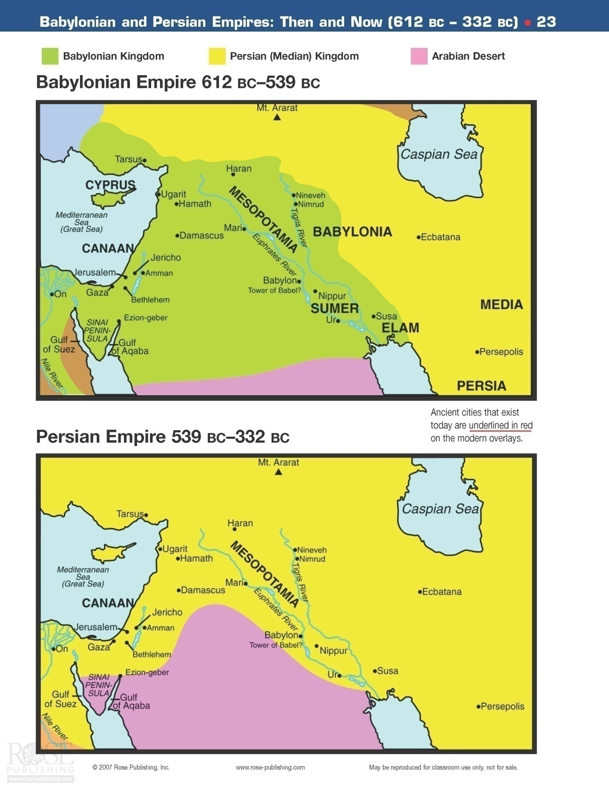
Wisdom Books

The book of Job:
Job lived in the time of the patriarchs, most likely. This is a powerful story concerning a just man’s relationship with God. Satan approached God in Heaven and told Him that men only follow God because they know that God will give them things… not because of any real love for Him. God told Satan that this was not true of devoted, faithful believers. They would follow God no matter what the situation, simply because they love Him and they know how much God loves them. Satan suggested a test of their contradictory beliefs. Job became the test case. Job was very faithful to God, but it was also true that he seemingly had a great, full life. What would happen if God allowed Satan to take these things away? God would allow Satan to “test” Job by making his life horrid… yet, God did require that Satan stop short of killing Job. Soon, Job had lost all of his wealth, family and health! He was incredibly perplexed, but did not turn his back on God. Even after losing most of his possessions and all of his children, he was heard to say…
"Naked I came from my mother's womb, and naked shall I return there. The Lord gave, and the Lord has taken away; Blessed be the name of the Lord." In all this Job did not sin nor charge God with wrong. Job 1:21-22

Satan then told God that Job was only holding out because he was not in any personal physical discomfort. That is when God told Satan that he could test Job in any way he wanted as long as he did not kill him…

Satan went out from the presence of the Lord, and struck Job with painful boils from the sole of his foot to the crown of his head. And he took for himself a potsherd with which to scrape himself while he sat in the midst of the ashes. Then his wife said to him, "Do you still hold fast to your integrity? Curse God and die!" But he said to her, "You speak as one of the foolish women speaks. Shall we indeed accept good from God, and shall we not accept adversity?" In all this Job did not sin with his lips. Job 2:7-10

Although Job was so very strong at the onset of this calamity, as time went by, he became more and more despondent. He wished that he had never been born.

"Why did I not die at birth? Why did I not perish when I came from the womb? Why did the knees receive me? Or why the breasts, that I should nurse? For now I would have lain still and been quiet, I would have been asleep; Then I would have been at rest. Job 3:11-13

A little while later, three of Job’s friends arrived. They were going to attempt to comfort him and help him with advice. For the first week, they all just sat together in silence.

And when they raised their eyes from afar, and did not recognize him, they lifted their voices and wept; and each one tore his robe and sprinkled dust on his head toward heaven. So they sat down with him on the ground seven days and seven nights, and no one spoke a word to him, for they saw that his grief was very great. Job 2:12-13

These were the friends:

Eliphaz the Temanite a great-grandson of Esau
Bildad the Shuhite in the lineage of Abraham
Zophar the Naamathite: Naamah was from northern Arabia
For the next several days, Job engaged in long discussions with each of these three men. Each one of them was convinced that God was punishing Job for certain sins that he must have committed. They all had a different twist on this theme, but all three called for Job to repent immediately and completely and beg for forgiveness for his sins. Job was not too pleased with their pitiful attempts at sympathy, to say the least. He had hoped that they would just give him some words of comfort. Instead, they were saying that it was obvious that he was an unrepentant sinner that was being punished by God. He told the three of them that they had no idea what he had done to deserve this punishment. In fact, Job still stated that he was blameless and had no idea why God was doing this to him. He realized that God was sovereign, and could therefore do what He pleased, but that still did not make it right in Job’s eyes. In fact, Job wanted desperately to argue his case in front of the Almighty. On the other hand, Job also thought that this would be a fruitless endeavor as God was so different than man... on a totally different and incredibly higher level. How could a man argue with God? Maybe if there were a mediator…
“For He is not a man like myself, that I should answer Him, that we should come together in judgment. Would that there were an arbiter between us, who could lay his hand upon us both and withdraw His rod from me.” Job 9:32-33
In point of fact, there would be an arbitrator that would come on the scene later in history. That arbiter is now every Christians’ defense attorney up in Heaven! His name is Jesus!
Job continued his private conversation with God…
“Are not the days of my life few? Let me alone, that I may recover a little before I go whence I shall not return, to the land of darkness and of gloom, the black, disordered land where darkness is the only light.” (Job 10:20-22)

He asked God to just let him have a break for a little while… he was going to die soon enough anyway.
Returning to speak to his three friends, Job finally can’t stand their condescending statements any longer and makes a wisecrack himself…

“No doubt you are the people and wisdom shall die with you.” Job 12:1-2

Then Job continues with his request to have an audience with God…

“Surely I would speak to the Almighty, and I desire to reason with God.” Job 13:3
“Hold your peace, let me alone, that I may speak, and let come on me what will.” Job 13:13
“Though He slay me, yet will I trust (hope) in Him: but I will maintain mine own ways before Him (I will surely defend my ways to His face).” Job 13:15
Then, for the first time, Job says something that suggests he realizes that he is not so perfect…
“How many are mine iniquities and sins? Make me to know my transgressions and my sin. Job 13:23
A very well known verse follows…
“Man that is born of woman is few of days and full of trouble. He cometh forth like a flower, and is cut down: he fleeth also as a shadow, and continueth not.” Job 14-1-2
So Job continues in his miserable mental and physical state, wondering why God would do this to him, yet realizing that God can and will do what He wants.
The three men (so called friends) next have a second and then a third round of talks with Job. Each time, they get a little more demanding in their speech that Job recognize his sin and repent immediately. Job gets even more angry with them and notes how he would have acted toward them had the roles been reversed:
“I have heard many such things: miserable comforters are ye all. I also could speak as ye do: if your soul were in my soul’s stead, I could heap up words against you, and shake mine head at you. But I would strengthen you with my mouth, and the moving of my lips should assuage your grief.” Job 16:1,4-5
Job continues his internal battle to attempt to understand why all of these horrible things are happening to him. He does not feel that the amount of judgment is appropriate for his actions in the past. He has finally noted that he is a sinner, but still feels that the amount of torture that he has been going through is not reasonable. He many times noted how other people seem to be getting away with “murder” without any apparent distress or punishment. What is the problem, God? Why? Why? Why? That is what Job wants to know. Why does it work this way?!
“God hath delivered me to the ungodly, and turned me over into the hands of the wicked.” Job 16:11
Yet, even in his despair, Job knows that someday he will be fine…
For I know that my redeemer liveth, and that he shall stand at the latter day upon the earth: And though after my skin worms destroy this body, yet in my flesh I shall see God: Whom I shall see for myself, and mine eyes shall behold, and not another. Job 19:23-27
This is an old time example of something that we all experience today. Even when we are in the depths of despair, we often go from strong feelings of faith to desperate feelings of hopelessness. That is what Job was doing while suffering so terribly.
Job finally told his three friends that he would not be a hypocrite and ask God to forgive him of sins that he did not recall committing. He felt that God would be even more upset with that hypocrisy.
“My righteousness I hold fast, and will not let it go: my heart shall not reproach me so long as I live…………..For what is the hope of the hypocrite, though he hath gained, when God taketh away his soul.” (Job 27:6&8)
“So these three men ceased to answer Job, because he was righteous in his own eyes.” Job 32:1
Next, a younger man came onto the scene to give Job his two cents. Elihu had been listening to the older folk talk and now he joined in the conversation Although Elihu had a slightly different argument than the other three friends, it still boiled down to the fact that he believed that Job must be being punished for his sins. So he really had nothing at all to offer Job. So, Job was finding no answers for his predicament. Things were looking very bleak. Then, God came on to the scene in a powerful way:
Then the Lord answered Job out of the whirlwind, and said: "Who is this who darkens counsel by words without knowledge? Now prepare yourself like a man; I will question you, and you shall answer Me. "Where were you when I laid the foundations of the earth? Tell Me, if you have understanding. Who determined its measurements? Surely you know! Job 38:1-5
God asks a rhetorical question. Gods point is that Job is simply too inferior a being to understand the ways of God. None of us can really understand just how and why God does what He does. We may be able to grasp the ultimate goals of our lives, but the understanding of just how God is working these out seems mighty elusive. God spends a lot of time reminding Job of His (i.e. God’s) power, intelligence, wisdom, goodness and love. This is simply to point out that God’s ways are not our ways… as it states elsewhere in the Bible. The question is whether we as His followers are going to remember who God is… a God of pure Love that certainly would never do anything that would ultimately not be in our best interests. As an analogy, think of a parent who requires a toddler get an appendix operation as the little one’s appendix has become infected. The toddler does not want the operation… thinks it is a terrible idea and knows that it will hurt. Yet, ultimately, even that little child knows enough to trust his father or mother to do what is best for him. That is the way we all should look at what is happening in our lives. God knows what He is doing… even when we do not know what He is doing. It will all work out for our best in the “end”… .and that “end” is an eternity of bliss!
"Shall the one who contends with the Almighty correct Him? He who rebukes God, let him answer it." Then Job answered the Lord and said: "Behold, I am vile; What shall I answer You? I lay my hand over my mouth. Once I have spoken, but I will not answer; Yes, twice, but I will proceed no further." Job 40:2-5

Then Job answered the Lord and said: "I know that You can do everything, And that no purpose of Yours can be withheld from You. You asked, 'Who is this who hides counsel without knowledge?' Therefore I have uttered what I did not understand, Things too wonderful for me, which I did not know. Listen, please, and let me speak; You said, 'I will question you, and you shall answer Me.' "I have heard of You by the hearing of the ear, But now my eye sees You. Therefore I abhor myself, And repent in dust and ashes." Job 42:1-6

Job now “sees” God and knows that God knows best. Remember we all need at times need to remember what God has directed us to do… “Be still and know that I am God”.

Here is another point to make… remember that no one can please God without faith. This is noted in the Bible. Although it certainly is possible for God to explain in enough detail for us to understand the “why” of Job’s question, He does not want to do this. Why may that be the case? I believe that it is important for God NOT to explain all of His actions to us as Christians. If we totally understand everything that happens to us in life, where is the need for faith. There would not be any. Yet, it is important for us to exercise our faith. How exactly? We should know God well enough to know that He loves us intensely and will take perfect care of His children. That being the case, we need show Him (and ourselves) our faith in Him by trusting Him in all things… even those things like Job was going through, when necessary. When we do this, God will surely bless us.

At the end of the book of Job, God rewards Job for his faithfulness and for recognizing the key to living in this world… complete trust in the goodness and love of God… and obedience to God. God, of course, knew that Job was indeed a “righteous man” as well. As for the four “friends” of Job – God reprimanded them for their terrible advice and lack of comfort during Job’s time of trouble.

Proverbs: This book concerns itself with short insights into the wisdom needed for living a proper, moral life. Topics include instruction on sin, wealth, poverty, the tongue, life, death, family, love, lust, gluttony, vengeance, pride, humility and many more. In general, the proverbs tend to compare and contrast the foolishness of a man who denies God with the wisdom of those who follow the one true God.
Proverbs is divided into seven chapter sections:
- Wisdom (1-9)
- Proverbs of Solomon (10:1-22:16)
- Thirty Sayings of the Wise (22:17-24:34)
- King Hezekiah’s collection of Solomon’s Proverbs (25-29)
- The Proverbs of Agur (30)
- The Proverbs of Lemuel (31:1-9)
- The Proverbs of the Worthy Woman (31:10-31)

Solomon tells us why these Proverbs were written…
To know wisdom and instruction, to perceive the words of understanding, to receive the instruction of wisdom, Justice, judgment, and equity; to give prudence to the simple, to the young man knowledge and discretion. A wise man will hear and increase learning, and a man of understanding will attain wise counsel, to understand a proverb and an enigma, the words of the wise and their riddles. The fear of the Lord is the beginning of knowledge, but fools despise wisdom and instruction. Prov 1:2-7

Wisdom is not native IQ but the ability to use the knowledge that one has to perform admirably in situations and problems encountered in everyday life. I like to say that the only thing that gets better as we get older is wisdom. Well, at least it should if we learn from our mistakes and successes.
As noted earlier, the first batch of proverbs deals with the topic of wisdom and how to get it. For example, my favorite Proverb is 3:5-6:
Trust in the Lord with all your heart, and lean not on your own understanding; In all your ways acknowledge Him, And He shall direct your paths. Prov 3:5-6

The key here is to trust in the Lord for wisdom. That is actually the main key for all the “wisdom proverbs”. One more example below…

My son, keep my words, and treasure my commands within you. Keep my commands and live, and my law as the apple of your eye. Bind them on your fingers; Write them on the tablet of your heart. Say to wisdom, "You are my sister," And call understanding your nearest kin, that they may keep you from the immoral woman, from the seductress who flatters with her words. Prov 7:1-5

Next come the Proverbs of Solomon. They are typically short and quick. Here are a few examples:

A wise son makes a glad father, but a foolish son is the grief of his mother. Prov 10:1

In the multitude of words sin is not lacking, but he who restrains his lips is wise. Prov 10:19

The fear of the Lord prolongs days, but the years of the wicked will be shortened. Prov 10:27

When pride comes, then comes shame; but with the humble is wisdom. Prov 11:2

The fruit of the righteous is a tree of life, and he who wins souls is wise. Prov 11:30

Whoever loves instruction loves knowledge, but he who hates correction is stupid. Prov 12:1

He who spares his rod hates his son, but he who loves him disciplines him promptly. Prov 13:24

There is a way that seems right to a man, but its end is the way of death. Prov 14:12

In the fear of the Lord there is strong confidence, and His children will have a place of refuge. Prov 14:26

A soft answer turns away wrath, but a harsh word stirs up anger. Prov 15:1

Pride goes before destruction, and a haughty spirit before a fall. Prov 16:18

He who is slow to anger is better than the mighty, and he who rules his spirit than he who takes a city. Prov 16:32
He who finds a wife finds a good thing, and obtains favor from the Lord. Prov 18:22

Chasten your son while there is hope, and do not set your heart on his destruction. Prov 19:18

A good name is to be chosen rather than great riches, Loving favor rather than silver and gold. Prov 22:1

King Hezekiah collated these sayings of Solomon:
As a dog returns to his own vomit, so a fool repeats his folly. Do you see a man wise in his own eyes? There is more hope for a fool than for him. Prov 26:11-12

Do not boast about tomorrow, for you do not know what a day may bring forth. Let another man praise you, and not your own mouth; a stranger, and not your own lips. Prov 27:1-2

He who gives to the poor will not lack, but he who hides his eyes will have many curses. Prov 28:27

From Agur:
Every word of God is pure; He is a shield to those who put their trust in Him. Do not add to His words, Lest He rebuke you, and you be found a liar. Prov 30:5-6
Proverbs 31: This ends with a beautiful long section concerned primarily with the qualities of a good wife. Most seem to attribute this portion of the 31st chapter to Solomon. He goes on to describe this virtuous woman who is strong in the Lord. Her husband is known by the elders as a very blessed man because of his wife.
These many sayings give the overall idea of the book of Proverbs. Certainly, if we all lived by their wisdom, this would be a much better world and we would be much better individuals!

Psalms: This is a great collection of songs and poetry written by several men over 900 years. They cover a wide range of topics including: praise for God’s greatness, thanksgiving, calling out for God’s help and grace, and so many others. They are a great comfort to all who read them as they call to God to hear their prayer, whether it be to praise Him, thank Him or plead with Him for His help in times of trouble. Most were meant for public worship, while others were obviously meant for private prayer. Psalms can be divided up into five sections:
- Book One (1-41) Around the time of David Man - Genesis
- Book Two (42-72) Around the time of David Deliverance - Exodus
- Book Three (73-89) After Israel’s fall Sanctuary - Leviticus
- Book Four (90-106) After Israel’s fall Wandering - Numbers
- Book Five (107-150) After the return from exile Word of God - Deuteronomy

King David authored about one half of the Psalms. A Levite in charge of music, Asaph, or one of his descendants, authored approximately 12 more. Moses wrote Psalm 90. Solomon wrote Psalm 72 and 127. Korah’s descendants, the priest who led a rebellion against Moses, wrote about twelve. A man named Ethan wrote one. King Hezekiah may have written some. There are 34 Psalms that have no known author.

There is another way of looking at the Psalms… the topical breakdown:
- Attributes of God (Glory, Holiness, Justice, Mercy, Love, Eternality, Omnipotence, etc.)
- Messianic Psalms (ex. Resurrection, Ascension, Millennium reign, death, etc.)
- Relationship Psalms (Shepherd and His flock plus the Son and His Father, etc.)
- Events in Israel’s history (ex. Babylonian captivity, Destruction of Jerusalem, etc.)
- Events in David’s life (ex. Fleeing Saul, Sin with Bathsheba, Coronation of Solomon…)
- Future Events (tribulation, Millennium)
- Imprecatory (crying out for God to punish the wicked)
- Confessional
- Worship
- Praise and Thanksgiving

Psalms has the most Messianic passages of any Old Testament book. It is quoted often in the New Testament. In fact, it is quoted second only to Isaiah.

There are many wonderful Psalms. Of course, the Shepherd’s Psalm, the 23rd, is the most famous. Many people like to study the 22nd through the 24th Psalms together as they make a beautiful story of the coming Lord Jesus. Other favorites include Psalm 19, 32, 33, 52, 91, 100, 107, 119, 121, and 148. There are many, many other beautiful and poignant Psalms as well. They should be read frequently.

Ecclesiastes: This is the book that shows that nothing at all in this life on earth can satisfy the human soul…nothing at all… except for God. The author, King Solomon, seemingly had it all and tried it all, but until he turned to God, it was all “vanity”.
What are some of the things that Solomon tried to bring him meaning in his life? Let me just list a few:
- Laughter
- Money
- Wine
- Sex
- Beautiful home and gardens
- Music
- Knowledge
- Work
- Wisdom
None of these things brought meaning to his life, unfortunately.

To everything there is a season, A time for every purpose under heaven: A time to be born, And a time to die; A time to plant, And a time to pluck what is planted; A time to kill, And a time to heal; A time to break down, And a time to build up; A time to weep, And a time to laugh; A time to mourn, And a time to dance; A time to cast away stones, And a time to gather stones; A time to embrace, And a time to refrain from embracing; A time to gain, And a time to lose; A time to keep, And a time to throw away; A time to tear, And a time to sew; A time to keep silence, And a time to speak; A time to love, And a time to hate; A time of war, And a time of peace. Eccl 3:1-8

This world that we live in is bounded by time. Everything will end at some point as far as our life on this earth is concerned. On the other hand, God has the controls for eternity. The things of this world cannot satisfy as they are limited by time… and for other reasons as well. Eternal things are under God’s control. He has put eternity in their hearts, except that no one can find out the work that God does from beginning to end. Eccl 3:11
Solomon went on to discuss the vanity of power, wealth, striving for more of everything and never being satisfied. He took a moment near the end of this book to point out that although life seemed so meaningless, it was still more reasonable to live wisely and not like a fool. Solomon tells the reader that he or she should rejoice in their youth as old age is just around the corner. Then, it will be so different:
In the day when the keepers of the house tremble, And the strong men bow down; When the grinders cease because they are few, and those that look through the windows grow dim; When the doors are shut in the streets, and the sound of grinding is low; When one rises up at the sound of a bird, and all the daughters of music are brought low; Also they are afraid of height, and of terrors in the way; When the almond tree blossoms, The grasshopper is a burden, and desire fails. For man goes to his eternal home, and the mourners go about the streets. Remember your Creator before the silver cord is loosed, or the golden bowl is broken, or the pitcher shattered at the fountain, Or the wheel broken at the well. Then the dust will return to the earth as it was, and the spirit will return to God who gave it. "Vanity of vanities," says the Preacher, "All is vanity." Eccl 12:3-8

Another favorite verse in this book is worth mentioning… there is nothing new under the sun. Eccl 1:9
There will be nothing that any of us ever experience on the earth that has not happened to someone else at some time in history.

Finally, the conclusion of this most unusual book in the Bible:

Let us hear the conclusion of the whole matter: Fear God and keep His commandments, For this is man's all. For God will bring every work into judgment, including every secret thing, Whether good or evil. Eccl 12:13-14

What then is the bottom line in this book? Solomon has written a book here wherein, at one point, he has stated that it would be better not to have been born considering the “vanity” of life on earth. Of course, there are millions of people alive today who disagree with him. Yet, there are many who agree or have agreed in the past. Apparently, the Buddha wished that he had never been born. Robert Kennedy was noted to say that his life was so sad that he wished he had not been born. There are, of course, millions more like these two. The fact is, that if you are reading this, you were born. Now what?
That brings us to the final comment by the sage King Solomon. What should we do while we live our life down here on earth? “Fear God and keep His commandments. For this is man’s all.” Our whole life should revolve around following God to the best of our ability. Do what He says, beginning with trusting Him for our salvation. Then trust Him for everything else. The good news is that God has made life not only palatable through His Son Jesus Christ, but, eventually, glorious. Yes, there will be difficult times on earth in this, our testing time. No doubt about that at all. But… WOW! The rewards in Heaven will be truly unbelievable!!!

Song of Solomon: This book describes the love of Solomon for a Shulammite girl. This is one of the 1005 songs that he composed. It was probably written in 950 B.C. or thereabouts. There are passages that portray the joys of love in marriage and there are many verses that suggest the love of God the Father (and Jesus) for His people.

The first few chapters show the beauty and excitement of blossoming love…

Let him kiss me with the kisses of his mouth-- For your love is better than wine. Because of the fragrance of your good ointments, Song 1:2-3

I am the rose of Sharon, and the lily of the valleys. The Beloved like a lily among thorns, so is my love among the daughters. The Shulamite like an apple tree among the trees of the woods, so is my beloved among the sons. Song 2:1-3

My beloved is like a gazelle or a young stag. Behold, he stands behind our wall; He is looking through the windows, Gazing through the lattice. My beloved spoke, and said to me: "Rise up, my love, my fair one, and come away. Song 2:9-10

The next section of the poem tells of Solomon coming in all his kingly glory to marry her. The bride sees him coming and speaks of his appearance. Solomon then notes the beauty of his bride…

Who is this coming out of the wilderness like pillars of smoke, Perfumed with myrrh and frankincense, with all the merchant's fragrant powders? Behold, it is Solomon's couch, with sixty valiant men around it, Song 3:6-7

Behold, you are fair, my love! Behold, you are fair! You have dove's eyes behind your veil. Your hair is like a flock of goats, going down from Mount Gilead. Your teeth are like a flock of shorn sheep which have come up from the washing, every one of which bears twins, and none is barren among them. Your lips are like a strand of scarlet, and your mouth is lovely. Your temples behind your veil are like a piece of pomegranate. Your neck is like the tower of David, Song 4:1-4

The young woman goes on to tell her ladies in waiting about her groom…

My beloved is white and ruddy, Chief among ten thousand. His head is like the finest gold; His locks are wavy, and black as a raven. His lips are lilies, dripping liquid myrrh. His hands are rods of gold Set with beryl. His body is carved ivory inlaid with sapphires. His legs are pillars of marble Set on bases of fine gold. His countenance is like Lebanon, excellent as the cedars. His mouth is most sweet, yes, he is altogether lovely. This is my beloved, and this is my friend, O daughters of Jerusalem! Song 5:10, 12-16

Next the honeymoon came as the Shulamite girl tells Solomon that she is ready to go to him.

I am my beloved's, and his desire is toward me. Come, my beloved, Let us go forth to the field; Let us lodge in the villages. Let us get up early to the vineyards; Let us see if the vine has budded, whether the grape blossoms are open, and the pomegranates are in bloom. There I will give you my love. Song 7:10-12
So this is a picture of a beautiful courtship and marriage of a man and a woman. Some theologians believe that it may be a “type” of the marriage that the Church has with Jesus Christ. That is a matter of opinion.

Conclusion: So this concludes our “walk” through the Old Testament. As one can see fairly clearly, it is the account of God’s dealings with his creation. In particular, this is told through His dealings with a group of people, the Jews. In this Testament, God gave His people laws written in stone. All that was needed for complete success in life was to follow these commandments, that is, to follow God. Unfortunately, this proved to be too difficult. Of course, God knew that this would happen. Nothing surprises Him. All through the Old Testament is the constant mention, quite clearly at times, more subtle at other times, that a New Covenant was to come. Since the time of Moses, there was a need to follow a clearly written moral law. When these laws were broken, there also was the need for repentance for sins. God provided a system for paying the penalty for their sins… i.e. repentance followed by sacrificing an “unblemished” lamb. This was a temporary system for God’s people to follow until a permanent answer for forgiveness of mankind’s sins was provided. As is turns out, the sacrificial lamb was a “picture” of what was to come.
A very common theme also was noted in the Old Testament. So often God’s people would turn their back on their Lord. God would then demand their repentance. It typically would not be forthcoming, so then judgment would ultimately come as it must always for unrepentant and unforgiven sin. But it is very noteworthy to remember, God always told of a time that would come when everything would be beautiful, all would be forgiven, and all His people would live together in peace and love for eternity. What was needed desperately, however, was someone to lead the people and provide what was necessary to save them from themselves… to save them from their sins. God was soon to provide this in the form of the Messiah, His only begotten Son, our Lord Jesus Christ. He would become the one True Lamb. He would be able to pay the penalty for all mankind’s sin as only He would be a sinless offering, a perfect substitutionary offering for sinful mankind. His shed blood would pay the price… the perfect Lamb of God. The story of His birth was next on the agenda as God was about to step into the world to show us how to live and to save us from our sins!

