
DANIEL SIMPSON POST 630

N. Main St, Elburn, IL 60119 Office Phone – 630-365-6530
Post email – elburnpost630@gmail.com
Website – www.elburnpost630.org

July 2026 Newsletter


Post Officers:
Commander: Norm Welker
Sr. Vice Commander: John Nevenhoven
Jr. Vice Commander: John Waynick
Adjutant: John Reece
Finance: John Waynick
Service Officer: Norm Welker
Chaplain: Tim Kolzow


DESIGNATED DISABLED PARKING SPACES are in the rear parking lot. There is a chair lift at the rear entrance (Gate St.). Also, there is a wheelchair lift at the front entrance (Main St. or Rt. 47). Please call ahead, Ph# 630-365-6530; someone will come and operate the lift.

Post Meetings

General Post meetings are held on the second Monday of each month. Doors open at 5:00 PM, dinner is served at 6PM, and Meeting starts at 7:00 PM. Members of the Legion Riders, Legion Auxiliary and Sons of the American Legion are welcome as well as prospective members and members of other Legion Posts.

Guests are asked to kindly sign in with the Sgt at Arms.

Post Calendar

July 2026
(Holiday/Notable/Post Event)

Sunday | Monday | Tuesday | Wednesday | Thursday | Friday | Saturday
 |  |  | 1 | 2 | 3 | 4
5 | 6 | 7 | 8 | 9 | 10 | 11
12 | 13 | 14 | 15 | 16 | 17 | 18
19 | 20 | 21 | 22 | 23 | 24 | 25
26 | 27 | 28 | 29 | 30 | 31

Important Dates

2nd – Queen of Hearts
3rd – Federal holiday observed for Independence Day
4th - Official Independence Day (1776) 250th Anniversary
3rd – 8th The US Navy and key maritime partners will host the historic International Naval Review 250 in the Port of New York and New Jersey to celebrate the Nation’s 250th
Birthday!
6th – National Fried Chicken Day
9th - Queen of Hearts 13th – American Legion Elburn Post 630 Meeting
14th – Bastille Day (France) and National Mac and Cheese Day

16th - Queen of Hearts
19th - National Ice Cream Day
4th annual American Legion Rides Tots for Tots Motorcycle ride and street party benefiting Kane County Toys for Tot via the Tots for Tots Foundation – 3PM 23rd – Queen of Hearts
26th - National Parents Day – actually signed into law by Former President Bill Clinton 1994 27th – Korean War Veterans Armistice Day commemorating the signing of the armistice that ended hostilities in the Korean Way in 1953.
30th – Queen of Hearts and International Day of Friendship

Happy 250th Birthday, America!

I have included several interactive websites so that we can continue to educate and be educated. However, we ought to get out from behind the screens and celebrate with our communities, families and friends with time together and great food! So, proudly fly Old Glory, don your patriotic best, fire up the grill, and hug the babies under a canopy of fireworks.

Elburn’s fireworks are on July 11th. Check out the flyers all over town.

My own family will be together to celebrate. All the while, my daughter and now Marine Corps Retired son-in-law make will be making their way home to Illinois this month to extend the celebration.

https://america250.org/

https://spiritofamerica.org

https://www.state.gov/freedom-250

https://www.eisenhowerlibrary.gov/celebrate-america-250

https://freedom250.org/celebration

https://www.whitehouse.gov/freedom250/

Happy Independence Day and be safe!



Next Post Meeting

The next monthly meeting of Elburn American Legion Post 630 will be held July 13th, 2026. Doors open at 5PM, dinner is served at 6PM in the Lower Level. Dinner has yet to be determined. Want to help? You can bring some type of dessert and donations are gladly accepted.

++++


As of June 25th, the Queen of Hearts is still out there hiding in one of many of the unopened envelopes on our Board. Who will find the Queen of Hearts??

Jackpot is over $33,000
Get your tickets fast! Come on down to the Bunker Bar on Thursday nights or stop by the office and pick some up. You can also call Norm at the office 630-365-6530 and start a subscription, so you never miss a chance.

Tickets are $1 each or 6 for $5.



Post Elections

Nominations were submitted to the membership on June 8th during the regular
June meeting and votes were cast. The following are the new officers of Elburn
Post 630: John Reece, Commander; John Nevenhoven, Sr. Vice Commander; Tyler Lawrence, Jr. Vice Commander. Let us wish these members well as they lead us into the next year. We are still looking for members to hold the offices of Adjutant and Finance officer.

++++

Then and Now

We know who are they now but, how did they look back then?



This veteran did his basic training This Air Force veteran enlisted in 1958 at Ft Leornard Wood. He started as station in Korea and March AFB as an MP. a driver but then switch to be an Engineer. After discharge in 1962 he was encouraged He served in several officer positions at the by his friend Steve McQueen to go into Post and is also a member of the SAL. acting. And the rest is history.

Answers will be in the August 2026 Newsletter with more photos.

Military, college or high school picture can be sent either Tim Kolzow (takolzow@gmail.com) or Jo Gabl (jojobean.gabl@gmail.com)


June’s Then & Now Answers


Bea Arthur – Actress Drew Carey – Actor



July Puzzle
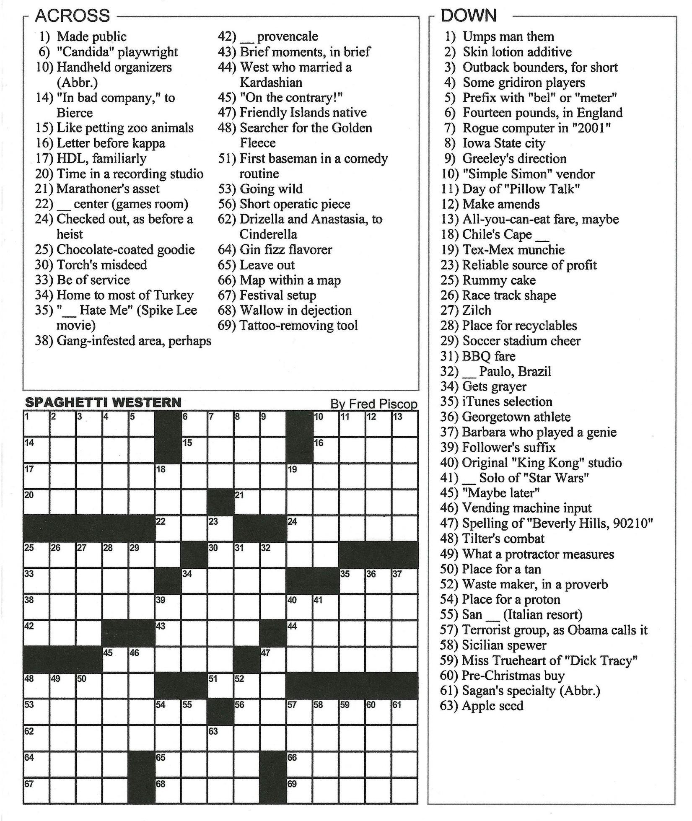

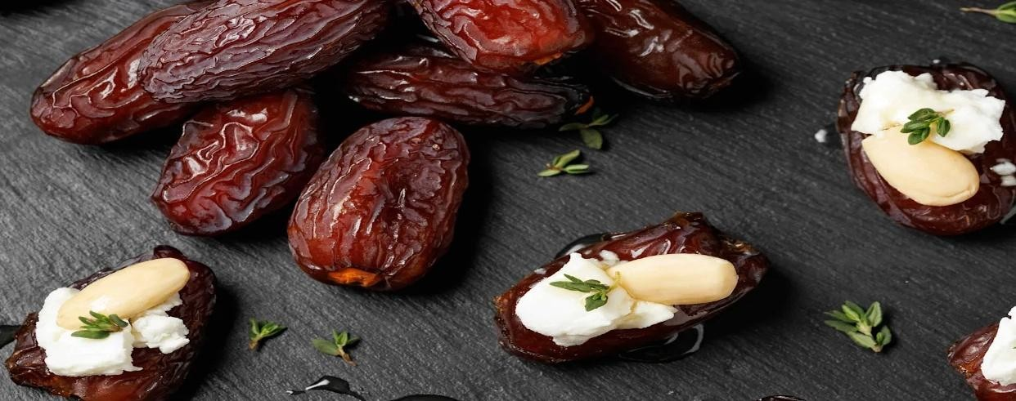
Dates Deliver Surprising Health Benefits You're
Probably Overlooking

This dried fruit
makes a nutritious
snack
—
as long as
you keep your
portion size in check.

Randi Gollin

Mon, April 6, 2026

Credit:

DronG

/

Getty

Images

Key Points

 |  | • | Eating dates can improve gut, heart, and bone health due to their fiber and nutrient
 |  |  | content.
 |  | • | Even though dates are healthy, it's important to eat them in moderation because of their sugar levels.
 |  | • | Pairing dates with fiber, protein, or fats can help balance blood sugar and maximize their health benefits.
If you're searching for a fuss-free, sweet snack that's also good for you, consider the benefits
of | dates |  |  | . The fruit of the date palm tree, with Middle Eastern roots dating back thousands of  years, these satisfying treats are beloved by home cooks and health professionals alike, for ample reason. We spoke to registered dietitians to learn more about their nourishing
properties and how eating them regularly can benefit our bodies.
Meet Our Expert
 |  | • | Connie Elick |  | , MS, RD, and |  | instructor of plant-based culinary arts |  | at the Institute of
 |  | •  • | Culinary Education’s Los Angeles campus  and author of several cookbooks,
  Desiree Nielsen |  | , RD, host of | The Allsorts podcast | ,
  including | Plant Magic: A Celebration of Plant-Based Cooking for Everyone
 |  | •  • | Amanda Holtzer |  |  | , MS, RD, and founder of |  | Amanda Ghee Nutrition
Dates, Explained
Dates are sold fresh and sun-dried, but the latter is more readily available in the U.S. Of the hundreds of varieties, Medjool and Deglet Noor are the most widely available. Moist and deliciously sticky with rich, concentrated flavor, these brown and amber-colored fruits are sold with or without pits.

The Benefits of Dates
Dates are considered a superfood, says Connie Elick, MS, RD, and instructor of plant-based
culinary arts at the Institute of Culinary Education’s Los Angeles campus. "Their nutritional benefits relate to bone health, digestive health, and heart health," she says.
Gut Health
fiber
"We often forget that dates are fruit; like all fruits, they do contain —1.6 grams per date—as well as small amounts of vitamins and minerals," says Desiree Nielsen, RD, host
of The Allsorts podcast, and author of the cookbooks, Plant Magic and Good for Your Gut.
Helps with constipation: Fiber supports digestion and is integral to other bodily functions.
"Adequate fiber intake is crucial for bowel regularity, proper digestion, blood sugar management, weight management, and satiety," says Amanda Holtzer, MS, RD.
Beneficial compounds: But the fruit's fiber content isn't solely responsible for keeping the

gut in working order. "Dates are a great gut health food, both because of their fiber but also
because they contain compounds that help feed the gut microbiome, like polyphenols,
sorbitol, and fructans,” explains Nielsen. A healthy microbiome can help influence our overall health, she adds.
Tips
prunes | , apricots, and | figs
Generally, dates have a higher concentration of polyphenols (antioxidants) than other dried fruits, such as .
Heart Health
Dates' fiber content also helps support heart health. "As fiber moves through the GI tract, one
of the things it binds to is LDL cholesterol particles (aka 'bad' cholesterol)," Holtzer says. Fiber helps remove these LDL particles through the stool, which helps reduce LDL cholesterol in the blood.
Potassium: Dates are a good source of potassium, which helps regulate blood pressure, a marker of cardiovascular health, Holtzer says.
Antioxidants: The polyphenols also make a valuable contribution, helping to decrease
inflammation and reduce damage from free radicals, Elick says.
Individuals with pre-diabetes or diabetes should exercise caution when consuming dates, as their high sugar and carbohydrate content may impact blood sugar levels. Always consult with a healthcare professional for personalized dietary advice.

Strong Bones
Dates contain calcium, which works with phosphorus, minerals that are essential for the formation and health of bones and teeth, Holtzer says."Magnesium plays a role in activating vitamin D (needed for bone health) and promoting the absorption of calcium, and contributes to bone density," Elick adds.
Big Picture
For all of their merits, Nielsen is wary of overstating the nutritional value of dates. "While their fiber content is substantial, you would need to consume a lot of dates to get meaningful
amounts of vitamins and minerals," she says. One Medjool date, she points out, has about 15
mg of calcium (about 2 percent of your daily needs) and 167 mg of potassium (our daily requirement is 2600 to 3400 mg).
How Much to Eat
While you could double down on your intake to move the needle, our experts caution against going whole hog.
Moderation: "Dates should be consumed as part of a balanced, varied, portion-controlled diet," Elick says, noting that some studies indicate that eating 2 to 3 dates per day can contribute to health benefits.
Carbs and sugars: "They are a plant-based, nutrient-dense, wonderfully healthy food. But when it comes down to brass tacks, 132 calories, 36 grams of carbs, and 32 grams of sugar for just two dates is significant," Holtzer says.
Diabetic conditions: For most healthy people, those numbers aren't cause for worry—and
for some, the high levels of carbohydrates, in combination with their iron content, may be an energy boost—but for others, they can be a forbidden fruit. "If you are someone with pre-
diabetes or | diabetes | , dates may not be the best option for you because of the high carb and
diabetes or | sugar content," Holtzer says.
Glycemic Index
As we bump up our serving size, the glycemic impact (GI) also increases, Nielsen says. "For folks who are watching their blood sugars, I would caution against what I often see online, which is characterizing dates almost as a 'freebie’ when it comes to blood sugars."
dried fig
Glycemic load: While Medjool dates have a GI of 55, which is at the edge of the low category, Nielsen says, that number doesn't tell the whole story. "The true glycemic impact of a food—if we're eating it on its own—is the glycemic load, or the GL. This measures the glycemic impact of the carbs, as well as the carbs themselves. So, a single date has a GL of 8, which is also low ... and roughly the same as a ."
Food Pairings
How you eat them also makes a difference. When dates are enjoyed with foods rich in fiber, protein, and healthy fats, these nutrients help moderate the impact of carbohydratecontaining foods on our blood sugar, Nielsen says.
Tips
Some dried dates contain sulfites, which can trigger allergic or negative reactions like rashes or eye sensitivity for some people.
What About Date Products?
Dates are also a star ingredient in other products, most notably date syrup and date sugar.
Processed Products: Date syrup that contains the whole date fruit will have a similar nutrient profile, Nielsen says, while date sugars may be derived from the whole food or more refined. "Some of the nutritional benefits of dates may be lost during processing, but still remain in date syrup or date sugar, and these may be more nutritious than typical refined white sugar," Elick says.
alternative sweeteners
Limit Intake: These should be consumed in moderation, she notes,
since they still contain sugar, carbohydrates, and calories. "As with most foods, it is better to
eat dates in their whole form, rather than heavily processed forms."
++++



July Puzzle Solution

