

**DANIEL SIMPSON POST 630**

**112 N. Main St, Elburn, IL 60119 Office Phone – 630-365-6530**

**Post email – elburnpost630@gmail.com**

**Website – www.elburnpost630.org**

# January 2025 Newsletter

**Post Officers:**

Commander: Norm Welker

Sr. Vice Commander: John Nevenhoven

Jr. Vice Commander : Joanne “Jo” Gabl

Adjutant: John Waynick

Sergeant at Arms: Lloyd Da Mask

Judge Advocate/

Parliamentarian: Paul Gardner

Chaplain: Tim Kolzow

Interim Finance: Tim Kolzow

Post Service Officer: Norm Welker

Historian: Mark Krebs

## Post Meetings

The Post meets on the second Monday of each month. Doors open at 6:00 PM for dinner and comradery. The meeting starts at 7:00 PM. All members and prospective members are encouraged to attend.



### DISABLED PARKING IS IN THE REAR LOT. LIFTS ARE AT BOTH

**ENTRANCES, WHEELCHAIR LIFT IN THE FRONT, CHAIR LIFT IN THE REAR. CALL US WHEN YOU ARRIVE SO WE CAN HAVE SOMEONE READY TO ASSIST YOU.**

**Traveling this year?**

## Check this out from Congressman Foster’s office;



|  |  |  |  |  |
| --- | --- | --- | --- | --- |
| [Home](https://iqconnect.house.gov/iqextranet/iqClickTrk.aspx?&cid=IL11BF&crop=15421.17903238.5305102.8105956&report_id=Home&redirect=https%3a%2f%2ffoster.house.gov%2f&redir_log=209874139354175) | [Contact](https://iqconnect.house.gov/iqextranet/iqClickTrk.aspx?&cid=IL11BF&crop=15421.17903238.5305102.8105956&report_id=Contact&redirect=https%3a%2f%2ffoster.house.gov%2fcontact%2femail-me&redir_log=9956596869287) | [Latest News](https://iqconnect.house.gov/iqextranet/iqClickTrk.aspx?&cid=IL11BF&crop=15421.17903238.5305102.8105956&report_id=Latest+News&redirect=https%3a%2f%2ffoster.house.gov%2fmedia%2fin-the-news&redir_log=737127375058293) | [Email Updates](https://iqconnect.house.gov/iqextranet/iqClickTrk.aspx?&cid=IL11BF&crop=15421.17903238.5305102.8105956&report_id=Email+Updates&redirect=https%3a%2f%2ffoster.house.gov%2fcontact%2fnewsletter&redir_log=406990898566310) | [Tell a Friend](https://iqconnect.house.gov/iqextranet/view_newsletter_setup.aspx?forward=Y&link=IL11BF%2501101163%2501Travel%2bPassports%250115421.17903238.5305102.8105956%2501elburnpost630%2540gmail.com%2501American%2bLegion%2501American%2bLegion%2bPost%2b630%2501112%2bN%2bMain%2bSt%253cbr%253e%250d%250aElburn%252c%2bIL%2b60119-9203%2501American%2bLegion%2501) |

Dear Friend,

During this busy holiday travel season, I wanted to provide an update on current processing times for U.S. passport applications and Trusted Traveler Programs, such as TSA PreCheck and Global Entry.

The current processing times for U.S. passport applications are as follows:

* Routine processing: 4 to 6 weeks.
* Expedited processing: 2 to 3 weeks.
* For travel within 14 days, urgent processing is available but requires an in-person appointment.

Detailed information on passport applications and processing is available at [travel.state.gov .](https://iqconnect.house.gov/iqextranet/iqClickTrk.aspx?&cid=IL11BF&crop=15421.17903238.5305102.8105956&report_id=&redirect=https%3a%2f%2ftravel.state.gov%2fcontent%2ftravel.html&redir_log=833554609336313) As always, [my office can assist w](https://iqconnect.house.gov/iqextranet/iqClickTrk.aspx?&cid=IL11BF&crop=15421.17903238.5305102.8105956&report_id=&redirect=https%3a%2f%2ffoster.house.gov%2fservices%2fhelp-federal-agency&redir_log=577762285896374)ith the passport application process or request updates about pending applications.

The Department of Homeland Security offers Trusted Traveler Programs to make airport screening more efficient for both domestic and international travel:

* [TSA PreCheck e](https://iqconnect.house.gov/iqextranet/iqClickTrk.aspx?&cid=IL11BF&crop=15421.17903238.5305102.8105956&report_id=&redirect=https%3a%2f%2fwww.cbp.gov%2ftravel%2ftrusted-traveler-programs%2ftsa-precheck&redir_log=96922143855462)xpedites traveler screening through TSA checkpoints at most major U.S. airports. Most applicants receive approval in 3 to 5 days.
* [Global Entry](https://iqconnect.house.gov/iqextranet/iqClickTrk.aspx?&cid=IL11BF&crop=15421.17903238.5305102.8105956&report_id=&redirect=https%3a%2f%2fwww.cbp.gov%2ftravel%2ftrusted-traveler-programs%2fglobal-entry&redir_log=525026235854464) provides expedited clearance for pre-approved, low-risk travelers upon arrival in the United States. While most applicants are approved within 15 days, those requiring additional review may take as long as 13 months.

Detailed information about these Trusted Traveler Programs, including eligibility requirements and instructions for applying, can be found at [cbp.gov/travel/trusted-traveler-programs .](https://iqconnect.house.gov/iqextranet/iqClickTrk.aspx?&cid=IL11BF&crop=15421.17903238.5305102.8105956&report_id=&redirect=https%3a%2f%2fwww.cbp.gov%2ftravel%2ftrusted-traveler-programs&redir_log=952537094089373)

Again, my office is here to help. If you have questions, please don't hesitate to contact us at any of the numbers below.

Sincerely,

Bill Foster

Member of Congress

## Post Meeting

The monthly meeting of Elburn Post 630 will be held on January 13th.The Lindquist Family is donating our evening meal. Dinner time is 6:00 PM. Please consider bringing a dessert to share. Tim is open to suggestions for future meals. Tim’s email is chaplain630@gmail.com or he can be reached at (630) 365-6530.

## Wreaths Across America – December 14, 2024

From Bruce Aderman SAL member and Venturing Crew 413 Leader

It was another successful Wreaths Across America Day in Elburn. [**Crew 413 Elburn**](https://www.facebook.com/VenturingCrew413?__cft__%5b0%5d=AZXxlTJ9LaeJpFJFAjpst7gySSYvInvaLd2RvAxYiFOWsSGzT0FNiv5prMFzr4Y6tHnpFuowPi778dtmfwmx4vJZ-FgwG1bC2EBFLnYDv_S4NZaoch1D-T0ThejOJZuUcdtJ-GrEHTz6_ounJV9Rj8zsuZ2f2TzxU32MOB4wAWUvuw&__tn__=-%5dK-R) is honored to be a part of this awesome community! We covered every veteran grave (360 total) in Elburn at St Gall and Blackberry Township Cemeteries. Thank you to the volunteers that came out to help place Wreaths and to [**American Legion Post 630**,](https://www.facebook.com/AmericanLegionPost630?__cft__%5b0%5d=AZXxlTJ9LaeJpFJFAjpst7gySSYvInvaLd2RvAxYiFOWsSGzT0FNiv5prMFzr4Y6tHnpFuowPi778dtmfwmx4vJZ-FgwG1bC2EBFLnYDv_S4NZaoch1D-T0ThejOJZuUcdtJ-GrEHTz6_ounJV9Rj8zsuZ2f2TzxU32MOB4wAWUvuw&__tn__=-%5dK-R) Maria Dripps-Paulson and [**Chuck Schmidt**](https://www.facebook.com/chuck.schmidt.568?__cft__%5b0%5d=AZXxlTJ9LaeJpFJFAjpst7gySSYvInvaLd2RvAxYiFOWsSGzT0FNiv5prMFzr4Y6tHnpFuowPi778dtmfwmx4vJZ-FgwG1bC2EBFLnYDv_S4NZaoch1D-T0ThejOJZuUcdtJ-GrEHTz6_ounJV9Rj8zsuZ2f2TzxU32MOB4wAWUvuw&__tn__=-%5dK-R) for your participation in the ceremonies. We also could not have been successful without those that sponsored wreaths including our corporate sponsors, Baxter & Woodman Cares, Schmidt's Towne Tap, Sons of the American Legion - Post 630, Westmore Carriers, Elburn Lions Club, JR Herra Plumbing, Obscurity Brewing and parishioners of St Gall Church. Thank you to all!

[**#crew413**](https://www.facebook.com/hashtag/crew413?__eep__=6&__cft__%5b0%5d=AZXxlTJ9LaeJpFJFAjpst7gySSYvInvaLd2RvAxYiFOWsSGzT0FNiv5prMFzr4Y6tHnpFuowPi778dtmfwmx4vJZ-FgwG1bC2EBFLnYDv_S4NZaoch1D-T0ThejOJZuUcdtJ-GrEHTz6_ounJV9Rj8zsuZ2f2TzxU32MOB4wAWUvuw&__tn__=*NK-R) [**#venturing**](https://www.facebook.com/hashtag/venturing?__eep__=6&__cft__%5b0%5d=AZXxlTJ9LaeJpFJFAjpst7gySSYvInvaLd2RvAxYiFOWsSGzT0FNiv5prMFzr4Y6tHnpFuowPi778dtmfwmx4vJZ-FgwG1bC2EBFLnYDv_S4NZaoch1D-T0ThejOJZuUcdtJ-GrEHTz6_ounJV9Rj8zsuZ2f2TzxU32MOB4wAWUvuw&__tn__=*NK-R) [**#wreathsacrossamerica**](https://www.facebook.com/hashtag/wreathsacrossamerica?__eep__=6&__cft__%5b0%5d=AZXxlTJ9LaeJpFJFAjpst7gySSYvInvaLd2RvAxYiFOWsSGzT0FNiv5prMFzr4Y6tHnpFuowPi778dtmfwmx4vJZ-FgwG1bC2EBFLnYDv_S4NZaoch1D-T0ThejOJZuUcdtJ-GrEHTz6_ounJV9Rj8zsuZ2f2TzxU32MOB4wAWUvuw&__tn__=*NK-R) [**#Elburn**](https://www.facebook.com/hashtag/elburn?__eep__=6&__cft__%5b0%5d=AZXxlTJ9LaeJpFJFAjpst7gySSYvInvaLd2RvAxYiFOWsSGzT0FNiv5prMFzr4Y6tHnpFuowPi778dtmfwmx4vJZ-FgwG1bC2EBFLnYDv_S4NZaoch1D-T0ThejOJZuUcdtJ-GrEHTz6_ounJV9Rj8zsuZ2f2TzxU32MOB4wAWUvuw&__tn__=*NK-R)

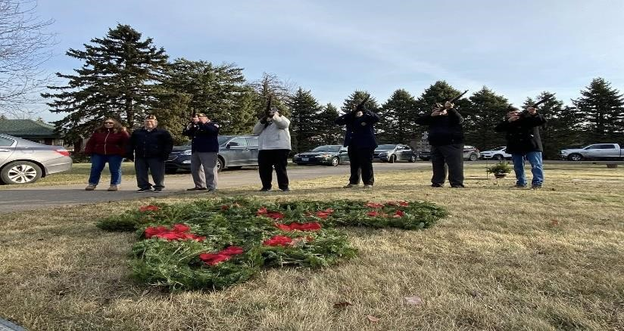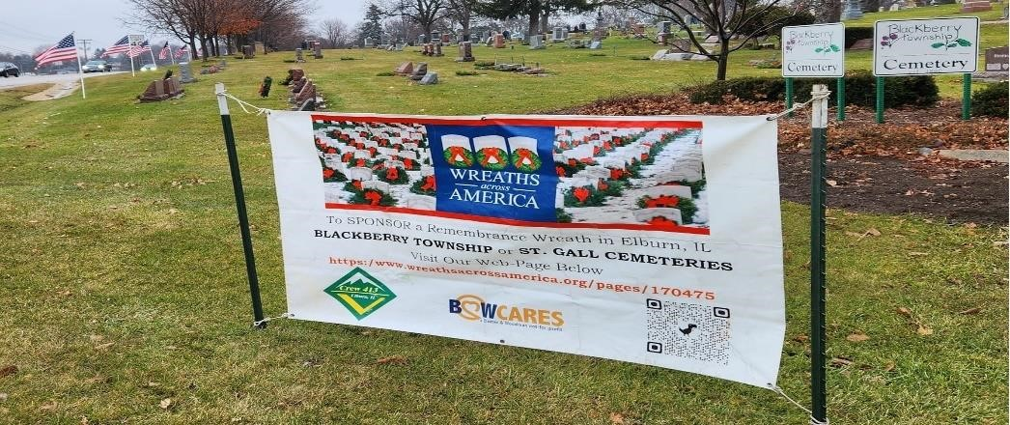

## Post Calendar

**January 2025**

(**Holiday**/**Notable**/**Post Event**)

|  |  |  |  |  |  |  |
| --- | --- | --- | --- | --- | --- | --- |
| **Sunday** | **Monday** | **Tuesday** | **Wednesday** | **Thursday** | **Friday** | **Saturday** |
|  |  |  | **1** |  | 3 | 4 |
| 5 | 6 | 7 | 8 |  | 10 | 11 |
| 12 | **13** | 14 | 15 |  | 17 | 18 |
| 19 | **20** | 21 | 22 | **23** | 24 | 25 |
| 26 | **27** | 28 | 29 | **30** | 31 |  |

**Important Dates**

1st New Year’s Day

2nd Queen of Hearts



9

th

Queen of Hearts

13

th

Post 630 Monthly Meeting

16

th

Desert

Storm

(

Persian

Gulf)

Began

(1991)

and

Queen

of

Hearts

20

th

Martin Luther King Jr. Day

23

rd

Queen

of

Hearts

27

th

Vietnam

War

Ce

ase

Fire

(1973)

AND

Holocaust

Remembrance

Day

30

th

Queen

of

Hearts



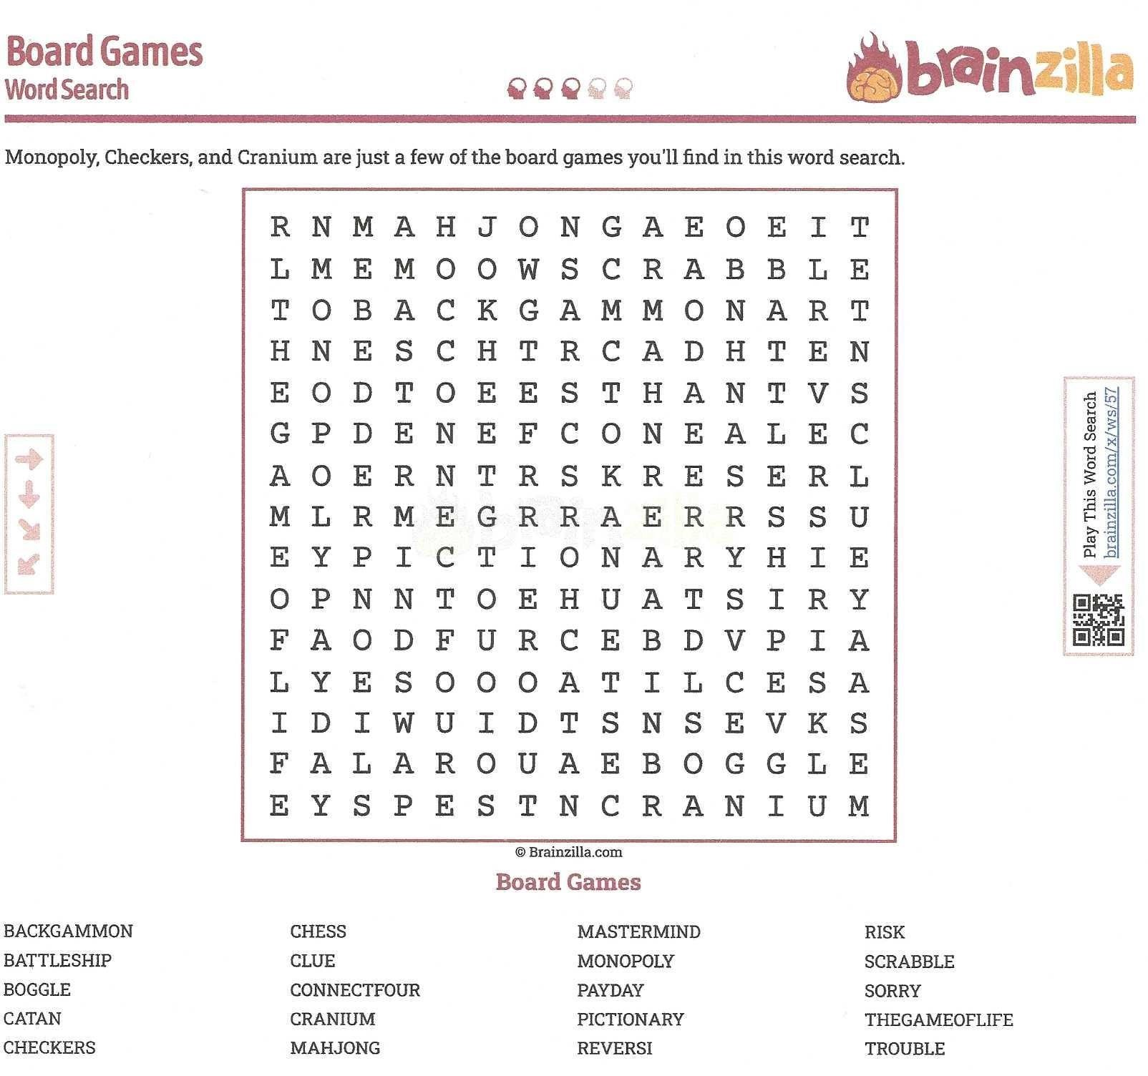

Truck, Cargo, 2**ity truck**

|  |
| --- |
|  |

### “NIGHT AT THE THEATER” RAFFLE SERIES

**WIN 2 TICKETS TO A PERFORMANCE AT THE PARAMOUNT THEATER IN AURORA, IL**

**RAFFLE TICKETS ARE $10.00 EACH.**

**EACH RAFFLE TICKET IS GOOD FOR ALL DRAWINGS!!!**

**FOR 2 TICKETS TO SEE**



**ON FEBRUARY 12TH 2025 @ 7PM**

What is more American than apple pie? A small-town waitress with a dream and the ingredients for success! Sugar, butter, flour. These aren’t the only ingredients Jenna, a waitress and expert pie maker, uses to make her famous pies. Stuck in a small town and a loveless marriage, Jenna unexpectedly becomes pregnant, and then finds acceptance and love in the most unexpected place.

Hoping to bake her way out of her troubles, she puts her heart and soul into her unique pies, winning over anyone who tastes them. But while battling expectations and self-esteem issues, Jenna’s delicious pies reflect her state of mind with names like I Hate My Husband Pie, and Pregnant., Miserable, Self-Pitying Loser Pie. Each of us will find something relatable in Jenna’s struggles and triumphs. Each of us will find something relatable in Jenna’s struggles and triumphs.

Full of romance and the joy of an uninhibited fling, Waitress challenges the story of a pregnant woman trapped in a small town between the life she’s living and the life she wants. Her customers,

co-workers, and the town’s handsome new doctor may all offer her conflicting recipes for happiness, but only Jenna can do the soul-searching.

**DRAWING ON January 23, 2025 during the Queen of Hearts Drawing**

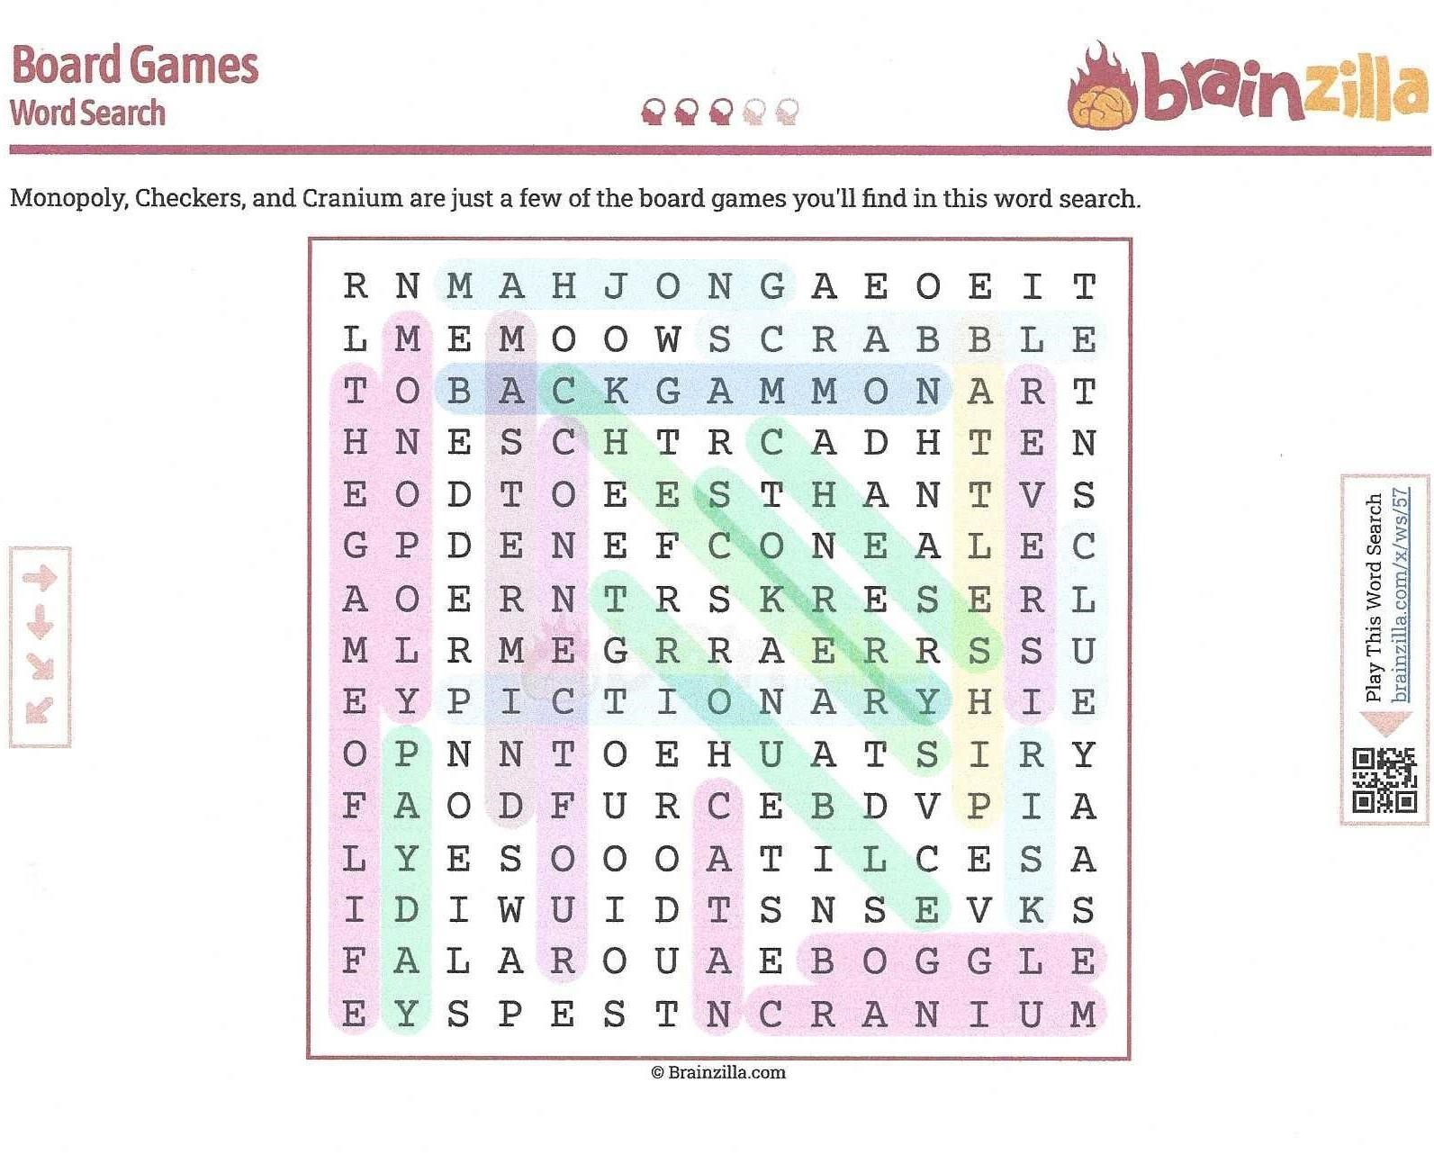

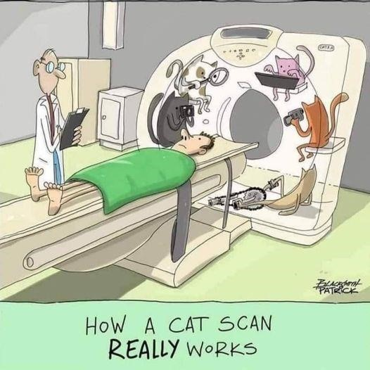

**Elburn Christmas stroll**

T

he Elburn Christmas stroll was in full

swing on

December 7

th

.

There was beautiful weather so

Santa could make a safe landing in Elburn. The

Elburn Fire Department gave Santa and Mrs. Claus

a ride to the American Legion Post 630 building to

light the Christmas tree with a little help from the

crowd which was on both

sides of Main St.

The

merriment continued as people visited the local

businesses to fill there Passport cards to win a

chance at a prize.

Inside the Post in the Bunker Bar children

came down to find juice, hot cocoa and

Christmas cookies. The adults of course

found Melissa behind the bar handing out

Hot Buttered Rum along with other adult

beverages. Post and Auxiliary members

were there to h

elp children with crafts and

writing letters and cards to our active

military. Parents and children were

amazed at the stories of military

adventures from Jerry Lonigro and Bob

Marriner. Mary Coffey, Joanne Gabl, and

Bard Veldhuizen were on hand to assist

with craft making and Norm Welker was

there to keep the chaos to a minimum

.

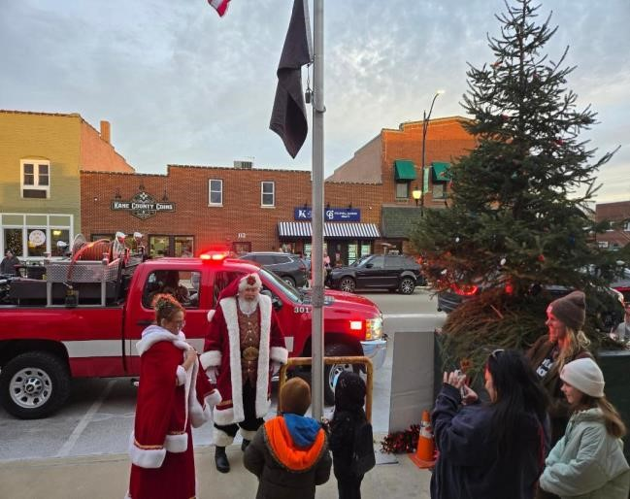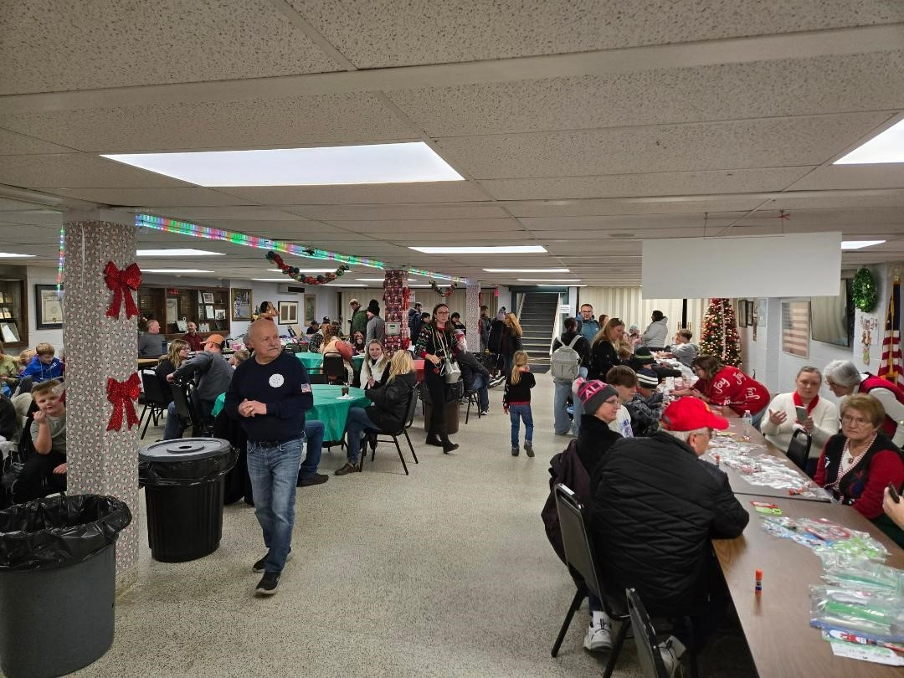

# Tips for Managing Diabetes



While diabetes is a serious health problem, the good news is that it is manageable — especially if diagnosed early.

[Steven K. Rothschild, MD,](http://doctors.rush.edu/details/1501) a [family medicine](https://www.rush.edu/services/family-medicine-services) physician at RUSH, offers nine tips to help you keep your [diabetes u](https://www.rush.edu/conditions/diabetes)nder control and avoid the often debilitating complications related to the disease:

1. **Eat a balanced diet.**

Seeing a dietitian every one to two years can be helpful if you have diabetes. They, along with your diabetes health care team, will help you plan a diet that is right for you.

1. **Exercise regularly.**

Make sure you're doing some sort of moderate physical activity at least three to four times a week, for 20 to 40 minutes each session.

Talk to your health care provider before starting any exercise program. He or she may want to do a few tests first. Talk to your health care provider before starting any exercise program. He or she may want to do a few tests first. If you have complications related to your diabetes like neuropathy or retinopathy there are certain types of exercise that you should avoid.

Tell your doctor what kind of exercise you want to do so adjustments can be made to your medicine schedule or meal plan. Remember, it is important to check your sugars prior to vigorous exercise.

1. **Get plenty of sleep.**

Keeping a regular schedule and getting enough sleep will help you keep your blood sugar levels in good control.

1. **If you smoke, quit.**

While smoking is bad for your health, it is especially harmful for people with diabetes. Nicotine in cigarette smoke causes large and small blood vessels to harden and narrow, resulting in reduced blood flow to the rest of your body.

1. **Manage stress as best you can.**

Stress, both physical and mental, can send your blood sugar levels out of whack. Consider a stress management workshop to help you learn better coping methods, find a support group or see a therapist.

1. **Practice good foot and skin care.**

Check your feet daily for calluses, cracks, or skin breakdown. If you notice any of the following, notify your doctor right away:

* + Redness
  + Ulcerations
  + Pus or a foul smelling drainage from your feet
  + Any of your toes have turned black and cold
  + Swelling in your ankles or feet

1. **Report signs of infection to your doctor.**

If you have any signs of infection — redness in areas of the skin, fevers, vomiting — call your doctor or health care provider immediately.

1. **Discuss sexual problems with your doctor.**

Diabetes can cause a variety of sexual and urologic problems for both men and women.

1. **Stay knowledgeable about diabetes.**

Continue learning about diabetes to maintain and improve your health. Rothschild suggests attending a diabetes class or scheduling visits with your diabetes educator at least once a year.

## From the Service Officer

