


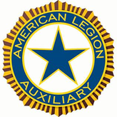

DANIEL SIMPSON POST 630
112 N. Main St, Elburn, IL 60119
Office Phone – 630-365-6530
Post email – elburnpost630@gmail.com
Website – www.elburnpost630.org

January 2026 Newsletter

Post Officers:
Commander: Norm Welker Chaplain: Tim Kolzow
Sr Vice Commander: John Nevenhoven Finance: John Waynick
Jr. Vice Commander: John Waynick Service Officer: Norm Welker
Adjutant: John Reece Sgt at Arms: Bob Marriner

Historians: Mark Krebs & Joanne Gabl
Judge Advocate/Parliamentarian: Paul Gardner


DISABLED PARKING IS IN THE REAR. THERE IS A WHEELCHAIR LIFT AT THE FRONT (Main St.) ENTRANCE AND A CHAIR LIFT AT THE REAR ENTRANCE. IF YOU CALL (630-365-6530) WHEN YOU ARRIVE, WE CAN HAVE SOMEONE THERE TO OPERATE THE LIFT FOR YOU.

Next Post Meeting

The next monthly meeting of Elburn American Legion Post 630 will be held on January 12, 2026. Doors open at 5PM, Dinner is served at 6PM.
On the menu: Fried Chicken and various salads. Want to Help? Bring some type of dessert.
Post Calendar

January 2026
(Holiday/Notable/Post Event)

Sunday | Monday | Tuesday | Wednesday | Thursday | Friday | Saturday
 |  |  |  | 1 | 2 | 3
4 | 5 | 6 | 7 | 8 | 9 | 10
11 | 12 | 13 | 14 | 15 | 16 | 17
18 | 19 | 20 | 21 | 22 | 23 | 24
25 | 26 | 27 | 28 | 29 | 30 | 31

Important Dates

1st – New Years Day
7th – Building Committee Meeting
8th – Queen of Hearts
11th - National Human Trafficking Awareness Day
12th – American Legion Elburn Post 630 Monthly Meeting
15th – Queen of Hearts
19th – Martin Luther King Jr. Day
22nd – Queen of Hearts
25th – Opposite Day
27th – Holocaust Memorial Day
29th – Queen of Hearts




Preamble of the American Legion Elements

“To inculcate a sense of individual obligation to the community,
state and nation.”

Always interested in building a better nation, the founders of The American
Legion believed that such building must start first with the individual in his or her own community. They made it one of the cardinal principles of the American Legion, to inculcate that sense of personal obligation to the community, state and nation into the individual citizen. That means educating citizens of responsibility to be active in making the hometown a better place in which to live, in discharging the duty of voting in elections, paying taxes promptly, contributing to community chest funds and blood banks. The word inculcate means to instill by persistent instruction; to teach an attitude, idea or habit by persistent instruction. Like the duties themselves, the reminders that they remain to be carried forward are never finished.

++++

LEGION DUES ARE OVERDUE!!!

Dues for the Post, SAL, Legion Riders, and the Auxiliary are due. Deadline was
December 31st, 2025. Check with your Adjutant and get your dues in quickly.

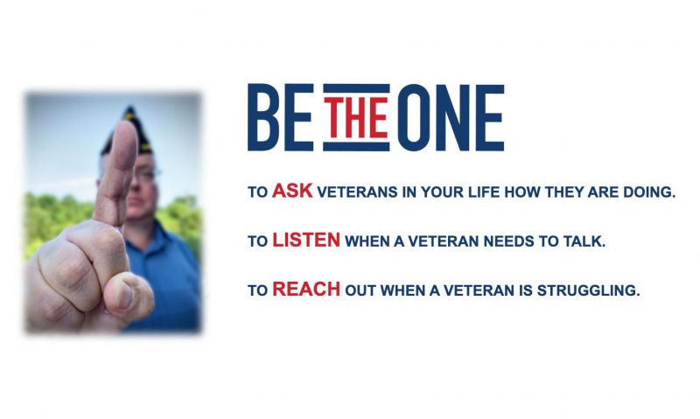
++++

As of December 18th, the Queen of Hearts is still out there hiding in an unopened envelope somewhere on our Board. Who will find the Queen of Hearts??
Jackpot is over $24,300
Get your tickets fast! Come on down to the Bunker Bar on Thursday nights or stop by the office and pick some up. You can also call Norm at the office 630-365-6530 and start a subscription, so you never miss a
Chance

Tickets are $1 each or 6 for $5.




Then and Now
Here are this month’s pictures of members “then”. Who are they now?



I know you’ve seen this seaman This member is a Vietnam vet.
around the Post with his wife. He is also a 50-year member with the
Served with the Navy many years ago American Legion and also served on
Served a Post Chaplain for several years several committees at the Post.

Answers in February 2026 Newsletter with more photos

We would like members of the Post 630 family (Legion, Auxiliary, Sons and Riders) to submit a picture of themselves during their time in service and now.
Non-military can send a college or high school picture Send your pictures to either Tim Kolzow (takolzow@gmail.com) or
Jo Gabl (jojobean.gabl@gmail.com)

Octobers Photo Answers

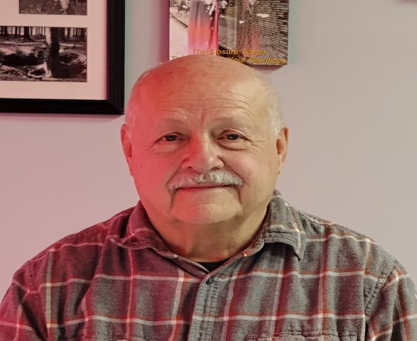

Norm Welker - Commander Bob Marriner – Sgt at Arms

January Puzzle

Tips for Managing Diabetes

While diabetes is a serious condition, it is manageable — especially if diagnosed early

While diabetes is a serious health problem, the good news is that it is manageable — especially if diagnosed early.
Steven K. Rothschild, MD, a family medicine physician at RUSH, offers nine tips to help you keep your diabetes under control and avoid the often debilitating complications related to the disease:

1. Eat a balanced diet.
Seeing a dietitian every one to two years can be helpful if you have diabetes. They, along with your diabetes health care team, will help you plan a diet that is right for you.

2. Exercise regularly.
Make sure you're doing some sort of moderate physical activity at least three to four times a week, for 20 to 40 minutes each session.
A regular exercise program can improve blood sugars, decrease the risk of heart disease, and help you lose weight.
Talk to your health care provider before starting any exercise program. He or she may want to do a few tests first. If you have complications related to your diabetes like neuropathy or retinopathy there are certain types of exercise that you should avoid.
Tell your doctor what kind of exercise you want to do so adjustments can be made to your medicine schedule or meal plan. Remember, it is important to check your sugars prior to vigorous exercise.

3. Get plenty of sleep.
Keeping a regular schedule and getting enough sleep will help you keep your blood sugar levels in good control.

4. If you smoke, quit.
While smoking is bad for your health, it is especially harmful for people with diabetes. Nicotine in cigarette smoke causes large and small blood vessels to harden and narrow, resulting in reduced blood flow to the rest of your body.
Because people with diabetes already have a greater risk of developing health problems like heart disease, stroke, kidney disease, nerve damage, foot problems and more, smoking makes the risks that much greater.

5. Manage stress as best you can.
Stress, both physical and mental, can send your blood sugar levels out of whack. Consider a stress management workshop to help you learn better coping methods, find a support group or see a therapist.

6. Practice good foot and skin care.
Check your feet daily for calluses, cracks, or skin breakdown. If you notice any of the following, notify your doctor right away:
- Redness
- Ulcerations
- Pus or a foul-smelling drainage from your feet
- Any of your toes have turned black and cold
- Swelling in your ankles or feet

While smoking is bad for your health, it is especially harmful for people with

diabetes. Nicotine in cigarette smoke causes large and small blood vessels to

harden and narrow, resulting in reduced blood flow to the rest of your body.

7. Report signs of infection to your doctor.
If you have any signs of infection — redness in areas of the skin, fevers, vomiting — call your doctor or health care provider immediately.

8. Discuss sexual problems with your doctor.
Diabetes can cause a variety of sexual and urologic problems for both men and women.

9. Stay knowledgeable about diabetes.
Continue learning about diabetes to maintain and improve your health. Rothschild suggests attending a diabetes class or scheduling visits with your diabetes educator at least once a year

++++

Important Vote coming up at the January meeting!

At the December 9th Post meeting, the topic of “No Weapons allowed” in the Post building was discussed. “Weapons” meaning any form of firearms and knives of a specific length. “Post” means the Post property. This includes anyone with a Concealed Carry License (CCL). In doing some quick research, in Illinois, a property owner may restrict the possession of firearms and knives (over 3in in length) on their property, if it is properly posted.
This includes people with a CCL.

Please attend the meeting on January 12th to have your opinion heard. If you cannot attend, you can send in an email (elburnpost630@gmail.com) expressing your views.

