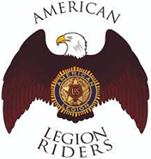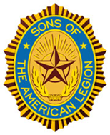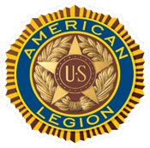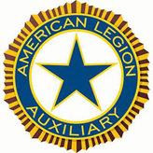

**DANIEL SIMPSON POST 630**

**112 N. Main St, Elburn, IL 60119**

**Office Phone – 630-365-6530**

**Post email –** **elburnpost630@gmail.com**

**Website – www.elburnpost630.org**

November 2024 Newsletter

Post Officers:

Commander: Norm Welker

Sr. Vice Commander: John Nevenhoven

Jr. Vice Commander: Joanne “Jo” Gabl

Adjutant: John Waynick

Sergeant at Arms: Lloyd Da Mask

Judge Advocate/

Parliamentarian: Paul Gardner

Chaplain: Tim Kolzow

Finance: Tim Kolzow

Post Service Officer: Norm Welker

Historian: Mark Krebs

Post Meetings

The Post meets are on the second Monday of each month. Doors open at 6:00 p.m. for dinner and comradery. The meeting starts at 7:00 p.m. All members and prospective members are

welcome to attend.

**DISABLED PARKING IS IN THE REAR LOT. LIFTS ARE AT BOTH ENTRANCES, WHEELCHAIR LIFT IN THE FRONT, CHAIR LIFT IN THE REAR. CALL US WHEN YOU ARRIVE SO WE CAN HAVE SOMEONE READY TO ASSIST YOU.**

**ATTENTION MEMBERS OF THE**

**AMERICAN LEGION POST 630**

**AND SAL SQUADRON 630!!!!**

Membership dues are due!!!!

American Legion Post 630 - $40

Sons of the American Legion Squadron 630 - $20 (18 and above), $13 (under 18) ASAP!

**Mail your payment to the office (112 N. Main St., Elburn 60119**

**or stop by and drop it off**

**Any questions** **call the office 630-365-6530**



Post Meeting

The monthly meeting of Elburn Post 630 will NOT be held on **November 11th, 2024.** Due to all the activities will be going on celebrating Veteran’s Day, it would make a long, trying day for all of us. **December 9th will be the next Post Meeting**. On the menu, Chili and cornbread.

Post Calendar

**November 2024**

(**Holiday**/**Notable**/**Post Event**)

|  |  |  |  |  |  |  |
| --- | --- | --- | --- | --- | --- | --- |
| **Sunday** | **Monday** | **Tuesday** | **Wednesday** | **Thursday** | **Friday** | **Saturday** |
|  |  |  |  |  | 1 | 2 |
| 3 | 4 | **5** | 6 | **7** | 8 | 9 |
| **10** | **11** | 12 | 13 | **14** | 15 | **16** |
| 17 | 18 | 19 | 20 | **21** | 22 | 23 |
| 24 | 25 | 26 | 27 | **28** | 29 | 30 |

**November - Military Family Month**

5: United States Presidential Election – VOTE!

7: Queen of Hearts

10: United States Marine Corps Birthday

11: Veterans’ Day and Veterans’ Day Ceremony, Veterans Memorial Park

(Remembrance Day: Britain & Canada) (Armistice Day: France)

**No Monthly Post Meeting**

14: Queen of Hearts

16: Post Veteran’s Day Dinner

21: Queen of Hearts

28: No Queen of Hearts; Thanksgiving Day

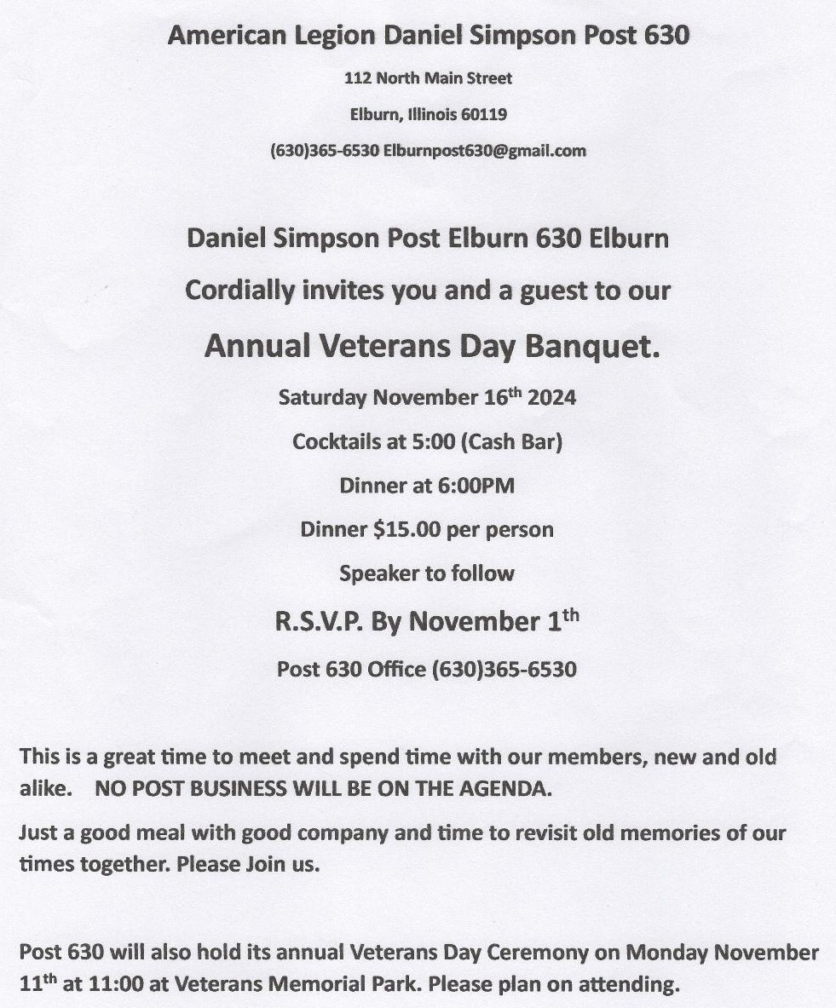

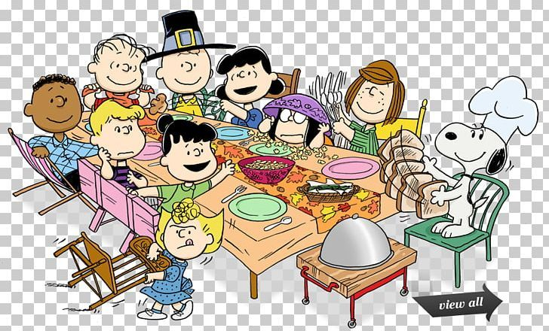The Elburn Community Center is hosting a Thanksgiving Dinner to be served at the

Elburn American Legion Post 630

on November 28th from 2PM to 6:30 PM

in the lower level. Come have dinner, watch football and visit with friends!

All are welcome. Donations are always accepted.

Greetings Elburn American Legion Family,

This is just a quick update and “Hello” from your ALR.

Things are going well with the Chapter. We are currently working on another meat raffle for gift cards from Reams Meat Market. 1st Place - $300, Second Place $150, and third place $75. The drawing will be held just prior to Christmas (probably during Queen of Hearts on Dec 19th). Only 200 tickets will be sold.

We will be going shopping at Farm and Fleet in Elgin on Saturday Nov 23rd to buy the toys for Kane County Toys for Tots. We will probably go out for breakfast following our shopping spree.

We are also looking at hosting the January 2nd Division Meeting. More to Follow.

One last note, I have been honored to be appointed as Chairman for the Department of Illinois American Legion Riders for this Legion Year. I will do my best to bring Honor on our Chapter and Post/Unit/Squadron.

That’s it for now. Be Safe.

John Reece

Director, Elburn ALR

