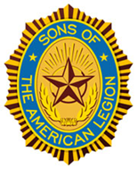
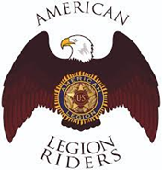
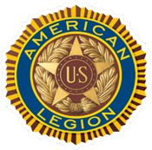
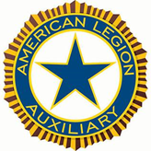

DANIEL SIMPSON POST 630
112 N. Main St, Elburn, IL 60119
Office Phone – 630-365-6530
Post email – elburnpost630@gmail.com
Website – www.elburnpost630.org

May 2026 Newsletter

Post Officers:
Commander: Norm Welker Chaplain: Tim Kolzow
Sr. Vice Commander: John Nevenhoven Finance: John Waynick
Jr. Vice Commander: John Waynick Service Officer: Norm Welker
Adjutant: John Reece Sgt at Arms: Bob Marriner

Historians: Mark Krebs & Joanne Gabl
Judge Advocate/Parliamentarian: Paul Gardner

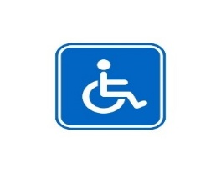
DISABLED PARKING IS IN THE REAR. THERE IS A WHEELCHAIR LIFT AT THE FRONT (Main ST) ENTRANCE AND A CHAIR LIFT AT THE REAR ENTRANCE (Gate ST). IF YOU CALL 630-365-6530 UPON ARRIVAL, SOMEONE WILL BE THERE TO OPERATE THE LIFT.

Next Post Meeting

The next monthly meeting of Elburn American Legion Post 630 will be held May 11th, 2026, in the Lower Level. Dinner will be Baked mostaccioli, garlic bread, Italian sausage and salad. Doors open at 5PM, dinner is served at 6PM. Want to help? You can bring some type of dessert and fruit pies are a Legion favorite.

Post Calendar

May 2026
(Holiday/Notable/Post Event)

Sunday | Monday | Tuesday | Wednesday | Thursday | Friday | Saturday
 |  |  |  |  | 1 | 2
3 | 4 | 5 | 6 | 7 | 8 | 9
10 | 11 | 12 | 13 | 14 | 15 | 16
17 | 18 | 19 | 20 | 21 | 22 | 23
24 | 25 | 26 | 27 | 28 | 29 | 30

Important Dates
National Military Appreciation Month and Month of the Military Caregiver

1st – National Space Day, May Day, Silver Star Banner Day (honors wounded, ill and injured veterans)
2nd – Kentucky Derby
4th - Star Wars Day “May the 4th be with you.”
5th - Cinco de Mayo and Teachers Day
7th – Queen of Hearts
8th - VE Day (Victory in Europe) and Military Spouse Appreciation Day (recognizes the sacrifices of spouses)
10th – Mother’s Day
11th – Post Meeting
13th – Children of Fallen Patriots Day (honors children of those who died in service)
14th – Queen of Hearts
15th – Peace Officers Memorial Day
16th – Armed Forces Day (honors all currently serving)
21st – Queen of Hearts
22nd – Maritime Day (observance for the US Merchant Marine)
25th – Memorial Day (Federal holiday honoring deceased service members)
28th – Queen of Hearts



Elements of the Preamble of the American Legion

To safeguard and transmit to posterity the principles of justice, freedom and democracy;

On this ideal of safeguarding and transmitting to posterity the principles of justice, freedom and democracy, all the youth-training programs of The American Legion are built. All Americans can be proud that in our international relations we have tried to live by the golden rule, the mark of justice. We have granted to others, as we prize it ourselves, the great boon of freedom. Through the Monroe Doctrine, we call a halt to foreign imperialism in the Western Hemisphere. We gave freedom to the Philippines. These principles are part of the American heritage. Legionnaires are pledged to protect and preserve that heritage.

++++


As of April 30th, the Queen of Hearts is still out there hiding in an unopened envelope somewhere on our Board. Who will find the Queen of Hearts??
Jackpot is over $30,500
Get your tickets fast! Come on down to the Bunker Bar on Thursday nights or stop by the office and pick some up. You can also call Norm at the office 630-365-6530 and start a subscription, so you never miss a chance.

Tickets are $1 each or 6 for $5.


From the Legion Riders Chapter 630

To all the members of the American Legion family and their families who attended or donated to the Toy run, we thank you and the children thank you.

This year’s Toys for Tots run is scheduled for July 19. There will still be a motorcycle run and a party afterwards at the Post but, it will take place in a block party kind of format in which streets will be closed, and the Public will be invited to attend. As in years past, food and beverages will be available and there will still be a band or two.

++++

Then and Now

Here are this month’s pictures of “then”. Who are they now?
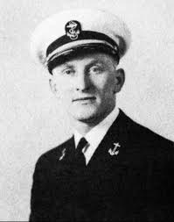
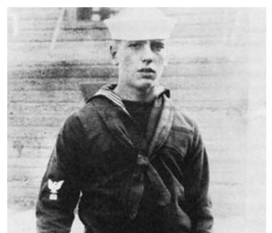

He served in the United States Navy during He enlisted in the U.S. Navy at the end of World World War II as a Lieutenant. War I and served as a signalman aboard
Junior Grade (LTJG). Was a gunnery and the USS Leviathan, a transport ship for
communications officer in troops. Much of his service was spent
anti-submarine warfare on PC-1139 ferrying soldiers between North Africa
and Europe

Answers in the June 2026 Newsletter with more photos

We would like members of the Post 630 family (Legion, Auxiliary, Sons and Riders) to submit a picture of themselves during their time in service and now.
Non-military can send a college or high school picture Send your pictures to either Tim Kolzow (takolzow@gmail.com) or
Jo Gabl (jojobean.gabl@gmail.com)

March’s Photo Answers
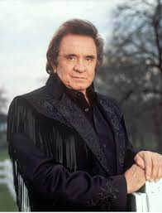


John Allen – USAF (Ret) Johnny Cash - Musician

++++

Post Meetings

The Post meets are on the second Monday of each month. Doors open at 6:00 PM for dinner and the camaraderie. The meeting starts at 7:00 PM. All members and prospective members are welcome and encouraged to attend.

++++

Upcoming events

Memorial Day
The Memorial Day Ceremony will be held at Blackberry Cemetery on Monday, May 25th at 10AM. Anyone wanting to participate, meet at Lions Park at 9:30 AM. We will begin marching over to the Cemetery at 9:45AM. The Ceremony begins at 10AM.
We need flag bearers and members to form a rifle squad
If you would like to be a flag bearer or in the rifle squad, please contact Norm at the office (630-365-6530) and leave a message about how you would like to help.
Bleachers will be set up but you can bring your own lawn chair.

Flag Day June 14
The Flag Day and the Retirement of Colors ceremony is still being arranged. This will take place at the Veteran’s Memorial Park by the tank. Watch your email for more information.

8 Ways to Prevent Stroke and Spot Its Warning Signs
Learning the signs of a stroke can save lives and greatly improve outcomes

By Sarah Song, MD, MPH, Neurologist, Rush University Medical Center.

Share to:

A few years back, I saw a young man whose wife — who is in the medical field — called 911 after recognizing his symptoms of weakness and numbness as a possible stroke.
As a result, he got to the hospital quickly and was treated with an intravenous clot-busting drug called tissue plasminogen activator, or tPA, which is the only urgent medication for stroke approved by the U.S. Food and Drug Administration. When I saw him after his discharge, he was in great health with no residual effects. He spoke of playing with his young son and how blessed he felt to have recovered completely.

Know the signs
It was handy that my patient was married to someone who knew the signs of stroke. But everyone, not just medical professionals, can recognize most strokes by following the FAST acronym. In fact, a study showed that the FAST acronym can identify up to 89% of all strokes — all we have to do is learn it.
- Face drooping (usually on one side)
- Arm weakness (the arm may drift down or feel numb)
- Speech difficulty (slurred speech or trouble getting words out or understanding others)
- Time to call 911
Knowing what FAST stands for can make all the difference in stroke recovery and survival.
If you observe or experience any of these symptoms, call 911 immediately and jot down the time you noticed the symptoms. Knowing when symptoms started, down to the minute, helps in making quick, difficult decisions in the ER.
Evidence shows that the sooner a stroke can be treated with tPA, the more likely you are to get back to your normal self. Remember, a stroke is like a heart attack in your brain.

Strategies for preventing stroke
In addition to educating my patients about how to look for the symptoms of stroke, I also talk to them about what they can do to lower their risk. Along with staying on top of stroke risk factors, such as high blood pressure, high cholesterol and diabetes, the following are a few strategies I share with them:
- Quit smoking: I encourage my patients who smoke to quit and recommend smoking cessation strategies for them.
- Stay active: Choose your favorite activity, for 30 minutes a day, five times a week.
- Maintain a healthy weight: It is important to maintain a healthy weight, especially around the middle. This “central obesity” is associated with diabetes, high cholesterol and high blood pressure, and is linked to increased stroke risk. The best diet is one centered on vegetables, whole grains and low saturated fats.
- Limit alcohol consumption: When drinking, no more than two drinks per day for men, and one for women.
- Stress less: Stress can spike blood pressure. To keep blood pressure low and minimize negative effects of stress, incorporate habits, such as stretching, meditation, or talking with friends – whatever works for you.
- Manage atrial fibrillation: For people who have atrial fibrillation, a common heart arrhythmia in older adults, I may prescribe a blood thinner if they have other risk factors or history of stroke. AFib, as it’s known, causes blood to pool and clot in the heart instead of being pumped efficiently to the rest of the body, so a blood thinner can help reduce stroke risk.
- Be mindful of estrogen: For women of reproductive age who smoke, experience migraines, or have a history of stroke, I recommend alternative forms of birth control to oral contraceptives, as estrogen can increase the risk of clots.
- Learn FAST now: Make a pact to learn the FAST acronym, as described above, and share that knowledge with the ones you love. Be an active participant in your own health so you can enjoy life to its fullest.
Also, always ask your doctor if you have any questions — he or she is there to help you.

May’s Puzzle






