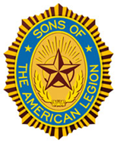
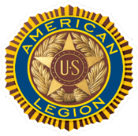
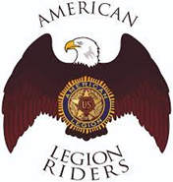
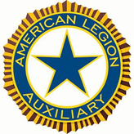

DANIEL SIMPSON POST 630
112 N. Main St, Elburn, IL 60119
Office Phone – 630-365-6530
Post email – elburnpost630@gmail.com
Website – www.elburnpost630.org

June 2026 Newsletter

Post Officers:
Commander: Norm Welker Chaplain: Tim Kolzow
Sr. Vice Commander: John Nevenhoven Finance: John Waynick
Jr. Vice Commander: John Waynick Service Officer: Norm Welker
Adjutant: John Reece Sgt at Arms: Bob Marriner

Historians: Mark Krebs & Joanne Gabl
Judge Advocate/Parliamentarian: Paul Gardner

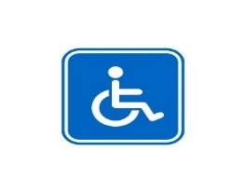
DISABLED PARKING IS IN THE REAR. THERE IS A WHEELCHAIR LIFT AT THE FRONT (Main ST) ENTRANCE AND A CHAIR LIFT AT THE REAR ENTRANCE (Gate ST). IF YOU CALL 630-365-6530 UPON ARRIVAL, SOMEONE WILL BE THERE TO OPERATE THE LIFT.

Post Meetings

The Post meets are held on the second Monday of each month. Doors open at 5:00 PM for Camaraderie. Dinner is served at 6PM. The meeting starts at 7:00 PM. All members of the Legion Riders, Legion Auxiliary and Sons of the American Legion are welcome. Also, prospective members are welcome and encouraged to attend.
Guests, please sign in with the Sgt at Arms.

Post Calendar
June 2026
(Holiday/Notable/Post Event)

Sunday | Monday | Tuesday | Wednesday | Thursday | Friday | Saturday
 | 1 | 2 | 3 | 4 | 5 | 6
7 | 8 | 9 | 10 | 11 | 12 | 13
14 | 15 | 16 | 17 | 18 | 19 | 20
21 | 22 | 23 | 24 | 25 | 26 | 27
28 | 29 | 30

Important Dates

1st – Wear a Dress Day (This was every day for Cpl. Klinger in M*A*S*H 4077)
5th – National Doughnut Day
4th – Queen of Hearts
6th – D-Day Anniversary (1944) - Anniversary of WW II Allied invasion in Normandy, France
7th – National Cancer Survivors Day
8th – American Legion Elburn Post 630 Meeting, 7PM
11th - Queen of Hearts
12th – Women Veterans Day
13th – Flag Retirement Ceremony, Veterans Memorial Park
14th – Flag Day - Celebrating the adoption of the United States flag and US Army Birthday
18th - Queen of Hearts
19th - Juneteenth National Independence Day
21st – Father’s Day
23rd – Coast Guard Auxiliary Birthday
25th – Queen of Hearts and Korean War started (1950)
25th – Battle of Little Big Horn (1876) – see this month’s history article for more
27th – National PTSD Awareness Day - PTSD resources and Insights in caring for families coping with PTSD. The links were taken from perationwearehere.com/significantdaysobservances.html

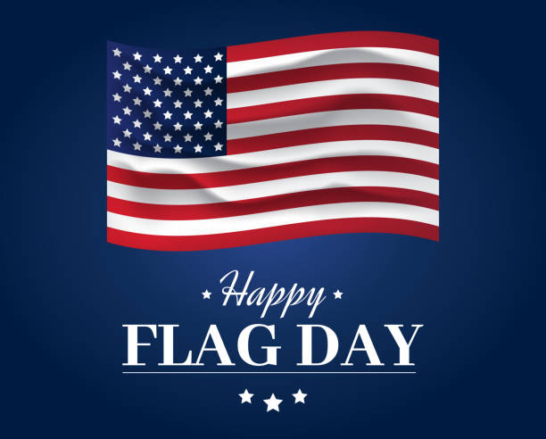
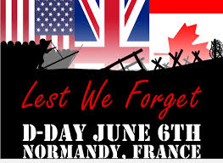
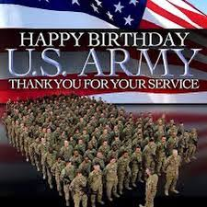

Next Post Meeting

The next monthly meeting of Elburn American Legion Post 630 will be held
June 8th, 2026, in the Lower Level. Dinner will be Hamburgers and Brats on the grill, assorted sides and desserts. Doors open at 5PM, Dinner is served at 6PM.
Want to help? You can bring some type of dessert and donations are gladly accepted.

++++

Preamble of the American Legion Elements

“To consecrate and sanctify our comradeship by our devotion to mutual
helpfulness.”

The last, or 10th clause, of our Preamble is the most important ideal to express. It marked a new concept in America - a concept that made The American Legion the greatest force for social betterment in all the history of the United States. Let us be factual and examine this. At the close of World War I, America was just emerging from its lusty era of rugged individualism. It was an era when the individual hammered out his own destiny and progress with little or no help from the government. An honest facing of the facts brings out that American society was then a cold society insofar as any organized public hands of helpfulness were concerned. The individual who fell upon evil times was left to private charity which meant mostly the churches and the Salvation Army. There were no public resources or services to help the unfortunates. When the veterans of World War I came marching home, they found the nation utterly unprepared to care for the combat casualties of the war. The wounded, the shell-shocked and the sick were lodged in poor houses, jails, asylums or what-have-you. Veterans of World War I were much more closely knit than those of World War II. They trained in the same camps, fought on the one great front. Those who came home unscarred were appalled by the plight of their less fortunate comrades. They felt a concern for their comrades and the dependents thereof, which was a new and dramatic aspect to what the country had known as friendship. This concern formed the bond among the charter members of The American Legion and gave them a great and noble cause to fight for - the adequate care and protection of their disabled comrades and dependents, the war widows and orphans. They faced a monumental task. Laws had to be drafted and enacted by Congress to provide compensation for the war-handicapped, build hospitals and get protection for the widows and orphans upon whom the war had laid its heaviest and cruelest hand. The American Legion wrote such laws, had them introduced in Congress, went out over the land to arouse the conscience of the people of America and mobilize support for its legislative aims. It did both with a sacrificial fervor that overcame all obstacles.

Congress enacted the laws, it provided administrative machinery, it appropriated the funds, it built hospitals. Then to bring about a single responsibility to carry out all veteran laws and achieve a unification of these government services. The American Legion put through Congress the legislation to create the Veterans Bureau which has become the Veterans Administration of today. Over the years, a great network of government hospitals were built and a great structure of veteran legislation was enacted, which made the American veterans the best cared for on earth. The rehabilitation program of The American Legion for the World War I veteran brought about in its successful development a great awakening of social responsibility in America. When the New Deal Program was being developed, the government planners looked at what The American Legion, through its vast rehabilitation program, had done for the veterans of World War I and they decided to do the same thing for all American people. So out of the rehabilitation brainchild of The American Legion, there came the Social Security System with its retirement benefits and elderly assistance programs for all the people. The planners looked at The American Legion program of temporary emergency aid to needy children of veterans and there was born - with the support of Legionnaires - the state and federal program of aid to dependent children, all children. This is how we can hail The American Legion today as an unparalleled force in these United States for social betterment. American Legion concepts and its ideal of devotion to mutual helpfulness warmed up the whole social climate of America. Today, America is extending its helpful hands all over the world through our assistance programs of foreign aid. It all came about because the veterans of World War I came home enriched with wonderful ties of friendship and gave those ties a meaning by consecrating them to the ideal of mutual helpfulness. The American Legion Preamble has been the beacon light of The American Legion for more than 100 years. In all that time, It has been amended only twice. The last amendment consisted of removing reference to the “The Great” and adding the “All”. It makes the Preamble read today "All Wars," to embrace all wars.

++++

The Battle of the Little Bighorn

A Clash of Cultures

The Battle of the Little Bighorn was fought along the ridges, steep bluffs, and ravines of the Little Bighorn River, in south-central Montana on June 25-26, 1876. The combatants were warriors of the Lakota Sioux, Northern Cheyenne, and Arapaho tribes, battling men of the 7th Regiment of the US Cavalry, along with their Crow, and Arikara scouts. The Battle of the Little Bighorn has come to symbolize the clash of two vastly dissimilar cultures: the buffalo/horse culture of the northern plain’s tribes, and the highly industrial based culture of the United States.
This battle was not an isolated confrontation, but part of a much larger strategic campaign designed to force the capitulation of the non-reservation Lakota and Cheyenne.
In 1868, after fierce fighting from 1865-1867 between U.S. Army personnel and Lakota and Cheyenne warriors, several Lakota leaders agreed to sign the Treaty of Fort Laramie. This treaty created a large reservation for the Lakota in the western half of present-day South Dakota, the Lakota's beloved Black Hills area. The United States wanted tribes to give up their nomadic life which brought them into conflict with other Indians, white settlers and railroads. Agreeing to the treaty meant accepting a more stationary life and relying on government-supplied subsidies.
However, Lakota leaders such as Sitting Bull and Crazy Horse rejected the reservation system. Likewise, many roving bands of hunters and warriors did not sign the 1868 treaty. They felt no obligation to conform to its restrictions, or to limit their hunting to the unceded hunting land assigned by the treaty. Their forays off the set aside lands brought them into conflict with settlers and enemy tribes outside the treaty boundaries.

The Stage is Set

Tension between the United States and the Lakota escalated in 1874, when Lt. Col. George Armstrong Custer was ordered to make an exploration of the Black Hills inside the boundary of the Great Sioux Reservation. Custer was to map the area, locate a suitable site for a future military post, and to make note of the natural resources. During the expedition, professional geologists discovered deposits of gold. Word of its discovery caused an invasion of miners and entrepreneurs to the Black Hills in direct violation of the 1868 Treaty of Fort Laramie. The United States negotiated with the Lakota to purchase the Black Hills, but the offered price was rejected by the Lakota. The climax came in the winter of 1875, when the Commissioner of Indian Affairs issued an ultimatum requiring all Lakota to report to a reservation by January 31, 1876, or be labeled as "hostiles." The deadline came with virtually no response from the Indians, and matters were handed to the military.
General Philip Sheridan, commander of the Military Division of the Missouri, devised a strategy that committed several thousand troops to find and to engage the "hostile" Lakota and Cheyenne, with the goal of forcing their return to the Great Sioux Reservation. The campaign was set in motion in March of 1876, when a 450-man force of combined cavalry and infantry commanded by Colonel John Gibbon, marched out of Fort Ellis near Bozeman, Montana. General George Crook set out from Fort Fetterman in central Wyoming Territory with around 1,000 cavalry and infantry in late May. A few weeks before that, General Alfred Terry left from Fort Abraham Lincoln in Bismarck (Dakota Territory) with 879 men. The bulk of this force was the 7th Cavalry, commanded by Lt. Col. George Armstrong Custer.
It was expected that any one of these three forces would be able to deal with the 800-1,500 warriors they likely were to encounter. The three commands of Gibbon, Crook, and Terry were not expected to launch a coordinated attack on a specific Indian village at a known location. Inadequate, slow, and often unpredictable communications hampered the army's coordination of its expeditionary forces. Furthermore, the nomadic lifestyle of the Lakota and Cheyenne people meant they were constantly on the move. No officer or scout could be certain how long a village might remain stationary, or which direction the tribe might choose to go in search of food, water, and grazing areas for their horses.

A Prophetic Vision

The region containing the Powder, Rosebud, Bighorn, and Yellowstone rivers was a productive hunting ground and the tribes regularly gathered in large numbers during early summer to celebrate their annual sun dance ceremony. This ceremony had occurred about two weeks earlier near present-day Lame Deer, Montana. During the ceremony, Sitting Bull received a vision of soldiers falling upside down into his village. He prophesized there soon would be a great victory for his people.
On the morning of June 25, the camp was ripe with rumors about soldiers on the other side of the Wolf Mountains, 15 miles to the east, yet few people paid any attention. In the words of Low Dog, an Oglala Lakota: "I did not think anyone would come and attack us so strong as we were."
On June 22, General Terry decided to detach Custer and his 7th Cavalry to make a wide flanking march and approach the Indians from the east and south. Custer was to act as the hammer and prevent the Lakota and their Cheyenne and Arapaho allies from slipping away and scattering, a common fear expressed by government and military authorities. General Terry and Colonel Gibbon, with infantry and cavalry, would approach from the north to act as a blocking force or anvil in support of Custer's far-ranging movements toward the headwaters of the Tongue and Little Bighorn Rivers. The Indians, who were thought to be camped somewhere along the Little Bighorn River, "would be so completely enclosed as to make their escape virtually impossible."

Custer Takes Position

On the evening of June 24, Custer established a night camp twenty-five miles east of where the fateful battle would take place on June 25-26. The Crow and Arikara scouts were sent ahead, seeking actionable intelligence about the Lakota and Cheyenne. The returning scouts reported that the trail indicated the village turned west toward the Little Bighorn River and was encamped close by. Custer ordered a night march that followed the route that the village took as it crossed the Little Bighorn River valley.
Early on the morning of June 25, the 7th Cavalry Regiment was positioned near the Wolf Mountains, about twelve miles distant from the Lakota/Cheyenne encampment along the Little Bighorn River.
Modern historians estimate the village numbered around 8,000, with a warrior force of 1,500-1,800 men. Custer's initial plan had been to conceal his regiment in the Wolf Mountains through June 25, which would allow his Crow and Arikara scouts time to locate the Indian village. Custer then planned to make a night march and launch an attack at dawn on June 26; however, the scouts reported the regiment's presence had been detected by Lakota or Cheyenne warriors. Custer, judging by the element of surprise to have been lost, feared the inhabitants would attack or scatter into the rugged landscape, causing the failure of the Army's campaign. Custer ordered an immediate advance to engage the village and its warrior force.
At the Wolf Mountain location, Custer ordered a division of the regiment into four segments: the pack train with ammunition and supplies (125 men), three companies (125 men) commanded by Captain Frederick Benteen, three companies (140 men) commanded by Major Marcus Reno and five companies (210 men) commanded by Custer. Benteen was ordered to march southwest with the objective of locating any Indians, "pitch into anything" he found, and send word to Custer. Custer and Reno's advance placed them in proximity to the village, but still out of view. When it was reported that the village was scattering, Custer ordered Reno to lead his 140-man battalion, plus the Arikara scouts, and to "pitch into what was ahead" with the assurance that he would "be supported by the whole outfit".

Reno's Command

The Lakota and Cheyenne village lay in the broad river valley bottom, just west of the Little Bighorn River. As instructed by Custer, Major Reno crossed the river about two miles south of the village and began advancing downstream toward its southern end. Though initially surprised, the warriors quickly rushed to fend off Reno's assault. Reno halted his command, dismounted his troops and formed them into a skirmish line, which began firing at the warriors who were advancing from the village. Mounted warriors pressed their attack against Reno's skirmish line and soon endangered his left flank.

Reno withdrew to a stand of timber beside the river, which offered better protection. Eventually, Reno ordered a second retreat, this time to the bluffs east of the river. The Lakota and Cheyenne, likening the pursuit of retreating troops to a buffalo hunt, rode down the troopers. Soldiers at the rear of Reno's fleeing command incurred heavy casualties as warriors galloped alongside the fleeing troops and shot them at close range, or pulled them out of their saddles onto the ground.

Reno's now shattered command recrossed the Little Bighorn River and struggled up steep bluffs to regroup atop high ground to the east of the valley fight.

Meanwhile, Captain Benteen had returned after finding no evidence of Indians or their movement to the south. He arrived on the bluffs in time to meet Reno's demoralized survivors. A messenger from Custer previously had delivered a written communication to Benteen that stated, "Come on. Big Village. Be Quick. Bring Packs. P.S. Bring Packs."
An effort was made to locate Custer after heavy gunfire was heard downstream. Led by Captain Weir's D Company, troops moved north in an attempt establish communication with Custer.

Assembling on a high promontory (Weir Point) a mile and a half north of Reno's position, the troops could see clouds of dust and gun smoke covering the battlefield. Large numbers of warriors approaching from that direction forced the cavalry to withdraw to Reno Hill where the Indians held them under siege from the afternoon of June 25, until dusk on June 26. On the evening of June 26, the entire village began to move to the south.

Custer's Fate

The next day the combined forces of Terry and Gibbon arrived in the valley where the village had been encamped. The badly battered and defeated remnant of the 7th Cavalry under Reno and Benteen was now relieved. Scouting parties discovered the dead, naked, and mutilated bodies of Custer's command on the ridges east of the river. Exactly what happened to Custer's command will never be fully known. From Indian accounts, archeological finds, and positions of bodies, historians can piece together the Custer portion of the battle, although many answers remain elusive.
It is known that after ordering Reno to charge the village, Custer rode northward along the bluffs until he reached a broad drainage known as Medicine Tail Coulee, a natural route leading down to the river and the village. Archaeological finds indicate some skirmishing occurred at Medicine Tail ford. For reasons not fully understood, the troops fell back and assembled on Calhoun Hill. The warriors, after forcing Major Reno to retreat, now began to converge on Custer's maneuvering command as it forged north along what today is called Custer or Battle Ridge.
Dismounting at the southern end of the ridge, companies C and L appear to have put up stiff resistance before being overwhelmed. Company, I perished on the east side of the ridge. The survivors rushed toward the hill at the northwest end of the long ridge. Company E may have attempted to drive warriors from the deep ravines on the west side of the ridge, before being consumed in fire and smoke in one of the very ravines they were trying to clear. Company F may have tried to fire at warriors on the flats below the National Cemetery before being driven to the Last Stand Site.
About 40 men of the original 210 were cornered on the hill where the stone monument now stands. Hundreds of Lakota and Cheyenne warriors surrounded them.
Toward the end of the fight, soldiers, some on foot, others on horseback, broke out in a desperate attempt to get away. All were pulled down and killed in a matter of minutes. The warriors quickly rushed to the top of the hill, dispatching the last of the wounded. Superior numbers and overwhelming firepower brought the Custer portion of the Battle of the Little Bighorn to a close.

Aftermath

The battle was a momentary victory for Lakota and Cheyenne. The death of Custer and his troops became a rallying point for the United States to increase their efforts to force native peoples onto reservation lands. With more troops in the field, Lakota hunting grounds were invaded by powerful Army expeditionary forces determined to conquer the Northern Plains Indians. Most of the declared "hostiles" surrendered within one year of the fight, and the Black Hills were taken by the US government without compensation to the Lakota.

https://www.nps.gov/libi/learn/historyculture/battle-story.htm

++++


As of May 28th, the Queen of Hearts is still out there hiding in an unopened envelope somewhere on our Board. Who will find the Queen of Hearts??
Jackpot is over $31,900
Get your tickets fast! Come on down to the Bunker Bar on Thursday nights or stop by the office and pick some up. You can also call Norm at the office 630-365-6530 and start a subscription, so you never miss a chance.

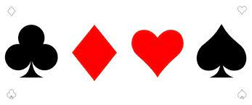
Tickets are $1 each or 6 for $5.
From the Commander

Post Elections
Nominations were submitted to the membership at the May Regular meeting.
The nominations are as follows: Commander – John Reece, Sr Vice Commander – John Nevenhoven, Jr Vice Commander – Tyler Lawrence. We are still looking for members to hold the offices of Adjutant and Finance officer. Voting for the New officers will be held on
June 8th at the Regular meeting.

Flag Day

Flag retirement ceremony will be held on June 13th at 10 AM at Veteran’s Memorial Park on North St. next to the Village Hall. Ceremony will be held behind the tank by the campfire pit. If you have an unserviceable flag that needs to be retired, you may bring it at that time

Then and Now
Here are this month’s pictures of “then”. Who are they now?
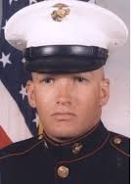
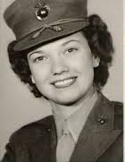

She enlisted in 1943 and was stationed He enlisted in the Marine Corps
at Marine Corps and Naval Air Stations Reserve in 1980 and served six
in Virginia and North Carolina during years as a field radio operator in
her career. Eventually, she was promoted the 25th Marine Corps Regiment
to staff sergeant. She was honorably in Ohio
discharged in September 1945.

Answers will be in the July 2026 Newsletter with more photos

Military, college or high school picture can be sent either Tim Kolzow (takolzow@gmail.com) or Jo Gabl (jojobean.gabl@gmail.com)
May’s Photo Answers

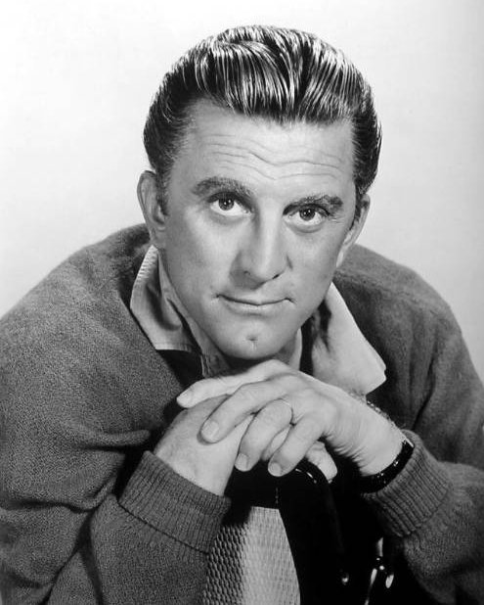
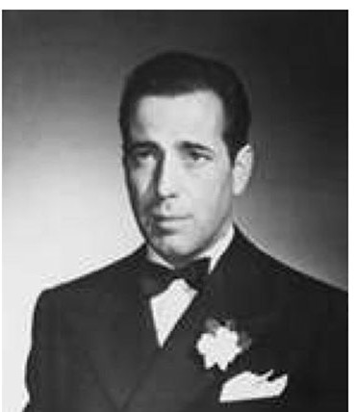

Kirk Douglas – Actor Humphery Bogart - Actor

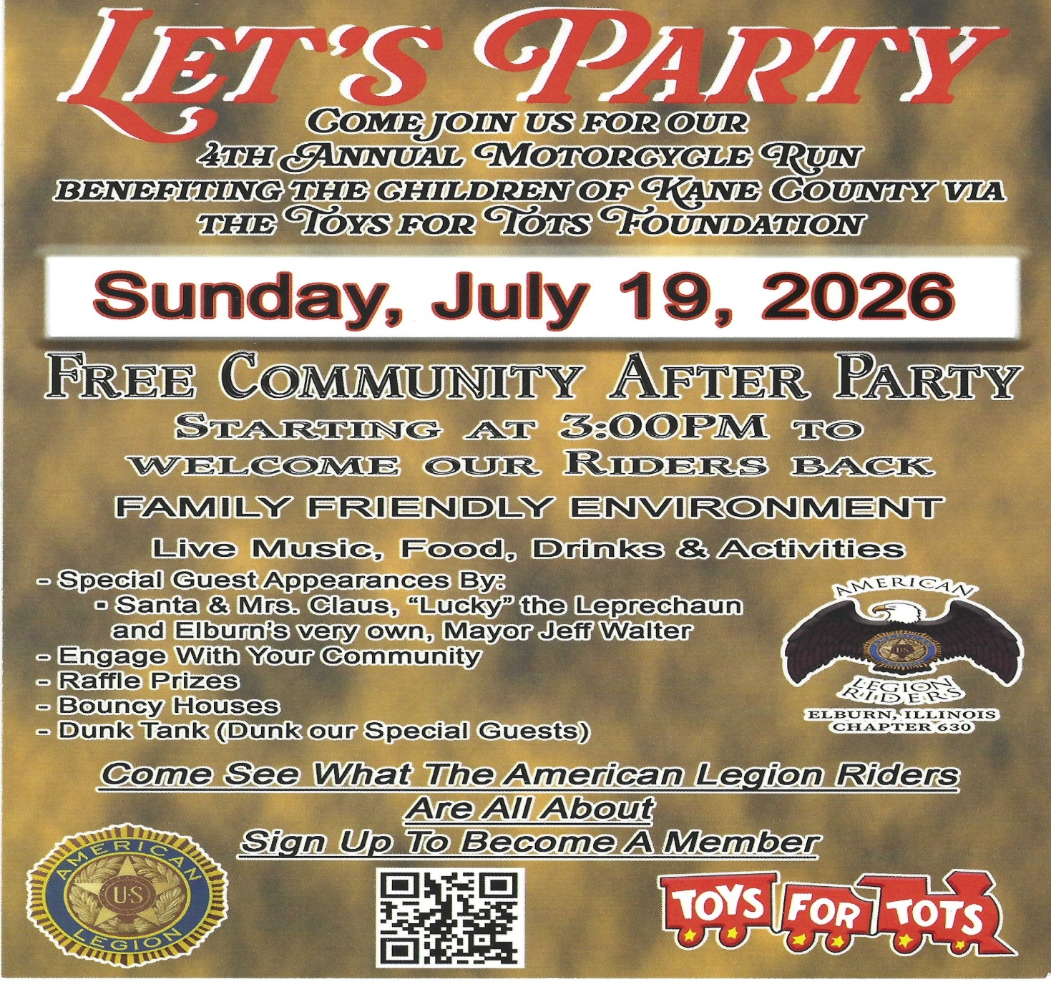

June Puzzle

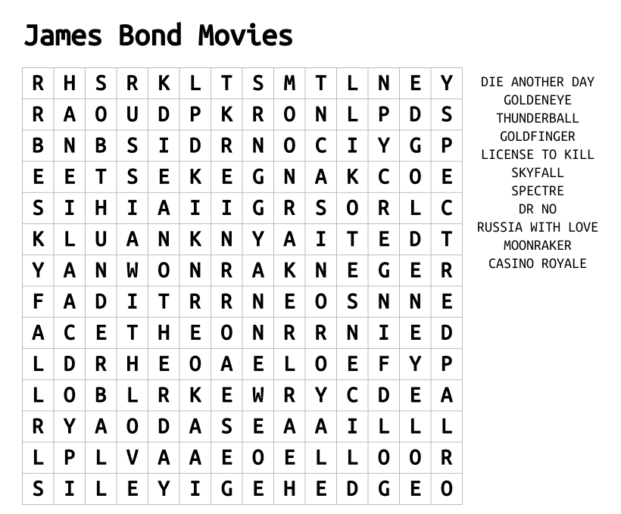

Memorial Day 2026 – Blackberry Cemetery

I want to thank everyone who participated in the Memorial Day service. Thanks to the people who put flags around BlackBerry cemetery, assisted putting flags on veteran’s gravesites, setup crew, flag holders, rifle squad, speakers for the service, boys and girls scouts, Venture crew and cleanup crew. There were 100 people attending the service. Thank you again for your help and attending the service.

Norm Welker, Commander Post 630

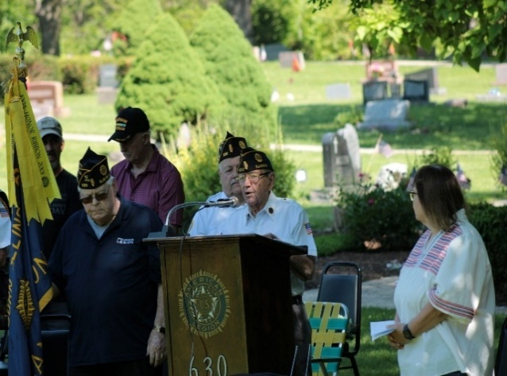
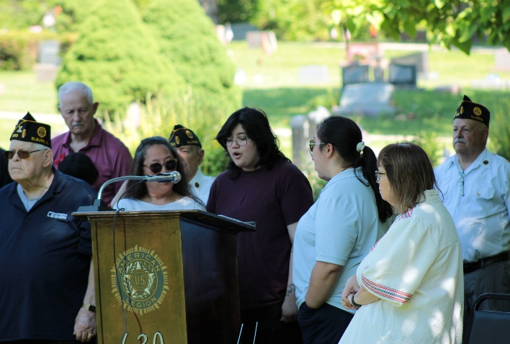

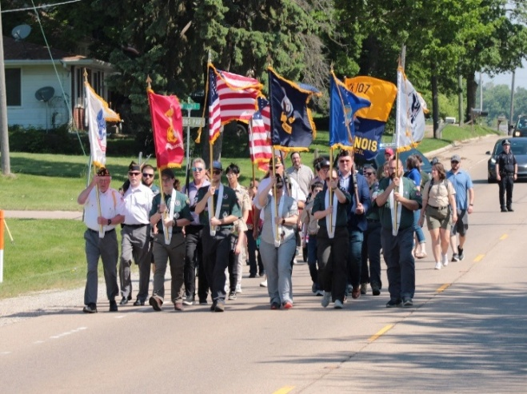
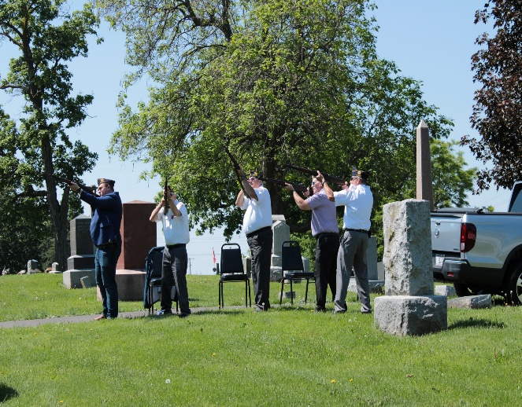

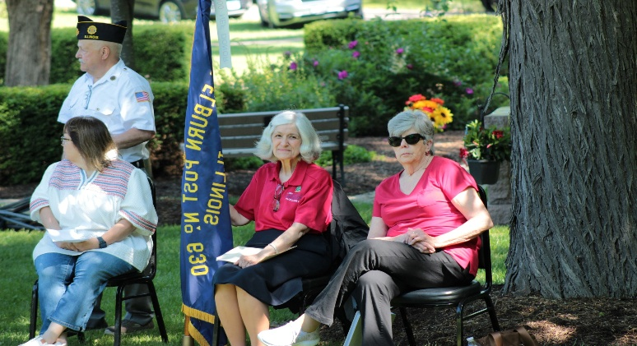
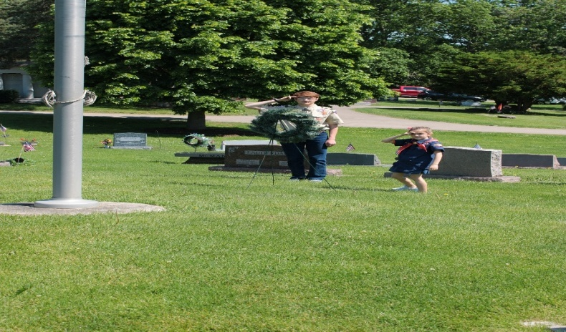

Awards all around!!

At the May Post meeting the following awards were handed out;

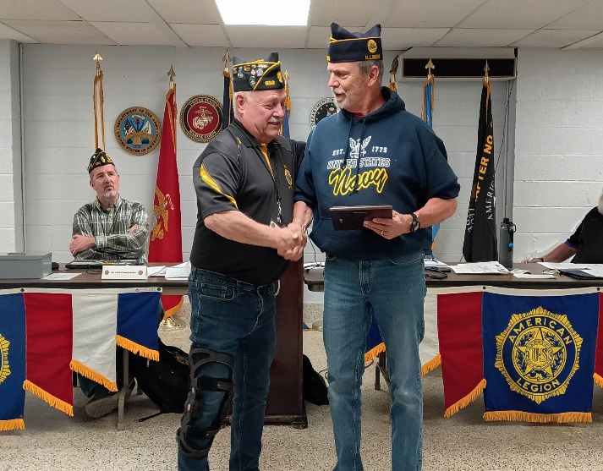

Finance Officer John Waynick received a Special Thanks plaque from Commander Norm Welker for all that he has done for the Post. John not only served in 3 officer positions but also cared for and maintained the Post and Bunker Bar. John and his wife will be moving down to Georgia soon. Good Luck, John!
.

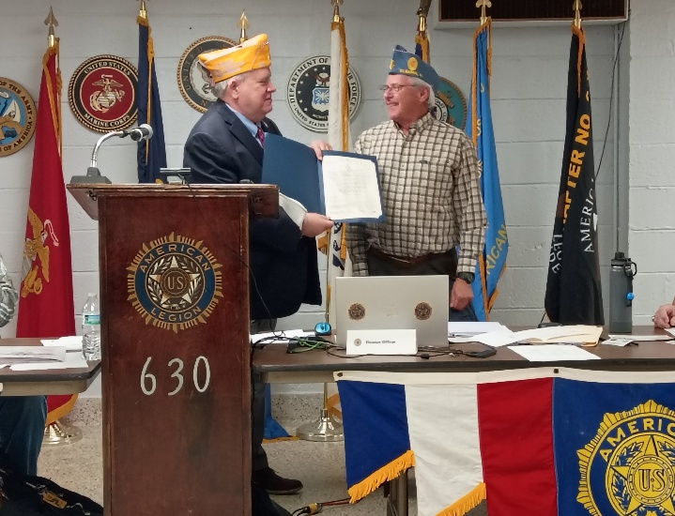

SAL National Committeeman Mike Vosar stopped by Post 630 to present the SAL Commanders 4 Pillars Achievement Award to SAL Squadron 630. Accepting the Award is Bruce Aderman, Sr Vice Commander for SAL Sqdrn 630.

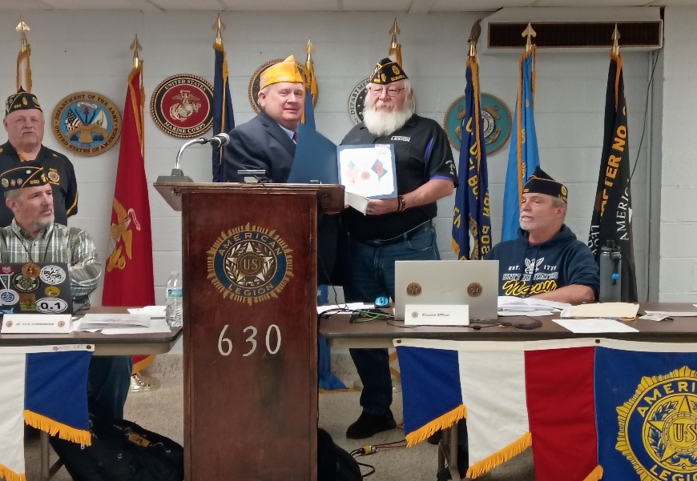

SAL National Committeeman Mike Vosar hung around long enough to also award Post Adjutant and SAL member John Reece a 10-year continuous Membership award.

