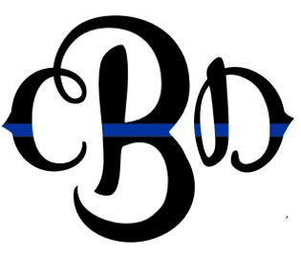

Colten D Brown Memorial Scholarship Foundation Inc
107 Muir Street
Warren PA 16365
814-730-3885
coltbrownscholarship@gmail.com
www.coltbrownscholarship.com
EIN 88-0908267
THE COLTEN D. BROWN MEMORIAL SCHOLARSHIP FOUNDATION, INC.
Dear Potential Supporter,

The Colten D. Brown Memorial Scholarship Foundation, Inc. has been established to help provide scholarships for students seeking to improve themselves through higher education at Penn State Erie, The Behrend College.

The Brown family lost Colten at the young age of 24, on January 6, 2021, after a courageous four-week battle with Covid-19. Colten was a graduate of Penn State Erie and was currently working to make a difference as an Erie County Adult Probation Officer. Colten was a loving son, brother, and uncle, who was very devoted to his friends and family. He had a history of sending people daily inspirational notes and being a friend who would be there to help anytime, day or night.

On Saturday, June 10, 2023, the ANNUAL COLTEN D. BROWN
MEMORIAL SCHOLARSHIP GOLF SCRAMBLE will be held at 8:30 a.m. at the Jackson Valley Golf Course located at 6927 Jackson Run Rd, Warren Pennsylvania. The net proceeds will go to fund the permanent scholarship created for students at Penn State Erie, The Behrend College. We are seeking community participation through your involvement as a business sponsor, raffle prize donor, and golfer participation. Please consider joining us with your support.

On behalf of the Brown Family

FOR THE EVENT WE NEED YOUR HELP
- Gold Sponsor:
  - Company name and logo displayed on the banner, main board at scramble, website, and announced during welcoming remarks
  - Free entry for a foursome in the scramble, entry must be received by May 12, 2023
(B). Silver Sponsor:
  - Company name and logo displayed on the sponsorship board at scramble, website, and announced during welcoming remarks
- Bronze Sponsor:
  - Company name and logo displayed at one of the 18 holes and on our website
- Donor:
  - Display on the donor board and website.
  - Donations will be picked up between May 22 and 26, 2023

- Gold Sponsor ($1000)
- Silver Sponsor ($500)
- Bronze Sponsor ($150)
- Donor

Sponsor/Donor Information:
Contact Name: ________________________________________ Organization Name (as you would like it to appear on materials also send a logo):
_______________________________________________________________
Address: City: State: Zip:
Phone: (____) _________________Email:

Payments can be made by check made out to: Colten D. Brown Memorial Scholarship Foundation, Inc. and returned by mail to 107 Muir St. Warren, Pa 16365. For more information, please call Pam Bright at (814) 730-3885 or email at coltbrownscholarship@gmail.com

