 Translated from Chinese (Simplified) to English - www.onlinedoctranslator.com
Wenbao Regional Partner System (Trial)
In order to increase the proportion of terminal customers, improve team enthusiasm, strengthen terminal service capabilities, and seize the sales proportion of small B customers, the company has decided to pilot the partnership model.
Solution Introduction:
Traditional sales model: fixed salary 60% + sales commission 30% + assessment 10%
Regional Partner Model: Abandoning the traditional salary structure and breaking the salary limit, the team shifts from working for the company to working for themselves. Individual income is determined by the sales volume of the region. The company provides product + team assessment standards + market breakthrough support + data support, etc., helping the region to quickly take shape and achieve sales of 250,000.
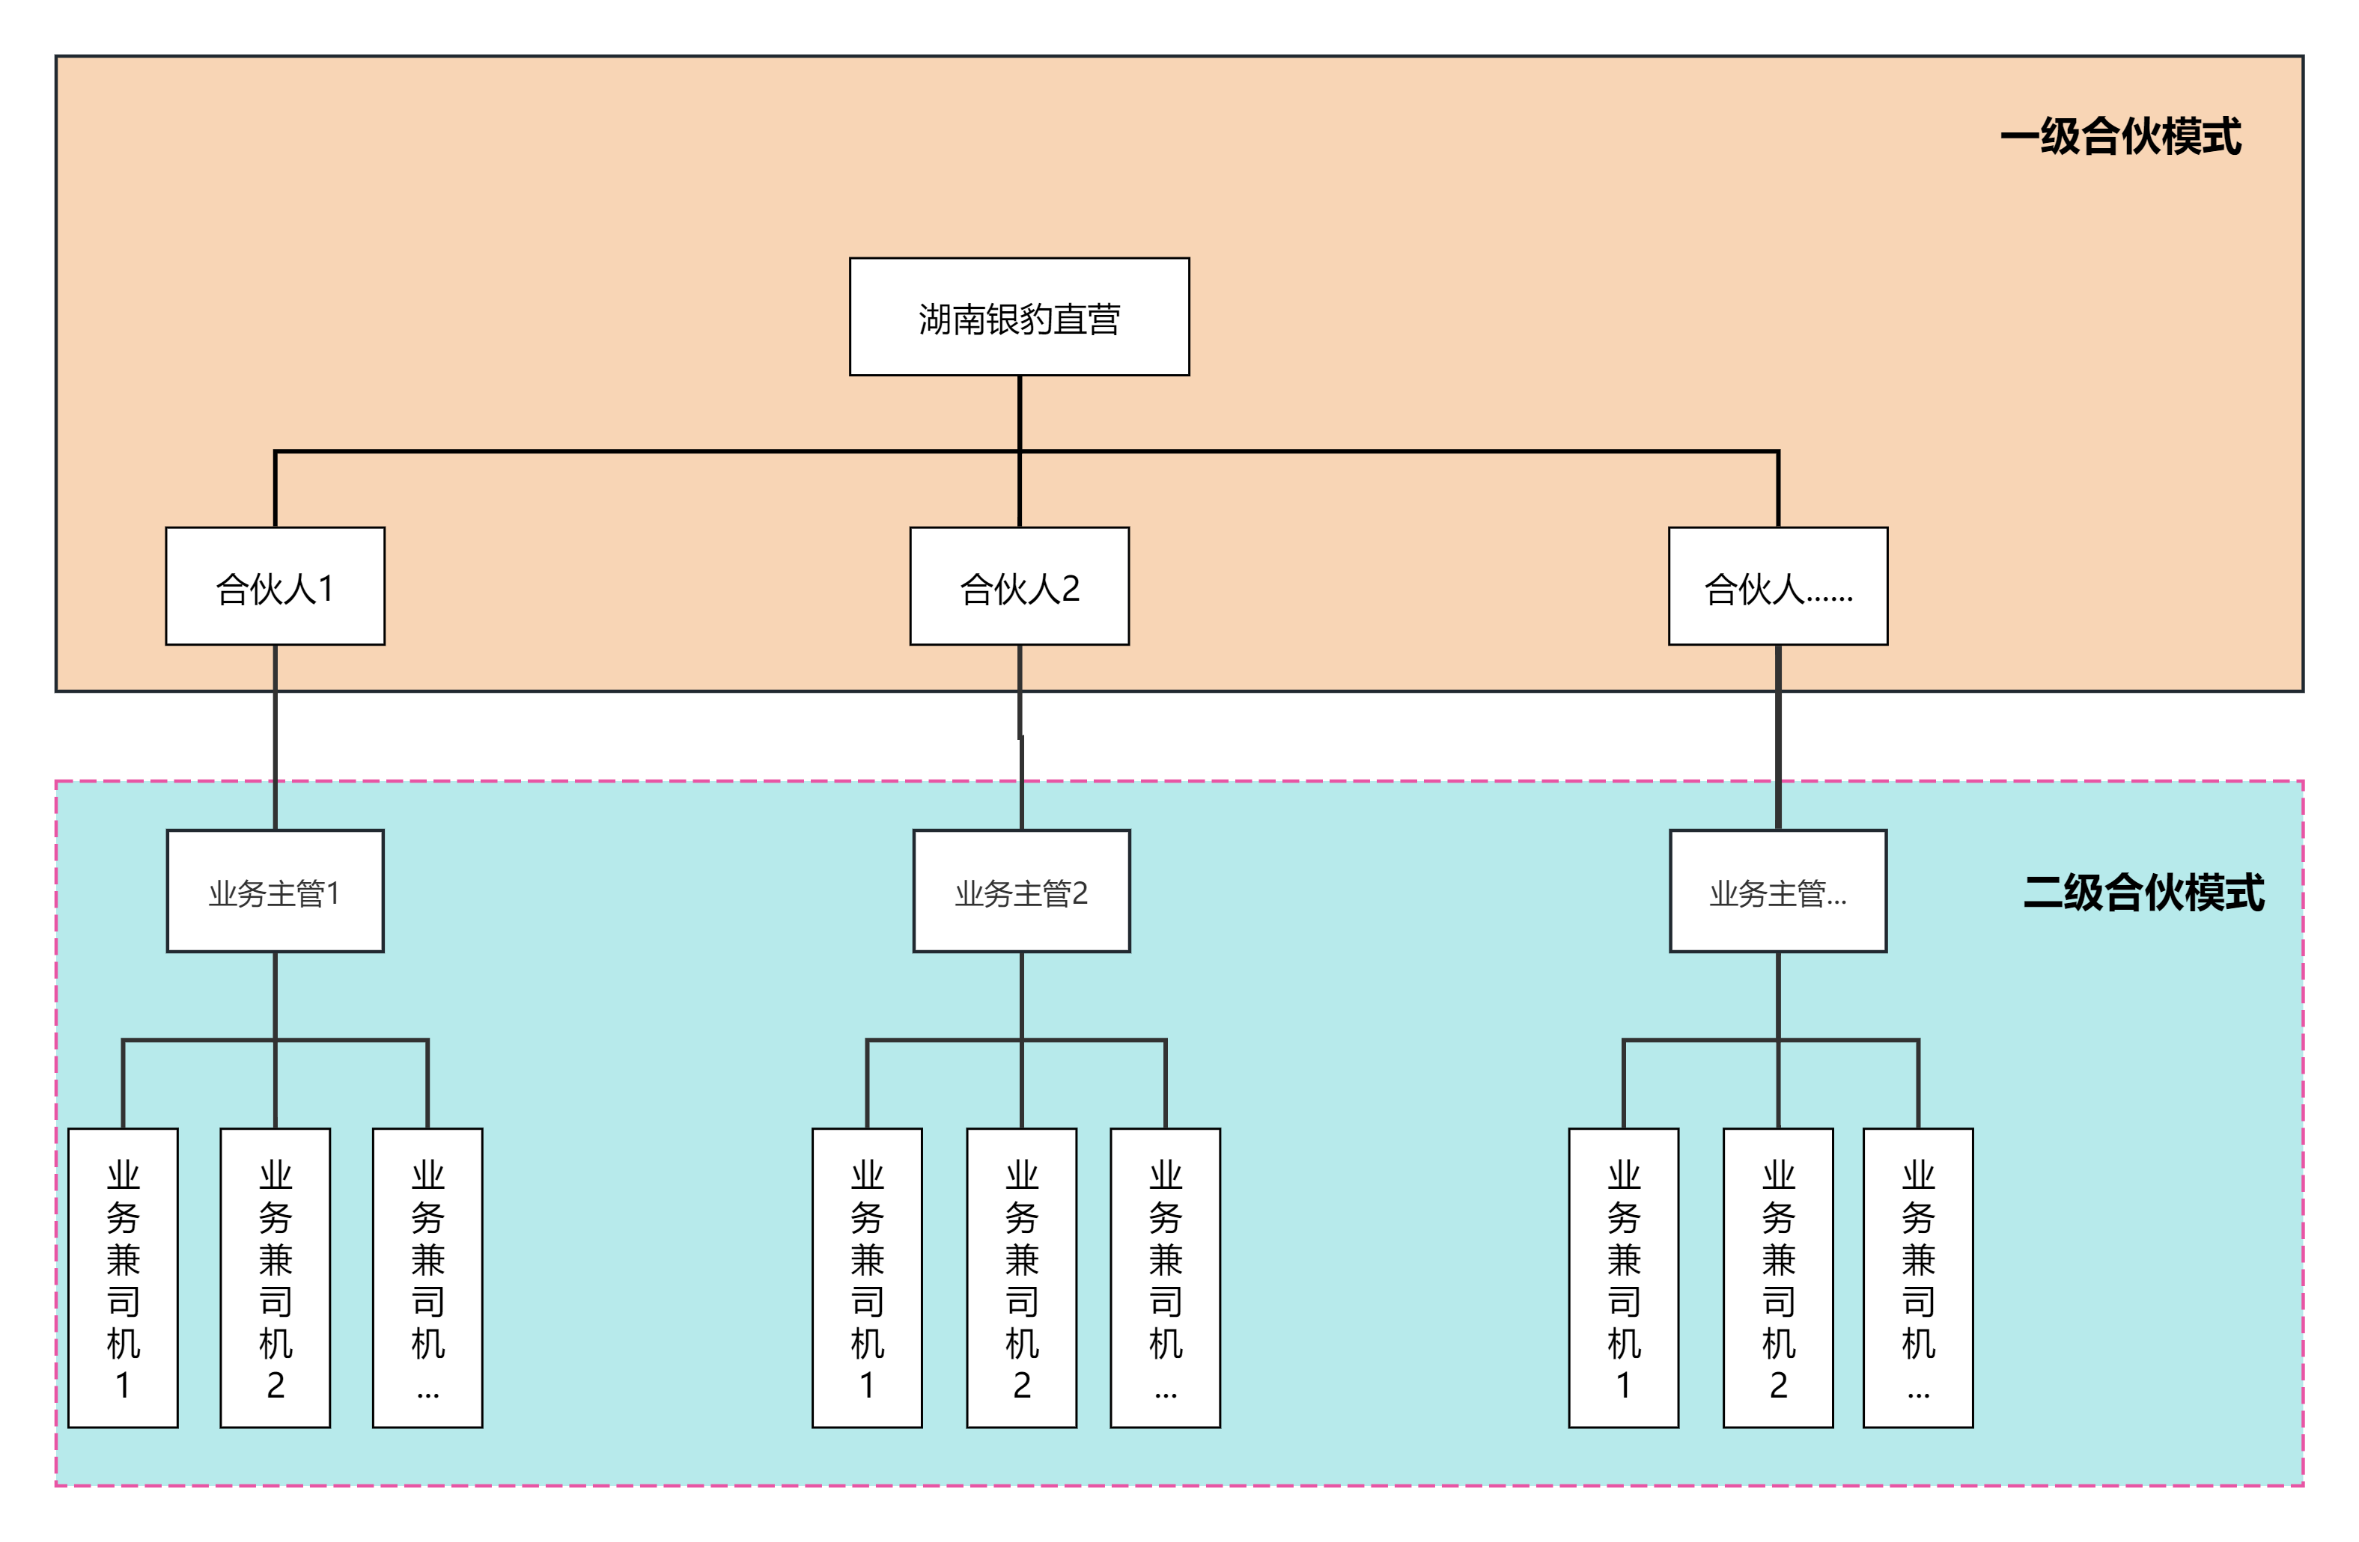
Solution Description:
1. Within the territory, the overall gross profit margin will be split 6:4 between the partner and the company. The partner will be responsible for customer retention, customer development, product distribution, new product development, and sales of slow-moving products within the territory.
2. In the early stage of undertaking a region, when the income is low, the partners will carry out the goods distribution alone. The company will provide vehicle rental and the partners will do the distribution themselves while carrying out customer maintenance and customer development in the region.
3. For regions with revenue below RMB 200,000, the company will send a special team to assist regional partners in rapid business expansion for one month, so that the region has the ability to generate initial revenue;
4. If the business volume in the area under its jurisdiction increases, partners may propose recruitment needs, and the company will be responsible for recruiting a team for them. The partners will be responsible for the salary, management, and work arrangements of the recruited personnel;
Salary calculation:
Partner Compensation Plan
Salary Distribution |  |  |  |  | Performance Forecast
 |  |  |  |  | Monthly basic delivery amount | Delivery gross profit | Partner income | cost |  |  | Monthly rewards and penalties | Forecast monthly income
Total gross profit | Warehousing costs | Remaining | Silver Leopard proportion | Proportion of partners | Monthly basic delivery amount | Delivery gross profit | Partner income | Vehicle costs | Labor costs | Other costs | Monthly rewards and penalties | Forecast monthly income
19% | 5% | 14% | 40% | 60% | 250,000 | 35,000 | 21000 | 6000 |  | 500 | 1000 | 15500

The partnership model breaks the income ceiling. Individual income is linked to regional turnover. Individuals are responsible for their own profits and losses, and are self-managed and inward-looking.

Regional division:
Changsha is divided into 10 areas based on current sales volume.
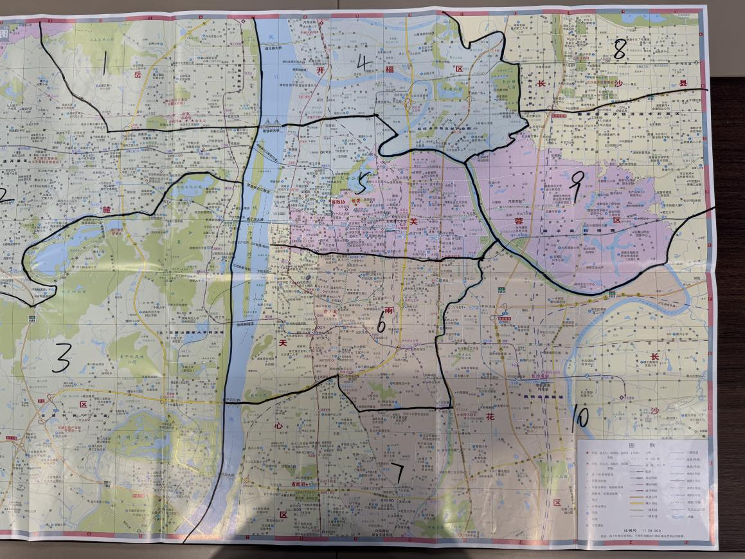
First Partner
Area 2: Pan Wentao
Assault Team: Wu Guiju, He Wenjun, Li Wenchi
Area 9: Yan Songyan
Assault Team: Liu Shuai, Zhang Weixiao, Gong Dan
Area 10: Zhu Zengjun
Assault Team: Li Li, Wu Xiaoming, Yang Yaping
1. After the partners have divided the regions, they will not be changed later. The partners will independently operate the regions under their jurisdiction and are prohibited from developing business and customers across regions;
2. If there are major issues such as partner resignation or unauthorized collusion, the company will be restructured;
3. During the blitz period, the regional blitz team will be responsible for delivery to regional end customers, and partners will coordinate;
4. The company in the region undertakes external delivery business, which is carried out by regional partners. The company provides cost subsidies and the delivery standards meet customer requirements;
5. Delivery route planning: plan routes in advance according to the area under your jurisdiction to avoid problems such as missed orders, wrong orders, and delivery delays;
New commission:
Gross profit per customer | Development Standards | Commission Points | time | Single customer sales
≥16 points | 100-5000 yuan | 10% | 30 days before file creation | 5000 yuan cap (cash payment)
12 points ≤ 16 points | 100-20,000 yuan | 6% | 30 days before file creation | 10,000 yuan cap (cash payment)
7 points ≤ 12 points | More than 1000 | 3% | 30 days before file creation | No upper limit (current settlement)
<7 points | More than 1000 | 1% | 30 days before file creation | No upper limit (current settlement)
The commissionApplicable to all company personnel:Assault Team,Business clerks, customer service, drivers, etc..
Promotion mechanism:
Salesman
Regional Director
Regional Manager
First-level partner
Second-level partner
Salesman

Company Partner

Account funds:
Partners have a three-day payment period. Payment must be made to the company's account within three days of receiving the goods. If payment is not made after three days, the company will not allow the goods to be shipped. For partners with monthly settlement clients in their area or for special circumstances, they can apply to the company for a longer payment period, which will be extended upon approval.

