1 Warehousing investment
accounted for around 26% of the total private equity (PE) investments
estate during January 2014 – January 2018. Around USD 3.4 billion (INR 22,100 crore) of institutional capital has flown into this sector during this period

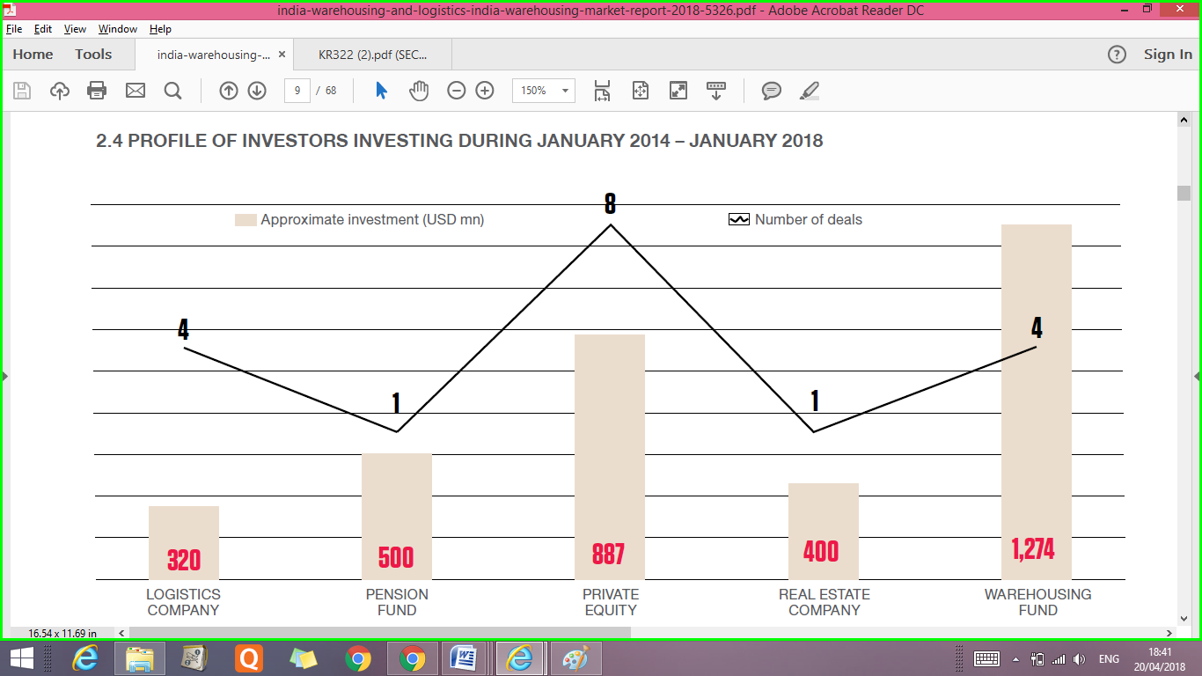

2
SOME OF THE NOTEWORTHY INVESTMENTS DURING JANUARY 2014 – JANUARY 2018 INCLUDE –

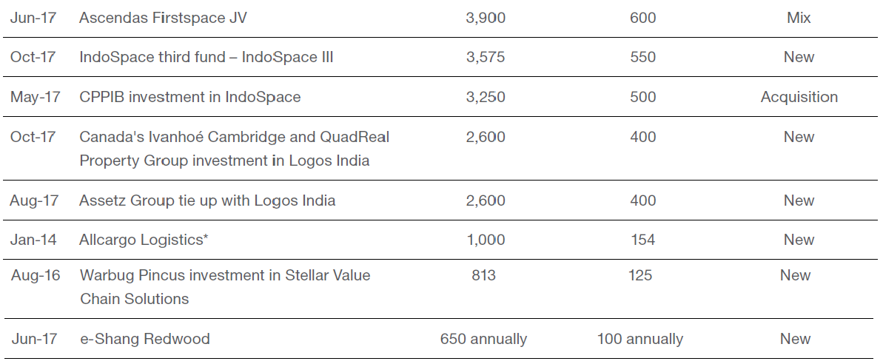

The Ascendas-Firstspace is a joint venture between Ascendas-Singbridge, Asia’s leading sustainable urban and business space solutions provider, and Firstspace Realty, an Indian partner with rich experience in industrial real estate in.

Ascendas-Singbridge's global logistics experience with a strong Indian presence
- Manager of over 30 million sq ft of industrial and logistics space across Asia-Pacific bringing international best practices
- Strong customer relationships with over 2,600 customers
- Developed and manages over 11 million sq ft of office space across five tier-1 cities in India since 1994
- Firstspace team had already developed two modern warehousing projects in Chennai and Bangalore before teaming up with Ascendas-Singbridge

Canada Pension Plan Investment Board and IndoSpace Form Joint Venture 'IndoSpace Core'(CPPIB)
Toronto, Canada/Mumbai, India – May 15, 2017: Canada Pension Plan Investment Board (CPPIB) and IndoSpace, India’s largest developer of modern industrial and logistics real estate, today announced the creation of IndoSpace Core, a joint venture that will focus on acquiring and developing modern logistics facilities in India. CPPIB has initially committed approximately US$500 million to the joint venture and will own a significant majority stake. IndoSpace Capital Asia will manage the new entity.
IndoSpace Core has committed to acquire 13 well-located industrial and logistics parks totalling approximately 14 million square feet, from current IndoSpace development funds. The joint venture will acquire the first nine facilities totalling approximately nine million square feet at closing, and the additional facilities within 24 months. The assets are prime industrial properties located in the top industrial and logistics hubs in India, including Chennai, Pune, Mumbai, Delhi and Bangalore.
IndoSpace Core has the option to acquire additional industrial and logistics parks totalling approximately 11 million square feet, which are currently being developed by IndoSpace funds and are worth approximately US$700 million. IndoSpace Core will also opportunistically acquire stabilized assets from third parties across India.
Sameer Sain, Co-Founder and Managing Partner, Everstone Group, said, “As the leading owner and developer of logistics and industrial spaces in India, IndoSpace is excited to partner with CPPIB, one of the premier owners of industrial real estate globally. The combination of our expertise and a strong macro backdrop, including Make in India, the GST rollout and growth in e-commerce, will provide significant opportunities for this joint venture.”
About Canada Pension Plan Investment Board
Canada Pension Plan Investment Board (CPPIB) is a professional investment management organization that invests the funds not needed by the Canada Pension Plan (CPP) to pay current benefits on behalf of 20 million contributors and beneficiaries. In order to build a diversified portfolio of CPP assets, CPPIB invests in public equities, private equities, real estate, infrastructure and fixed income instruments. Headquartered in Toronto, with offices in Hong Kong, London, Luxembourg, Mumbai, New York City, About IndoSpace
IndoSpace (www.indospace.in) is the pioneer and largest provider of modern industrial and logistics real estate in India and currently has 21 industrial and logistics parks across India. It is a joint venture between the Everstone Group (www.everstonecapital.com) and Realterm (www.Realterm.com). The Everstone Group is a premier India and South East Asia focused private equity and real estate firm. Realterm is a multi-strategy private equity real estate operator whose industrial platforms, Realterm Logistics and Aeroterm, are industry leaders with over 300 operating and development properties in North America, Europe and India.
India’s logistics industry is expected to grow at 10-11% annually to reach a size of ~USD 200 billion by 2021.

Mumbai: IndoSpace, a joint venture of private equity firm Everstone Group and US-based industrial real estate firm Realterm, on Tuesday said it has launched its third fund, IndoSpace III, with a target corpus of $550 million, which would take its total assets under management to above $1 billion.
Currently, IndoSpace’s portfolio includes 28 logistics and industrial parks across the country.
Its major tenants include Amazon.com Inc., Nissan Motor Co., DHL Supply Chain India Pvt. Ltd, PepsiCo India Holdings Pvt. Ltd and Bosch Group.
There has been a bunch of deals in the warehousing and logistics space in recent months.
Earlier this month, logistics investment and development firm LOGOS India raised $400 million from Ivanhoé Cambridge and Vancouver-based QuadReal Property Group.
LOGOS India seeks to develop and own modern logistics facilities across major cities such as Mumbai, Pune, Chennai, the National Capital Region (NCR), Bengaluru, Hyderabad and Ahmedabad.

In June, Singapore-based Ascendas-Singbridge Group announced a joint venture with realty firm Firstspace Realty to enter the Indian industrial logistics and warehousing market. They jointly aim to invest $600 million over the next 5-6 years and develop around 15 million sq. ft of space.
In April, Embassy Industrial Parks, a joint venture between real estate developer Embassy Group and private equity firm Warburg Pincus India Ltd, bought 24 acres of land in Gurugram, Haryana, to build an industrial and warehousing hub at a cost of Rs140 crore, Mint reported.
First Published: Tue, Oct 31 2017.

Logos ties up with Assetz Property Group to raise $400 million fund

BENGALURU: Logos Group, an Asia-Pacific region property logistics company, has entered into a partnership with real estate developer Assetz Property Group to expand its operations in India and raise a new fund.
The two partners have set up a standalone platform, Logos India, which is working on closing its first Indian logistics venture with an expected $400 million of equity commitments to potentially develop assets worth $1 billion.

The State Oil Fund Of Azerbaijan Invests US$100 Million Into ESR's Logistics Portfolio In Japan
Tokyo/Shanghai/Singapore/Baku, 13 February 2017 — ESR (e-Shang Redwood), one of the leading logistics fund developers and managers in Asia announced that it has closed on a US$100 million investment from the State Oil Fund of Azerbaijan ("SOFAZ").
Rapid growth in the operations of third-party logistics companies and the e-commerce sector, combined with Japan's stable overall economy and the shortage of modern warehouse space (less than 10 percent of the total market supply), has made the logistics sector here an attractive option for developers and investors.
Shashi Kiran Shetty, Chairman of Allcargo Logistics, is plotting the next phase of growth for the company he set up about 25 years ago “after listening to his inner voice”. The integrated logistics firm has traversed organic and inorganic routes including 12 acquisitions, one of which was at least five times the size of the Indian firm.
Shetty’s focus is to turn Allcargo into a $2-billion global leader by 2020.
GST Has The Potential To Create Mega Warehousing Hubs In The Country: Adarsh Hegde, Joint MD, Allcargo Logistics Ltd.

BREAKING DOWN 'Year Over Year - YOY'
YOY comparisons are a popular and effective way to evaluate the financial performance of a company and the performance of investments. Any measurable event that repeats annually can be compared on a YOY basis. Common YOY comparisons include annual, quarterly and monthly performance.
AMAZON There is any role model to be idolised in the logistics domain then Amazon it is. What started as a simple digital platform for sale of books has now turned into a massive e-commerce giant with a global presence. Started in 1994, its 1997 initial public offering (IPO) was valued at USD 461 million. After 20 years, the company’s market capitalisation stands at a stupendous USD 530 billion as on November 1, 2017. Today, Amazon facilitates the sale of a wide range of products and brands to customers in every nook and corner of the world through its online platform. Furthermore, its delivery service has set new benchmarks for the supply chain segment.

Apart from conventional storing services, warehouses in India now provide value-added services like consolidation and breaking up of cargo, packaging, labelling, bar coding, reverse logistics, etc.
The growth in warehousing in India is primarily being driven by the following factors:
- Growing manufacturing activity
- Rising domestic consumption,
- Increasing international trade
- Emergence of organised retail in the country
- Increasing private and foreign investments in infrastructure
- Easing of government regulations

India’s warehousing industry
The size of the Indian warehousing industry (across commodities and modes) is pegged at about INR560 billion (excluding inventory carrying costs, which amount to another ~INR4,340 billion). The industry is growing at over 10% annually.
Warehousing forms a crucial link in the overall logistics value chain. It accounts for ~5% of the Indian logistics market (excluding inventory carrying costs, which amount to another ~30%).
Multiple business models exist within the warehousing industry. The key segments can be represented as:
- Industrial/Retail warehousing: accounts for ~55% of the total market
- CFS/ICD: ~14% share
- Agri warehousing: 15% share
- Cold stores: ~16% share

Unimaginable Potential of Warehousing & Logistics sector
India’s largely under invested warehousing & logistic sector could perk up with a corresponding rise in manufacturing
Resultantly, as compared to advanced countries, india’s warehousing sector remains at a relatively modest stage. The size of the Indian warehousing industry, across commodities and modes, is pegged at about Rs 56,000 crore. The warehousing industry, growing over 10 per cent annually, is mostly dominated by unorganised players who account for 85 per cent of the market. Modern warehousing companies or organised players account for the rest of the 15 per cent share.
The logistics sector is broadly classified into three areas – transportation, distribution and storage. While studies have been conducted into the former two, storage and warehousing remain less known and subject to much lesser research and examination, even though warehousing constitutes 15 to 35 per cent of the total costs of logistics.
focuses on the existing warehousing sector dynamics, insights on upcoming demand and investors’ returns along with providing a definitive view on the country’s warehousing market.
Some key takeaways of the warehousing for the entrepreneurs are :-
Total warehousing space requirement in India expected to grow at a CAGR of 9 per cent from 919 million sq ft in 2014 to 1,439 million sq ft by 2019.
Manufacturing will continue to remain one of the biggest demand drivers of the warehousing sector with an annual requirement of 61 million sq ft of incremental space between 2014 and 2019.
With the government’s renewed focus on incentivising the manufacturing sector, the logistics market will reap the benefits in the coming years.
Investment in warehouses can provide an opportunity of realising returns in the range of 12 to 20 per cent per annum to investors willing to explore this sector.
The biggest challenge though for manufacturers is the present central sales tax structure which is forcing companies to locate warehouses in all the states they operate in, resulting in an inefficient supply chain.
Introducing GST will streamline the taxation procedure thereby creating an effective supply chain.
Historically, Indian companies have considered warehousing activity as an unavoidable cost and the objective ? always been to reduce this cost as much as possible. Such an attitude has resulted in huge under-investment in the sector. However, increasing competition and introduction of global best practices by multinational companies are compelling Indian businesses to rethink on the importance of warehousing activity and the resultant benefits of managing an efficient supply chain.”
The institutional investors, real estate developers, high net worth individuals (HNIs) and private equity funds planning to invest in the warehousing sector are huge in number in different cities in India,but have limited understanding of the various aspects of this sector.
There are visible macroeconomic signs that indicate India’s GDP is expected to grow at better rates than the previous several quarters. The manufacturing sector in India will play a critical role in that growth and would lead to continuous demand for warehousing real estate space across regions in India. Also, the government is considering reviving the SEZ sector, which would further help in pushing manufacturing growth in India leading to further investments.
To be sure, the Indian government, despite the backward nature of the sector, has recognised its importance. In order to create a trade-related infrastructure and to facilitate import and export of goods and services, the government announced the setting up of a free trade and warehousing zone (FTWZ) in the foreign trade policy . The FTWZ is a special category of the special economic zone (SEZ) and is governed by the SEZ Act. The SEZ Act defines FTWZ as a special economic zone carrying mainly trading, warehousing and other related activities.
Laying down the parametres, the SEZ Act states that the minimum area for a FTWZ should be 40 hectares with a build-up area of 100,000 sqm. The act allows, through an automatic route, 100 per cent FDI for the development and establishment of storage and warehousing facility, including warehousing of agricultural products with refrigeration and cold storage.
Clearly, with the new government’s emphasis on boosting manufacturing – there appears to be no way out for India to get into the competitive mode – warehousing and storage could see better days. The Supply chain management is all about flow, be it the flow of goods from the producer to the consumer or flow of information from the consumer to the producer. Warehouses play a critical link in this process and were conventionally set up as inventory buffer points along the supply chain so that any irregularities within this chain could be ironed out. However, the need to reduce the service response time and contain inventory cost has necessitated the progression of warehouses from storage points to distribution centres. Additionally, the advent of technology has made it possible to operate the warehouses more efficiently and achieve greater integration with the rest of the supply chain modules.
In order to enthuse potential developers, a set of fiscal and regulatory benefits has been provided. These include a 100 per cent tax holiday under Section 801A of the Income-Tax Act, 1961. Since FTWZ is a foreign territory within the political boundaries of India, all purchase transactions conducted are not treated as import. Likewise, all sales transactions are not treated as export. Hence, value added tax (VAT) central sales tax and excise duties are exempted on all transactions; exemptions are also valid on service tax. These include service tax on rentals, labour, value added services and primary transportation from port to FTWZ and from one zone to the other.
Still, the warehousing industry has come a long way from the days of storage in godowns to modern highly automated warehousing parks. The shift from godowns to warehouses has increased activity in the supply chain network. Apart from storage, they are more and more being used for value added functions like distribution and cross docking.

