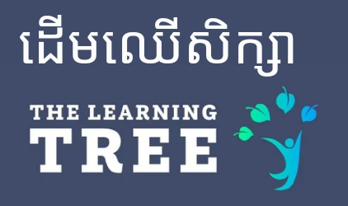

**Tuition Payment Policy**

The aim of this policy is to establish a fair, consistent, and transparent approach to the payment of tuition fees. It is designed to support a positive and respectful relationship between parents and the school by ensuring that everyone clearly understands the expectations and procedures.

As a tuition-based institution, The Learning Tree relies on the timely and reliable collection of fees to continue providing high-quality education. This policy ensures that all parties are aware of and follow a standardized process, promoting equity and accountability for all families.

**Tuition Fees Based on 203 Teaching Days and 8 Hours of Contact Per Day**

**Full-Day Program K1 (2 years old) to Year 6 (11 years old):** $1800 per year.

**Half-Day Program K1 and K2:** $960 per year.

**Payment options**

We offer several discounts to support families and encourage long-term commitment. Tuition fees must be paid in full before the first day of school. Students with any outstanding balance will not be permitted to start or return to school until the balance is cleared.

**Yearly payment - 10% Discount**

* Payment must be made by August 15th to ensure that the student can begin school on time. (The school calendar will be provided for clarity)
* K1 to Year 6 full time with discount = $1620
* K1 and K2 part time with discount = $864

**Termly payment - 5% Discount**

* 3 payments made before the beginning of each term. (August 15th, December 15th and March 15th.
* K1 to Year 6 full time with discount = $570 per term.
* K1 and K2 part time with discount = $288 per term.

**Monthly payment**

* Monthly payments must be made by the 1st day of each calendar month.

**Multiple Sibling Discount**

* 5% discount for every child enrolled with or after the initial child.

**Included in Tuition Fees Additional Fees**

* Enrolment fee Additional uniforms $10 each
* Yearly capital fee Lunch $1 per day
* 2 uniforms (*Charged at the end of each month*)
* Morning snack After school clubs
* All learning materials & resources

**Payment Methods**

* All payments must be made in US dollars ($).
* Payments can be made in cash or online transfer using the details provided below.

**Terms and Conditions**

1. The Learning Tree is fully committed to providing a safe and secure environment for all students. We maintain public liability insurance to ensure protection in the unlikely event of an incident on our campus. Additionally, all staff members are trained in First Aid by the Cambodian Red Cross, equipping them to respond appropriately in case of medical emergencies. We uphold a strong duty of care to every child in our care and take all reasonable steps to safeguard their physical and emotional well-being during school hours and on school premises.
2. All tuition and fees are due on the indicated dates. Failure to make payments within three (3) weeks will result in exclusion of your child from The Learning Tree. In the case of there being a waiting list for your child’s class, the place will be given to the first child on that list.
3. Refunds on paid tuition will only be considered upon written request and will apply only to full terms not attended. No partial refunds will be issued for students who leave during a term.
4. Tuition fee refunds are only applicable to students who are permanently withdrawn from The Learning Tree. Refunds will not be granted for temporary absences—such as holidays or other time away during the school term—if the student remains enrolled, unless there are exceptional circumstances, such as serious long-term illness or the family relocating to another country.

**Fee Increases**

Tuition fees are reviewed annually during the development of the budget and are subject to change. Parents will be notified at least 2 months before the start of the new school year if any changes have been implemented.