Grandpa Thom and a New Kidney
What is a kidney? It is a part inside our bodies that does a very important job. It filters our blood to get rid of anything bad for our bodies. For example, many people will have a filter for their drinking water to get rid of bad chemicals or germs. Our kidneys do the same type of thing. Our blood passes through our kidneys that act like a filter to remove anything bad or that should not be there.
Sometimes, those kidneys get worn out and do not work. That can be very dangerous for our bodies and we can even die. So, when the kidneys stop working, people use a machine that takes their blood and filters it and then, returns it back to the body
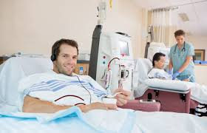
Grandpa Thom had a problem where his kidneys stopped working. So, he would go to a building in Modesto, California where he could get hooked up to one of the filtering machines three days a week. This kept his blood healthy so he could go about his life doing normal things like everyone else.

Well, Grandpa Thom and I learned something really cool. Even though you have two kidneys in your body, you can get along just fine with only one. We learned that I could give one of my kidneys to Grandpa Thom and he would not have to use machines to filter his blood. So, we did it. We went to a hospital where they removed one of my kidneys and placed it inside Grandpa Thom. It worked great! With a new kidney, he looked really good and he felt awesome. No more machines and three trips a week to get his blood filtered!
We were both very thankful to the doctors and nurses that helped us at the hospital. Heavenly Father has helped the world to discover many ways to treat our bodies and make them better.
Part of Twin Power is to share what you can with others to bless their lives. Sharing and being kind is a big part of being like Jesus. Grandpa Thom was a great example of always wanting to help other people.

