**Poppy Thom and the Dune Buggy**

**When Poppy and I were about 14 or 15 years old, our scouting troop decided to make a dune buggy. Our scout master was a mechanic of sorts and had all kinds of connections. He was even able to get a car donated for all of us to work on. It was an old Mercury Hudson from the 50”s. Here’s a sample of what it looked like before we started to take it apart.**

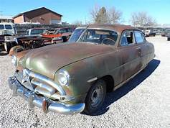

**The first job was to strip all the metal from the body. This was an old car and all the metal was super thick and heavy. But, there was a problem. The car was too long for a dune buggy. It had to be cut down so it was not too long. So we cut out a big part of the middle of the car and then, start to work on the engine. It barely ran, but our leader was able to get it started. He was also able to get some new engine equipment that made it more powerful and fast.**

**We also had a friend of our leader make some really cool custom seats for the car. It had a really nice upholstery in black vinyl. They had what you call a diamond tuck design to them.**

**This was a good experience for all of us scouts. It was fun and we learned a lot. When all the work was done, it was time to test drive it.**

**One of our friends was first to drive it. The passenger seat was not bolted down so it was just sitting on the ground near the dune buggy. Our friend was new at driving a car and accidentally ran over the new passenger seat. He was not very popular from that point on!**

**Twin Power is learning new things and feeling good about accomplishing a project. You don’t have to be a twin to learn and achieve.**