Poppy Thom and Father and Sons Outings
One of the things Poppy and I really looked forward to as young boys was when our ward or stake would have a fathers and sons outing. Most of the time this was a campout in the mountains. And, we loved to go camping!
When the big day would come, we would race home from school and then, get everything ready for the campout. We pulled out sleeping bags, cooking pots and pans, tarps (ground covers), firewood, food…we would have everything ready so that when our dad came home from work, we were ready to load up the car and get going.
At the campout the first thing to do was to set up our camp. We wanted to do that before it got dark. This meant we would find the most level piece of ground and then try to remove all the rocks we could. Then we would lay down some pine boughs to make things soft for our sleeping bags. Then, down went the ground covers. Then, our sleeping bags. One thing our dad taught us was that you can dig a shallow hole in the ground and that will help you stay in one place through the night. You won’t slip down or all around because your bottom would stay in that shallow hole.
Then, we would make a camp fire. This was always fun. We would either make a tee pee fire or a log cabin fire. See the photos below:

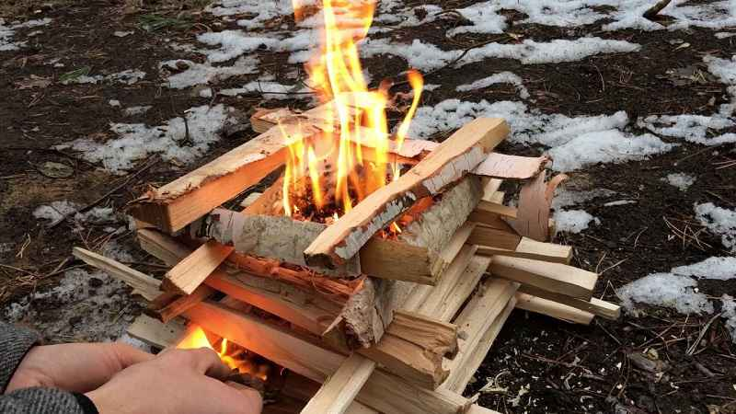
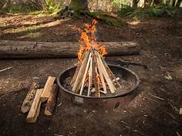
This Photo by Unknown Author is licensed under CC BY-SA

Then, when it was dark, we would play a game called “Capture the Flag” with all our friends. You have to sneak into the camp of another team and steal their flag before they can catch you and return it to your team’s camp.
At night we would sleep under the stars – no tent. Our dad would show us all the different constellations and explain why the stars seems to move around. We would see shooting stars stream across the pitch-black night sky. Then, we would be so tired that we would fall asleep and try to stay warm in our sleeping bags. In the morning, we would have some of our dad’s famous buttermilk pancakes.
Twin Power is enjoying your parents while doing fun things. Parents are great! You don’t have to be a twin to enjoy your parents and family.

