Poppy and the “Web” Kayak
When Poppy and I were just starting high school, our Teacher’s Quorum decided to do a week-long adventure. After a lot of discussion among our group, we decided that making our own kayaks and going down 110 miles of the Colorado River would be a really great adventure.
Making the kayaks was a new experience for us. We had a pattern that we used to cut out what we call the “ribs” of the kayak. After we cut out the ribs, we then had to attach the “runners” around the ribs to give the kayak its shape. The runners came to the front and back of the kayak to give it a streamline shape for cutting through the water.
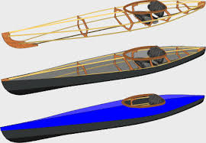

Once we had the shape put together, we then wrapped it in canvas, a very strong fabric. But, the fabric by itself was not waterproof. To make sure water did not come into our kayaks, we had to paint the canvas with a waterproof paint. This made the canvas material very tight.
Poppy’s kayak was lime green. Then, on the front of his boat he painted a spider web. What? A spider web? Why would he do this? Well, it was because he had a girlfriend named, Debbie Webb. He wanted to name the kayak after her.
We all had our kayaks put on a special trailer and headed out for the mighty Colorado River. We thought there were going to be giant rapids and fast, surging white water. We were wrong. The part of the river we went to was very mild and slow moving. Each day we did about fifteen miles and then set up camp. It was a fun trip and one we never forgot.
We did have one little problem. In some places the water was shallow near the shoreline. One day Poppy put his kayak into the water and accidentally jumped into his kayak while it was sitting over a stump. It poked a hole right through the canvas! We did our best to patch it up, but for the rest of the trip, Poppy was baling out water from the inside of his kayak.

