Grandpa Thom and Peru Earthquake
Grandpa Thom was a dedicated, hard-working missionary in the country of Peru, South America. H e had many wonderful experiences that helped him develop a stronger testimony of the gospel and a desire to do good throughout his whole life. Because of his mission, he wanted to obey Heavenly Father’s commandments, to help others find the truth and be a good example of the gospel.
On May 31, 1970, there was a tremendous earthquake in Peru. It was a very scary experience for many of the people, but for the people up high in the Andes Mountains, it was a time of mass destruction and loss of life. They lived in a town called, Yungay.
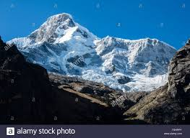
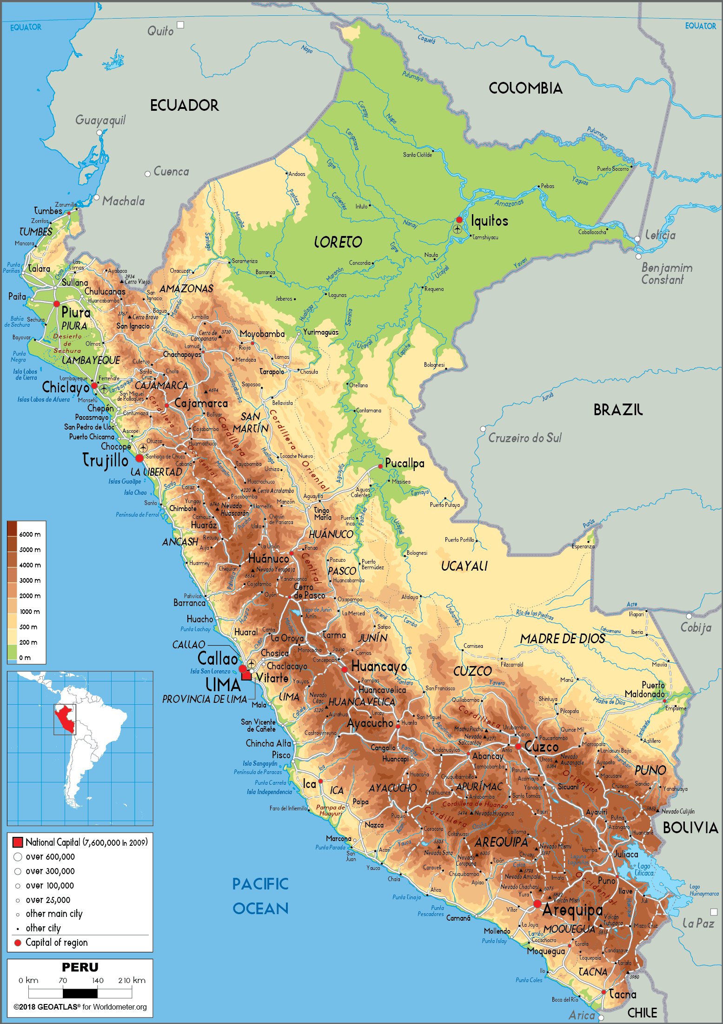
Can you imagine what it would be like if you could lift a huge boulder and then throw it into a bath tub full of water? Water would come gushing out and flood your whole house. That is similar to what happened in Peru. A gigantic piece of a glacier ice fell from a very high mountain called Huascaran (see photo) and crashed into a mountain lake. A monster wave of water, mud, rock and trees came splashing out of the lake. It then started to make its way down a valley toward, Yungay, a town of 20,000 people. The wave of water and debris was so great that it completely covered the city and killed all of the residence – except for a few that I will tell you about in a minute.
It is almost hard to believe and understand. But the next time you are in the car and you see houses and businesses all over your city, try imagine those all being covered with mud and rock – everything. The only things remaining in Yungay were the tops of the tallest trees. Everything else was gone!
The town was covered and disappeared in the matter of a few seconds. Today, it is a national cemetery and landmark for those who died in this awful natural disaster. This avalanche is the deadliest in history.
Grandpa Thom has shown me photographs taken from the air of the complete destruction of the town. You can see photos of the path of the flood coming down the valley and wiping out the town. Grandpa Thom also had photos of giant rocks as big as your living room that landed on the mountain village.
Then, in the photos, you can see where the flood is heading down the valley toward the next town of Caraz. The path of the flood was heading directly toward this town and would have meant another complete ruin of a mountain village. But, as the photos demonstrated, the flood took a turn and went around the town! Thousands of people were spared instant death. It was a miracle. It was something that most people and even experts cannot explain. Why did it make the turn and avoid killing so many people in that town?
Grandpa Thom explained to me that weeks earlier in the town of Yungay, the missionaries from our church were told by the people and leaders of other churches to leave Yungay and never come back. People even threaten physical harm to the missionaries. So, they left and went to the town of Caraz, further down the valley.
This earthquake and avalanche happened on a Sunday. All the faithful members of the church that were in Yungay came down to Caraz to attend church with the missionaries and other members. So, the avalanche that killed the people the whole town of Yungay did not hurt the faithful members of the church. They were protected as they were being faithful and obedient. And, when the flood came toward Caraz, they were protected again as the flood made a turn around Caraz and then, back to its natural course down the valley.
Part of Twin Power is seeing the protection of the Lord for his righteous children. When we are obedient, we can expect the blessings of our Heavenly Father.

