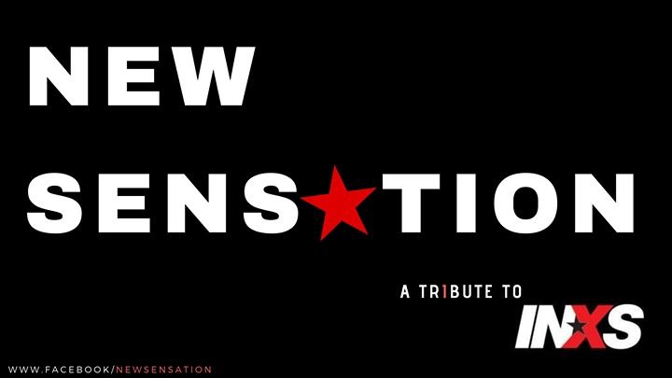ABOUT US
New Sensation is the long awaited INXS tribute band that pays homage to the greatest rock band to come out of Perth Western Australia.

WHAT WE DO
Focused on delivering a high energy professional show that features the greatest music tracks that spanned INXS’ illustrious 40 year career, New Sensation embody the spirit of INXS each and every time they take to the stage to pay tribute.

This fully authentic show takes audiences on an engaging musical journey through all the biggest INXS hits, spanning 4 decades, with tracks such as Listen Like Thieves, Burn for You, Need You Tonight, I Send a Message, Never Tear Us Apart, Original Sin, Don’t Change, Devil Inside and of course what's a New Sensation show without the iconic smash hit New Sensation!

These and many, many more are all in store for the ardent and most fervent INXS fan...

But enough about us.... Come and immerse yourself in the sights, sounds and emotion that is New Sensation.

Experience the Difference!

BOOK US NOW FOR YOUR UPCOMING EVENT
We pride ourselves on exceeding expectations and making it work for you.

http://www.newsensationinxs.com

BOOK US NOW FOR YOUR UPCOMING EVENT

CONTACT INFORMATION

Agent Bookings:
Focus Promotions
Sean Davidson
Ph: 0400 363 633
admin@focuspromotions.com.au

Direct Bookings:
Jeremy Harris
Ph: 0419 966 948
newsensationinxstribute@gmail.com

Experience the Difference!

BOOK US NOW FOR YOUR UPCOMING EVENT
We pride ourselves on exceeding expectations and making it work for you.

www.facebook.com/newsensationinxstributeband

