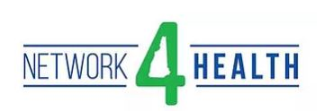
New Manager Development Program
Application for the New Manager Development Program with Granite State College
Effective date: September, 2018

Date of Submission:

Applicant Information
Name of Applicant | Company Name |  | Address
Write here | Write here |  | Write here
Title/Position | Email |  | Phone
Write here | Write here |  | Write here
Start Date at this Company | Years in Current Position |  | Years of Management Experience
Write here | Write here |  | Write here
Manager’s Name |  | Manager’s Title
Write here |  | Write here
Manager’s Phone |  | Manager’s Email
 |  | Write here
In a few sentences, can you please describe the reasons you think this training will benefit you?
Write here

Please describe 3 management skills you would like to have improved as a result of completing this program.
Write here

Manager Approval |  | Applicant Agreement
Please note, once signed and approved by Network4Health, a completed copy will be emailed back to the applicant and manager.
By typing my name below, I am recommending this employee to participate in the New Manager Development program. I understand that the commitment for completion of this program will be for the employee to be in a classroom for 1 day per month for 3 months, as well as 2 hours of independent work per week.  Signed:______________________________Date:______________ |  | By typing my name below, I am agreeing to participate fully in the New Manager Development program. I understand that the commitment for completion of this program will be to attend classroom sessions for 1 day per month for 3 months, as well as complete 2 hours of independent work per week.  Signed:______________________________Date:______________
For Network4Health Use Only:
Date Received: |  | Approved?  ____Yes ____No
Comments:
Signed and Date:

