Remote Learning

Need Job Skills?
Now is The Time!

Learn necessary skills for getting, keeping, and advancing in a job, from interviewing to communication and conflict resolution
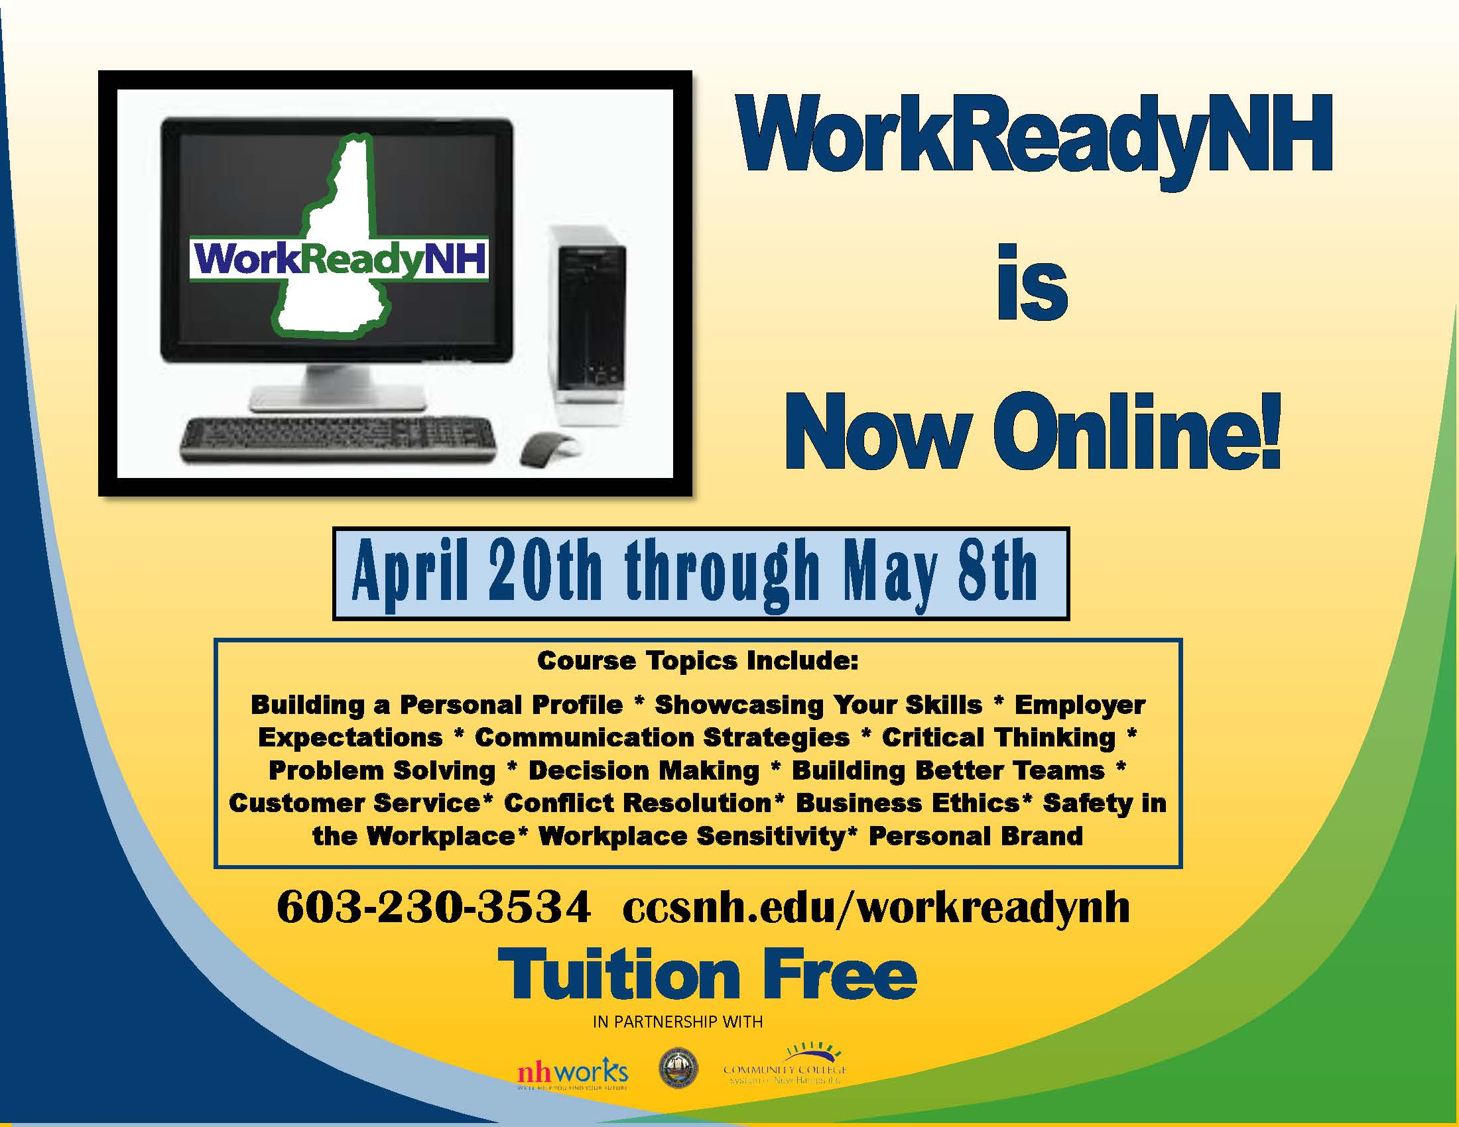

After 60 hours of online learning, you will earn

two highly recognized credentials:
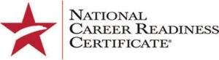
- WorkReadyNH Certificate
- National Career Readiness Certificate (NCRC)
issued by ACT
To register, contact akalampalikis@ccsnh.edu Manchester/Nashua/Derry

