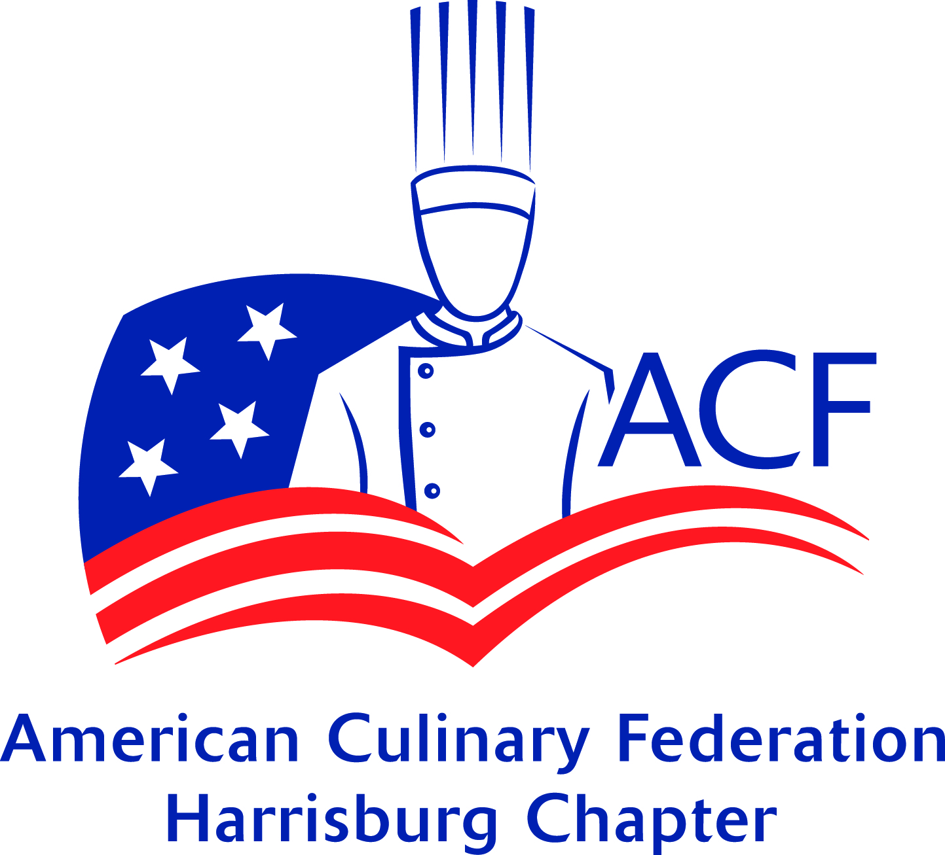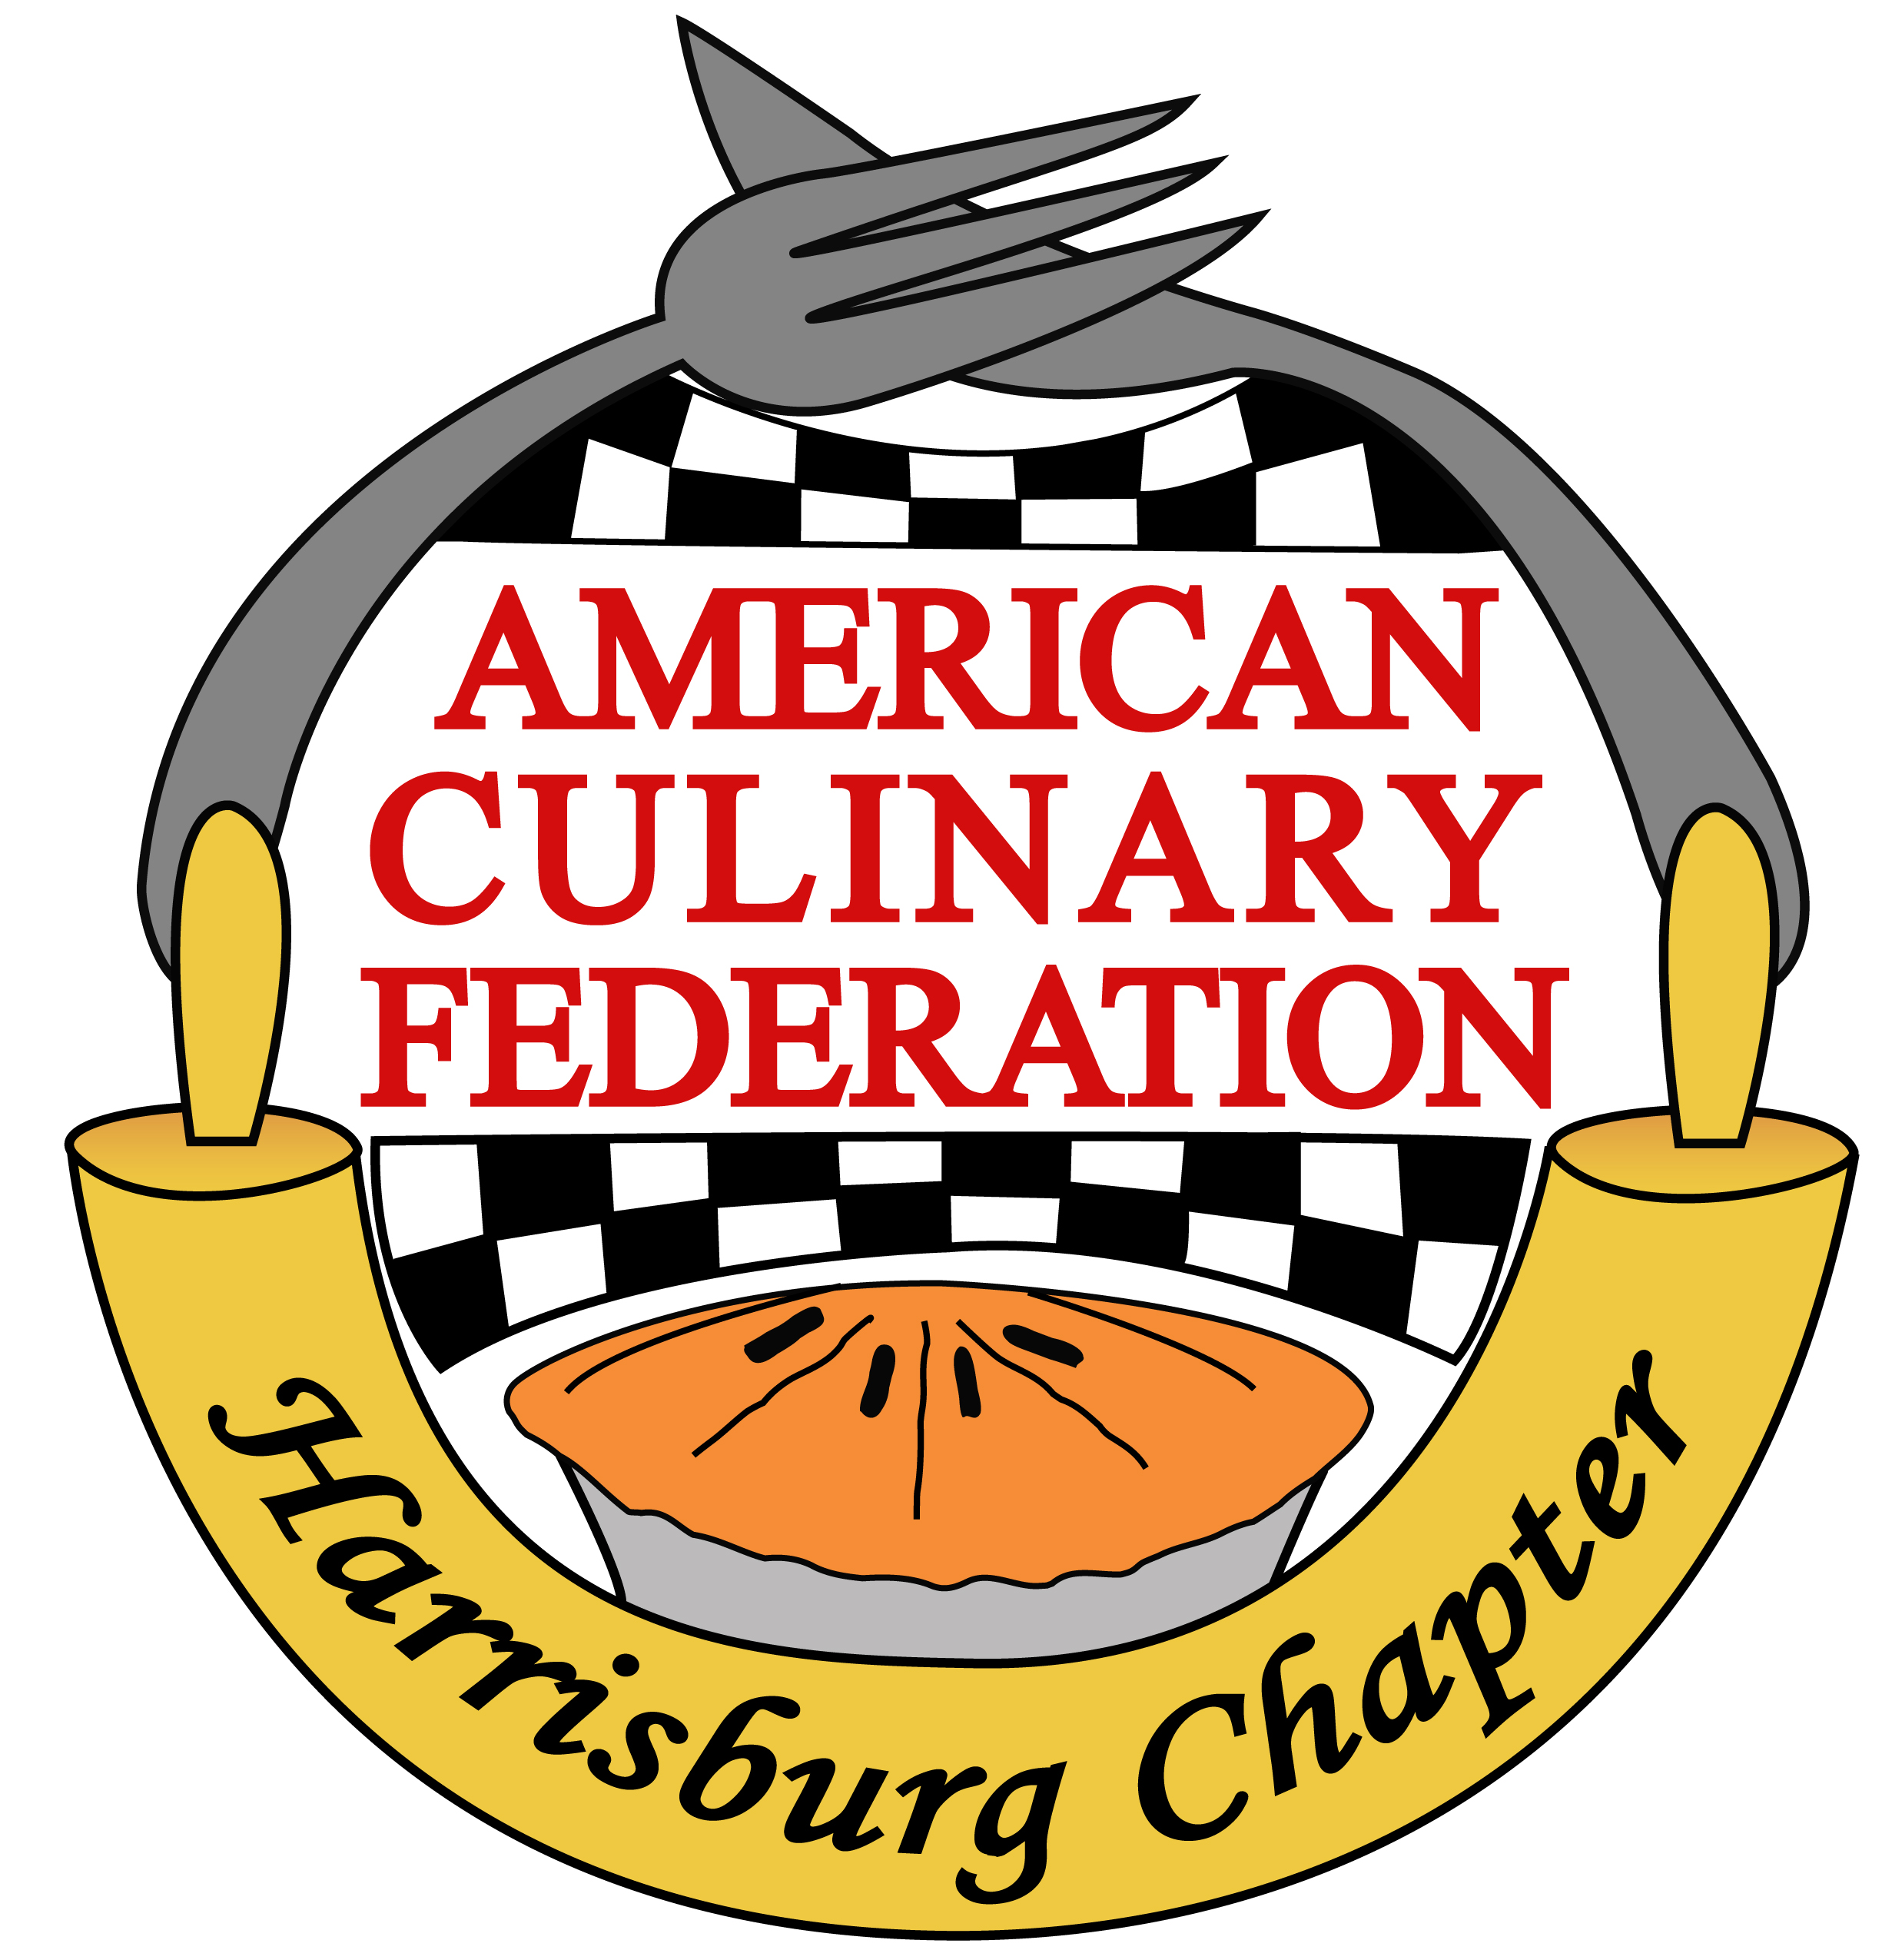**American Culinary Federation** **Harrisburg Chapter- PA 181**

**MISE EN PLACE**

**January 2021**

**President’s Greeting**

Good day to each of you,

I hope that you remain safe and well as this reaches you. It was great to start the new year off with many of you at our first meeting this past Monday. Thank you again to Jon Bellem for attending and speaking about his new initiative [Support 717](https://www.facebook.com/search/top?q=support%20717) and a look at his operation, Another Round in Lemoyne.

We started the meeting with our new Executive Board Officers taking the oath of office. As a board, we are hitting the ground running and looking forward to this opportunity to provide strong leadership. Our board met for our first meeting in early January to overview our responsibilities and discuss immediate changes we wanted to implement. The newsletter will be going out the same week as the meeting to provide current updates and links to upcoming events. Chef Long has added a Recipe of the Month section as well!

Our website is another area that needed immediate attention. The auto-renewal was set for Feb. 1st. Renee tackled the customer service at GoDaddy to properly establish our account with a new website to build over the next few months. All content is able to be copied with our website staying active, and the proper security and storage will be established for it to be an actual functioning and usable site! Our board will continue to meet monthly and establish both short-term and long-term goals to present.

I congratulate all the 2020 Chapter Award recipients honored at Monday’s meeting. Thank you for representing our chapter with your professionalism and dedication to our industry! While not officially until August, please keep in mind, you will form the nomination committee for this year’s recipients and can keep your eyes out for super stars!

There are many upcoming events with links to register/view included here:

2021 Culinary Goals: Earn ACF Certification! Mon. Jan. 25th at 4 p.m. ET [**Click Here to Register!**](http://r20.rs6.net/tn.jsp?f=001SAOagQUGE0RAfN7vDLbfWIpQaBjPIJcpVJ6WtkOx_4kWDBifAdhBLYOxmHpraC6isymst7oa2XKMnK76IQE1vJh2Wudiyx2-7Q75-qQVNBM6VZwXHIvfeXAxOc2rSmTSnb3qlAr0IqB2WbMTktV7bR9_jla4BKLvqcj_2LIIMkSnCqNgJhnpUY8SDAx1j-oYYzR21nGAqf0=&c=QPlb5UjLQ0BnVVbXE2O9PcCMs0O_XVu2E5yT1D1OEDO3HDyrWTrS3g==&ch=zHSHbwl6Dr7cATKEDKhh4dn_FKWahHrObMz22fKfdj5e7CGA4FcVHg==)

Culinary Business Insights: Spotlight on Food Trucks Thurs. Jan. 28th at 11 a.m. ET[**Click Here to Register!**](http://r20.rs6.net/tn.jsp?f=001SAOagQUGE0RAfN7vDLbfWIpQaBjPIJcpVJ6WtkOx_4kWDBifAdhBLX2VZC8-IBkOUFn1XZP3IvIkWgWOIiRz7WI645macQH2SmNm9eckzxuAIcGAAEznpzXB_k7ldITT6jeXMgD_aEiqy6M8jOjVq8ogtm8Z5HHYbuoxvj0_Z25OgqJJC5Km4J71aIse8oh2v3DmwTq1Ecc=&c=QPlb5UjLQ0BnVVbXE2O9PcCMs0O_XVu2E5yT1D1OEDO3HDyrWTrS3g==&ch=zHSHbwl6Dr7cATKEDKhh4dn_FKWahHrObMz22fKfdj5e7CGA4FcVHg==)

Just a Taste streamed live at 7 p.m. on Jan. 26, 2021 on Harrisburg University presents’ website, [www.HUConcertSeries.com](http://www.HUConcertSeries.com), and on HU Presents’ Facebook page @HUPresents.

I look forward to seeing you at our next meeting on Monday, February 15th at 6:30 via zoom as Chef Kurt Wewer will join us as our guest speaker. Chef Wewer has been working closely with the LEAF Project and recently is entering a new development stage with the education side. The zoom link is provided below with the schedule and will be emailed in future communications.

Be well, stay healthy and happy.

*Chef Autumn Patti*

ACF Harrisburg Chapter President

****Recipe of the Month**

*From the Kitchen of your Vice President*

Chef Thomas J Long CEC AAC

**Honey-Soy Roasted Parsnips**

This is a twist on roasted parsnips with an Asian flair. You can add more Sriracha if you like it a little more heat.

**Ingredients**

|  |  |
| --- | --- |
| 1 lb. | Parsnips peeled and cut into ¼ inch thick slices |
| 2 Tbsp  1 ½ Tbsp  1 Tbsp  1 Tsp  1 Tsp  As needed.  1 Tbsp | Canola oil  Soy Sauce  Honey  Sriracha sauce  Chopped Garlic  Food Release  Chopped green onion tops. |
| **Directions** |  |

Pre-Heat oven to 350 degrees. In a 2-quart bowl combine parsnips, oil, soy sauce, honey, sriracha, and garlic. Spray a ¼ size sheet pan with food release. Spread out parsnips to an even layer on the tray and roast for 20-25 minutes. Stir halfway through the roasting process. Finished product should be tender and slightly caramelized. Garnish with chopped green onions before serving.

## Ingredient of the Month

## January 2021 – Parsnips

Parsnip is a root vegetable closely related to carrot and parsley. They all belong to the family Apiaceae. It is a long, tuberous root vegetable that has cream-colored skin and flesh. The parsnip is usually cooked, but it can also be eaten raw. Parsnips have a sweet taste similar to a carrot. The distinctive sweet flavor of the root will only develop after a hard frost.

Though the parsnip is grown in the southern part of the United States, it has become a favorite of cold climate gardeners. They take several months to mature before harvest in the late fall and can be kept in the ground and harvested throughout the winter.

Parsnips have been eaten for thousands of years. Parsnip was used as a sweetener before the arrival of cane sugar in Europe. Parsnips were the U.S. Colonists main form of starch until the potato became more popular in the mid-nineteenth century. Parsnips are often mistaken for carrots in historical records and recipes.

Parsnips are high in vitamins C and K which are important for immune health and blood clotting. They are also rich in dietary fiber and the minerals manganese and folate.

**Selecting and Storing Parsnips**

•Parsnips can sometimes be found year-round at supermarkets but are more prevalent in the fall and winter months.

•Large roots tend to be more fibrous with a tough woody core, while the smaller roots are sweeter and more tender.

•Look for parsnips near the carrots with their green tops removed. They should be very firm, relatively smooth and without dark or soft spots.

•Avoid parsnips that are soft, shriveled, or have blemishes.

•Store uncooked parsnips in the refrigerator loosely wrapped in a plastic bag for up to three weeks.

•Cooked parsnips will keep for up to three days in an airtight container in the refrigerator.

•Parsnips can be frozen up to three months.

**Eating Parsnips**

•Similar to carrots, parsnips can be prepared in a variety of ways such as steaming, boiling or pureeing but are at their sweetest when roasted.

•To avoid mushy parsnips, add them to soups and stews near the end of the cooking time.

•Parsnips have a high starch content and can be fried similar to potatoes

•Parsnips are used for making jam, marmalade preserve and cakes.

**Fun Facts about Parsnip**

Roman Emperor Tiberius adored parsnips and every year had them brought from France where the colder climate allowed the roots to develop a sweeter flavor.

In Europe, parsnips were used to sweeten jams and cakes before sugar was widely available.

Exposure to the leafsap of fresh parsnip can cause a contact dermatitis, similar to poison ivy.

Since most of the vitamins and minerals in parsnips are found close to the skin, many will be lost unless the root is finely peeled or cooked whole.

***Presented by American Culinary Federation Education Foundation.*** *Complete the quizzes* by logging on to the [ACF online learning center](https://www.acfchefs.org/OLC), to earn one hour of continuing-education credits toward ACF certification.

**Student Spotlight- *by Faith Brenneman***

*Tips & tricks from former students on how to be a better Student Chef*

* **Read your recipes closely**- It’s one thing to know what ingredients you will need to make your recipe, but you need to understand how to properly prepare them! Example, if you need softened butter to cream with your sugar you must pull your butter early enough to soften and know how to properly cream! May sound silly but READ those recipes!
* **Clean & wash as you go**- nothing is worse than a pile of dishes at the end of lab day. After READING those recipes, plan accordingly for some down time as food is cooking, chilling, resting, or whatever it’s doing! That is your time to fill the sinks, clean your equipment, wipe down your area.

* **Grab some spoons**- Spoons (in my opinion) is apart of your set up. When getting your equipment ready, always grab a handful of spoons. From tasting throughout the cooking process, polêing, making quenelles, or to help plate- ALWAYS have spoons at your disposal!
* **Don’t be afraid of messing up**- We all been there at one time or another when we read our recipes, grabbed our spoons, got our mise en place, and felt confident on the plate we were working on. But sometimes getting sidetracked or taken away from our prime directive at that very minute can cause chaos in seconds. We all must remember; we can mess up and still (sometimes!) make something good! Only the fearless can be great!
* **Experiment at home**- It’s never a bad idea to roll out some recipes at home! Even if you are unsure of a technique or never made something before- it’s a guarantee your family will be there to help taste test most times! It’s a great way to get a head start on your labs and think about any questions you have about a particular dish or technique.
* **Use your Resources**- In today’s age we got endless resources on everything and anything. Not just talking about textbooks, or lecture PowerPoints but online sources like our Chapter approved Education Center (<http://acfharrisburg.org/?page_id=2966>), fellow peers, and even your Chefs. Just make sure your source is reliable- do research on your resource!

**2021 Meeting Locations & Education**

All Zoom meetings will start at 6:30 pm, until further noted. Links and information are also found on our website: [www.acfharrisburg.org](http://www.acfharrisburg.org)

January 18, 2021 *Via Zoom*

Guest Speaker: Jon Bellem, Another Round, Support 717

*Recording:* <https://youtu.be/9JbOWgcwGUg>

February 15, 2021 *Via Zoom*

Guest Speaker: Kurt Wewer, LEAF Project

Zoom link: <https://hacc.zoom.us/j/96059618776?pwd=M0VtQlpHdWp5ay9Fc3AyeWZoUk4vdz09>

March 15, 2021 *Via Zoom*

April 19, 2021 *Via Zoom*

May 17, 2021 *Via Zoom*

Tour of new Hershey E&R operations, Ice Cream Making Demo (TBC)

June 21, 2021 HERSHEYPARK

July 19, 2021 TBC

August 16, 2021 TBC

September 20, 2021 TBC

October 18, 2021 Hershey Country Club—Golf Outing

November 15, 2021 TBC

December 20, 2021 John Gross & Co. (TBC)

**2021 MEETING HOSTS & EDUCATION PRESENTERS NEEDED**

If you are interested in hosting a meeting or would like to provide an educational component, please contact Autumn Patti at [arpatti@hacc.edu](mailto:arpatti@hacc.edu) or [acfharrisburg@gmail.com](mailto:acfharrisburg@gmail.com)

**Meeting Minutes from January 18, 2021:**

Meeting began via Zoom at 6:30pm – Motion Chef Peffley, 2nd Chef Gipe, approved by all in attendance.

Board in attendance: Present— Chef Autumn Patti, Chef Thomas J Long, Chef Cher Harris, Renee J. Nasta and Rasheeda Carter.

Number of participants in attendance: 30 meeting

Autumn greeted the Chapter and welcomed everyone to the meeting including guests. She thanked those attending and did a Roll Call by listing all meeting participants’ names.

Pledge by: Chef Patti Prayer by Chef Gipe

Chairman of the Board, Chef Peffley lead the swearing in of the 2021-2022 officers for the Board. President-Chef Autumn Patti, Vice President- Chef Thomas J. Long, Treasurer- Chef Cher Harris, Secretary- Renee J Nasta and Student Representative-Rasheeda Carter.

**Autumn congratulated and presented each of the 2020 Chapter Award recipients with their plaque:**

* Chef of the Year: Chef Nicholas Arnold, CEC
* Pastry Chef of the Year: Chef Susan Notter, CEPC
* Educator of the Year: Chef Autumn Patti
* Student Chef of the Year: Rasheeda Carter, HACC Culinary and Baking student
* Chapter Partner of the Year: PRLA Central Chapter
* Ed Byrem Volunteer Award: Renee Nasta
* Chef Professionalism: Chef Anna Smith, CC
* Hermann Rusch Award: Chef John Reis, CFBE
* President’s Award/Chapter Award: Chef Autumn Patti

Autumn introduced our Guest presenter- John Bellem, owner of Another Round-a secondhand restaurant equipment store located in Lemoyne specializing in restaurant equipment, small and large. He is open currently by appointment only. John also formed the Support 717 Go Fund Me page to assist local struggling restaurant employees due to the current economic crisis due to COVID-19. To date they have helped 14 different families and raised approximately $10k through a charity event in which he thanked Chef Gipe and Chef Reis for their participation. John encouraged everyone to check out their website and Facebook page for more information and upcoming events, links are below-<https://support717.business.site/?utm_source=gmb&utm_medium=referral>

<https://www.facebook.com/Support717/>

**Secretary’s Report:**

November Mise en Place can be found on the website and was emailed out as both a pdf and word document.

Motion to approve the November 2020 minutes as written and recorded in *November 2020 Mise en Place*:

Motion: Chef Peffley, 2nd Chef Harants, accepted by all in attendance.

As the new 2021 Secretary, Renee Nasta thanked the membership for the opportunity to serve and briefly discussed the upcoming migration to a new website and email hosting platform.

**Treasurer’s Report:**

Chef Harris presented the January 2021 report.

December 2021 report- Total: $8748.35

* Checking acct: $3399.58 (changes: -$10 service fee, -$404.30 GoDaddy, website renewal, email transfer,-$328.60 Levin, Award plaques)
* Savings Acct: $5348.77 (includes +$0.31 interest)

Motion to approve the Treasurer’s Report: Chef Corle, 2nd Chef Reis, accepted by all in attendance

Discussion on researching possible new bank account options was presented. No answers have been provided when contacting M&T regarding a monthly service fee that started being deducted last year.

**President’s Message**

Autumn discussed the new board members meeting to get started in early January. The first meeting was to overview the bylaws and the roles and responsibilities we have. Some immediate changes we want to implement include new sections in the newsletter, a new website, research bank accounts, revise meeting format to make more productive, a need for a membership committee lead, and educational topics for this year. Each month the board will meet in the off two weeks of the chapter meeting. Our next meeting includes establishing both short and long-term goals.

Other announcements were discussed. Autumn foresees zoom meetings until June when we are scheduled for Hershey Park. She plans to start zoom meetings at 6:30 until further noted. Educational webinars and presentations are back in full swing- check out Chef Table for many opportunities. Also, she noted the NE Chef Connect in Pittsburgh has officially been cancelled.

She attended the PRLA Central Chapter meeting the week prior. They are looking for new board members and current searching for an officer elect. That individual is basically trained for a year and then takes the Treasurer role, with all other officers bumping up a position. On the state and national levels, the PRLA continues to support efforts for COVID relief legislature. Events to note:

Just a Taste streamed live at 7 p.m. on Jan. 26, 2021 on Harrisburg University presents’ website, [www.HUConcertSeries.com](http://www.HUConcertSeries.com), and on HU Presents’ Facebook page @HUPresents.

PA Flavors moved to August 21st and the PRLA Golf Outing is scheduled for October 18th.

**Vice President’s Message**

Tom greeted the chapter and shared his excitement with joining the board. He has wanted to be involved for years and the pandemic opened the opportunity in his schedule. He did take on the Membership Committee and will be looking for members to join him on this. He wants to reach out to past members and get their feedback. We wants to start a secondary school initiative as well to reach out and target students working with Faith and Rasheeda. More to come.

Also, new to the newsletter will be a recipe featured each month, corresponding with the Ingredient of the Month (when possible).

**Student Representative’s Message**

Rasheeda greeted the chapter. She plans to work with Chef Long to increase membership. She wants to include more value and get more members involved. Education is the reason she attends and she wants to keep that strong. Autumn noted that she offered several great topics to include in upcoming meetings. Her perspective and voice should add value to students. Rasheeda sending emails out to students might hold more value.

**Education Committee**

Anna is working on several programs for the upcoming months, Chef Clark presenting on sous vide, a tour of the new Hershey facilities with Chef Cher Harris and more! February’s meeting will be a presentation from Chef Weaver about the LEAF Project. Chef Reis mentioned that the LEAF Project has “Cooking Class in a Box;” where local Chefs provide a recipe and LEAF provides the ingredients. Chef Reis will be featured in the Valentine’s Day box. For more information; <http://www.leafprojectpa.org/>.

*All education presentations and meeting locations are found in the monthly Mise en Place, (above), yet are tentative based on our current environment changing weekly. Autumn noted that all meeting locations will be tentative at this point but will be held via zoom at 6:30pm until further notice*.

**Website**

Our chapter’s website was set to autorenew on Feb. 1st. Our current website is extremely slow and outdated with no security. Renee dedicated time to talking with GoDaddy to get a new site established to remove the 3rd party Wordpress that we are no longer using. The email is also being transferred to being a secured email connected to this website. The current site will remain active for 3 months to allow Renee to move the data. She asked the chapter if there is anything specific they want to see? Discussion was held on the amount of time data should be stored. The consensus was 5 years. Autumn stressed that all data will be backed up onto flash drives to be stored with board members to pass on. If possible, Google Drive links can be inserted to view the information directly from the site. Renee stressed that the more content that is stored on the website, the slower it will function. She plans to work over the next 3 months to make a user-friendly site that people will want to visit.

**Social Media Committee**

Renee asked for volunteers to assist with social media and specifically is interested in having one student from each school act as liaison offering a “sneak peek” to the membership through their eyes of their classes and culinary experiences. Heidi Howard from PRLA offered to assist in sharing and promoting our chapter activities and to share content.

*\*If interested please email Renee content to post on our Chapter’s Facebook page at* [*rj_nasta@yahoo.com*](mailto:rj_nasta@yahoo.com) *or text her pictures at 1-717-821-3531. Also, check out our chapter’s YouTube channel: ACF Harrisburg!*

**Junior Membership/ Student Outreach**

*Rasheeda Carter presented for Faith Brenneman*

**Keep a look out for the Monthly Newsletter!** Student Spotlight will be including a page on Student Success featuring Tips & Tricks from former Students. In the months to come Student Spotlight will focus back on Outstanding Students within the Chapter.

**Instructors**- if you have a student or students you think deserve to be recognized, please email me at [faithbrenneman97@gmail.com](mailto:faithbrenneman97@gmail.com) or by completing the following form: [**https://docs.google.com/forms/d/1aUB_PT_gwQ8tGCQXAkkEgbf9GByja5QMA7j2DJDzckY/viewform?edit_requested=true**](https://docs.google.com/forms/d/1aUB_PT_gwQ8tGCQXAkkEgbf9GByja5QMA7j2DJDzckY/viewform?edit_requested=true)

Faith has been in contact with Young Chef’s Club President Chef Ashten Garrett. The Young Chef’s Club (YCC) focuses on providing opportunities to collect, learn, and share education across the U.S. Club Members range from 18-25 years old, and are automatically enrolled upon membership with ACF. I attached the link from the ACF website if anyone was interested- <https://www.acfchefs.org/ACF/Partnerships/YoungChefs/ACF/Partnerships/YCC/Default.aspx>

Chef Garrett and her have made arrangements to video call within the month to talk about what the ACF and their student involvement moving forward, along with some other stuff! I will share with Chapter Students whatever knowledge he shares with me! If Students have a particular question(s) they wish for me to ask- please email me.

Below are some Webinars that have YCC’s is promoting. I have included them below with the link to register.

***January 25, 2021. 4pm ET***

***2021 Culinary Goals: Earn ACF certification!***  
[**Click here to register.**](https://us02web.zoom.us/webinar/register/WN_QoWzZogESmulllZ1oNafrg)Considering ACF Certification or working toward your next credential?

*ACF’s certification program is the only culinary program with stackable credentials and is recognized throughout the industry as the standard for excellence in professional skills and knowledge. Join ACF Certification Chair; John C. Schopp, CEC, CEPC, CCE, CCA, AAC and the panel of chefs for this informational and inspirational discussion. The Chefs will share best practices for practical exams, tips on how to best plan your next steps and ask all of your questions about ACF Certification.*

***January 28, 2021. 11am ET***

***Business Insights for Culinary Students; Spotlight on Food Trucks (Intro Skill Level)***[**Click here to register.**](https://us02web.zoom.us/webinar/register/WN_YeB1putYQQaJyupaJFPnlQ)

*January 28th’s Webinar presented by the ACF Young Chefs Club, in collaboration with Massachusetts Restaurant Foundation Education Foundation features Chefs who will discuss the skills needed to run a successful food truck business. Think outside of traditional Chef roles, as we learn more about the challenges and benefits of working in mobile kitchens. Q&A and discussion to include feedback and guidance from Culinary professionals for young chefs entering the foodservice industry.*

Rasheeda shared her community Food Truck nights encouraging us all to support one another during these unusual times- Food, Fun and Fellowship!

* FOOD TRUCKS**

All events are located at **705 Drexel Road Harrisburg, PA 17109 in Devon Manor.**

Wednesday from 5-7 pm in April-May booked except for May 5. That week, it will be on Tuesday May 4 from 4:30-6:30 pm.

April 7: Stocks on Second and Farm Show Milkshakes

April 14: The Kitchen Table

April 21: 717 Taco and J and P Winery

April 28: Blazing Swine BBQ

May 4: Lucky Penny Burger Co.

May 12: The Kitchen Table and The Cupcake Truck

May 19: Philadelphia Hoagie Co.

May 26: Uncle Paul

June 2: Mad Dash Concessions

June 9: The Italian Job

June 16: 717 Taco

June 23: Blazing Swine BBQ

June 30: Chef de Crepe

July 7: Lucky Penny Burger Co.  4:30-6:30 and The Cupcake Truck

July 14: Philadelphia Hoagie Co.

July 21st: The Vineyard and Brewery at Hershey and The Potato Coop

**Apprenticeship Update**

Chef Corle reported- they recently participated in certification exams and will continue to work hard to achieve certifications. Has been challenging due to circumstances surrounding COVID. LCCTC hosted a virtual Skills USA testing with two students participating and took GOLD! The LCCTC program received a $3000 grant towards starting a greenhouse program and herb garden.

**Competition Committee**

Nothing new to report.

**Certification Committee**

Nothing new to report.

**Accreditation Committee**

Nothing new to report.

**American Academy of Chefs**

At this time, the Academy Dinner is still scheduled at the Southern Regional Chef Connect in Nashville at the Westin with Chef Rico on April 11, 2021. As of now, this is still the plan moving forward.

**Community Outreach**

**Ronald McDonald House**

Nothing new to report.

*Volunteers are always needed. Visit* [*https://www.rmhc-centralpa.org/volunteer/*](https://www.rmhc-centralpa.org/volunteer/) *for more information.*

**Central PA Foodbank**

Nothing new to report.

*The Central PA Food Bank* ***needs volunteers*** *to assist in packing at their offsite location. Visit:* [*https://www.centralpafoodbank.org/ways-to-give/give-time/*](https://www.centralpafoodbank.org/ways-to-give/give-time/) *to sign up.*

**Budget/Finance & Fundraising Committee**

Nothing new to report at this time.

**New Business**

**Membership Committee- “ReBoot”**

Vice President Chef Thomas Long volunteered to Chair our new Membership committee during our latest Board meeting. A strong, active membership is the life blood of an organization and we feel this is an area in need of further focus. He asked for volunteers to work with him on the committee to reach out to existing and past members, encourage students to participate and create initiatives to grow our membership. Rasheeda Carter volunteered to assist with student outreach.

Town Hall Meeting- Michael Harants announced the upcoming town hall meetings for the candidates running for national officer positions. He asked that as many members as possible attend and ask questions.

Motion to adjourn the meeting: Chef Long, 2nd: Chef Harants. The meeting adjourned at 8pm.

**Next meeting: Feb. 15th at 6:30pm via zoom with Chef Kurt Wewer and LEAF**

**Culinarian’s Code**

As a proud member of the

American Culinary Federation,

I pledge to share my professional knowledge and skill with all Culinarians.

I will place honor, fairness, cooperation and consideration first when dealing with my colleagues.

I will keep all comments professional and respectful when dealing with my colleagues.

I will protect all members from the use of unfair means, unnecessary risks and unethical behavior when used against them for another’s personal gain.

I will support the success, growth, and future of my colleagues and this great federation.

**ACF Harrisburg Chapter PA 181**

**2021-2022 Officers**

**President:**

**Chef Autumn Patti**

***Program Director, Asst. Professor***

***Culinary Arts, Baking & Pastry Arts Programs***

***HACC, Central Pennsylvania’s Community College***

[**arpatti@hacc.edu**](mailto:arpatti@hacc.edu)

**Vice President:**

**Chef Thomas J Long CEC AAC**

***Director of Dining Services***

***HACC, Central Pennsylvania’s Community College***

[**icechef257@aol.com**](mailto:icechef257@aol.com)

**Secretary:**

**Renee Nasta**

***NJ Nasta, Inc.***

[**Rj_nasta@yahoo.com**](mailto:Rj_nasta@yahoo.com)

**Treasurer:**

**Chef Cher Harris CEPC**

***Corporate Pastry Chef***

***Hershey Entertainment & Resorts***

[**cdharris@hersheypa.com**](mailto:cdharris@hersheypa.com)

**Student Representative:**

**Rasheeda Carter**

***HACC Culinary, Baking & Pastry Arts student***

[**chamee1101@aol.com**](mailto:chamee1101@aol.com)

**Chairman of the Board:**

**Chef Brian D. Peffley, CEPC CCE AAC**

***Pastry Instructor***

***Lebanon County C.T.C.***

[**BPeffley@lcctc.k12.pa.us**](mailto:BPeffley@lcctc.k12.pa.us)