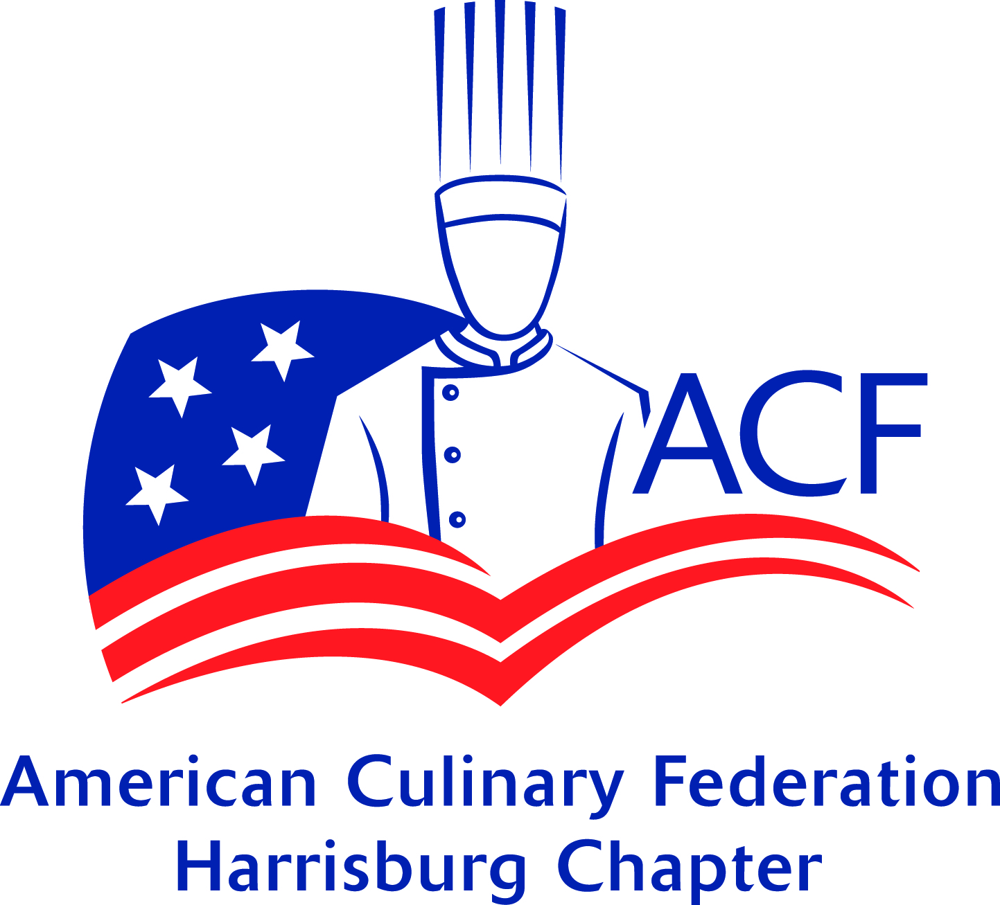
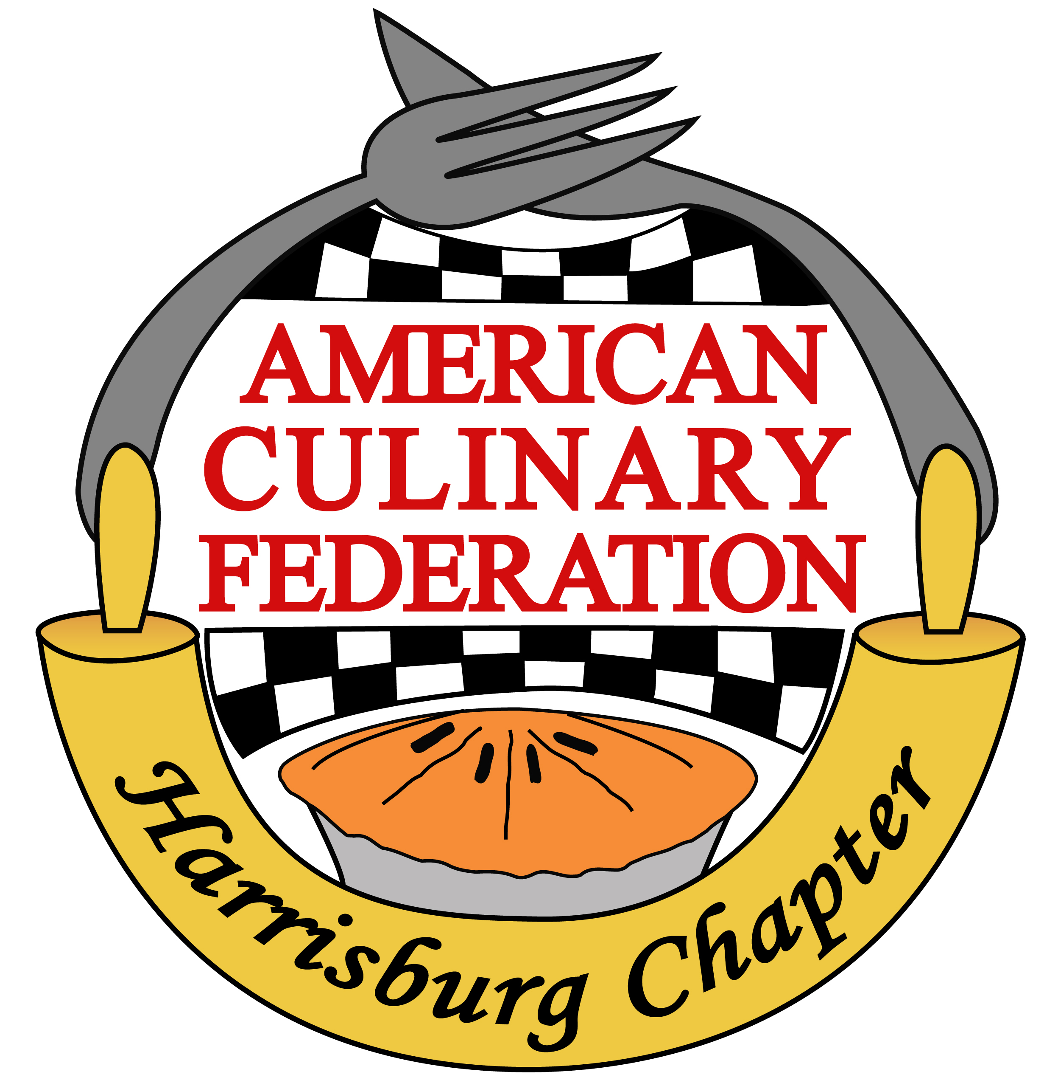
American Culinary Federation Harrisburg Chapter- PA 181
MISE EN PLACE
JULY 2021

President’s Greeting
Good day to you all!

Our annual fundraiser, PA Flavor is quickly approaching on Saturday August 21st at the Farm Show Complex in Harrisburg! We need your help for this event to be successful. Email arpatti@hacc.edu if you are able to volunteer.

Our August meeting will be on Monday, August 16th. A huge thank you to Chef Nicholas Arnold for opening his home to us and hosting our chapter's meeting! I am very anxious to gather and reconnect with one another as members, as well as prospective members coming as guests. Our pre-gathering, starting at 4pm, will allow us as a membership to reconnect with one another in this casual fun setting, followed by a productive business meeting starting at 7pm. Both the gathering and meeting will reside outdoors and poolside- bring/wear your suits, towels, lawn chair, and bug spray as needed! Bring your taste buds to play a flavorings challenge and fill your pockets with cash to play the 50/50 raffle to benefit our student scholarship fund! And most importantly, bring yourself! Please RSVP to Chef Cher Harris at cdharris@hersheypa.com for the address.

As we are not fully out of this pandemic, I respectfully remind us all to stay home if you are not feeling well. I look forward to seeing many of you there!

Chef Autumn Patti
ACF Harrisburg Chapter President
Recipe of the Month
From the Kitchen of your Vice President
Chef Thomas J Long, CEC AAC

This is a great summer treat that can be made very quickly and will please your family and guests

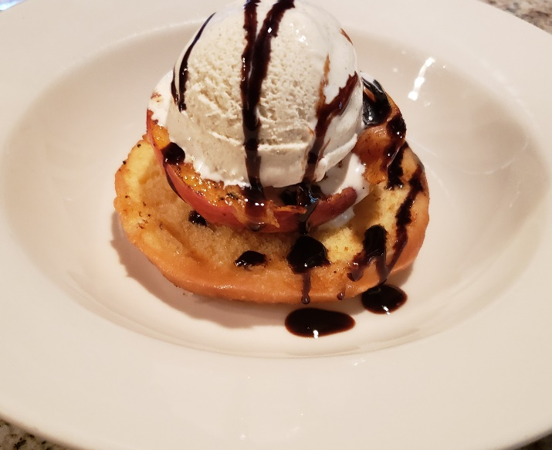
Grilled Peach and Glazed Donut Sundaes Serves 4

Ingredients
2 freestone peaches cut to produce 4 halves
2 Tbsp Honey
1 Teaspoon Ground Cinnamon
2 Glazed Donuts cut in half lengthwise
As Needed Food release
½ pint vanilla bean ice cream
2 oz Balsamic glaze
Directions
Pre-heat Grill to medium heat. Combine honey & cinnamon together to make a glaze. Paint cut side of peach halves with honey glaze. Spray cut side of donuts with food release. Brown donuts on both side on grill and remove from heat. Grill peaches cut side down for 1- 2 minutes

To present:
Top each donut half with grilled peach cut side up. Top each peach half with a 2 oz scoop of vanilla bean ice cream (I like Haagen-Dazs) and drizzle with 1 Tbsp. of Balsamic glaze

Tropical White has yellowish green skin with a creamy white flesh. The tropical white guava tree blooms amazing white flowers with feathery stamens and sweet fragrance.
Ruby Supreme guava is baseball sized and turns yellow when ripe. The inner flesh is highly aromatic, soft, sweet and pink.

SELECTING AND STORING • Good quality guava will have no cuts or tears in them. • Guava should be firm when gently squeezed. Soft guava will be the sweetest but will not last very long. If it feels soft or the skin breaks under gentle pressure than it should only be purchased if eaten the same day. • Guava has a short shelf-life due to its high sugar content. Ripened guava will keep at room temperature for 1-2 days. • In the fridge, ripe guava will last for about 4-5 days. Unripen guava will last in the fridge for 2-3 weeks. Whole fruit tends to last a couple of days longer than cut or peeled fruit. • In the freezer, ripe guava will last for about 8 months, but the quality of the fruit will decrease.

CULINARY • The entire guava is edible, including the skin and seeds. • Guava is often eaten raw like an apple. Raw guava is also consumed with a mix of spices such as salt, pepper and cayenne powder. • In Taiwan, guava is sold on many street corners and night markets during hot weather, accompanied by packets of dried plum powder mixed with sugar and salt for dipping. • In Mexico and other Latin American countries, the popular beverages like agua fresca and Pulque de guava are made with guava Due to guava’s strong fragrance and taste, it is often found in liquid form in nectar, juices, syrups or cooked in desserts. • Guava contains pectin, making it a prime candidate for creating jellies, jams, sauces, marmalades and even candies.

FACTS • India is the leading guava producer in the world today. • Guava is perennial plant that usually lives around 40 years. • Guava wood is prized in the world of meat smoking. • Leaves of guava are used as source of black pigment that has application in the textile industry.

To Take the Quiz- https://www.acfchefs.org/ACF/Partnerships/Chef_and_Child/Ingredients/IngredientsArchives/ACF/Partnerships/CCF/Ingredients/Archives/
Presented by American Culinary Federation Education Foundation
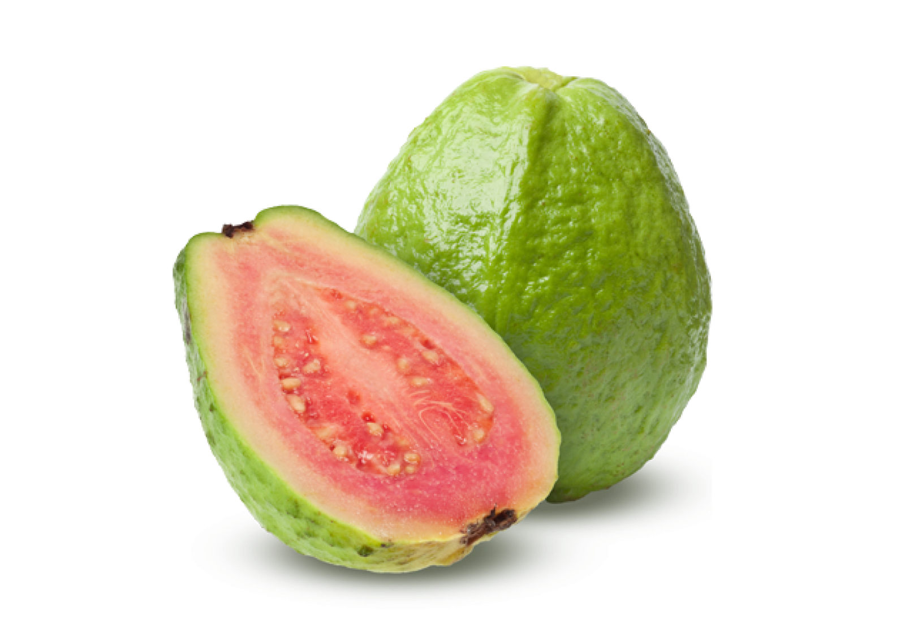

2021 Meeting Locations & Education
All Zoom meetings will start at 6:30 pm, until further noted. Links and information are also found on our website: www.acfharrisburg.org

January 18, 2021 Via Zoom
Guest Speaker: Jon Bellem, Another Round, Support 717
Recording: https://youtu.be/9JbOWgcwGUg

February 15, 2021 Via Zoom
Guest Speaker: Kurt Wewer, LEAF Project
Recording: https://youtu.be/GLM0LnO0RxA

March 15, 2021 Via Zoom
Guest Speaker: Andrea Grove of Elementary Coffee Co
Recording: https://youtu.be/VQZEImnrs-I

April 19, 2021 Via Zoom
Tour of new Hershey E&R operations, Ice Cream Making Demo (TBC)
Recording: https://youtu.be/L8RfuitvO3E

May 17, 2021 Via Zoom
Virtual Tour of Crostwater Distilled Spirits in Lewisberry, PA. www.crostwater.com

June 21,2021 HERSHEYPARK!!! IN PERSON!

July 19,2021 Via Zoom
Chapter Membership Meeting, Yield Educational Series Part 3
Recording: https://youtu.be/_xINlNlatJA

August 16, 2021 Membership Potluck at Chef Nicholas Arnold’s home 4-8:30pm

September 20, 2021 DCTS & via Zoom with PA Beef Council, Beef Cutting & Cooking demo
with local beef farm connection from membership
Education 6:30-7:30pm, Meeting 7:30-8:30pm

October 18, 2021 The Hotel Hershey, 7-9pm

November 15, 2021 Sysco of Central PA (TBC)

December 20, 2021 Holiday Gathering at John Gross & Co. (TBC)

2022 MEETING HOSTS & EDUCATION PRESENTERS NEEDED
If you are interested in hosting a meeting or would like to provide an educational component, please contact Autumn Patti at arpatti@hacc.edu or acfharrisburg@gmail.com

Meeting Minutes from July 19, 2021:
Meeting began via Zoom at 6:31 pm –
- President Chef Patti requested the meeting be brought to order, Motion: Chef Reis

- Board in attendance: Present— Chef Autumn Patti, Chef Thomas J Long, Chef Cher Harris, Renee J. Nasta and Rasheeda Carter.

- Number of participants in attendance: 21

- President Chef Patti greeted the Chapter and welcomed everyone to the meeting including guests and completed roll call. She thanked those attending.

- Pledge by: Chef Patti led the membership in the Pledge of Allegiance.

- President Chef Patti reintroduced us to the Culinarian Code and would like to add the recitation to our meetings going forward. The Culinarian Code can be found on our chapter website, national website, and the last page of this newsletter. Chef John Reis read it for the membership.

Culinarian’s Code
As a proud member of the American Culinary Federation, I pledge to share my professional knowledge and skill with all Culinarians.

I will place honor, fairness, cooperation, and consideration first when dealing with my colleagues.
I will keep all comments professional and respectful when dealing with my colleagues.
I will protect all members from the use of unfair means, unnecessary risks and unethical behavior when used against them for another’s personal gain.
I will support the success, growth, and future of my colleagues and this great federation.

Secretary’s Report- Renee J Nasta

- President Chef Patti presented the May newsletter for discussion. She requested a Motion to accept the May Minutes as presented in the May 2021 Mise en Place. Motion made by Chef Corle, 2nd Chef Harants - Accepted by all, Motion passed.

No newsletter or meeting for the month of June due to the Hersheypark outing.

Treasurer’s Report- Chef Cher Harris, CEPC
June & July 2021 report-

General ACF Harrisburg Financial Account Info:
- Officially opened an account at PSECU on April 22nd
- Got ACF rebates set-up in May
- Transferred money from M &T account to PSECU on June 22
- M&T Bank account closed on July 14

PSECU Account- "ACF Harrisburg"
Savings Account:
previous balance: $5,349.35
Interest credit: .05
ending balance: $5,349.40

Checking Account:
Previous balance: $3,046.83

ACF rebate 6/9 +47.50
ACF rebate 6/22 +47.50
MMG Insurance 6/30 - 600.00
APYS dividend 6/30 + 0.04
Venmo Test 7/2 +/- 0.64
Venmo Test 7/2 +/- 0.96
Goodling Dinner (check) 7/13 +2300.00
PRLA Rebate on insurance7/13 + 600.00
ACF rebate 7/19 + 80.75
Ending balance: $5,522.62

Scholarship Fund:

Previous balance: $200.00

Donation 6/10/21 $50.00
Donation 6/13/21 $200.00
Donation 6/13/21 $100.00
Donation 7/13/21 $250.00
Donation 7/13/21 $100.00
Ending balance $900.00

TOTAL ACCOUNT BALANCE: $11,771.97

Motion to accept June Treasurer’s report as presented made by Chef Garrett 2nd: Chef Reis. July report Motion to accept by Chef Harrants, 2nd by Chef Long - Accepted by all, Motion passed.

$$$ If you would like to donate, please make checks payable to Harrisburg ACF Chapter PA 181 and give to a member of the Board.
Scholarship Fund is set up to accept donations through Venmo-
use Cher Harris/pastry-queen-14

President’s Message- Chef Autumn Patti:

- President Chef Patti attended the National ACF meeting on the 12th and reviewed the National ACF Election results. Chef Kimberly Brock Brown, CEPC has been voted the new ACF National President, first female and pastry chef nominated.
- Attended ACF Northeast Regional Conference call
- PRLA webinar
- Smart Talk- Apprentice and Chef Corle
- Chef Long on Facebook LIVE!

CHAPTER NEWS- Membership in the Community (Old Business)

Please join us in congratulating Chef Brian Peffley, CEPC CCE AAC, on being selected by the Board of Directors of SkillsUSA Inc. to receive one of its highest honors: the SkillsUSA Outstanding Career and Technical Educator Award.

Congratulations to Katlyn Nissley for earning a Silver Medal in the 2021 SkillsUSA National Commercial Baking Competition.

Congratulations to member Chef Charlie Gipe, CEC AAC, on his recognition from SkillsUSA for his dedication as an evaluator in the 2021 National SkillsUSA Culinary Arts Competition. Thank you for your continuous mentorship and commitment Chef! Congratulations! Additionally Charlie is working with the Sholom House in designing a new kitchen space for them. And, with Chef Bob Roebuck, CEC, AAC, the two chefs are participating in the judging for several Kansas City Chili Society events.

2020 Chapter Awards recipients have been recently highlighted on social media. Chef Patti feels this should be done in January next year, along with nomination letters received to pull the postings from.

And today, Chef Tom Long, CEC, AAC and Chef Steve Gump presented their favorite grilled dishes on Live from the Chef’s Apprentice in celebration of National Culinary Arts Month. It can be viewed here: https://youtu.be/SeuIi_g3Upg

Chef Patti asked for any other membership celebrations from those attending. Congratulations to Renee on her graduation and upcoming CC certification!

NATIONAL UPDATES-
National Convention is August 2nd – 5th. Virtual options available for members. The Board of Governors meeting and the AAC Induction Dinner will be on Sunday, August 1st.

At the last meeting, the chapter supported Chef Patti not going to the National Convention due to our chapter’s economic reasons. The Board of Governors meeting did not provide a virtual option. Also, a National Presidents gathering and meeting is planned at the convention. Chef Patti changed her plans to attend based upon the importance of representation for our chapter. She will drive to Florida and stay thru the President’s meetings, attending Monday’s educational programs and Opening Reception.
President Chef Patti requested reimbursement for 1 night at the hotel, 1 day parking, Monday Education Pass Access, and the Opening Reception, totally $489. This was approved by the Board. Chef Patti asked for a vote on this within the membership as well.
Motion to Approve by Chef Harants, 2nd Chef Reis- Accepted by all, Motion passed.

Applications for 5 National Task Forces due by July 23rd. Deadline to vote for the Dr. L. J. Minor Chef Professional Award is July 23rd.

Our vote for Hermann Rusch Lifetime Achievement Award was submitted. Chef Patti reviewed the feedback and specific comments advocated for each nominee. Our ballot for Thomas Recinella, CEC, AAC has been submitted.

NE Regional Conference call:
Chef Patti emailed Barry Young asking for a few items to be added to represent our chapter on the call. This includes PA Flavor on August 21st and our upcoming Certification Exam on August 12th/13th, as well as requesting time to discuss the President’s Gathering at the convention. The call included updates previously mentioned as well as these requested items. Our October Golf Outing was also mentioned. Chefs from other chapters were asked to support our chapter’s events via social media and were invited to attend.

CHAPTER UPDATES-

- Centralized Chapter Kitchen Update: A partnership has been created between the Chapter and NJ Nasta Inc. to utilize their onsite training kitchen for Chapter use for community and competition use. This partnership includes our chapter’s resources with ServSafe training for their employees in return. Please contact Renee Nasta, rj_nasta@yahoo.com or call/text 717-821-3531, if you are interested in using this space. Kitchen is located at 6107 Schoolhouse Rd. Elizabethtown, PA 17022, just off of Rt. 743 in Conewago Twp.

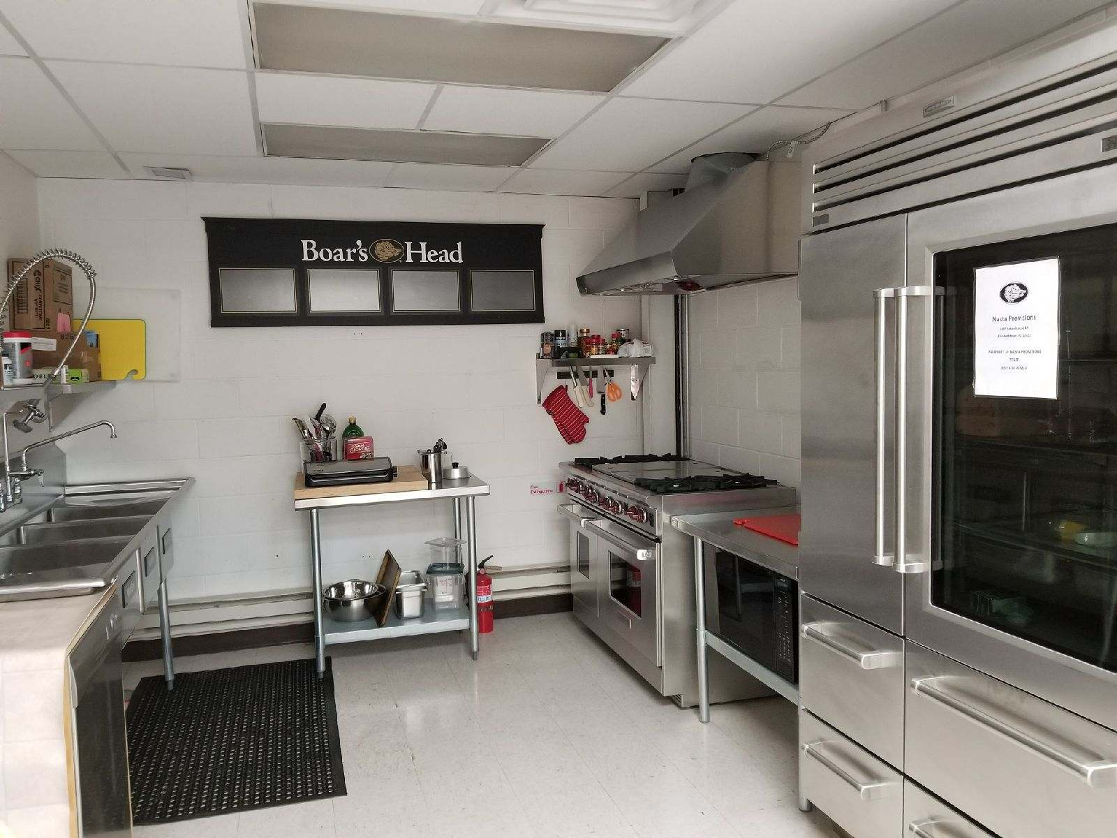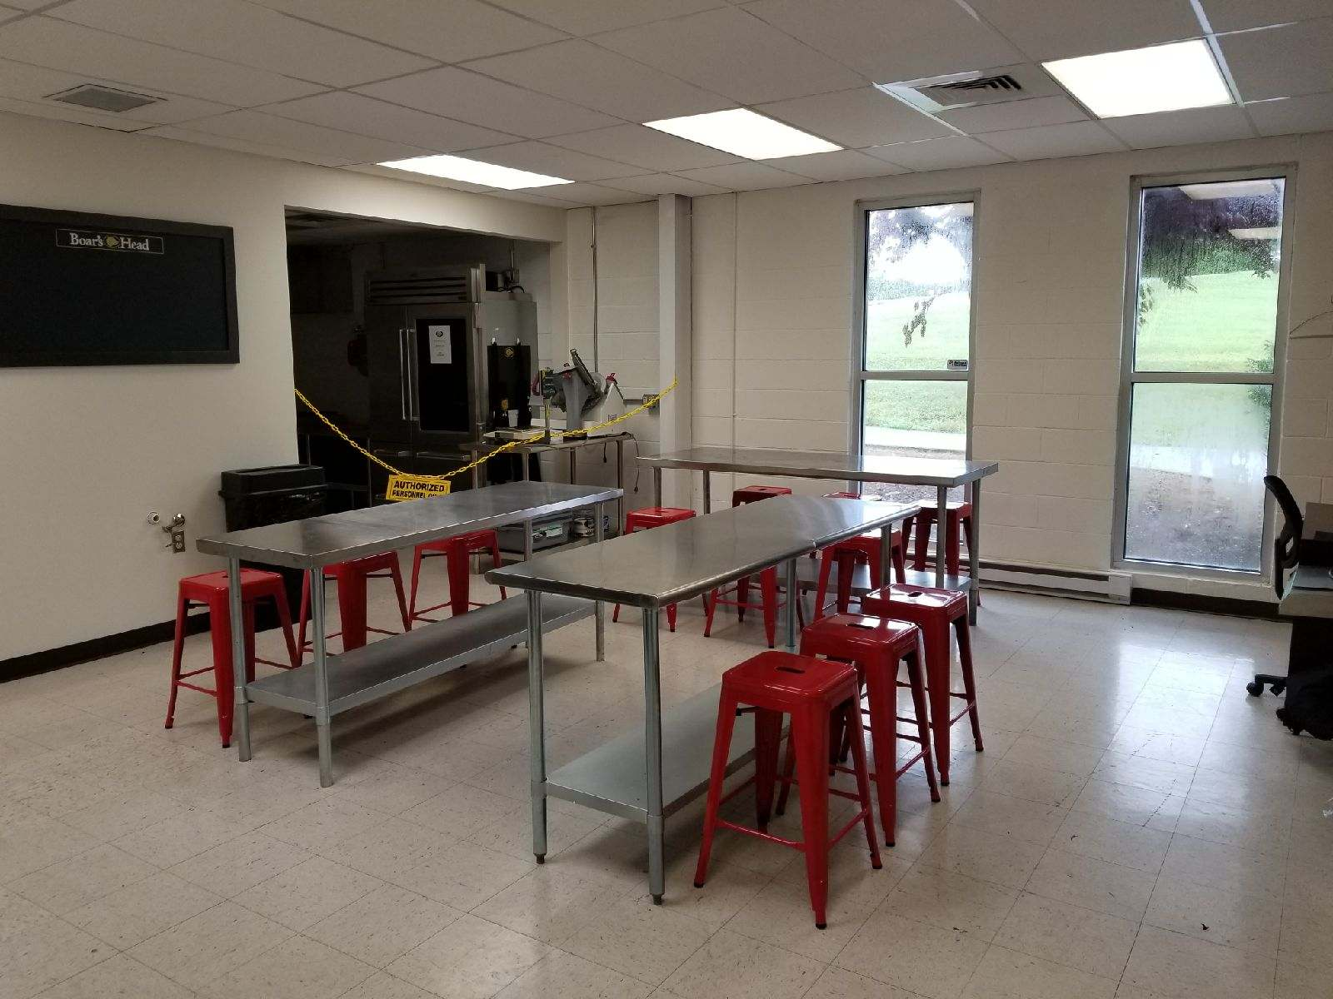

- August 16th meeting will be at Chef Nicholas Arnold’s home. Potluck style format for dinner and Chapter meeting to follow. Beginning at 4pm, watch for email from Chef Cher Harris.

- Budget & Finance Committee organized an August 11th fundraising dinner for the Goodlings. $2300 check received, the committee would like to contribute $1000 to Scholarship fund and the remainder after expenses ($1000 estimated) to general chapter fund. Chef Gipe, Chef Roebuck, Chef Reis and Chef Harris will be participating in the event. Chef Patti opened for further discussion from the membership on this. Chef Reis requested help with food donations. Chef Tim Harris offered products from his farm for the event. The two will connect further. Chef Reis expressed the committee is looking to do 3-4 dinners a year. Chef Patti encouraged additional members

- As referenced in an email previously. Our Chapter is hosting an ACF Certification Test at LCCTC, on August 12th and 13th. The test is on the national website now that examinees can register. Chef Harants in coordinating the evaluators. Chef Corle gave an update on the Apprentices testing for their written exams for CSC and CPC on July 27th. They have completed all their academic requirements, these tests are their final step. See the committee overview in Committee Reports below.

- Chili Cookoff: October 2nd Alex’s Chili Cookoff for a Cause- Chef Patti would like to represent our Chapter and provide the ingredients for the samples. The chapter expressed their support. She will complete the registration form and officially enter the cookoff.

- Ronald McDonald House: Are accepting volunteers again & operating still under restrictions due to COVID. Visit https://www.rmhc-centralpa.org/volunteer/ for more information.

PA Flavor Update: will be held August 21st at the PA Farm Show complex

PA Flavor Committee- Patti, Blythe & Arnold

Joint event with PRLA, PA Brewers Association, and our Chapter.
Chef Patti noted she has already planted the seed that for the next event, she would like to bring PA Preferred back into involvement.
Our commitments for this year-
1. Help to secured restaurants and vendors with booth participation. Checked off the list.
2. Demonstrations- 8 different live demonstrations elevated on a stage with chapter members. The stage will include 2 tables infront as our booth, ACF quick sign up, promotional items and new signage, networking, entertainment, samples, and more. Chef Patti overviewed the schedule.
3. VIP hors d’oeuvres and food stations. Historically we had schools in session and plenty of students to help, not to mention Chef Blythe for putting it all together with products onhand feeding the masses. This year, we have developed a menu to round out booth offerings and represent PA ingredients. Help with production and service for over 1000 attendees is needed. Production prep days- Thursday and Friday. Final production and event- Saturday. NEED VOLUNTEERS!! ANYONE CAN HELP! Email arpatti@hacc.edu

Committee Review:

In May, Chef Patti requested a Committee Review of all current committees. There was many comments that our chapter has too many committees. Each chairperson was asked to define the purpose and mission of their committee, as well as planning future activities and goals to achieve this purpose.

Chef Patti’s concept of a committee is a group of members- a team, coming together for a focused purpose, leading the chapter to work towards the goals of the committee. Focused conversations and a focused direction. Leading in the planning, organizing, etc. not solely the doing aspect. Committees are coming together as a team and bringing the chapter together as a group for each event. There will be a lot of overlap- every event will need to involve the Marketing Committee.

Updates were provided from the Board meeting on 2 committees.
Competition Committee update- Cochairs Chef Susan Notter and Chef Ben Bedard joined by Chef Cher Harris. Social Media Committee changed to Marketing Committee.

Executive Committee-Chef Patti
Chef Patti overview the goals of the Executive Committee. See a full report below in Committee Reports.

Junior Membership/ Student Outreach-Faith Brenneman
Rasheeda Carter reported the committee met to discuss the purpose and mission of the committee- “To give support, encouragement and direction. We acknowledge as a committee that our purpose nay change as we start talking and meeting with Junior members.”
The committee focus is on engaging student members and introducing them to ACF both locally and nationally. See a full report below in Committee Reports
To view the full discussion on Junior Member involvement initiatives, visit our YouTube channel, https://youtu.be/_xINlNlatJA
Student Representative’s Message- Rasheeda Carter
Rasheeda presented the Chopped! The ACF Way-

This month’s ingredients were Ribeye steak, collard greens, chickpeas, and carrots.

CHOPPED! The ACF Way
July Participants were Chef Tom Long and Chef Joe Garrett.

Chef Tom Long’s Chicken Fried Steak with Warm Bacon Dressing

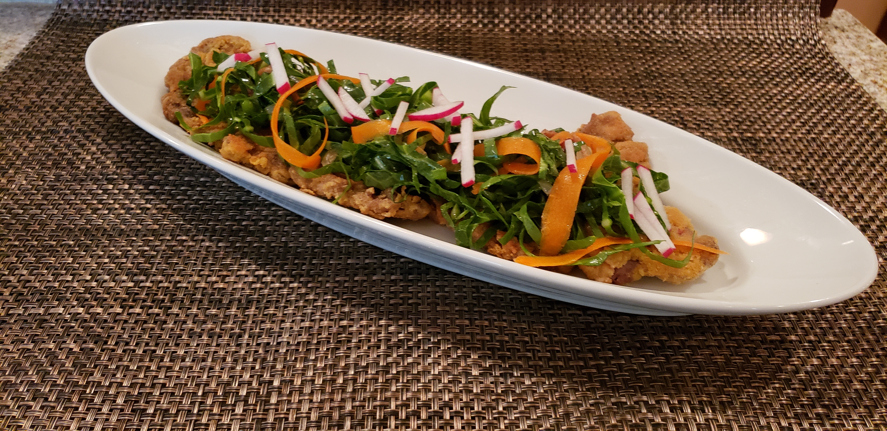
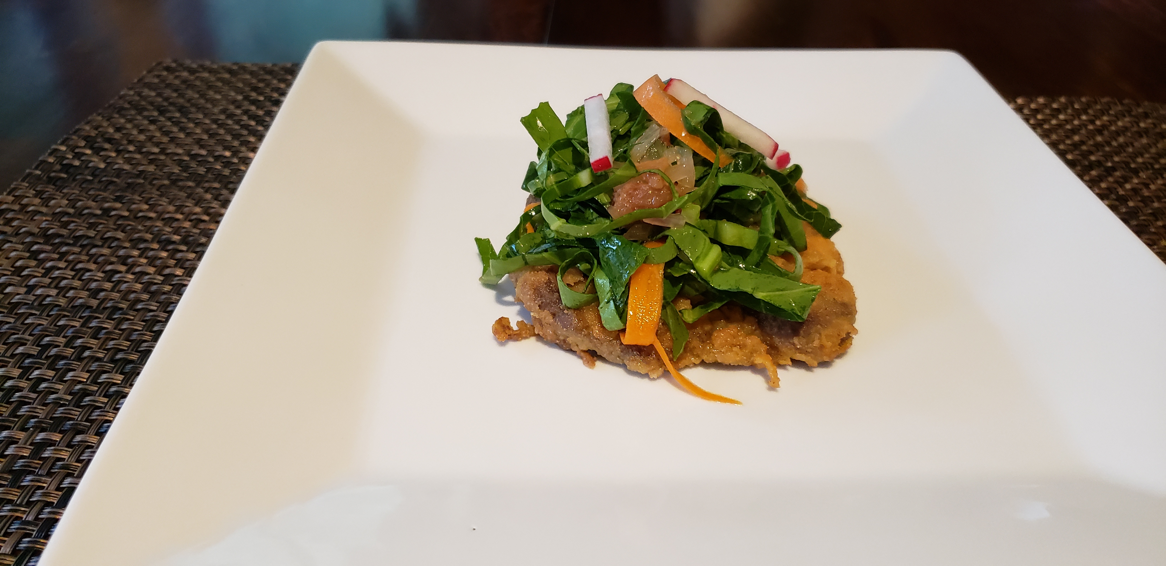

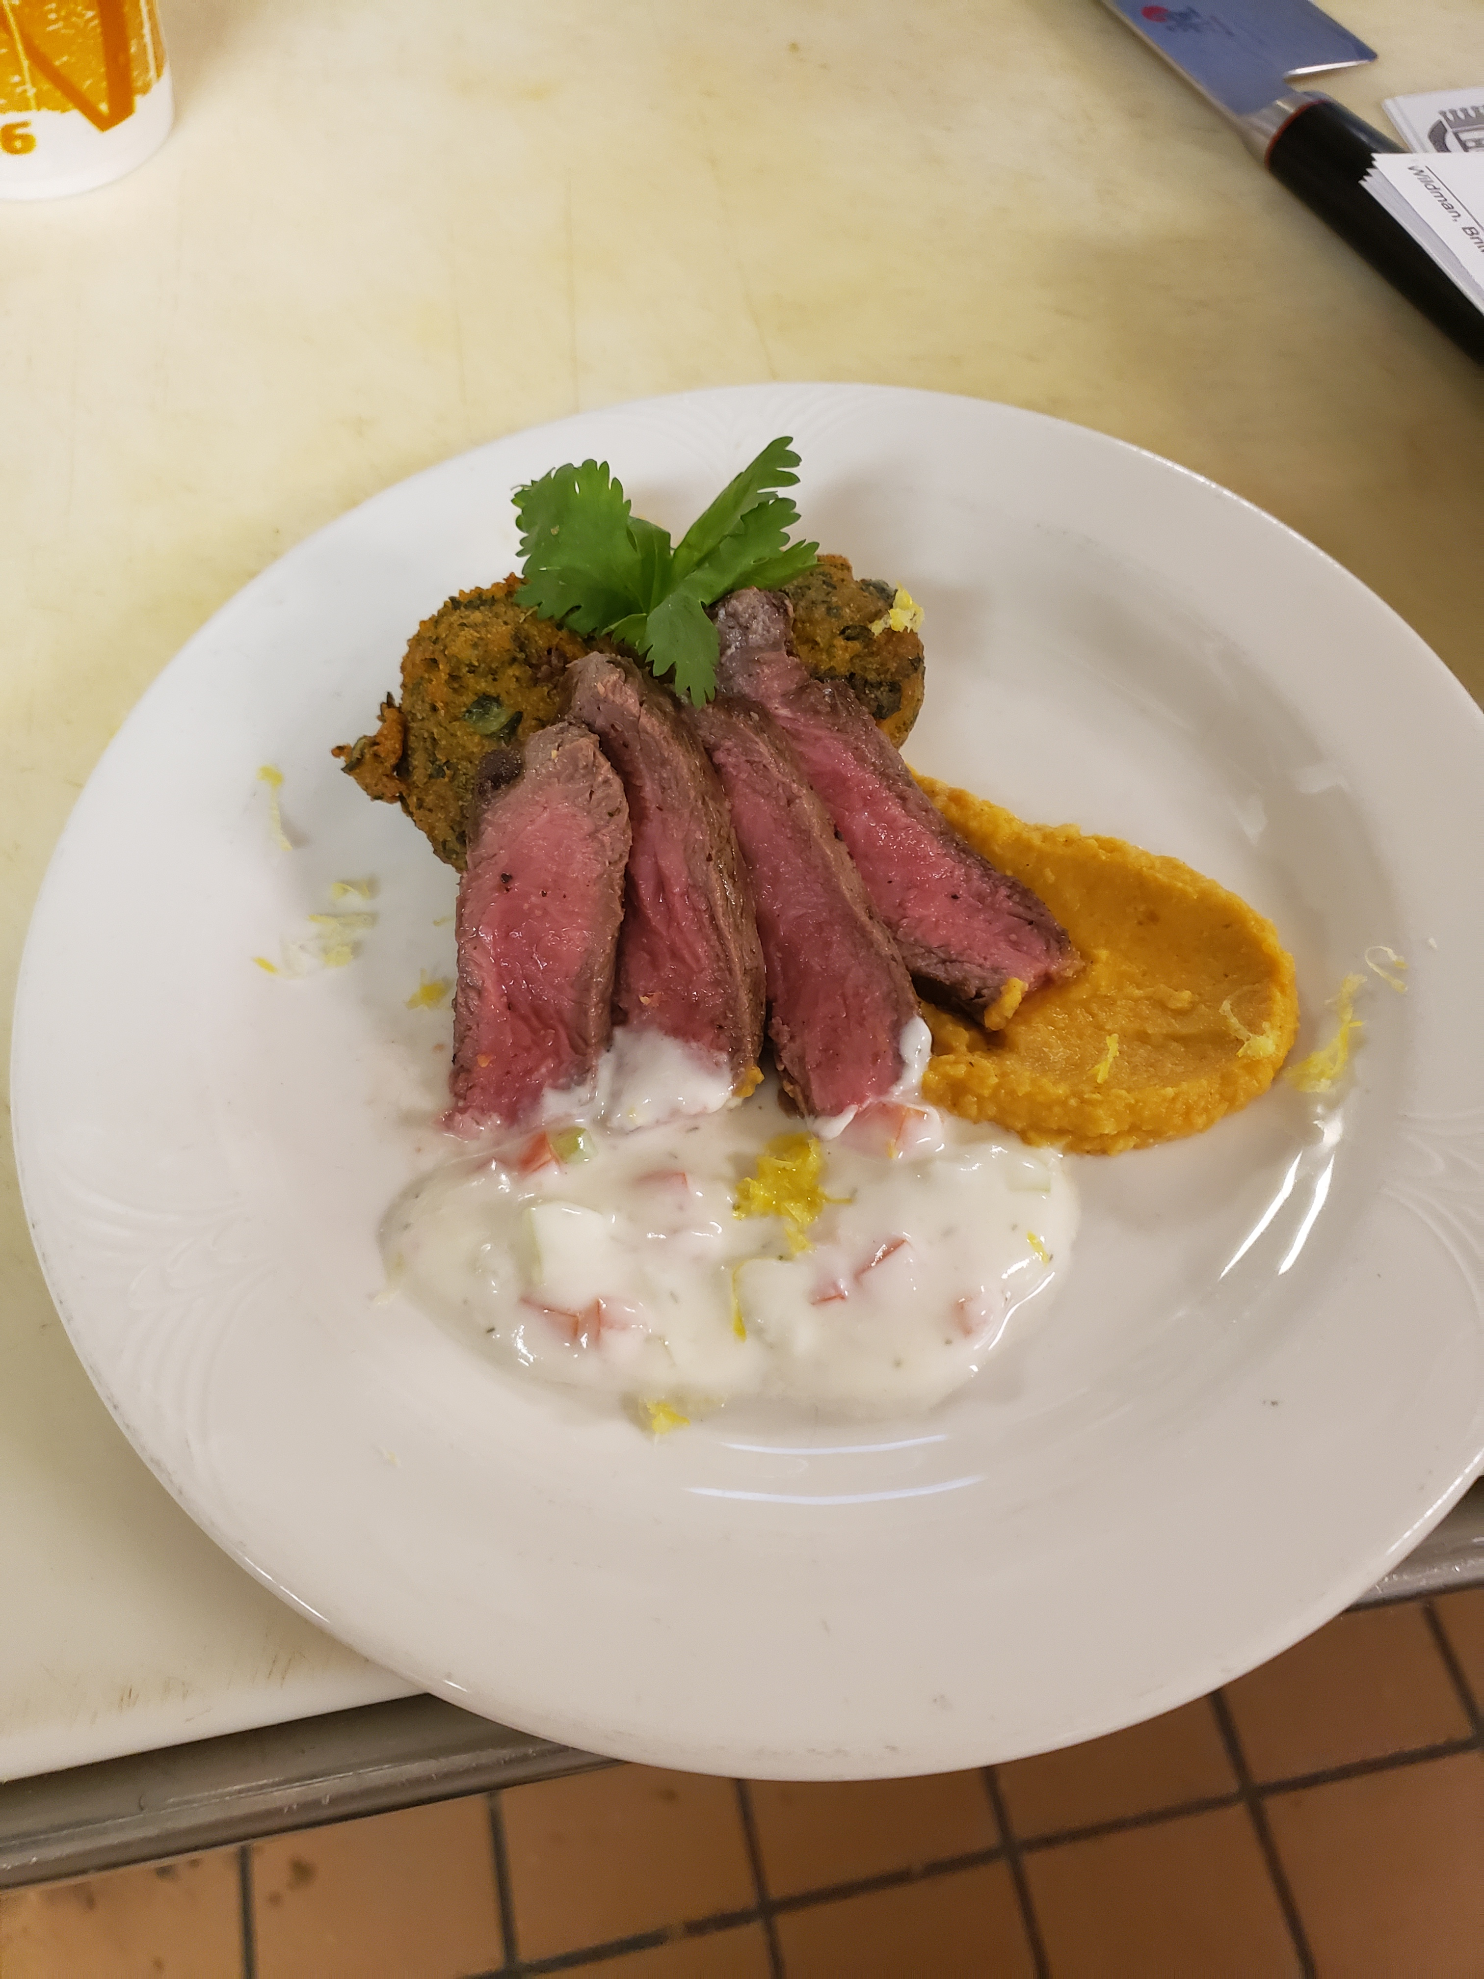
Chef Joe Garrett’s Cast Iron Seared Rib eye with a roasted carrot and ginger hummus, collard green Falafel and Cucumber tomato yogurt sauce.

HEY STUDENTS!!! GIVE US SOME HELP- Ideas for Mystery Box Ingredients!!

- Students, please send ingredient ideas to Rasheeda at rcc85553@hawkmail.hacc.edu
- We will pick 4 ingredients/spices that need to be included in your dish.
- We will send out an email with the “basket” ingredients on the Wednesday after the meeting. You will purchase the ingredients, create your recipe, and take a picture or share your plate with us at the next meeting.
- We would like 3 VOLUNTEERS for each month.
- No Chopped! For the month of August

Education Committee- Anna Smith
President Patti shared the purpose of this committee is “to provide valuable education to our members.”
Committee discussed existing and new initiatives for education. Would like to provide more content for social media and to support members and attract new members. See a full report below in Committee Reports
Upcoming education:
- September education- PA Beef Council demonstration
- October- Foley Seafood
- November- Sysco warehouse tour (TBC)

Educational Presentation: Yields Part 3- Chef Michael Harants CEC, CCE, AAC-
Lobster Fabrication and Yield, Edible Portion demonstration
WATCH HERE! https://youtu.be/xqWCi_s6LyE and https://youtu.be/uDuAVqS4st4

Marketing Committee Update- Renee J Nasta

Renee provided an update on promotional materials for the Chapter to be used during community events, recruiting and educational formats. The marketing committee is working on ways support the efforts of the chapter in awareness, education and connection. Our primary purpose is to support the chapter in all ways through various types of media. Generic business cards and new signage are being ordered and we will be seeking to secure sponsorship and donation opportunities as we move forward. See a full report below in Committee Reports

*Please email Renee content to post on our Chapter’s Facebook page at rj_nasta@yahoo.com or text her pictures at 1-717-821-3531.

Also, check out our chapter’s YouTube channel: ACF Harrisburg! https://youtu.be/hFAMmZKoEss

The Following committee reports were tabled until the August meeting- Certification Committee, Budget & Finance Committee, PRLA Golf Outing Subcommittee, Mentorship Committee
Motion by Chef Corle, 2nd by Chef Barb, Accepted by all, Motion passed.

Motion to adjorn the meeting at 8:31pm by Barb Byrem, 2nd by Chef Reis, Accepted by all, Motion passed.

Committee Reports

ACF PA181 Harrisburg Chapter- Executive Committee
Autumn Patti, President; Tom Long, Vice President; Cher Harris, Treasurer; Renee Nasta, Secretary; Rasheeda Carter, Student Representative, Brian Peffley,
Goals and Strategies
  - Engage current members and increase participation. (Committee Review, Email communications, social media efforts)
  - Add value to our chapter and meetings to increase attendance and participation. (Education programs, Chopped, Membership Minute, Email communications, social media efforts)
  - Establish an annual budget and increase revenue. (Finance Committee)
  - Grow our membership. (Membership Committee)
  - Provide support to the community, educational programs, industry, and professionals in Central PA. (Community Outreach, Junior Membership, Apprenticeship, Certification, Accreditation, Mentorship, and Scholarship Committees.)
  - Increase the Chapter's awareness, both locally and nationally. (Educational Resources, Social Media, BOG presence, Chapter Presidents' gathering, Chef's Table, networking)

Junior Membership Committee Minutes
6/29/2021 2:00 PM| Via Phone Call
Meeting called by Faith Brenneman, Chair  Type of meeting Committee Meeting | Attendees- Faith Brenneman, Chair, Rasheeda Carter

Agenda Items

Topic
Call to Meeting & Purpose
Meeting Started at 1:30PM. Purpose of this Committee is to help guide our Junior Members in all their kitchen endeavors. To give support, encouragement, and direction. We acknowledge as a committee that our purpose may change as we start talking, and meeting with the Junior Members.
Review of Committees Responsibilities & Duties
As stated above. Help represent our Junior Members, while giving them a platform to express concerns, needs, and ideas. Leadership, help in/with Mentorship, give direction, offer support.
Understanding who are OUR Junior Members
Individuals who are enrolled, attending, recent graduates of a Culinary and/or Baking program- secondary and post-secondary, or simply a food enthusiast. Someone who is new to ACF. We don’t want to discourage anyone from being included in Junior Membership for any reason, Ex. School, industry experience, age, etc. As for now, our focus is Students in our local CTC programs, and post-secondary institutions.
What we are doing VS. What should we be doing; Brainstorming, up for discussion
As of today, we have Student Spotlight for the Chapters Monthly Newsletter- Mise En Place. Instructors are encouraging Students to attend the virtual meetings. Faith is going to reaching out to chapter instructors (secondary and post-secondary) and asking how ACF is introduced to Students. Is it just a quick topic of “this is the ACF…” or are students given a breakdown of who we are, what we do, how they can benefit, etc. This will help us as a committee see how the Chapter and ACF is presented. We can then gauge how we need to present and provide information to our Junior Members/potential Junior Members.
“Back to School/ACF Night” Event/ZOOM Idea
This was an idea Faith and Rasheeda both had for a while. This is going to have to depend on what responses are given back from instructors. But the idea is to have an “informal” Junior Member’s Back to school/back to ACF night via Zoom, or another virtual platform. We want to invite any and all new Junior Members for a meeting to go over the ACF- who, what, when, where, and why! Rasheeda and Faith will facilitate the meeting, answering any questions students have. We would want to invite some Senior Members and Instructors of the Chapter (Chef’s A. Patti, B. Peffley, R. Corle, C. Dacko Etc.) to give their feedback and remarks. The idea of this is to take out the intimation factor of coming to a Chapter Meeting without knowing what to expect and who is there. Get their feet wet, and comfortable with their fellow Junior Members. Committee will reconvene July 19, 2021 to revisit this event idea, and go over responses from instructors and if and how the committee will move forward.
Open Discussion
Faith would like to know if and how York County School of Technology was involved in the ACF. To her knowledge they are not currently affiliated with the ACF. This isn’t a dire situation, yet with the upcoming academic year it may be a better conversation now versus later. The Committee understands as a Chapter we have a lot of institutions under its wings now therefore, Faith will reach out to Chef A. Patti on how to approach the conversation, if any.
Question arose- does the current time and day (Mondays) work for Junior Members? Do we need to look into having a special time and day for just Junior Members? This is stated within the bylaws to have a time that works BEST for them.
Adjourn
Meeting called at 2:48PM

Other Information
Resources – N/A
Special notes – Committee must present an overview to Chef A. Patti by no later than July 11,2021. Overview must include objectives, goals, and any strategies/activities presented.

ACF PA181 Harrisburg Chapter- Education Committee
Chair: Anna Smith; Members: Autumn Patti

Purpose:
To provide valuable education to our members.

Goals:
The committee will organize and manage:
- educational presentations at monthly meetings
- educational events throughout the year
- educational content and awareness on social media
- educational support for students, educators, professionals, and industry partners
- CEH certifications

Initiatives:
- Grow committee with outreach in communicating purpose and goals to members. Prefer to include at least one additional educator with direct access to student learning needs.
- 2022 Educational Program Survey
  - Will be developed to send out in August. Purpose is to determine the demand for specific educational topics.
  - Do you have an educational presentation and want to be a presenter at one of our 2022 meetings? Topic __________________ Preferred month_____________
  - Do you want to host a meeting in 2022? Preferred month_____________
  - We will include a list of available topics we can secure education for to build data for interest.
  - Also, an “other topic” category asking for suggested contacts.
- Plan local tours- Mushroom Crawl (Spring 22- Country Fresh, ToJo’s,, Phillips), Bow Creek Farms (Oct?), etc. (2-3 per year)
- Education posts on social media
  - Developing a spreadsheet of food-related days each month. Will pair 5-8 with videos and/or recipes created by chapter members. Starting with August. For July meeting, the committee will present this concept and request any additional items needed for the next 2 months.
  - Providing content to the Marketing Committee to create original posts on social media.
- Maintaining the content on the Education page on the chapter’s website, communicating needs to the Chapter Secretary.

Future goals:
Educational summit (start discussion in 2022)

ACF Harrisburg PA181- Marketing Committee Meeting

Social Media Committee- Chair- Renee Nasta, Autumn Patti June 28, 2021, 530pm
Purpose: Our primary purpose is to support and promote the chapter in all ways through various types of media.
Change of Name: To reflect the committee’s purpose more accurately, a name change was discussed at the June 28th Board Meeting. Marketing more reflects the purpose rather than Social Media Committee. Discussion followed by unanimous vote- motion passed.
Goals/Objectives-
Short Term/Immediate-
- Generic Business Card containing Chapter information for use in recruiting and promotion.
- New retractable banners with chapter information for use during events- i.e.: PA Flavor
- Print Materials- Certification information, ACF Application, ACF QuickApp and Member information
- Social Media- Continue to share and create original content whenever possible on all platforms. Look to other committees for content creation.
Long Term-
- Add minimum 2 new members to committee.
- Add Student/Apprentice “reporters” to create and contribute content.
- Create a Sponsorship program for advertising opportunities and income generation.
- Connect social media platforms to our website and YouTube channel.

ACF Harrisburg PA181- Certfication Committee
Chair: Michael Harants

Michael would like to add two people to committee to act in Admin positions, act as exam administrator and coordinate student support. Ideally one of these roles will be filled by a culinary student to mentor them to take over as committee chair for our chapter within the next 2-3 years.

The goal of the certification committee is 3 fold:
1. To further elevate the chapter’s presence with a high number of certified members, to include students.
2. To be the preferred location for the Central Pa area for ACF certification testing.
3. To raise additional funds to support our educational programs and scholarship fund.

Ideally, we’d have several locations to support certification:
Large/Medium events: LCCTC
Medium and Small events – HACC and one or two of our tech programs
Small or single events: John Gross Company

He would like to get a few dates on the books, but we’re dependent on our locations; I’ll reach out to the program leads to see what is the possible.

For additional support he asked Bob Corle to support the Certification committee and we can put it out to the general student membership to see whom may be interested. I think it should be a post-secondary student but wouldn’t mind adding a 4th person, a secondary student, to liaison at the secondary level especially around graduation to encourage and support secondary and post-secondary students graduating from an accredited program to apply for their earned certification as students graduating from an ACF accredited program.

Employment Opportunities

- Chef de Cuisine, Circular at The Hotel Hershey
https://careers.hersheyjobs.com/job/13296834/chef-de-cuisine-circular-hershey-pa/

- Chocolatetown/Hershey Park – cooks, dishwashers, pastry cooks, servers, bartenders https://www.hersheyjobs.com/

- Executive Chef opportunity with Whippoorwill Club (Whippoorwill) in Armonk, New York: http://bit.ly/whippoorwill-profile

- Café Associate- FT & PT positions, competitive pay and benefits! Hiring for Camphill, Enola and Linglestown. Rock Street Cafe Café: Call 717-367-6868 or go to www.nastaprovisions.com

- Two culinary educator positions-Northampton Community College: https://northampton.wd5.myworkdayjobs.com/en-US/NCC/job/Bethlehem/Culinary-Chef-Faculty_JR1029

- LINE COOKS• PREP COOKS• SERVER ASSISTANT/EXPEDITOR• SERVER-Café Fresco: http://www.cafefresco.com/

- Retail Food Inspection Specialist (HARPS)Department of Public Safety-Health Office: http://harrisburgpa.gov/careers/

- Full Time Cook - Village Square, Messiah Lifeways at Messiah Village-Cura Hospitality Mechanicsburg, PA 17055:
https://www.indeed.com/viewjob?from=appsharedroid&jk=8bfee45e6f0263dd

- Executive Chef- Springhaven Club, Wallingford, PA: https://www.thespringhavenclub.com/

- Executive Chef- St Joseph Country Club, MO: https://stjosephcountryclub.com/

- Lead Line Cook- Dolphin Head Golf Club, Hilton Head, SC: https://dolphinheadgc.com/

- Director of Foodservice - Kenbrook Bible Camp, Lebanon PA: http://www.kenbrook.org/

ACF Harrisburg Chapter PA 181

Culinarian’s Code
As a proud member of the
American Culinary Federation,
I pledge to share my professional knowledge and skill with all Culinarians.
I will place honor, fairness, cooperation and consideration first when dealing with my colleagues.
I will keep all comments professional and respectful when dealing with my colleagues.
I will protect all members from the use of unfair means, unnecessary risks and unethical behavior when used against them for another’s personal gain.
I will support the success, growth, and future of my colleagues and this great federation.

2021-2022 Officers

President:
Chef Autumn Patti
Program Director, Asst. Professor
Culinary Arts, Baking & Pastry Arts Programs
HACC, Central Pennsylvania’s Community College
arpatti@hacc.edu

Vice President:
Chef Thomas J Long CEC AAC
Director of Dining Services
HACC, Central Pennsylvania’s Community College
icechef257@aol.com

Secretary:
Renee Nasta
NJ Nasta, Inc.
Rj_nasta@yahoo.com

Treasurer:
Chef Cher Harris CEPC
Corporate Pastry Chef
Hershey Entertainment & Resorts
cdharris@hersheypa.com

Student Representative:
Rasheeda Carter
HACC Culinary, Baking & Pastry Arts student
chamee1101@aol.com

Chairman of the Board:
Chef Brian D. Peffley, CEPC CCE AAC
Pastry Instructor
Lebanon County C.T.C.
BPeffley@lcctc.k12.pa.us

