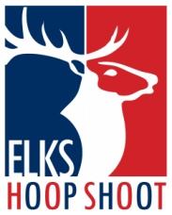 2026 Texas State Hoop Shoot Reservation Form
DoubleTree by Hilton Hotel Dallas Near the Galleria
4099 Valley View Ln.
Dallas, TX 75244
We will provide 1 room for 2 nights and meals for each contestant and 2 guests. You may purchase extra meals and rooms by Feb 9th. We cannot guarantee room availability after that date. Please do not call the hotel directly as you may not get the special room rate. Contact Keith Stanley: Keith.Stanley2327@outlook.com or 817-319-2327. Extra rooms are $131.00 each plus tax to be paid at check in. This includes breakfast for all in the room. Hotel will need a credit card if you order room service, movies, or other.
This box is for the contestant only.
Shooter :
Guest :
Guest :
FRIDAY night : |  | SATURDAY night :
This includes Hotel Room, Friday night social meal, Saturday and Sunday morning breakfast, and Saturday night Banquet
This box is for Extra Family Members of Shooters or Elks
NAME OF ELK OR EXTRA FAMILY MEMBER :
Extra Room Reservations,  # of Rooms Needed : |  |  |  |  | FRIDAY |  |  |  |  | SATURDAY
Friday Social Meal # |  |  |  | @ $25.00 =
Saturday Night Banquet # |  |  |  | @ $36.00 =
Saturday Night Kids Banquet # |  |  |  | @ $20.00 =
TOTAL
CASH ONLY to pay for extra meals

