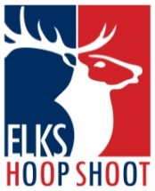Elks National Hoop Shoot
Congratulations on winning your local Hoop Shoot competition! You should be very proud of this accomplishment. You will now advance in the Elks Hoop Shoot contest and compete at the District Level. This competition will include other contestants from your area.
January 18th, 2025 – District competition
Arlington East Recreation Center
1817 New York Avenue
Arlington, TX 76010
Follow the signs to the competition.
8-9 Registration at 10:30AM, Contest begins at 11:00AM
All other age groups, registration is 11:00AM
State Competition:
Friday/Saturday, February 14-15, 2025, in Carrollton TX
Regional Competition:
Friday/Saturday, March 14-15, 2025, in Carrollton, TX
National Hoop Shoot Competition
Friday/Saturday, April, 2025 in Chicago, IL

Keith Stanley, 817-319-2327
Keith.Stanley2327@Outlook.com
District Hoop Shoot Director- Arlington Lodge, 2114

