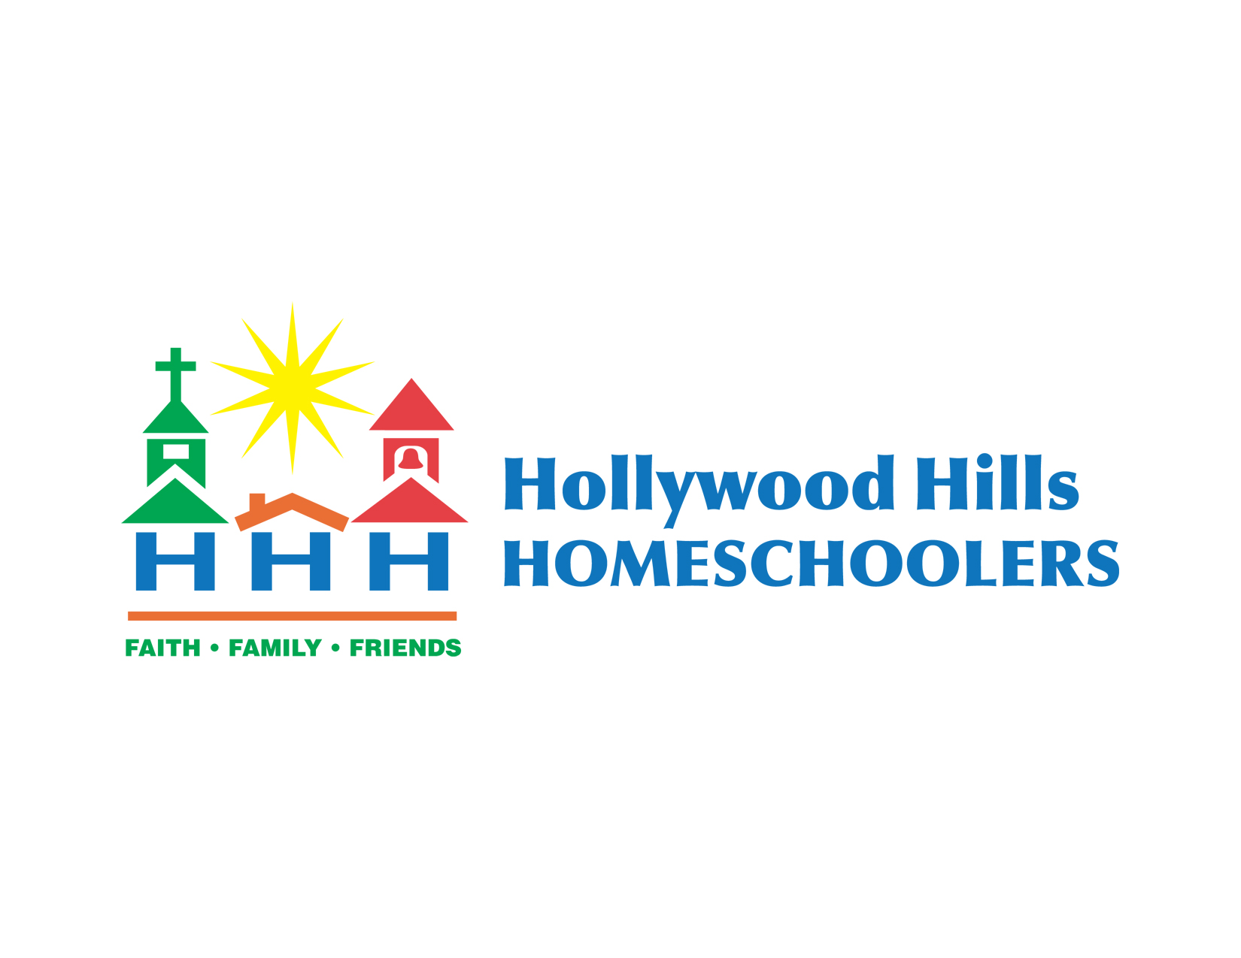
Calendar 2022/2023
hollywoodhillshomeschoolers@gmail.com
website: hollywoodhillshomeschoolers.com

Date Event Time Room
8/12/22 | Friday | Co-op Registration Opens |  | Online
8/14/22 | Sunday | Co-op Teacher Orientation- (TG) | 7–9pm | 206
8/16/22 | Tuesday | Challenge Begins | 8:30 am-3:30 | Library
8/23/22 | Tuesday | CC Foundations Begins | 8:30-3pm
8/25/22 | Thursday | New to Homeschooling 101 | 7-9pm | Ministry Cntr
8/28/22 | Sunday | Orientation Co-op (TG) | 7-9pm | Great Hall
8/28/22 | Sunday | Registration Closes | 9 pm | Online
9/1/22 | Thursday | Co-op Work Day with Pizza Lunch | 9:30-12:30 | Upstairs
9/8/22 | Thursday | Co-op Begins | 9:30-3:30pm | Upstairs
10/4/22 | Tuesday | CC No Classes All Programs
11/15/22 | Tuesday | CC Foundations Last Day | 8:30-3pm | Upstairs
11/17/22 | Thursday | Fall Fest – After classes | 12-2pm | Park TBD
11/24/22 | Thursday | Co-op No Classes Happy Thanksgiving
12/8/22 | Thursday | Co-op Last Day of Fall Semester | 9:30-3pm | Upstairs
12/15/22 | Thursday | Co-op Make-up Day | 9:30-3:30pm | Upstairs
12/25/22 | Sunday | Have a Blessed Christmas
1/12/23 | Thursday | Orientation/Co-op Registration (TG) | 7-9pm | Great Hall
1/17/23 | Tuesday | CC All Programs resume | 8:30-3pm | Upstairs
1/19/23 | Thursday | Co-op Starts | 9:30-3:30pm | Upstairs
1/26/23 | Thursday | Spelling Bee | 1:30-3:00pm | 208
2/9/23 | Thursday | Field Day No Co-op Classes | 10-1pm | Playground
2/28/23 | Tuesday | CC No Classes All Programs
3/9/23 | Thursday | Science Fair - Dinner Served | 6-9pm | Great Hall
3/21/23 | Tuesday | CC Spring Break
3/23/23 | Thursday | Co-op No Classes Spring Break
3/26/23 | Sunday | Talent Show | 6-8pm | Great Hall
4/6/23 | Thursday | Co-op No Classes Easter Break
4/9/23 | Sunday | Happy Easter – He lives!
4/13/23 | Thursday | Co-op Resumes | 9:30-3:30pm | Upstairs
4/18/23 | Tuesday | CC Foundation/Essentials Last Day | 8:30-3pm | Upstairs
4/25/23 | Tuesday | CC Memory Master Testing | 8:30-3pm | Upstairs
5/4/23 | Thursday | Co-op Last Day | 9:30-3:30pm | Upstairs
5/5/23 | Friday | CC Awards Night | 6:30-9pm | Great Hall
5/11/23 | Thursday | Co-op/CC Work Day (Make-up Day) | 9-2pm | Upstairs
5/20/23 | Saturday | Promotion Night / Art Fair | 6-9pm  Early setup | Ministry &  Great Hall
5/29/23 | Monday | Memorial Day – God Bless America!

ALL ABOVE DATES ARE SUBJECT TO CHANGE
Please check our website for any additions and/or changes.

