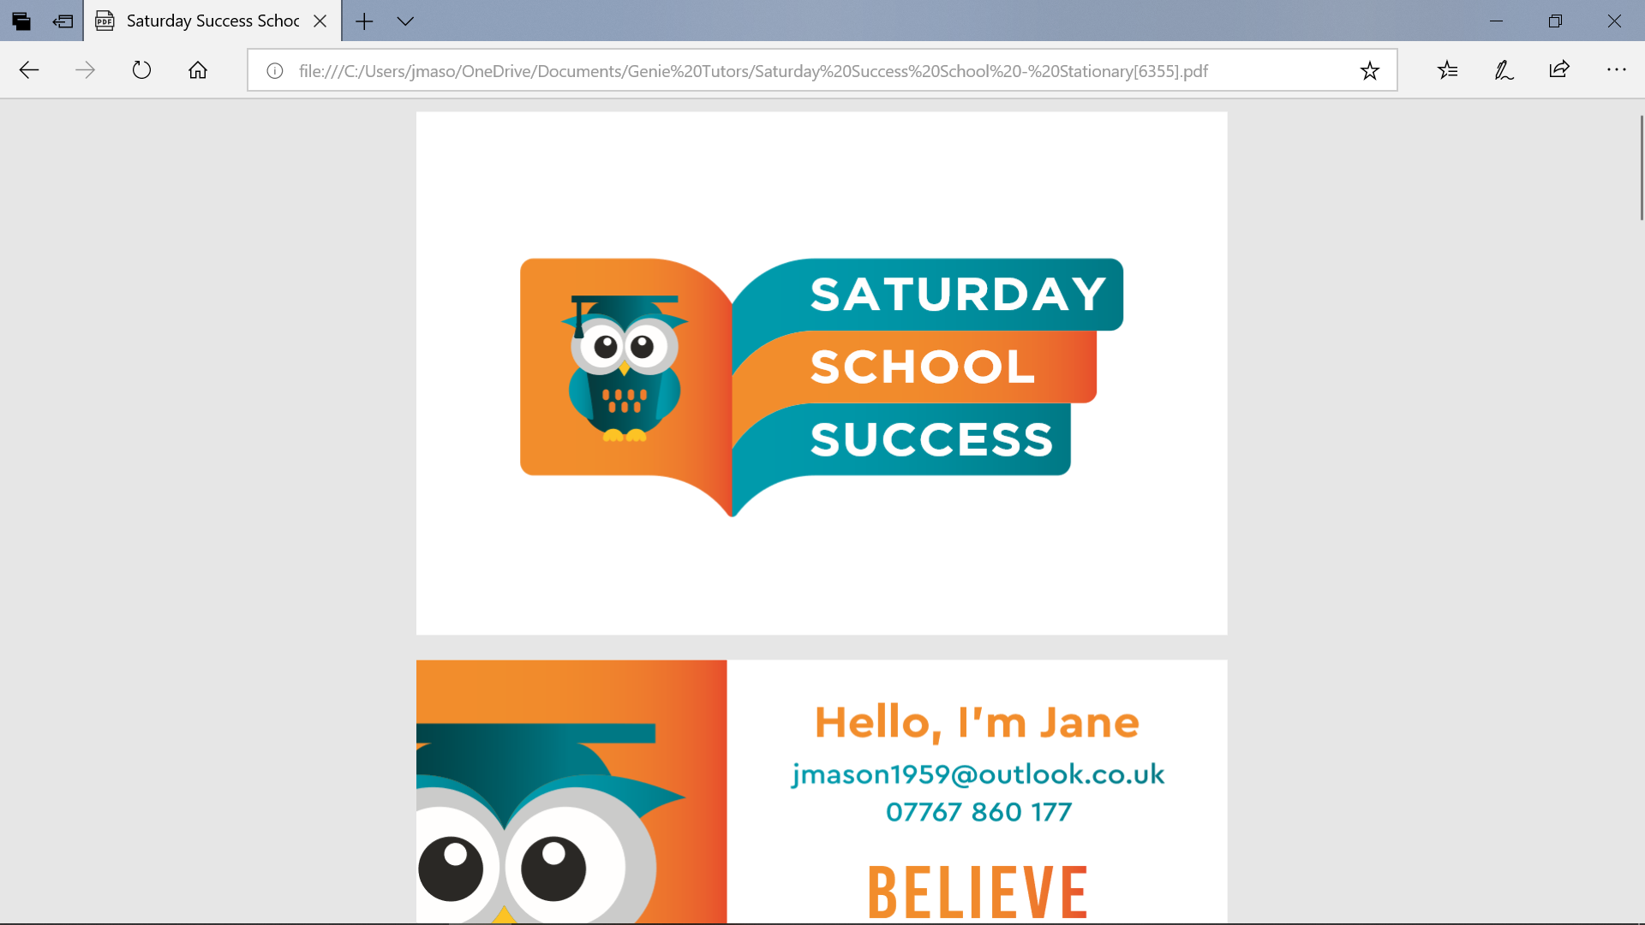****

**Saturday School Success Ltd**

**Tutoring Risk Assessment for Covid 19 outbreak**

|  |  |  |
| --- | --- | --- |
| **Streetly Methodist Church**  Assessment conducted by:  Jane Mason | Job title: Director Of Saturday School Success | Covered by this assessment: all staff . all parents /carers and attending pupils, |
| Date of assessment: 16.07.2020 | Review interval: every school half term | Date of next review: January 2021 |

|  |
| --- |
| **Related documents** |
| Safeguarding policy , Heath and Safety Policy and Fire Evacuation Policy |

|  |  |  |  |  |
| --- | --- | --- | --- | --- |
| **Risk rating** | | **Likelihood of occurrence** | | |
| **Probable** | **Possible** | **Remote** |
| **Likely impact** | **Major**  Causes major physical injury, harm or ill-health. | High (H) | H | Medium (M) |
| **Severe**  Causes physical injury or illness requiring first aid. | H | M | Low (L) |
| **Minor**  Causes physical or emotional discomfort. | M | L | L |

| **Area for concern** | **Risk rating prior to action**  **H/M/L** | **Recommended controls** | **In place?**  **Yes/No** | **By whom?** | **Risk rating following action**  **H/M/L** |
| --- | --- | --- | --- | --- | --- |
| Awareness of policies and procedures | **Low** | Tutoring Staff will read and familiarise themselves with relevant policies, including the following:   * + **Health and Safety Policy**   + **Child Protection and Safeguarding Policy**   + **Fire Safety Policy**   + **Privacy Policy** * The parents of children who attend tutoring are given relevant information, with all policies being found on the website.   [www.Saturday](http://www.saturday) school success.co.uk   * Staff are contacted weekly by email updating Government guidance and Church Policy * All staff members undergo updated DBS checks every **three years** | **Y** | **Jane Mason** | **LOW** |
| Limit risk of infection around the building | **L** | * The sessions will be arranged for an hour with a fifteen minute gap to enable parents to leave before new parents arrive * Parents and children must follow the one way system * Parents and children need to arrive promptly and not queue in the corridor after the session , * From March 2021 Parents will wait in the car park and children will be escorted to the fore door , one group at a time * Parents must adhere to the safety rules for sanitization and social distancing set out in this risk assessment. * Track and Trace is in place for all tutors who sign in . * JM, DB and SC carry out lateral flow tests at their work place | **Y** | **Jane Mason** | **Low** |
| Arrangements for social distancing around the building | L | * Parents to use main entrance and leave through the blue door , children enter the hall and parents leave * Parents to leave quickly * Children to use hand sanitizer at the door / table , before and after the session * No cash payments will be taken, all payments on line * Sarah will take the attendance register and direct children to their tables | **Y** | **Jane Mason** | **Low** |
| Parents fully informed of all new safety measures | L | All new information on the website .   * List the measures in an easy to understand format * No cash payments * Children to bring own stationery in a named sealed bag * Saturday School Success will provide named, sanitised white boards and pens in a sealed bag * Children to bring no bags but can carry a drink to their table * Children will be socially distanced at the table (max three children) * Tables will be sanitised before and after every session * Chairs will be sanitised before and after every session | **Y** | **Jane Mason** | **low** |
| Fire safety procedures are in place | **L** | * The tutoring manager consults with the Church that the fire safety arrangements are place and adhered to . * Fire Drill procedures including social distancing arrangements are in place with Streetly Methodist Church . * Evacuation points are clearly marked and identified by Streetly Methodist church and adhered to by Saturday School Success * To be reviewed with church after fire drill | **L** | **Jane Mason** | **L** |
| Information through Test and Trace | **L** | * Saturday School Success has all data stored on the Company Laptop. By taking an attendance register all data would be given if required to Streetly Methodist Church * Parents would be made aware of the data being given and JM would inform them of the Covid risk if presented * This approach would prevent queuing at the Main door and would be accurate * All data to be checked electronically to ensure accuracy before start date . | **L** | **Sarah Cotter** | **L** |
| Feedback given at the end of the session |  | * Parents will receive feedback by feedback slip. JM is available for text or telephone conversations. * Pupils will leave quickly from the building when SC sends them to parents waiting in car park | **Y** | **All tutors** | **L** |
| Accidents and injuries whilst on the premises | **L** | * There is always at least one trained first aider working at tutoring * The teacher in charge ensures that the tutoring staff are aware of where first aid supplies are kept. * The **first aider** maintains a record of all emergency contacts and known medical conditions of the children attending tutoring * All accidents and incidents are reported to Jane Mason and appropriate forms completed * Parents contacted immediately by Sarah Cotter (first aider) | **L** | **Jane Mason**  **Sarah Cotter** | **L** |
| Pupils expectations of safety measures |  | * Children need to bring their own stationery, making sure it is only used weekly for tutoring. * All tables and chairs will be sanitised before and after each session   Whiteboards will be sanitised after each session and kept for  specific table use   * Work provided will be printed 72 hours before the session and put into wallets, after this only the child will touch it * Children can ask to go to the toilet but an adult will go with them . They must wash their hands on their return * Sticker stamps provided and kept in wallets , Stamps put on by tutors |  |  |  |
| Toilet use and hand washing and sanitising |  | * Children will be allowed to use the toilet facilities but will follow the one way system to return to the Hall * Sanitise when entering the building |  |  |  |
| Cleaning Capacity of Guild Hall |  | * The staff will sanitise when entering the building * The staff will clean the tables before, during and after the session * The staff will clean the chairs before, after and during the session * Work to be provided in plastic wallets , children will touch their own work * JM will ensure the building is secure and sanitised on leaving |  |  |  |
|  |  |  |  |  |  |

Saturday School Success in line with Government Guidance for Schools and feel safe to open in a smaller capacity to ensure safety measures can be adhered to at all times. All new guidelines are included and updated termly .

January 2021