Test to see how PCTEL measures TDI issues
Tom Warfield
Test setup:
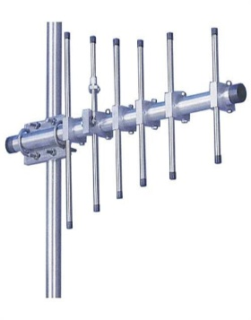
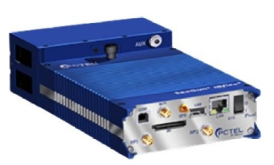
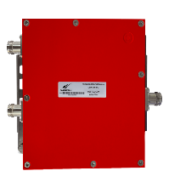
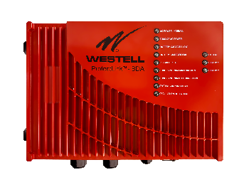
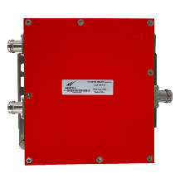
Attn

Viper (NC State) and Wake (County) control channels. Viper uses C4FM while Wake uses CQPSK. Control channels are always FDMA, even in a P25 Ph2 network. Viper is Phase 2, Wake is Phase 1. Here is a Google search brought up in regard to how the two modulation methods compare in regards to timing issues:
“CQPSK (often called LSM/Linear Simulcast Modulation) is preferred for simulcast sites because it is highly resistant to inter-symbol interference and multipath distortion in multi-transmitter networks.
Performance in Simulcast: CQPSK (LSM) is superior in simulcast environments because its waveforms allow for easier decoding by subscribers when receiving signals from multiple sites with different arrival times.”

Donor directly into the PCTEL
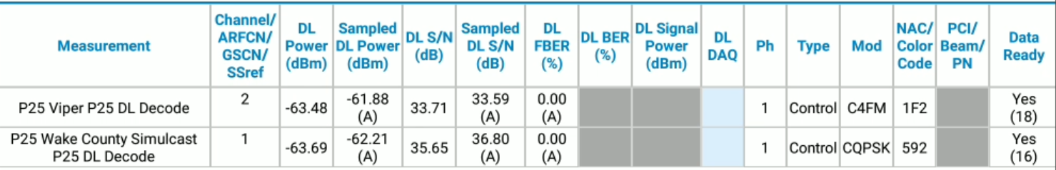

Donor into the PCTEL after splitting and combining
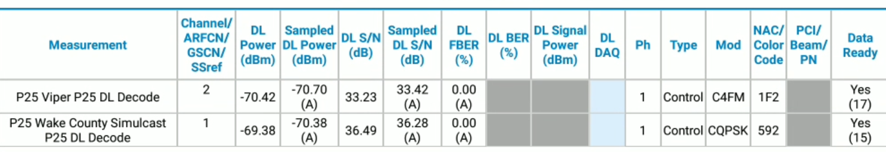
BDA into PCTEL after attenuation and combining
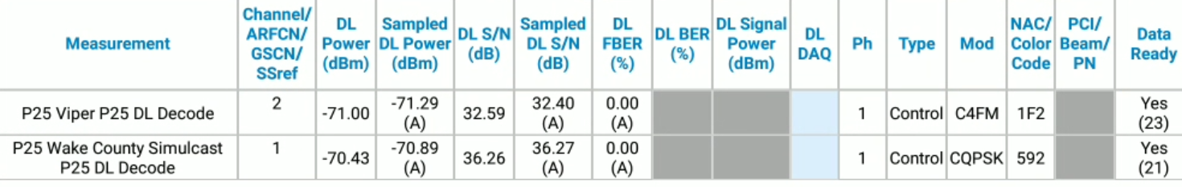

Note: Both the Donor and BDA power levels are approximately the same (-71dBm) for the following results.
Below: Donor and BDA combined @150kHz
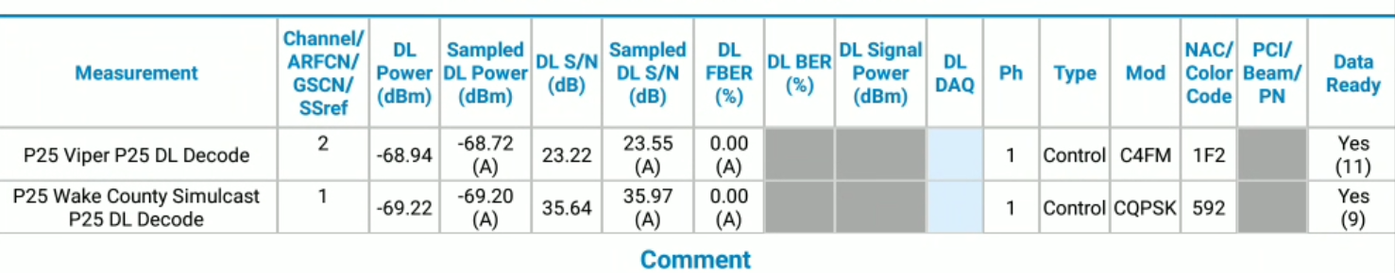
Below: Donor and BDA combined @75kHz
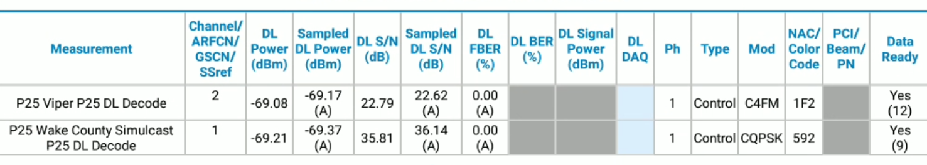
Below: Donor and BDA combined @25kHz
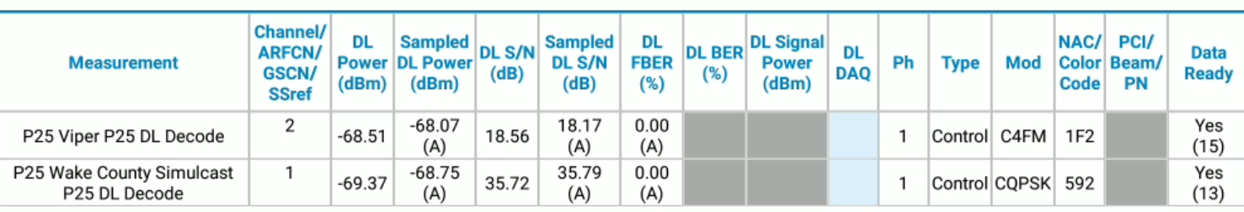
Below: Donor and BDA combined @12.5kHz
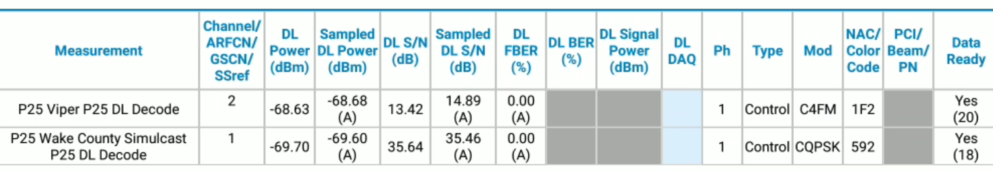

10dB of attenuation was removed from the BDA. There was no change to the setup for the Donor. Measured power levels did not reflect the 10dB change. I guess this is RF being RF.
Below: Power from Donor only. Notice that Viper is lower than it was above. 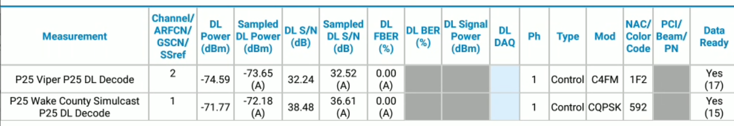
Below: Power from BDA only with 10dB less attenuation.
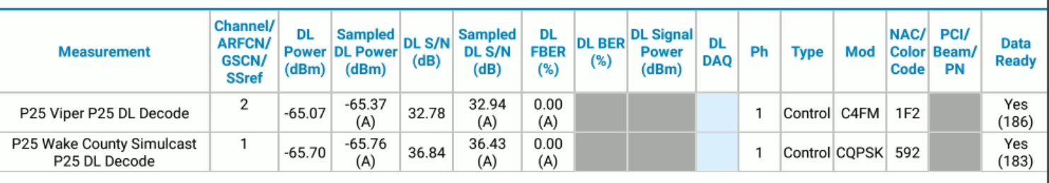

Below: Donor and BDA combined @150kHz
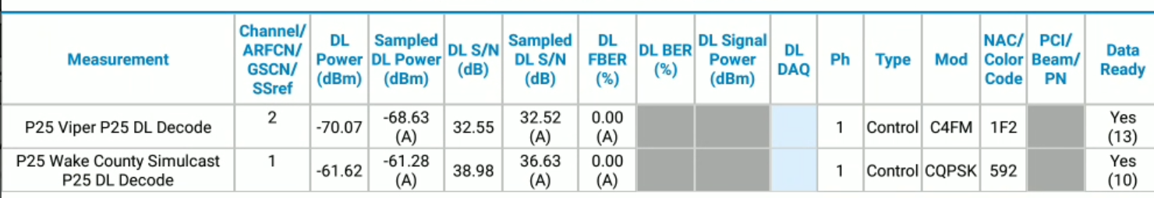
Below: Donor and BDA combined @75kHz
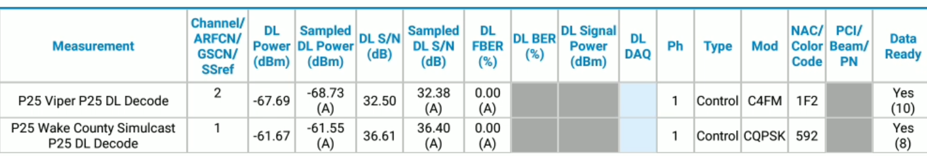
Below: Donor and BDA combined @25kHz
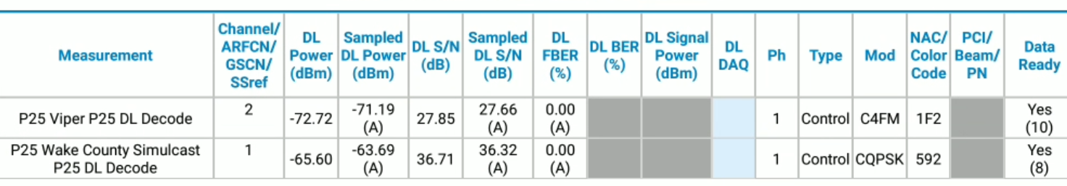

Below: Donor and BDA combined @12.5kHz
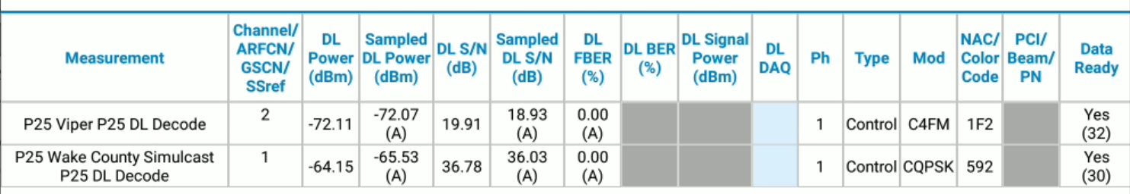

Conclusion: My theory was BER would show TDI more so than SNR. My theory was 100% wrong. SNR clearly is better at showing a degraded signal quality.

