# Architectural Control Committee

# Request Form

|  |  |  |  |
| --- | --- | --- | --- |
| Name: |  | Date Submitted : |  |
| Address: |  | Phone Number: |  |

#### Type of work to be completed (Circle One)

|  |  |  |  |  |
| --- | --- | --- | --- | --- |
| Shed | Fence | Pool | Addition | Deck |
| Porch | Patio | Garage | Other(explain below) | |

#### Timeframe for Construction

Approximate Start Date :

Approximate Completion Date :

#### Detailed Description of Work

Please include details on dimensions, type of material to be used, your plot plan, the exact location of the change on your plot plan (to scale if possible) and any other pertinent information you want to include for the Architectural Control Committee. A contractor's diagram is also acceptable

Please submit this request form to:

#### Clairborne Architectural Control Committee

P.O. Box 549

Bear, DE 19701

If you mail your request, please do so via certified mail return receipt so that you have proof of delivery.

You may also choose to deliver this request form personally to one of the Architectural

Control Committee Members listed below.

|  |  |  |
| --- | --- | --- |
| Jeremy Keffer | 56 Eaton Place | (484) 769-3256 |
| Mike Stone | 23 Pegasus Place | (302) 743-0897 |
| Ed DeLooze | 5 Airdrie Drive | (302) 530-2950 |

Please make sure that the request form is dropped off in person (not just placed in a mailbox). This will ensure that your request is processed in a timely manner.

# Plot Plan Example

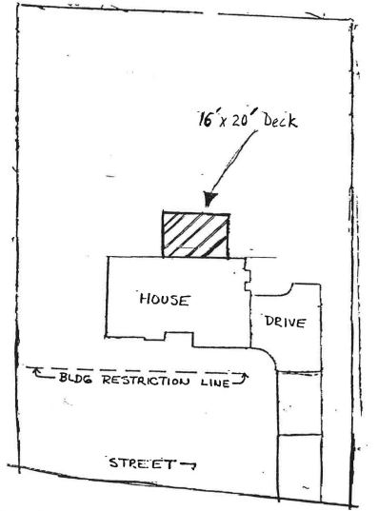

#### Project Information

16' W X 20' L pressure treated deck.

6" X 6" Pressure treated posts to rest on concrete footings

Deck framing to consist of 2" X 10" floor joists on 16" centers

Deck floor will be 5/4" X 6" pressure treated material