* Pledge of Allegiance: J. Wagner March 20, 2018 @ 10:30AM
* Chaplin’s Prayer: D. Bernard
* Roll Call:
  + Commander – J. Wagner - Present
  + Senior Vice Commander – E. Olney - Present
  + Junior Vice Commander – B. Kurland - Absent
  + Adjutant - B. Dismukes - Present
  + Finance Officer - R Duffney - Present
  + Judge Advocate - B. Dismukes - Present
  + Sargent-At-Arms - J Connor – Present
  + Chapter Executive Committeeman – J. Connor - Present
  + Chapter Alternate Executive Committeeman – Mel Gillenwater - Present
  + Trustee Year 2 - S. Fantino - Present
  + Trustee Year 1 - M. Abbott - Present
  + Service Officer - J. Friese - Present
  + Welfare Officer – Ed Charles - Present
  + Historian - N/A
  + Chaplain - D. Bernard - Present
  + Americanism Officer - R. Duffney - Present
  + Chapter Surgeon - Pete Palkowski

* Introduction of Guests and New Members:

None

* Reading of the Minutes of the Last Meeting:

Read and approved

* Report of the Finance Officer: **Balance** $ 7,274.72 (check from Bill Dismukes $49.90 for overpayment to be deposited)
* Reading and Actions on Bill’s Payable: None
* Reports of Committees: (Reports waved due to the election process taking priority)
  + Membership Candidates : N/A
  + Welfare Officer: N/A
  + Americanism Officer: N/A
  + Special Committees: N/A
* Unfinished Business:
  + The VA patient transportation cart was completed and dedicated on March 16, 2018. The check for $800.00 was presented to VA Volunteer Services, all actions are complete.
* New Business:
  + Support for the annual JROTC scholarship program was requested by Jack Wagner. We have presented a check in the amount of $500.00 in the past. A motion to support this again this year was made by Bill Dismukes, seconded by Ed Charles and a unanimous vote by the 12 members present.
  + Support for the presentation of 15 Purple Heart medals awarded has been funded by National in the past. National can no longer provide funding and has past that cost down to State and Chapter level. The 15 medals are $15.00 each and require our Chapter to provide the $275.00 this year. A motion by Bill Dismukes and seconded by Ed Charles with a unanimous vote perused; a Warrant will be generated and provided to the Finance Officer.
  + Rob Brief the committee on the DEC meeting he attended in Jacksonville. Only action require was to provide funding to the Department. The calculations for the amount are $1.00 for each chapter member and 10% of Viola collections minus any cost associated with the collections. Attached find the work sheet for the amount required to be sent to the Department Finance Officer. A Warrant will be provided to the Chapter Finance Officer to pay the amount of $235.00.
  + A secret ballot vote is required to fill the position of Senior Vice Commander. To individuals were nominated, Dan Bernard and Gene Olney were on the ballot. Ballots were cast, collected by one Trustee and counted. Dan Bernard was voted in to the position of Senior Vice Commander.
  + The Commander advised all present that Hendry County is being designated a Purple Heart County. The VA Services Officer has contacted us to be present at the ceremony. Jack Wagner received ok from the Department Adjutant to bring Hendry County in to Chapter 696. A plaque will be presented to the County Commissioners on the 27th of March. A Warrant will be issued to cover the cost of the plaque once a receipt is received. Members of the executive staff will be present for the ceremony.
  + Commander received information on raffle tickets for the convention. The information sheet is attached. Jack Wagner and Bill Dismukes will attend the convention this year.

Good of the Order: Meeting Adjourned: Motioned by Sam Fantino 2nd by  Dan Bernard to Adjourn at 11:45. All were in favor.

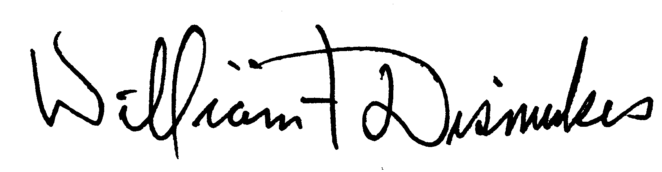

Bill Dismukes

Adjutant

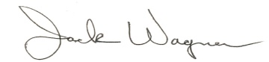

Approved by: J.Wagner