- Pledge of Allegiance: J. Wagner May 15, 2018 @ 10:30AM

- Chaplin’s Prayer: D. Bernard

- Roll Call:
  - Commander – J. Wagner - Present
  - Senior Vice Commander - D. Bernard – Present
  - Junior Vice Commander - B. Kurland – Present
  - Adjutant - B. Dismukes - Present
  - Finance Officer - R Duffney - Present
  - Sargent-At-Arms - J Connor – Present
  - Chapter Executive Committeeman – J. Connor - Present
  - Chapter Alternate Executive Committeeman – Mel Gillenwater - Absent
  - Trustee Year 2 - S. Fantino - Present
  - Trustee Year 1 - M. Abbott - Present
  - Service Officer - J. Friese - Present
  - Welfare Officer – Ed Charles - Absent
  - Historian - N/A
  - Chaplain - D. Bernard - Present
  - Americanism Officer - R. Duffney - Present
  - VA Representative - Pete Palkowski - Present

- Introduction of Guests and New Members:
None
- Reading of the Minutes of the Last Meeting:
Read and approved
- Report of the Finance Officer: Balance = $6,253.46
- Reading and Actions on Bill’s Payable:
None
- Reports of Committees: (Reports waved due to the election process taking priority)
  - Membership Candidates : N/A
  - Welfare Officer: Welfare report final and provided to the Adjutant
  - Americanism Officer: Report due end of April
  - Finance Report due: End of April
  - Special Committees: Pete Palkowski briefed on activities ongoing at VA. He also provided the new Florida Benefits document to the management team. His notes are attached.

- Unfinished Business:
  - None
- New Business:
  - Adjutant provided an excel spreadsheet established to track the two funding sources. Viola Collections and disbursements are separate from Operating Expenses and must be accounted for separately. The Adjutant will maintain the spreadsheet.
  - Adjutant explained to the committee how the funds we received for having all reports in and on time. The $50.00 for enrolment is kept in a separate account managed by the national Finance Committee and invested. The profits are distributed to the chapters and States proration to number of active members on the rolls at the time reported.
  - Jack Wagner received a Thank You card from JROTC of Lee County and shared it with the staff.
  - Jack Wagner has still not received any correspondence from Walmart Headquarters on our request to use the Cape Coral store for Viola Collections. We will pursue Sam’s Club for collection this Memorial Day.
  - Jack Wagner provided a copy of a letter sent to COSTCO suggesting that COSTCO become a Purple Heart Facility. He will report on the progress at the next meeting.
  - The VA Clinic requested support from Chapter 696 in their support of Homeless Vets. Chapter 696 purchased $100.00 worth of fruits from Sam’s Club and delivered them. Sam’s Club provided the VA Clinic with a $25.00 Gift Card for purchases for Homeless Vets. Chapter 696 provided a letter of thanks to Sam’s Club a copy is attached to this report.
  - Jack Wagner and Bill Dismukes met with the Miracle baseball Club and they have agreed to be designated a Purple Heart team. The ceremony will be held on the 29th of June on the field prior to the game. Chapter 696 will provide the team a plaque at the presentation. The cost of the plaque was approved by the executive committee.
  - The program by National in support of Israeli wounded personnel is on hold do to current conditions in Israel.
- Good of the Order: Rob Duffney made a motion that the Chapter provides a $500.00 check to defray some of the costs that the members attending the Florida Convention will occur, seconded by Pete Palkowski all in favor. Meeting Adjourned: Motioned by Dan Bernard 2nd ^{by} Sam Fantino to Adjourn at 11:25. All were in favor.
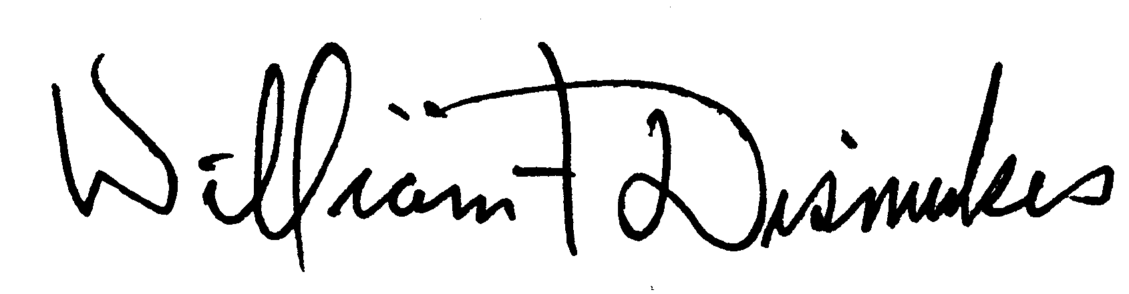
Bill Dismukes
Adjutant
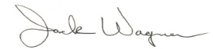
Approved by: J.Wagner

