- Pledge of Allegiance: J. Wagner June 19, 2018 @ 10:30AM

- Chaplin’s Prayer: D. Bernard

- Roll Call:
  - Commander – J. Wagner - Present
  - Senior Vice Commander - D. Bernard – Present
  - Junior Vice Commander - B. Kurland – Absent
  - Adjutant - B. Dismukes - Present
  - Finance Officer - R Duffney - Present
  - Sargent-At-Arms - J Connor – Present
  - Chapter Executive Committeeman – J. Connor -
  - Chapter Alternate Executive Committeeman – Mel Gillenwater - Absent
  - Trustee Year 2 - S. Fantino - Absent
  - Trustee Year 1 - M. Abbott - Absent
  - Service Officer - J. Friese - Present
  - Welfare Officer – Ed Charles - Present
  - Historian - N/A
  - Chaplain - D. Bernard - Present
  - Americanism Officer - R. Duffney - Present
  - VA Representative - Pete Palkowski - Absent

- Introduction of Guests and New Members:
In attendance were Jack Brunton Chapter and Department Commander, Richard Hunt Past Department Commander, Ralph Santilllo Veterans Museum, and Nicholas Napolitano Veterans Museum.
- Reading of the Minutes of the Last Meeting:
Approved
- Report of the Finance Officer: Balance = $5,318.81
- Reading and Actions on Bill’s Payable:
Jack Wager $49.95 for the Naples Plaque
- Reports of Committees:
  - Membership Candidates : N/A
  - Welfare Officer: Welfare report final and provided to the Adjutant
  - Americanism Officer:
  - Finance Report due: Submitted to National and to Department Adjutant
  - Special Committees:

- Unfinished Business:
  - None
- New Business:
  - Adjutant. Reported on the 136 Chapter members by conflict and Associate Members
WWII – 19
Korea – 12
Vietnam – 89
AF/IF – 7
Associates - 7
Total = 136
- Commander Wagner thanked all that attended the Naples procuration and dedication of Naples becoming a Purple Heart City on June 6th.
- Commander Wagner announced that Fort Myers will become a Purple Heart City on July 16th. A plaque will be presented. A motion to fund the plaque was seconded and the motion passed.
- Friday June 29th is “Military Appreciation Night” at Hammond Stadium. At this program the Miracle Base Ball team will proclaim itself to be a Purple Heart Team. A plaque will be presented by Chapter 696. All Veterans and their Families will have free admittance to the game and festivities. Tickets can be picked up at the box office prior to the game. Purple Heart members will meet at the picnic area on the left side of the stadium.
- Our Commander, Adjutant, and Americanism Officer attended the Annual State Convention of the Department of Florida in Jacksonville. Florida from May 30th to June 3rd. An excellent program coming away with a lot of information.
- Our Adjutant Bill Dismukes was asked by the incoming Department Commander too be his Adjutant; he accepted.
- Our Commander Wagner discussed numerous ways that we will be tackling fund raising. We will be submitting Request for Grants, Possibly working with the management of the Miracle Ball Team on fund raiser at their home games; Ed Charles will do a follow-up with COSCO on a possible grant. Commander Wagner asks all to think of possible fund raising ideas.
- Last month Commander Wagner and Adjutant purchased $100.00 of fruits to be given by the VA Clinic to homeless Veterans. The fruit was purchased at Sam’s Club and the club provided a gift card valued at $25.00; this was given to the VA clinic to aid in their food drive.
- Adjutant Dismukes announced that all reports with the exception of the IRS 990-N for FY 17 were submitted to Department and National. After July the Adjutant will file the updated IRS 990-N and forward copies to National and to Department.
- Our Chapter has received a request from the 2nd Vice President Jack Albert of the Naples Veterans to assist in providing a Purple Heart Medal to the surviving relative of Vito Portanova (Jack Albert’s mother). I have received a Purple Heart that we will have engraved and given to Navy Capt. Albert to present to his mother. Jack Albert asked if we could do the presentation on the 7th of August at the Veterans Museum. His wife will film the event and jack will fly to New York and present it to her. Commander Wagner will provide a Citation from the MOPH.
- Good of the Order: Meeting Adjourned: Motioned by Dan Bernard 2nd by Jerry Frease to Adjourn at 11:25. All were in favor.
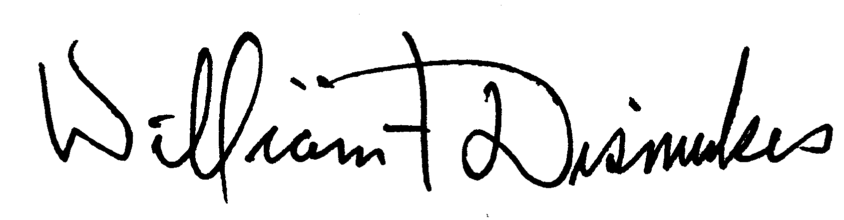
Bill Dismukes
Adjutant
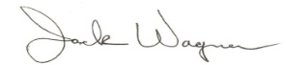
Approved by: J.Wagner

