- Pledge of Allegiance: J. Wagner September 18, 2018 @ 10:30AM

- Chaplin’s Prayer: D. Bernard

- Roll Call:
  - Commander – J. Wagner - Present
  - Senior Vice Commander - D. Bernard – Present
  - Junior Vice Commander - B. Kurland – Present
  - Adjutant - B. Dismukes - Present
  - Finance Officer - R Duffney - Present
  - Sargent-At-Arms - J Connor – Present
  - Chapter Executive Committeeman – J. Connor - Present
  - Chapter Alternate Executive Committeeman – Mel Gillenwater -
  - Trustee Year 2 - S. Fantino -
  - Trustee Year 1 - M. Abbott - Present
  - Service Officer - J. Friese - Present
  - Welfare Officer – Ed Charles - Present
  - Historian - N/A
  - Chaplain - D. Bernard - Present
  - Americanism Officer - R. Duffney - Present
  - VA Representative - Pete Palkowski - Present

- Introduction of Guests and New Members:
None
- Reading of the Minutes of the Last Meeting:
Adjutant read the minutes of June 19, 2018. Motion to accept, Seconded, and approved by all.

- Report of the Finance Officer: Balance = $5,110.17
To be deposited $8.00 from merchandise sales.
Receipt of $100.00 from Patriot Gillenwater

- Reading and Actions on Bill’s Payable:
None

- Reports of Committees:
  - Membership Candidates : N/A
  - Welfare Officer:
  - Americanism Officer:
  - Finance Report due:
  - Special Committees: Pete Palkowski gave a report of the chance of leadership at the VA Clinic in Cape Coral – report attached.

- Unfinished Business:

Commander Jack Wagner updated the executive staff on all activities that occurred during the summer break. The Ft Myers Miracle l became a PH entity, Moose Lodge Bingo netted the chapter $360.00, and the Walmart Viola collection netted the Chapter $428.35. Also, August the 7th was celebrated at the Museum with the dedication of the Department of Florida placing on permanent loan the panels celebrating the War on Terrorism along with the presentation of a WWII Purple Heart to the Nephew of the fallen gunner who lost his life in the Battle of the Bulge. At this event the Gutenberg Foundation provided a check for $100,000 of which $25,000 will be used to build out a special Purple Heart memorial area in the Museum. Chapter 696 presented a plaque to Culliton-Metzger Charitable Foundation for their support to Purple Heart item in the city of Cape Coral. Later that day members of the Chapter travelled to the city of Naples for an event honoring those presented with the Purple Heart. A handmade quilt of red, white and blue with a Purple Heart was presented to members of Chapter 696 in attendance. 5 members of the Chapter were invited to attend “Spirt of 45” in Naples Florida. This year’s theme was a celebration of the Purple Heart. Post 4174 became a Purple Heart facility at the post in Lehigh Acres on August 12th. The Chapter presented a plaque to the organization. Finally, on September 8th Chapter 696 attended the “Parade of Hero’s”.
- New Business:
  - Adjutant. Reported on the 136 Chapter members by conflict and Associate Members
WWII – 19
Korea – 12
Vietnam – 89
AF/IF – 7
Associates - 7
Total = 136
  - Adjutant Dismukes gave a summary of the Department Executive Committee held 9 September at Crystal River Florida. A copy of the minutes is attached.
  - Commander Wagner briefed on the status request of the two grant requests submitted. The first went to John E. and Aliese Price foundation – this no longer exists. The second was submitted to the Kiwanis Foundation which has not responded as of this meeting.
  - Our next Viola collections are scheduled for Nov 10th at the Walmart in Cape Coral with one additional on December 7th.
  - Pride and Patriotism will be held on November 11th at 6 PM. We have provided funding of $750.00 in the past. A motion was put to the executive board to provide the same amount for this year. The motion was seconded and approved by the board.
  - The board motioned, seconded and approved the funding of a monthly fee of $20.00 for a storage locker for the materials used in our Viola Collections. A Warrant will be issued for the Finance officer to send a check to Ms. Shizue Giles at 4269 Island Circle Unit B Fort Myers Fl 33919. We will pay this amount quarterly.
  - Finally, due to the conflicting meetings at the Museum, the board recommended that the meetings be at 10AM and that the Adjutant notify all concerned. Motioned, seconded and approved without exception.
.
- Good of the Order: Meeting Adjourned: Motioned by Dan Bernard 2nd by Jerry Frease to Adjourn at 11:25. All were in favor.
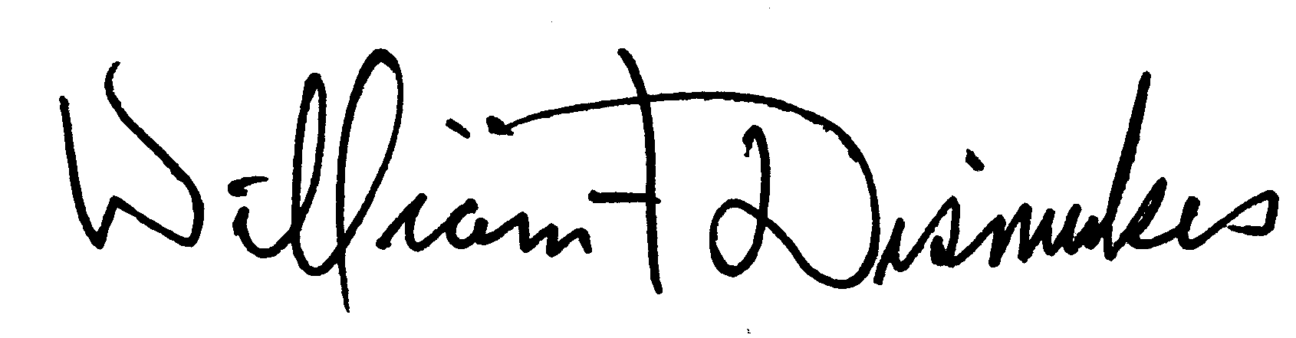
Bill Dismukes
Adjutant
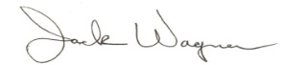
Approved by: J.Wagner

