- Pledge of Allegiance: J. Wagner October 16, 2018 @ 10:00AM

- Chaplin’s Prayer: D. Bernard

- Roll Call:
  - Commander – J. Wagner - Present
  - Senior Vice Commander - D. Bernard – Absent
  - Junior Vice Commander - B. Kurland – Present
  - Adjutant - B. Dismukes - Present
  - Finance Officer - R Duffney - Present
  - Sargent-At-Arms - J Connor – Present
  - Chapter Executive Committeeman – J. Connor -
  - Chapter Alternate Executive Committeeman – Mel Gillenwater - Absent
  - Trustee Year 2 - S. Fantino - Absent
  - Trustee Year 1 - M. Abbott - Present
  - Service Officer - J. Friese - Absent
  - Welfare Officer – Ed Charles - Present
  - Historian - N/A
  - Chaplain - D. Bernard - Absent
  - Americanism Officer - R. Duffney - Present
  - VA Representative - Pete Palkowski - Absent

- Introduction of Guests and New Members:
  - Roger Murry
- Reading of the Minutes of the Last Meeting:
Adjutant read the minutes of September 19, 2018. Motion to accept, Seconded, and approved by all.

- Report of the Finance Officer: Balance = $4,457.05

- Reading and Actions on Bill’s Payable:
- Warrant issued for a TV for Jacobs Veteran Home $691.12
- Warrant issued for Pride and Patriotism $750.00
- Check for deposit from Chapter 759 for portion of the cost of the TV $300.00
- Reports of Committees:
  - Membership Candidates : N/A
  - Welfare Officer: N/A
  - Americanism Officer: N/A
  - Special Committees:. N/A

- Unfinished Business:
  - None

- New Business:
  - Adjutant announced the next DEC is 12-13 January 2019 at the Plantation in Crystal River
  - Adjutant announced the Department Convention is 10-14 April, 2019 at the Plantation also
  - Department WEB page has seen considerable work and is ready for viewing
  - Adjutant has posted The Purple Heartbeat of the Chapter WEB site
  - Commander announced that on Saturday October 20th we would be honoring 15 Veterans that were too sick to make the Honor Flight. We will meet on the second floor of the RSW airport. Commander will email instructions.
  - Wednesday November 7th the village of Estero will become a Purple Heart Village. The executive staff Ok’d a 12x15 Plaque. The Adjutant will provide a Warrant. Adjutant will bring 10 PH Supporter pins and one Large Coin for the presentation
  - 4 Members of the executive staff will be attending a ceremony at Ave Maria Law School on 9 November at Noon. The Adjutant will provide a Warrant. Adjutant will bring 10 PH Supporter pins and one Large Coin for the presentation
  - November 10th we have a scheduled fund raiser at the Walmart on Del Prado in Cape Coral
  - State Adjutant provided an update to the ongoing activities at National and State.
  - Commander provided a message requesting support to a Gold Star Mother to help with a leaky roof on her Trailer. The board discussed the merits given the Hurricane damage in North Florida and decided due to limited funds that we should support the Hurricane victims first.
  - Adjutant provided the Finance an advanced copy of instructions for the funds due to Department of Florida in mid-December. The Adjutant will provide the amount of funds and provide a warrant to the Finance Officer.
.
- Good of the Order: Meeting Adjourned: Motioned by Ed Charles 2nd by: Mike Abbott to Adjourn at 11:25. All were in favor.
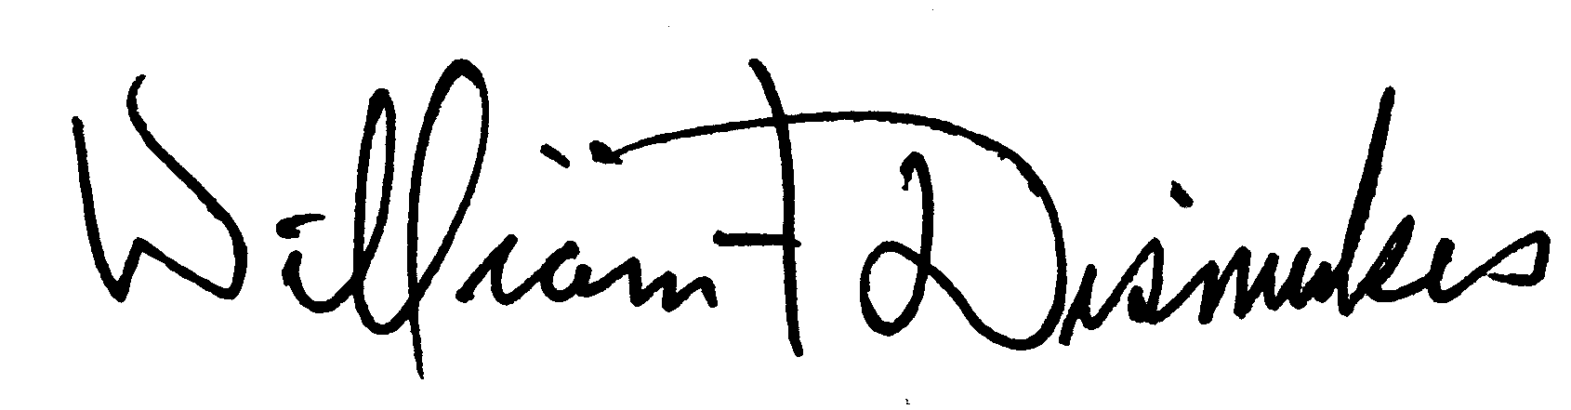
Bill Dismukes
Adjutant
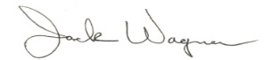
Approved by: J.Wagner

