- Pledge of Allegiance: D. Bernard November 20, 2018 @ 10:00AM

- Chaplin’s Prayer: D. Bernard

- Roll Call:
  - Commander – J. Wagner - Absent
  - Senior Vice Commander - D. Bernard –
  - Junior Vice Commander - B. Kurland – Absent
  - Adjutant - B. Dismukes - Present
  - Finance Officer - R Duffney - Present
  - Sargent-At-Arms - J Connor – Present
  - Chapter Executive Committeeman – J. Connor - Present
  - Chapter Alternate Executive Committeeman – M. Gillenwater - Absent
  - Trustee Year 2 - S. Fantino - Absent
  - Trustee Year 1 - M. Abbott - Absent
  - Service Officer - J. Friese - Present
  - Welfare Officer – Ed Charles - Pesent
  - Historian - N/A
  - Chaplain - D. Bernard - Present
  - Americanism Officer - R. Duffney - Present
  - VA Representative - Pete Palkowski – Absent

- Introduction of Guests and New Members:
  - N/A
- Reading of the Minutes of the Last Meeting:
Adjutant read the minutes of October 16, 2018. Motion to accept, Seconded, and approved by all.

- Report of the Finance Officer: Balance = $4,606.77

- Reading and Actions on Bill’s Payable:
  - None
- Reports of Committees:
  - Membership Candidates : N/A
  - Welfare Officer: N/A
  - Americanism Officer: N/A
  - Special Committees:. N/A
  - Thanks to those that attended the Village of Estero Proclamation, Ava Maria Law School Program, Pride and Patriotism, and the Unites Airline Lunch.
  - Thanks to those participating in the Walmart Collection - $635.51.

- Unfinished Business:
  - Next collection is scheduled for the 7th of December will probably be delayed until January 2019 due to the conflict with the Salvation Army collection the same day at Walmart.

- New Business:
  - Adjutant announced the next DEC is 12-13 January 2019 at the Plantation in Crystal River
  - Next event will be at the Avow Hospice in Naples – Bert Kurland is the guest speaker.
  - Adjutant Dismukes asked for a motion to have a plaque placed in the new Purple Heart display at the museum in Cape Coral, $250.00 will be sent to the Museum for this request. Motion was approved, seconded, and approved by the committee
  - Department of Florida has requested Chapters that can afford to donate funds for the Disaster Relief Fund to please consider a donation. The Adjutant asked for a motion to approve $250.00, seconded and approved by the committee.
  - Chapter 696 is nominating Commander Jack Wagner as Patriot of the year. Dan Bernard and Bill Dismukes are tasked to submit the nomination.
.
- Good of the Order:
  - Our Viola supply was exhausted and requires a refill. A Warrant will be sent to the Finance Officer to place the order for 1,000. Violas cost $125.00
  - We have been asked by the Cape Coral chapter of the Moose Lodge to possibly become a Purple Heart Entity. Patriot Duffney, a Moose member offered that it may be against the charter of the Moose to do this. Dan Bernard will take the action on this to verify the validity of the request and report to the commander if this is possible.
  - The date for the official dedication of the Purple Heart display at the museum is being set for the evening of the 7th of December. As more information becomes available a message to the Chapter with the details of the event will be sent in an email to all Chapter Members.
  - A copy of the Purple Heart display program is attached.
  - Meeting Adjourned: Motioned by Ed Charles, 2nd by Jerry Friese, to Adjourn at 11:10. All were in favor.
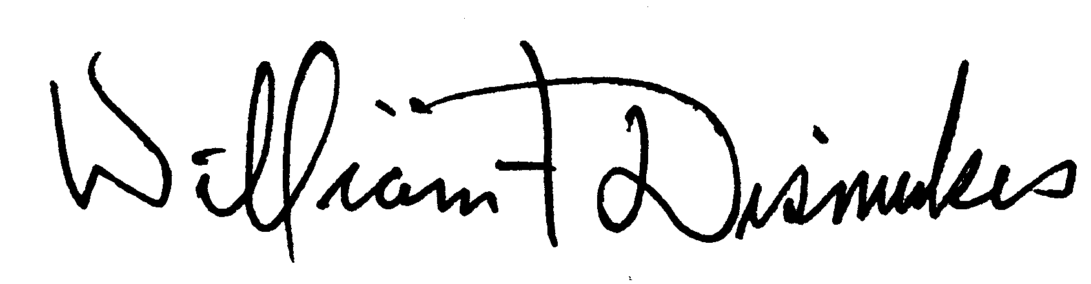
Bill Dismukes
Adjutant
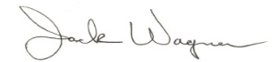
Approved by: J.Wagner

