* Pledge of Allegiance: D. Bernard December 19, 2018 @ 10:00AM
* Chaplin’s Prayer: D. Bernard
* Roll Call:
  + Commander – J. Wagner - Present
  + Senior Vice Commander - D. Bernard – Present
  + Junior Vice Commander - B. Kurland – Absent
  + Adjutant - B. Dismukes - Present
  + Finance Officer - R Duffney - Present
  + Sargent-At-Arms - J Connor – Present
  + Chapter Executive Committeeman – J. Connor -
  + Chapter Alternate Executive Committeeman – M. Gillenwater - Absent
  + Trustee Year 2 - S. Fantino - Absent
  + Trustee Year 1 - M. Abbott - Absent
  + Service Officer - J. Friese - Present
  + Welfare Officer – Ed Charles - Present
  + Historian - N/A
  + Chaplain - D. Bernard - Present
  + Americanism Officer - R. Duffney - Present
  + VA Representative - Pete Palkowski – Present

* Introduction of Guests and New Members:
  + N/A
* Reading of the Minutes of the Last Meeting:

Adjutant read the minutes of November 20, 2018. Motion to accept, Seconded, and approved by all.

* Report of the Finance Officer: **Balance** = $3,666.35
* Reading and Actions on Bill’s Payable:
  + None
* Reports of Committees:
  + Membership Candidates : N/A
  + Welfare Officer: N/A
  + Americanism Officer: N/A
  + Special Committees:. N/A
* Unfinished Business:
  + Next collection will be scheduled for Presidents Day at Walmart
* New Business:
  + Adjutant announced the next DEC is 12-13 January 2019 at the Plantation in Crystal River
  + The Executive Committee received a briefing from Amy Emme of GOCIV organization as a possible fund raiser for the Chapter. After a lengthy discussion no decision was made. Members requested documentation from her organization that will be forwarded to the National Adjutant for review to determine if this is a valid method that would be allowable by Headquarters MOPH. Once guidance/approval is obtained an additional meeting will be arranged with MS. Emme.
  + Several members of the committee attended a Pearl Harbor Day celebration at the AVOW Hospice in Naples. Junior Vice Commander Bert Kurland was the quest speaker and did an outstanding job.
  + Moose lodge 1899 of Fort Myers became a Purple Heart facility on Friday 19 December.
  + Moose Lodge 2199 of Cape Coral will become a Purple Heart facility. We will arrange with that lodge to assist at a second Bingo event in the near future. The last event netted Chapter 696 $360.00.
  + The War on Terrorism dedication at the museum in Cape Coral will be formally dedicated on the evening of 26 January 2019. Commander Wagner will be leading our Chapter along With past Department Commander Richard Hunt. The Adjutant sent out a blast email to 90+ patriots of the Chapter.
* Good of the Order:
  + At 1130 a motion to adjourn was presented by Rob Duffney, seconded by Ed Charles with all in favor the December meeting was closed.

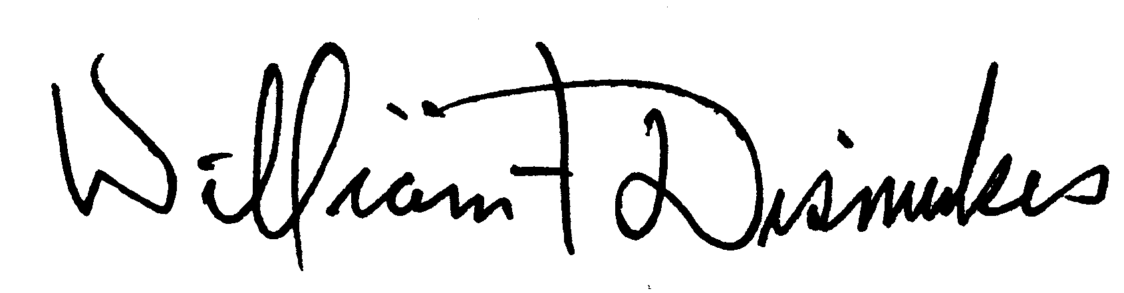

Bill Dismukes

Adjutant

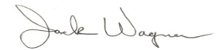

Approved by: J.Wagner