- Pledge of Allegiance: Jack Wagner January 12, 2019 @ 10:00AM

- Chaplin’s Prayer: D. Bernard

- Roll Call:
  - Commander – J. Wagner - Present
  - Senior Vice Commander - D. Bernard – Present
  - Junior Vice Commander - B. Kurland – Present
  - Adjutant - B. Dismukes - Present
  - Finance Officer - R Duffney - Present
  - Sargent-At-Arms - J Connor – Present
  - Chapter Executive Committeeman – J. Connor - Present
  - Chapter Alternate Executive Committeeman – M. Gillenwater - Absent
  - Trustee Year 2 - S. Fantino - Absent
  - Trustee Year 1 - M. Abbott - Absent
  - Service Officer - J. Friese - Present
  - Welfare Officer – Ed Charles - Present
  - Historian - N/A
  - Chaplain - D. Bernard - Present
  - Americanism Officer - R. Duffney - Present
  - VA Representative - Pete Palkowski – Present

- Introduction of Guests and New Members:
  - Kenneth D. Westgate
- Reading of the Minutes of the Last Meeting:
Adjutant read the minutes of December 18 , 2018. Motion to accept, Seconded, and approved by all.

- Report of the Finance Officer: Balance = $3,686.45

- Reading and Actions on Bill’s Payable:
  - None
- Reports of Committees:
  - Membership Candidates : N/A
  - Welfare Officer: N/A
  - Americanism Officer: Provided a copy of the letter sent to a student in Montana recognizing her writing “Why Our Veterans Are American Heroes”. This letter will be placed in the Department permanent files
  - Special Committees - N/A

- Unfinished Business:
  - Next Chapter event is the Grand Opening on the “Wall on Terror” at the Veterans Museum on 26 January.
- New Business:
  - Commander presented information from Patriot Palkowski about the City of Sanibel becoming a Purple Heart City. This may occur on 5 February.
  - Patriot Frease is working with the city of Fort Meyers Beach to be proclaimed a Purple Heart City. More information to follow.
  - Commander stated that he would like to pursue getting the Spring Training Teams of the Boston Red Socks and Minnesota Twins becoming Purple Heart Teams. The commander will take the lead.
  - In the past the Chapter has been given complimentary tickets to the Everblades Hockey Team at Hertz Arena. He will attempt to get these again.
  - The Election process for the FY 19-20 has been moved up and must be completed by 30 March 2019. Motions for the seven elected positions resulted in only one individual for each position:
    - Commander – Jack Wagner – Accepted
    - Senior Vice Commander – Dan Bernard – Accepted
    - Junior Vice Commander – Bert Kurland – Accepted
    - Finance Officer – Robert Johnston – Accepted
    - Sergeant at Arms – Jim Connor – Accepted
    - Trustee 2 years – Rob Duffney – Accepted
    - Trustee 1 year – Peter Palkowski
  - A motion to accept the slate of officers was made, seconded, and approved by the executive staff.
  - Commander Wagner offered the following assigned positions:
    - Adjutant – Bill Dismukes – Accepted
    - Chapter Executive Committeeman – Sam Fantino – Accepted
    - Chapter Alternate Executive Committeeman – Mel – Gillenwater
    - Service Officer – Jerry Frease – Accepted
    - Welfare Officer – Ed Charles – Accepted
    - Historian – Sam Fantino – Accepted
    - Chaplain – Dan Bernard – Accepted
    - Americanism Officer – Rob Duffney – Accepted
  - The Museum requested that the Chapter provide a flag to be flown on the flag pole at the entrance, – discussion ensued, a motion to approve the purchase was given, seconded, and approved with one dissension.
  - Commander Wagner read a letter that was sent to the family of Patriot Mel Gillenwater whom loosed his wife Christmas Day. The Executive Staff was in agreement to send $100.00 to the Florida charity listed in the obituary. A motion to approve, seconded, and approved by all.
  - The Convention this year will be held in Clear Water Florida. Commander Jack Wagner mentioned that the previous year we had a full page add in the Convention Booklet and asked if we would do the same this year. A motion from the floor was for $250.00 to procure an ad this year, seconded and approved.
  - Peter Palkowski provided an update (attached) on the status of the VA Health Clinic is open for business as the Government shutdown continues.
  - Chapter 696 was advised by National of a transfer to Chapter 696 of patriot:
    - L42440 Frank J. Bubb Jr. 9507 Parkwood Court Fort Myers Florida 33908

- Good of the Order:
  - Dan Bernard informed the group that the storage locker where we keep the collection material will no longer be available the end of March. Ed Charles has offered to store the equipment in his garage.
  - Meeting Adjourned: Motioned by B. Kurland, 2nd by Ed Charles at 11:10.

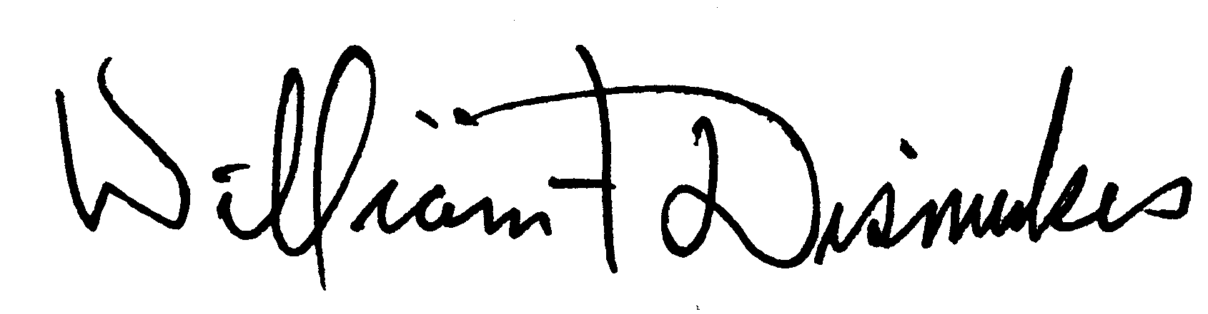
Bill Dismukes
Adjutant
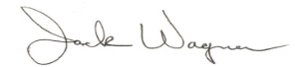
Approved by: J.Wagner

