- Pledge of Allegiance: Jack Wagner February 19, 2019 @ 10:00AM

- Chaplin’s Prayer: Ed Charles

- Roll Call:
  - Commander – J. Wagner - Present
  - Senior Vice Commander - D. Bernard – Present
  - Junior Vice Commander - B. Kurland – Excused (hospital)
  - Adjutant - B. Dismukes - Present
  - Finance Officer - R. Johnston - Present
  - Sargent-At-Arms - J Connor – Present
  - Chapter Executive Committeeman – S. Fantino - Present
  - Chapter Alternate Executive Committeeman – M. Gillenwater - Absent
  - Trustee Year 2 - R. Duffney - Present
  - Trustee Year 1 – Pete Palkowski - Present
  - Service Officer - J. Friese - Present
  - Welfare Officer – Ed Charles - Present
  - Historian - N/A
  - Chaplain - D. Bernard - Present
  - Americanism Officer - R. Duffney - Present
  - VA Representative - Pete Palkowski – Present

- Introduction of Guests and New Members:
  - Charles V. Clayton accepted his application for membership and forwarded to National
  - Kenneth D. Westgate accepted his application for membership and forwarded to National
- Reading of the Minutes of the Last Meeting:
Adjutant read the minutes of January 13, 2019. Motion to accept, Seconded, and approved by all.

- Report of the Finance Officer: Balance = $3,206.62
  - Adjutant deposited $359.00 from the Viola collection Saturday
  - Rob Duffney gave a Check for $100 from one of the chapter patriots

- Reading and Actions on Bill’s Payable:
  - None
- Reports of Committees:
  - Membership Candidates : N/A
  - Welfare Officer: N/A
  - Americanism Officer:
  - Special Committees – Pete Palkowski gave an update to ongoing activities at the VA - attached

- Unfinished Business:
  - Commander Wagner updated the tentative Viola collection date for CY 2019 – Saturday March 30; Saturday May 18th; Thursday July 4th; Wednesday August 7th and Saturday November 9th.
  - Commander Wagner stated that here was an excellent turnout at the official dedication for the Purple Heart Wall at the museum on the 26th of January.
  - A standing ovation for Bob Johnston for his hard work and efforts making the Wall a reality.
  - On Tuesday March 5th at 9:15 the city of Sanibel will be proclaimed a Purple Heart City. We must be in Sanibel prior to 9 AM. City offices are located at 800 Dunlap Road.
  - The chapter participated in an awards ceremony at 3PM in the museum for a fallen soldier that died as results of his wounds while hospitalized in Japan. The family never received his awards. Present at the event was congressman Rooney - presenter, Mayor of Cape Coral and other officials.
  - The remaining raffle tickets were purchased and collected by the adjutant to deliver to the convention drawing.
  - Adjutant Dismukes updated the group on the ongoing activities at National. Difficulties remain between the Order and the Foundation. Legal action pending.
  - Department of Florida is in ok financial position and will not be directly affected by the actions stated.
- New Business:
  - Commander presented information from Patriot Palkowski about the City of Sanibel becoming a Purple Heart City
    - 5March -0915

- Good of the Order:
  - Meeting Adjourned: A Motioned by Dan Bernard and 2nd by Sam Fantino at 11:10 was approved by all present.

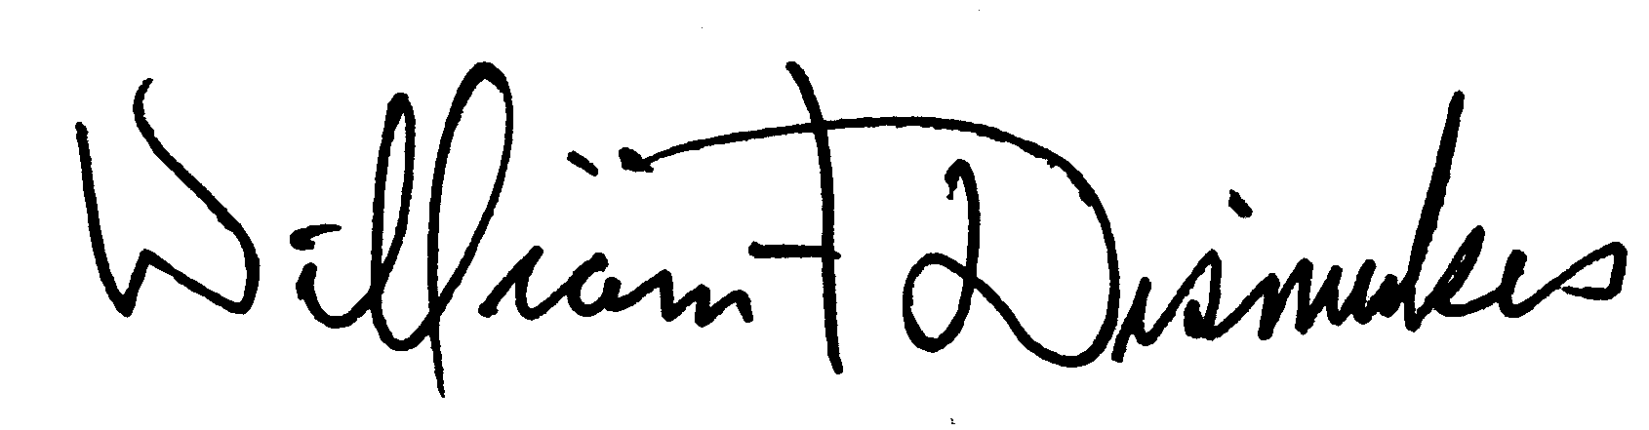
Bill Dismukes
Adjutant
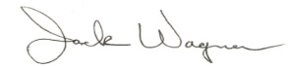
Approved by: J.Wagner

